TweetsReport

Aitor Ameztegui

September 8, 2016

## About this document

This document was produced by [Emily J. Rollinson](http://rollinsonecology.com) ([ejrollinson](https://twitter.com/ejrollinson) on Twitter).

The code generating this document was originally developed by [Francois Michonneau](https://github.com/fmichonneau) ([fmic_](https://twitter.com/fmic_) on Twitter) for the 2015 Evolution meeting and can be found [here](https://github.com/fmichonneau/evol2015-tweets).

It has since been [adapted](https://github.com/jlehtoma/iccb2015-tweets/blob/gh-pages/index.Rmd) for ICCB-ECCB 2015 by Joona Lehtomaki ([jlehtoma](https://twitter.com/jlehtoma) on Twitter).

I originally adapted this code for the 2015 Ecological Society of America Meeting (#ESA100) in Baltimore, MD, and have reproduced it here for the 2016 Ecological Society of America Meeting (#ESA2016) in Fort Lauderdale, FL.

Tweets using the hashtag #ESA2016 were aggregated from Twitter using the R package [twitteR](https://cran.r-project.org/web/packages/twitteR/index.html) and the Twitter API. The aggregated tweets are [available on Figshare](https://figshare.com/authors/Emily_Rollinson/781925).

This document was generated using RMarkdown, and the source is [available on GitHub](https://github.com/erollinson/erollinson.github.io).

This document (and associated code) is released under a CC0 licence.

## Basic summary

Of the most recent 12k tweets tagged #ESA2016 (As of 4:30 PM 8/13/2016):

|  |  |
| --- | --- |
| Description | n |
| Total of original tweets (no retweets): | 1274 |
| Number of users who tweeted: | 2583 |

## The 5 most favorited tweets

Todo mi apoyo a los #HeroesAnónimos que trabajan en #IFBenitatxell y otros #IIFF. Ejemplo de profesionalidad y compromiso @InfoEmerg.

— FranHervias |  2016-09-06  | 92 retweets, 74 favorites.

El protocolo #OACEL no lo siguen muy bien que digamos, pero una peli de dibujos sobre #iiff es un punto <https://t.co/RoEJ1MNBUI>

— eforestal |  2016-09-03  | 56 retweets, 55 favorites.

Y si se cae el sistema informático durante la extincion #IIFF? En el COR siempre nos quedará la tradicional pizarra <https://t.co/zGrLG0EQUm>

— Plan_INFOCA |  2016-09-03  | 19 retweets, 55 favorites.

Durisimo dia para las #BRIF en #IIFF x toda #España combatiendo @BrifDaroca en #IFBolulla mucha fuerza to2 medios! <https://t.co/QzbpSzcf87>

— AT_Brif |  2016-09-05  | 57 retweets, 54 favorites.

Asi esta #IFCandeleda #Avila ahora mismo 16:50 "refrescado"por una DESCARGAAA! del #43Grupo #IIFF #IFCandeleda <https://t.co/Ni9RqN9kS0>

— AT_Brif |  2016-08-31  | 36 retweets, 51 favorites.

## The 5 most retweeted tweets

05/09/2016 Nivell de Preemergència. Risc extrem #IIFF / Nivel de Preemergencia. Riesgo extremo #IIFF <https://t.co/ppc0I6ebEK>

— GVA112 |  2016-09-05  | 96 retweets, 27 favorites.

Todo mi apoyo a los #HeroesAnónimos que trabajan en #IFBenitatxell y otros #IIFF. Ejemplo de profesionalidad y compromiso @InfoEmerg.

— FranHervias |  2016-09-06  | 92 retweets, 74 favorites.

Hoy el mapa de riesgo de #IncendiosForestales es terrorífico. Mucha precaución #IIFF #STOPincendios <https://t.co/q0vvxyKiIK>

— TheoOberhuber |  2016-09-06  | 83 retweets, 34 favorites.

Así se vive desde dentro un incendio forestalAtaque directocon mochila extintora[20kgs] y rematando con #IIFF <https://t.co/o0OJp8pPXK>

— briftabuyo |  2016-09-07  | 63 retweets, 49 favorites.

Durisimo dia para las #BRIF en #IIFF x toda #España combatiendo @BrifDaroca en #IFBolulla mucha fuerza to2 medios! <https://t.co/QzbpSzcf87>

— AT_Brif |  2016-09-05  | 57 retweets, 54 favorites.

## Top tweeters

All generated tweets (including retweets)

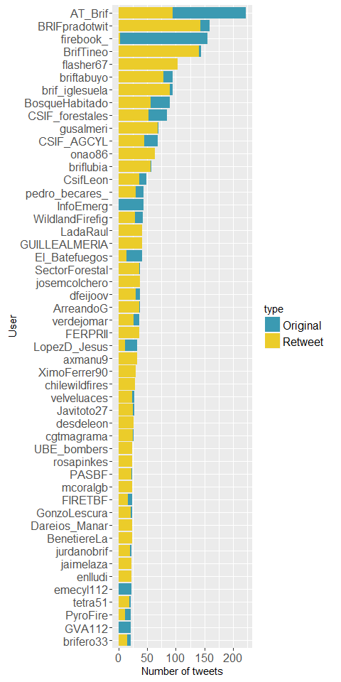

Only for original tweets (retweets excluded)

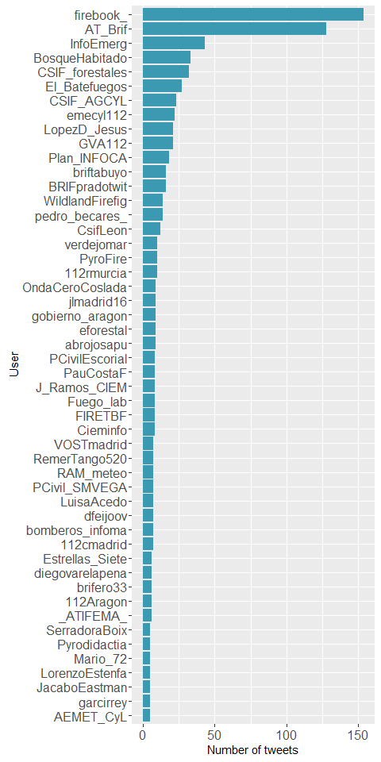

## Most favorited/retweeted users

The figures below only include users who tweeted 5+ times, and don't include retweets.

### Number of favorites received by users

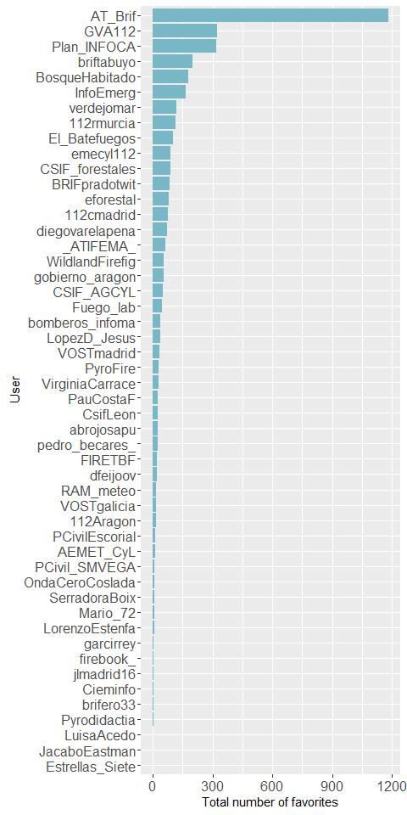

### Number of retweets received by users

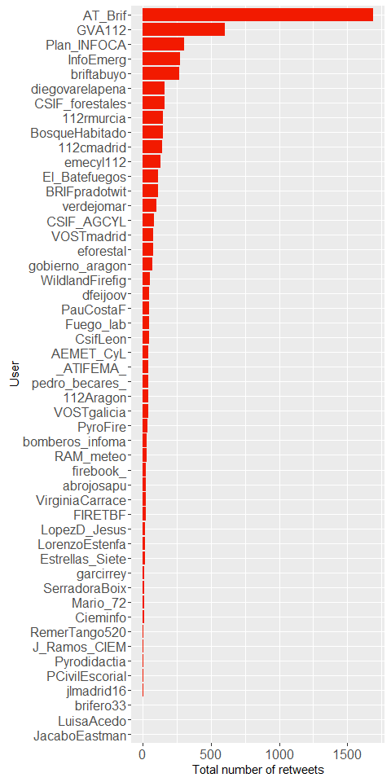

### Mean numbers of favorites received

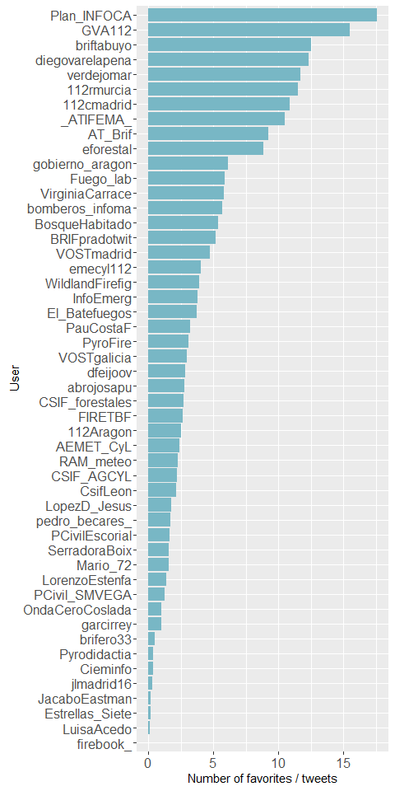

### Mean numbers of retweets received

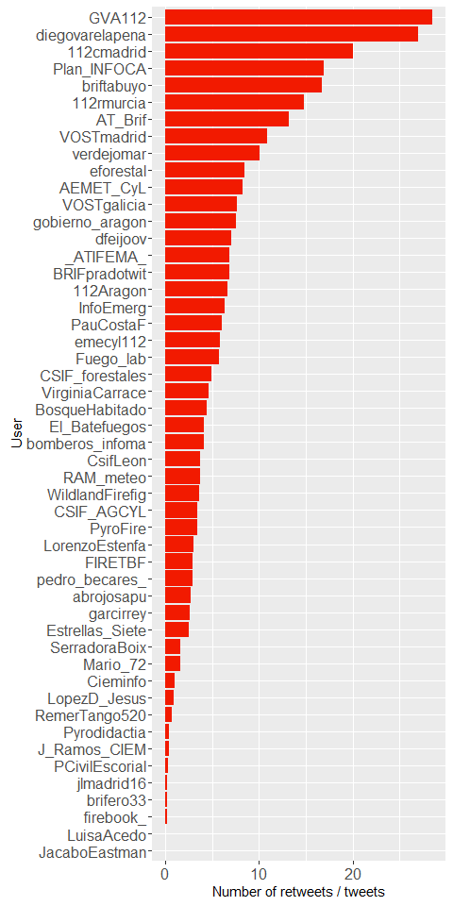

## Word cloud

The top 100 words among the original tweets.

## Warning in wordcloud(., max.words = 100, colors = pal, random.order =  
## FALSE, : eledu00a0u00bdedu00b4u00a5 could not be fit on page. It will not  
## be plotted.

## Warning in wordcloud(., max.words = 100, colors = pal, random.order =  
## FALSE, : edu00a0u00bdedu00b4u00a5incendios could not be fit on page. It  
## will not be plotted.

## Warning in wordcloud(., max.words = 100, colors = pal, random.order =  
## FALSE, : forestalesedu00a0u00bdedu00b4u00a5 could not be fit on page. It  
## will not be plotted.

## Warning in wordcloud(., max.words = 100, colors = pal, random.order =  
## FALSE, : edu00a0u00bdedu00b4u00a5 could not be fit on page. It will not be  
## plotted.

## Warning in wordcloud(., max.words = 100, colors = pal, random.order =  
## FALSE, : edu00a0u00bdedu00b4u00a5extrema could not be fit on page. It will  
## not be plotted.

## Warning in wordcloud(., max.words = 100, colors = pal, random.order =  
## FALSE, : edu00a0u00bdedu00b4u00b4 could not be fit on page. It will not be  
## plotted.

## Warning in wordcloud(., max.words = 100, colors = pal, random.order =  
## FALSE, : preemergència could not be fit on page. It will not be plotted.

## Warning in wordcloud(., max.words = 100, colors = pal, random.order =  
## FALSE, : profesionales could not be fit on page. It will not be plotted.

## Warning in wordcloud(., max.words = 100, colors = pal, random.order =  
## FALSE, : emergenciassev could not be fit on page. It will not be plotted.

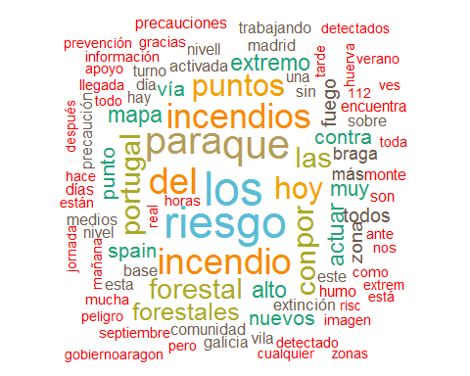

To the extent possible under law, Emily J. Rollinson has waived all copyright and related or neighboring rights to Summary of tweets at the 2016 Ecological Society of America conference. This work is published from: United States.