A template for writing manuscripts in Rmarkdown

Francisco Rodríguez-Sánchez1,2*, Second Author3

1 Estación Biológica de Doñana (CSIC)

2 Universidad de Sevilla

3 Second Author affiliation

* Corresponding author: [example@example.com](mailto:example@example.com)

# ABSTRACT

Write your abstract here.

*Keywords*: Rmarkdown, reproducible science

# INTRODUCTION

Write your introduction here. You can cite bibliography like this (Yan and Gerstein 2011, Sutherland et al. 2011) if you provide a BibTeX file with references. See <http://rmarkdown.rstudio.com> for more information.

You can even specify the desired output format for your bibliography by including a style file for a specific journal (e.g. “ecology.csl”). Many different bibliography styles (CSL files) can be obtained at <http://citationstyles.org/>, <https://github.com/citation-style-language/styles>, or <https://zotero.org/styles>.

# METHODS

## Study Area

We worked in a **beautiful** place with lots of trees, like *Quercus suber* and *Laurus nobilis*.

## Data collection and analysis

We applied a linear model where

$$y_{i}=α+β*x_{i}$$

We used the statistical language R (R Core Team 2020) for all our analyses. These were implemented in dynamic rmarkdown documents using knitr (Xie 2014, 2015, 2021) and rmarkdown (Xie et al. 2018, 2020, Allaire et al. 2020) packages. All the multilevel models were fitted with lme4 (Bates et al. 2015).

# RESULTS

Trees in forest *A* grew taller than those in forest *B* (mean height: 25 versus 13 m).

And many more cool results that get updated dynamically, e.g. see Table 2 and Fig. 1. Note Tables and Figures are cross-linked and numbered automatically.

Table 1: A glimpse of the famous Iris dataset.

|  |  |  |  |  |
| --- | --- | --- | --- | --- |
| Sepal.Length | Sepal.Width | Petal.Length | Petal.Width | Species |
| 5.1 | 3.5 | 1.4 | 0.2 | setosa |
| 4.9 | 3.0 | 1.4 | 0.2 | setosa |
| 4.7 | 3.2 | 1.3 | 0.2 | setosa |
| 4.6 | 3.1 | 1.5 | 0.2 | setosa |
| 5.0 | 3.6 | 1.4 | 0.2 | setosa |
| 5.4 | 3.9 | 1.7 | 0.4 | setosa |

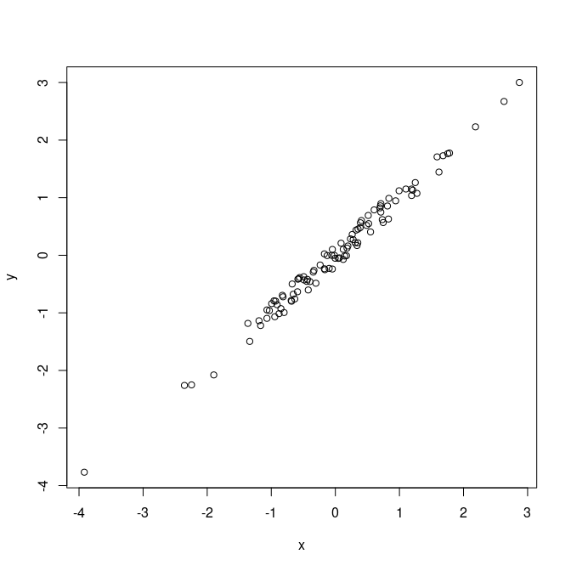

Figure 1: Just my first figure with a very fantastic caption.

# DISCUSSION

Discuss.

# CONCLUSIONS

Wrap up

# ACKNOWLEDGEMENTS

On the shoulders of giants.

# REFERENCES

Allaire, J., Y. Xie, J. McPherson, J. Luraschi, K. Ushey, A. Atkins, H. Wickham, J. Cheng, W. Chang, and R. Iannone. 2020. Rmarkdown: Dynamic documents for r.

Bates, D., M. Mächler, B. Bolker, and S. Walker. 2015. Fitting linear mixed-effects models using lme4. Journal of Statistical Software 67:1–48.

R Core Team. 2020. R: A language and environment for statistical computing. R Foundation for Statistical Computing, Vienna, Austria.

Sutherland, W. J., D. Goulson, S. G. Potts, and L. V. Dicks. 2011. Quantifying the impact and relevance of scientific research. PLoS ONE 6:e27537.

Xie, Y. 2014. Knitr: A comprehensive tool for reproducible research in R. *in* V. Stodden, F. Leisch, and R. D. Peng, editors. Implementing reproducible computational research. Chapman; Hall/CRC.

Xie, Y. 2015. Dynamic documents with R and knitr. 2nd edition. Chapman; Hall/CRC, Boca Raton, Florida.

Xie, Y. 2021. Knitr: A general-purpose package for dynamic report generation in r.

Xie, Y., J. J. Allaire, and G. Grolemund. 2018. R markdown: The definitive guide. Chapman; Hall/CRC, Boca Raton, Florida.

Xie, Y., C. Dervieux, and E. Riederer. 2020. R markdown cookbook. Chapman; Hall/CRC, Boca Raton, Florida.

Yan, K.-K., and M. Gerstein. 2011. The spread of scientific information: Insights from the web usage statistics in PLoS article-level metrics. PLoS ONE 6:e19917.

###### Supplementary Table (on new page)

Table 2: Now a subset of mtcars dataset.

|  |  |  |  |  |  |  |  |  |  |  |  |
| --- | --- | --- | --- | --- | --- | --- | --- | --- | --- | --- | --- |
|  | mpg | cyl | disp | hp | drat | wt | qsec | vs | am | gear | carb |
| Merc 280 | 19.2 | 6 | 167.6 | 123 | 3.92 | 3.440 | 18.30 | 1 | 0 | 4 | 4 |
| Merc 280C | 17.8 | 6 | 167.6 | 123 | 3.92 | 3.440 | 18.90 | 1 | 0 | 4 | 4 |
| Merc 450SE | 16.4 | 8 | 275.8 | 180 | 3.07 | 4.070 | 17.40 | 0 | 0 | 3 | 3 |
| Merc 450SL | 17.3 | 8 | 275.8 | 180 | 3.07 | 3.730 | 17.60 | 0 | 0 | 3 | 3 |
| Merc 450SLC | 15.2 | 8 | 275.8 | 180 | 3.07 | 3.780 | 18.00 | 0 | 0 | 3 | 3 |
| Cadillac Fleetwood | 10.4 | 8 | 472.0 | 205 | 2.93 | 5.250 | 17.98 | 0 | 0 | 3 | 4 |
| Lincoln Continental | 10.4 | 8 | 460.0 | 215 | 3.00 | 5.424 | 17.82 | 0 | 0 | 3 | 4 |

###### Supplementary Figure (on new page)

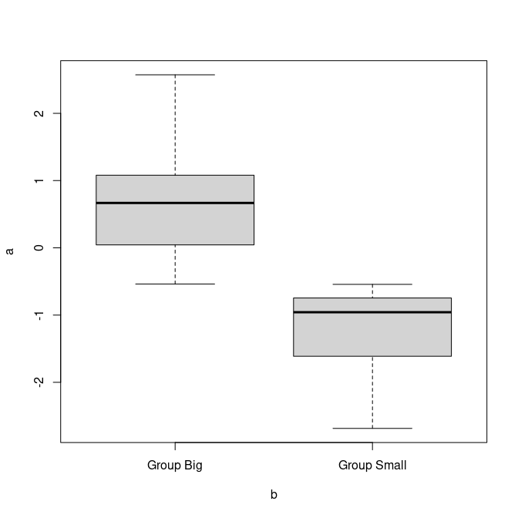

Figure 2: A boxplot.