# **OBJECTIVES:**

* To interface seven-segment to the AVR simulator.

# **MATERIAL:**

* Atmel Studio or the assembler of your choice.
* <https://lcgamboa.github.io/js/picsimlab.html?../picsimlab_examples/> (Simulator)

# **WEB SITES:**

* [www.microchip.com](http://www.microchip.com/) for Atmel Studio Software

# **ACTIVITY 1**

1. Connect a common cathode 7-segment directly to PORTD.

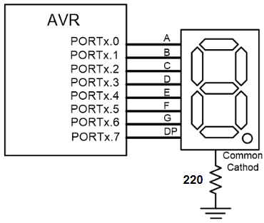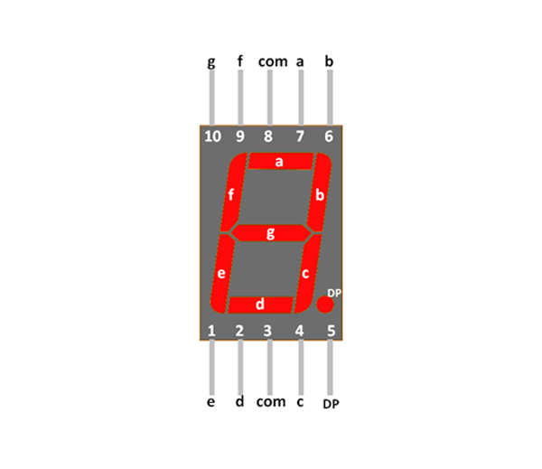

1. Write the following program in the AVR Studio, build and download to the picsimlab.

LDI R20, 0xFF

OUT DDRD, R20

LDI R20, 0b00000111

OUT PORTD, R20

HERE: RJMP HERE

# **ACTIVITY 2**

Modify the previous program to display 9 on the 7-segment.

# **ACTIVITY 3**

Use a **look-up table** to write a subroutine that displays the value stored in R21 on the 7-segment.

# **ACTIVITY 4**

1. Connect two 7-segments to the same port of AVR, as shown below.

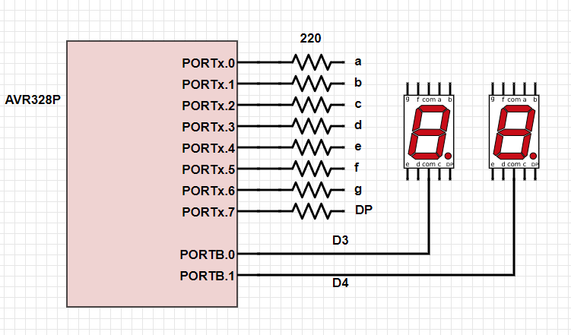

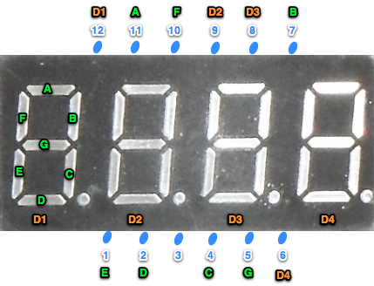

1. Display 23 by scanning on those two 7-segments.