Pakin Panawattanakul 6580043

1.1 Class Diagram
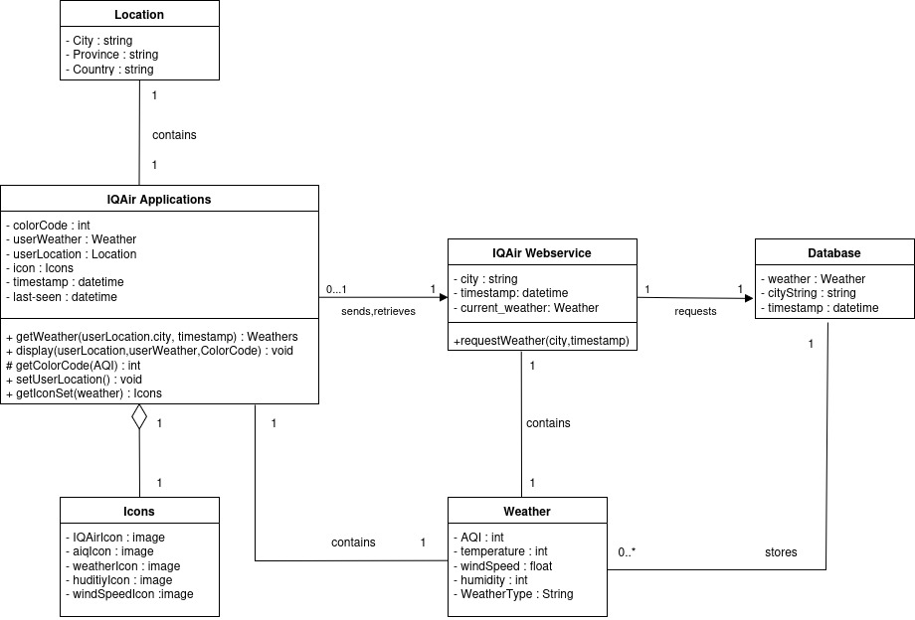

1.2 Sequence Diagram
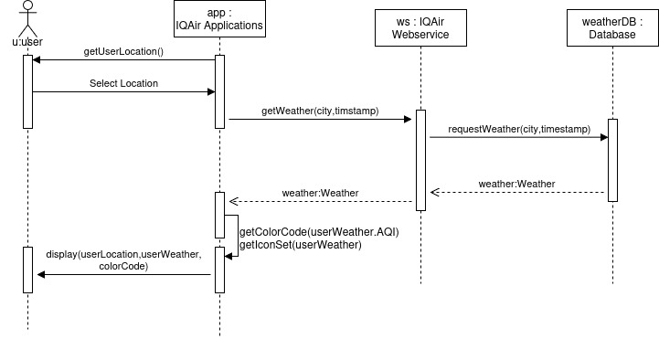

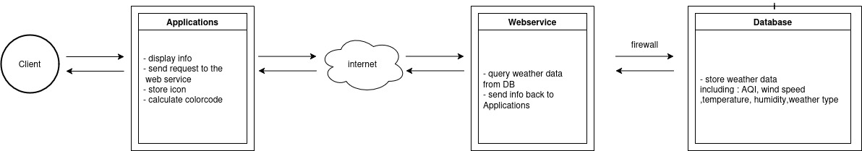
1.3 Software Architecture

