Exercise 2 (23 points) – individual work
- The answers can be typed or handwritten (handwriting must be clear and readable), in this exercise sheet or your own sheet (put your name & ID at the top of the sheet). All answers must be saved to only 1 PDF file.
- Some questions also require the submission of processes/workflows (file.rmp or file.ipynb).
- In case of re-submission (after first grading) or submission after solution is given, your points will be weighted by 0.5.
-------------------------------------------------------------------------------------------------------------------------------------------------------

Record | Vehicle | Gender | Time | Class
1 | Car | Male | pm | A
2 | Car | Female | am | B
3 | Bus | Male | pm | A
4 | Bus | Female | pm | B
5 | Bus | Male | pm | A
6 | Car | Female | pm | B
7 | Bus | Male | am | B
8 | Bus | Male | am | A
9 | Car | Male | pm | A
10 | Bus | Male | am | B

1. (Total 10 points)
1.1 (4 points) From the table, calculate GINI when splitting data by each attribute (answer in 4
decimal places). And based on GINI, which attribute should be chosen as a tree node first?

At root node there are 5 A and 5B, and have Gini = 0.5000
Split by Vehicle | GINI = 0.5000  Info gain = 0.5-0.5 = 0
Split by Gender | GINI = 0.2857  Info gain = 0.5 - 0.2857 = 0.2143
Split by Time | GINI = 0.4167  Info gain = 0.0833
Which one to choose first? | Choose Split by Gender first since it has lower gini than other 2 attributes. => higher information gain

1.2 (4 points) Consider another dataset that has 12 records (6 in class yes, 6 in class no), and a nominal attribute "brand" with 3 categories {iPhone, Samsung, Oppo}. When splitting the data by brand, using both binary split and multi-way split, entropies after split are as shown in the table. Calculate gain ratio for each split option.
Note 1: Find entropy before split from the full data set
Note 2: Use bin sizes to calculate split penalty for each option
Entropy before split = -0.5log2(0.5) - 0.5log2(0.5) = 1
Split penalty for each option
- 0.9183
- 0.8113
- 0.9799
- 1.5546

Option | Split Method | Bin size | Total entropy  after split | Gain Ratio
1 | Bin1: brand = iPhone, Samsung  Bin2: brand = Oppo | 4 yes, 4 no  2 yes, 2 no | 1 | (1-1)/0.9183  =0
2 | Bin1: brand = iPhone, Oppo  Bin2: brand = Samsung | 5 yes, 4 no  1 yes, 2 no | 0.9729 | 1-0.9729/0.8113  =0.0334
3 | Bin1: brand = iPhone  Bin2: brand = Samsung, Oppo | 3 yes, 2 no  3 yes, 4 no | 0.9793 | 1-0.9793/0.97]9  =0.0211
4 | Bin1: brand = iPhone  Bin2: brand = Samsung  Bin3: brand = Oppo | 3 yes, 2 no  1 yes, 2 no  2 yes, 2 no | 0.9675 | 1-0.9675/1.5546  =0.0209

1.3 (2 points) From question 1.2, which split option should be chosen if we use gain ratio as the criterion? And which option should be chosen if we use information gain as the criterion instead?

If we use Gain ratio as criteria option 2 is the best with 0.334 gain ratio. Using information gain the best option will change to 4 but Gini and Entropy often bias toward Multiway split. But we prefer binary split

2. (Total 5 points) Consider the following rule set generated from training data in question 1.1
Rule 1 if gender = female then class = B
Rule 2 if gender = male && vehicle = bus then class = A
Rule 3 if vehicle = car && time = pm then class = A
Rule 4 if vehicle = bus && time = am then class = B

There are 8 combinations of attribute values e.g. (car, male, am), (car, male, pm), (car, female, am), (car, female, pm), … To check exhaustive and mutual exclusive properties, you need to check whether every combination can be predicted by only 1 rule.

2.1 (1 point) Find combination (there is 1) that indicate the lack of exhaustive property.

There is no (car,male,am) in any rule set so it is lack exhaustive property

2.2 (2 points) Find combinations (there are 2) that indicate the lack of mutual exclusive property, and rules that are triggered by each combination.

- (bus,male,am) : rule 2(car,pm), rule 4(bus,am
- (car,female,pm) : rule 1(female), rule3(car,pm)

2.3 (2 point) If we solve the conflicts in question 2.2 by following rules with the highest accuracy, what would be the prediction for each combination in 2.2.

Accuracy of R1 = 3/3 , R2 = 3/5, R3 = 2/3, R4 = 2/3
Prediction (bus,male,am) = class B
Prediction (car,female,pm) = class B

3. (Total 8 points) Retrieve Past Campaign Data.

3.1 (2 points) Build a work flow for classification task.
- Step 1. Split data into 2 partitions: 70% of the data for training and 30% for testing.
- Step 2. Use either decision tree or rule induction to classify response. Adjust parameters to get high accuracy (>= 85% on test data). If the accuracy is already high, you may adjust parameters to get better or clearer patterns (e.g. bigger tree nodes with higher coverage or smaller nodes with more conditions).
- Step 3. Submit your workflow. Make sure that it outputs at least performance table and decision tree or rule set. Name the workflow question3.rmp.

3.2 (3 points) Capture (a portion of) tree or rule set and highlight node/rule that predict yes. The node/rule that you choose should have high coverage, high accuracy, and contain interesting conditions. In case of rule set, don't pick default rule without any precondition.
Questions/Instructions | Answers
(a) Show the captured tree/rule & describe pattern that predicts yes in words (read all conditions in the rule, or all conditions that lead to the leaf node). | 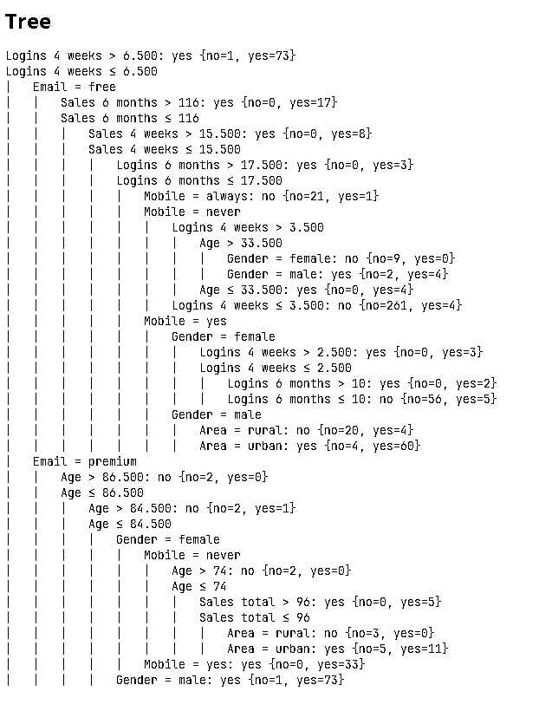  Pattern: (login 4 weeks <= 6.5, mail = premium, Age < 86.5, Age < 84.5, Gender = male )
(b) Report coverage of this pattern, i.e. number or percentage of records it covers. | High coverage 74 records
(c) Report accuracy of this pattern | (73/74)*100 = 98.6849 %

3.3 (3 points) Capture (a portion of) tree or rule set and highlight node/rule that predict no. Follow the same guidelines as in question 3.2.
Questions/Instructions | Answers
(a) Show the captured tree/rule & describe pattern that predicts no in words. | 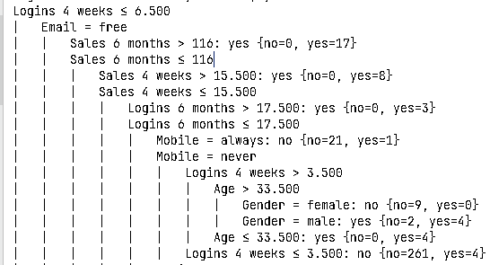  Pattern : (logins 4 weeks < 6.5, Email = free, Sales 6 months <= 116, Sales 4 weeks <= 15.5, Logins 6 months <= 17.5, Mobile = never, Login 4 weeks <= 3.5)
(b) Report coverage of this pattern. | 265 records
(c) Report accuracy of this pattern | (261/265)*100=98.4906%

