Exercise 5 (14 points) – individual work
- The answers can be typed or handwritten (handwriting must be clear and readable), in this exercise sheet or your own sheet (put your name & ID at the top of the sheet). All answers must be saved to only 1 PDF file.
- Some questions also require the submission of processes/workflows (file.rmp or file.ipynb).
- In case of re-submission (after first grading) or submission after solution is given, your points will be weighted by 0.5.
-------------------------------------------------------------------------------------------------------------------------------------------------------
1. (Total 6 points)
Retrieve cpu data, which contains the following attributes. All of them are numeric.
Attribute | Description
MYCT | Machine cycle time (nanoseconds)
MMIN | Minimum main memory (kilobytes)
MMAX | Maximum main memory (kilobytes)
CACH | Cache memory (kilobytes)
CHMIN | Minimum channels (units)
CHMAX | Maximum channels (units)
PERF (target) | Performance score

  - (3 points) Predict PERF by linear regression method.
Instructions/Questions | Answers
Step 1. Run linear regression to predict PERF in split validation with split ratio = 0.7. When setting linear regression parameters, don't use feature selection & colinear feature elimination.
Step 2. Run linear regression as in step 1. This time, use feature selection (pick 1 method that gives best result) & colinear feature elimination.
Step 3. Compare results from steps 1 and 2. Identify attribute(s) that can be considered redundant or can be excluded from the regression model. | Redundant attributes =
Also submit your workflow that performs both steps. The output in each step must include linear regression table and performance vector (RMSE, RRSE, r, and r²). Name the workflow question1_1.rmp.

1.2 (3 points) Use 1 machine learning method (decision tree, SVR, neural network) to predict PERF instead. Try to get better performance than linear regression. If any data preprocessing is needed, do it.
Instructions/Questions | Answers
Submit your workflow. Name the workflow question1_2.rmp. Make sure that it output the same performance vector as in 1.1. | Your method =
Briefly explain which data preprocessing is applied to which attribute (if there is any). | Explain preprocessing
Briefly explain how the method's parameters are set differently from classification task. | Explain setting (diff from classification)

2. (Total 8 points) Use training data in the following table to answer questions
2.1 (3 points) Consider AdaBoost model trained by the following training data.
Training Data
Record | A | B | C | Buy (class)
1 | T | T | positive | yes
2 | F | T | negative | no
3 | F | F | neutral | yes
4 | T | F | negative | no
5 | F | T | positive | no
6 | T | T | positive | yes
7 | F | T | negative | no
8 | T | F | positive | yes
9 | F | F | negative | no
10 | T | T | neutral | yes

AdaBoost model
Base classifier 1, weight = 2.197
if C = negative then buy = no
if C = neutral then buy = yes
if C = positive then buy = yes
Base classifier 2, weight = 2.079
if A = F && B = F then buy = yes
if A = F && B = T then buy = no
if A = T && B = F then buy = no
if A = T && B = T then buy = yes
Base classifier 3, weight = 2.708
if A = F then buy = no
if A = T then buy = yes

(a) During 3 rounds of training base classifiers, which training records are easiest to predict?

(b) Find ensemble predictions for record 3 and for record 5.

2.2 (2 points) After training 5 weak classifiers, their predictions on training data are as follows.
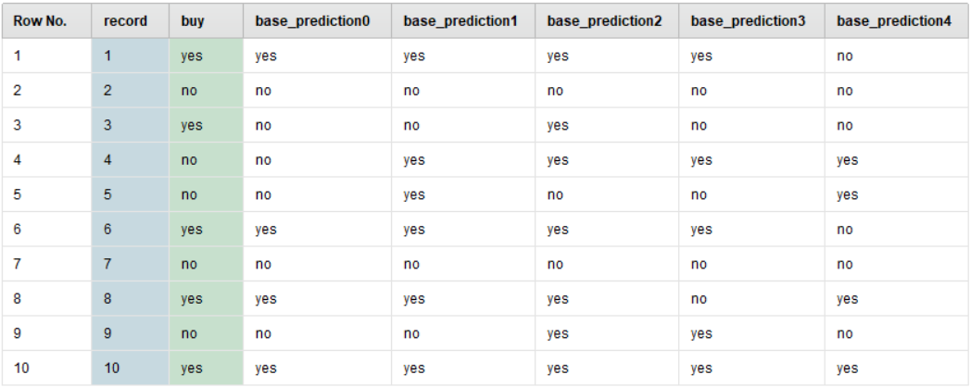

(a) Using voting ensemble by majority vote, find ensemble prediction for record 3.

(b) Find the training accuracy of this voting model (when it predicts all training records).

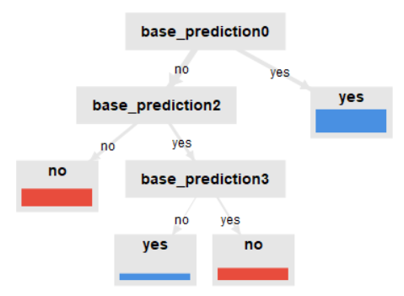
2.3 (3 points) Suppose that we train meta decision
tree classifier to learn the prediction patterns of 5 weak
classifiers in 2.2 (i.e. the table in 2.2 is training partition
for meta training). The meta model is as follows.

(a) Find ensemble prediction for record 3.

(b) From the meta model, list all base classifiers that contribute to the final prediction.

(c) From the meta model, list all base classifiers that don't contribute to the final prediction

