Exercise 6 (21 points) – individual work
- The answers can be typed or handwritten (handwriting must be clear and readable), in this exercise sheet or your own sheet (put your name & ID at the top of the sheet). All answers must be saved to only 1 PDF file.
- Some questions also require the submission of processes/workflows (file.rmp or file.ipynb).
- In case of re-submission (after first grading) or submission after solution is given, your points will be weighted by 0.5.
-------------------------------------------------------------------------------------------------------------------------------------------------------

1. (Total 7 points) Retrieve wholesale data. Each record represents annual purchases of a wholesaler's customer.
Attribute | Short description
ID | Customer ID
Fresh | Annual purchase of fresh products
Milk | Annual purchase of milk products
Grocery | Annual purchase of groceries
Frozen | Annual purchase of frozen food
Detergents_Paper | Annual purchase of detergent & paper products
Delicatessen | Annual purchase of ready-to-eat foods

1.1 (5 points) Create workflow for K-Means clustering. Submit it with the name question1.rmp.
Instructions | Answer
Step 1. Apply necessary preprocessing e.g. normalization. Then, run K-Means using K = 2-10. You can do it manually or use "Optimize Parameters (Grid)" operator.

Step 2. Report/capture DBIs for different K values. And based on these DBIs, which K is chosen? | Show DBIs for K = 2-10  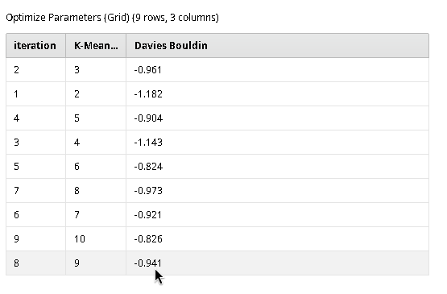  Chosen K = 6
Step 3. Base on the chosen K, your workflow must output cluster model (i.e. centroid plots/tables). | 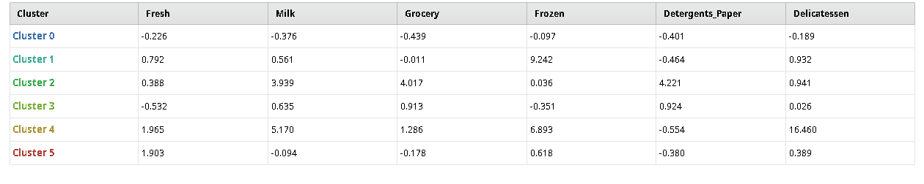
Step 4. Base on the chosen K, your workflow must output cluster profiles in the form of rules/trees or summary statistics (at least attribute means) of the original attributes before preprocessing.

1.2 (2 points) From the results in Steps 3 & 4 of question 1.1, choose 1 cluster. Briefly discuss its pattern, e.g. how this cluster differs from the others, which attributes (identify 1-2 attributes) set it apart from the others.
Cluster ID (from centroid plot) =

Characterizing attributes =

Discussion =

2. (Total 8 points) Use the following methods on wholesale data in question 1.
2.1 (6 points) Run Gaussian Mixture (GM).
Instructions | Answer
Step 1. Run GM with BIC optimization and inverted likelihood scoring.  Note: you may get error when choosing GM's normalization parameter. In that case, apply 0-1 normalization separately before the GM. | Number of clusters discovered by GM =
Step 2. Set an outlier threshold such that records with very high inverted likelihood scores are deemed outliers. | Show outlier records with their IDs and scores (GM)
Step 3. Locate the outliers in Step 2 in at least 1 scatter plot where they are clearly separated from inliers.  Note: check from scatter matrix first to see which pair of attributes gives clear patterns of outliers. | Capture scatter plot with outliers (GM)
Step 4: Use either distance-based or LOF to detect outliers instead of GM. | Chosen method =  Show outlier records with their ID and scores  (other method)
Also submit the workflow that performs Steps 1-4. Name your workflow question2.rmp.

2.2 (2 points) Pick 2 records that you suspect them to be outliers. They can be outliers found by any method in question 2.1 or even from clustering result in question 1.1. Inspect their attribute values. Report which of their values are very high or very low compared to the values of inliers.
Record ID | Observations on attribute values
Outlier 1 =
Outlier 2 =

3. (Total 6 points) Use python functions to run hierarchical clustering (HAC) on dogbreeds.csv. Compare the following types of linkage.
3.1 (3 points) Capture dendrogram & report cophenetic correlation of each linkage type.
Linkage | Dendrogram & cophenetic correlation
Single link

Complete link

Group average
(i.e. average link)

3.2 (1 point) Which linkage type gives clusters that best fit the data?

3.3 (2 points) Consider result from the best linkage type in (3.2), if we cut the dendrogram into 2 clusters, which dog breeds will belong to which clusters.
Cluster | Dog breeds
Cluster 1
Cluster 2

