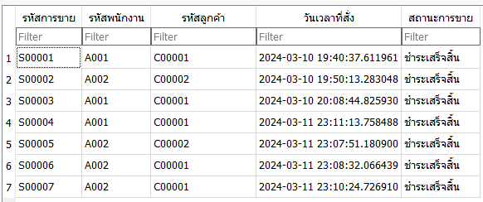



Oreder detail

**Silp**

**Vertify**

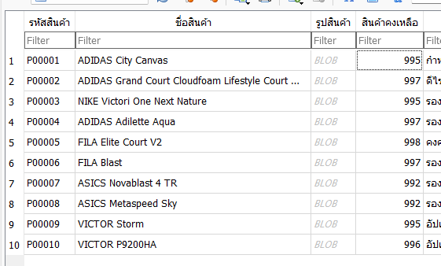

**Up price**

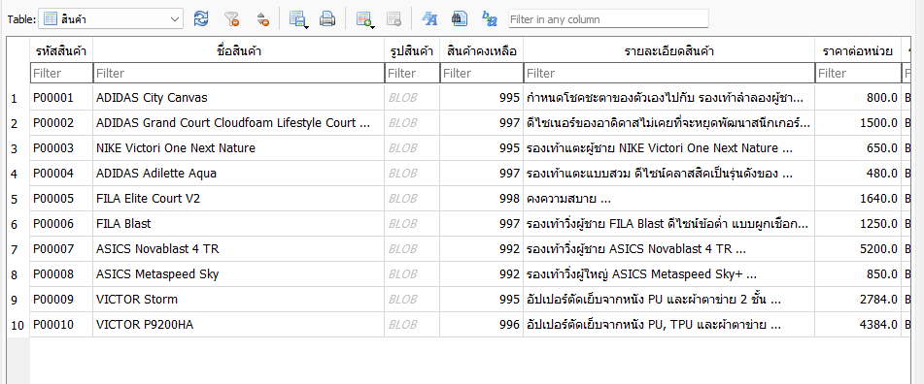



updatedb.update_plus_value_product('P00008',3)

**#**

