**SOCCER BABY COMPETITION**

1. **Competition Introduction**  
   The soccer baby competition is a robot soccer event aimed at exercising preschool children’s mechanical structure design skill, computational thinking and teamwork ability. The participants need to complete the decoration of the robot character through independent design and construction. The two robots of the same team need to adapt and cooperate in the competition to complete the task in the shortest time.
2. **Venue and Materials**

6x8 maps, each square is 10*10cm. The goal size is 27cm*12cm*12cm, and the sides are rectangular trapezoids. The soccer is a cube with sides of 5cm*5cm*5cm.

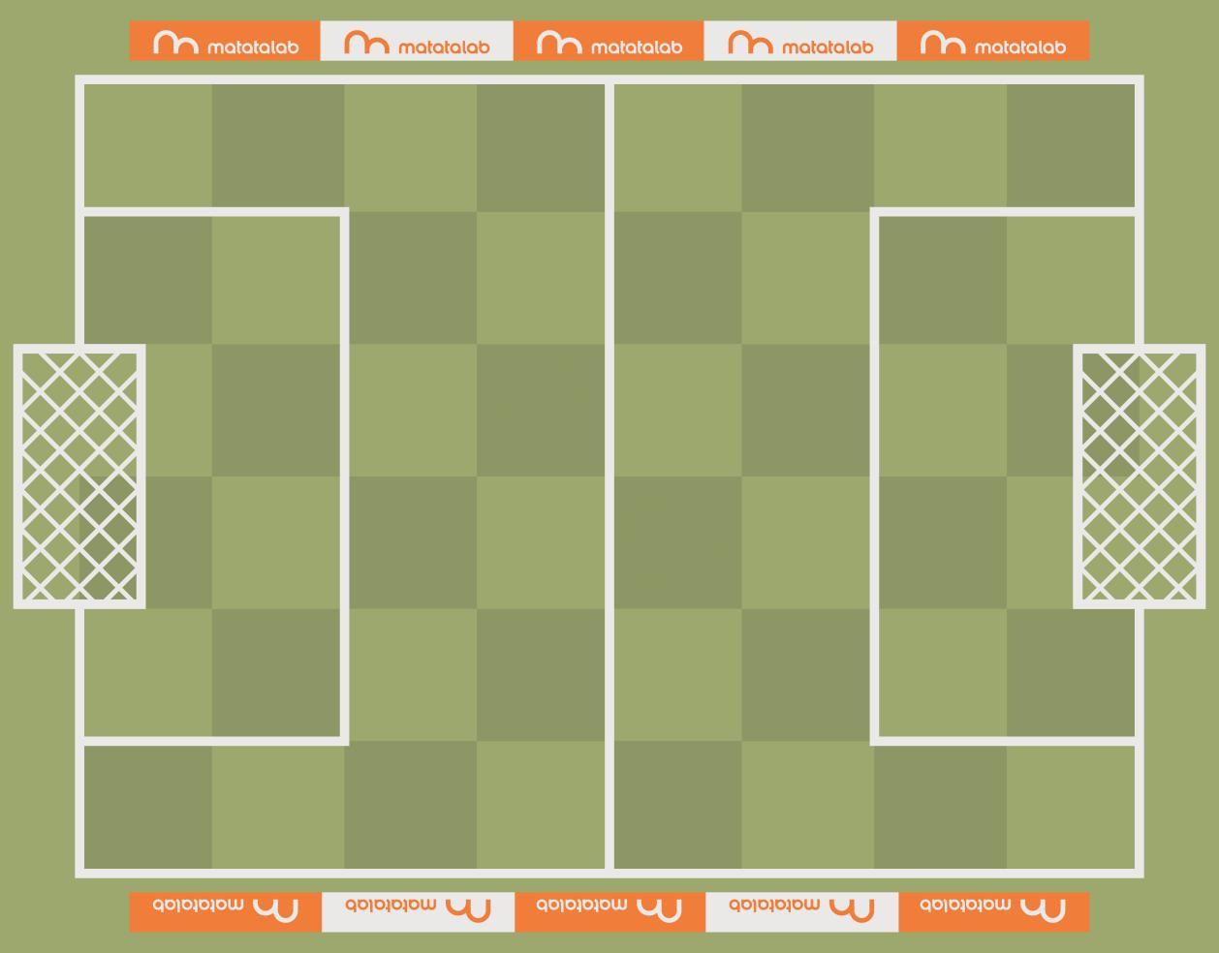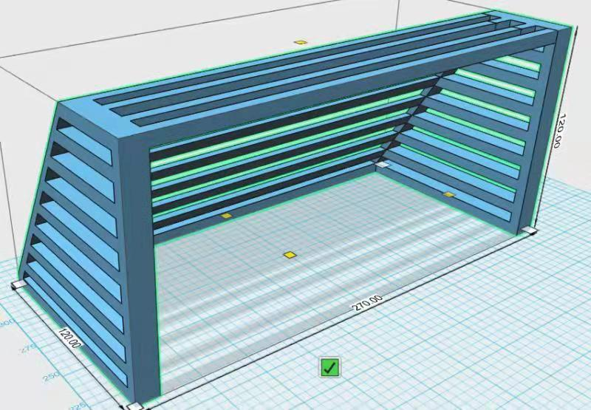

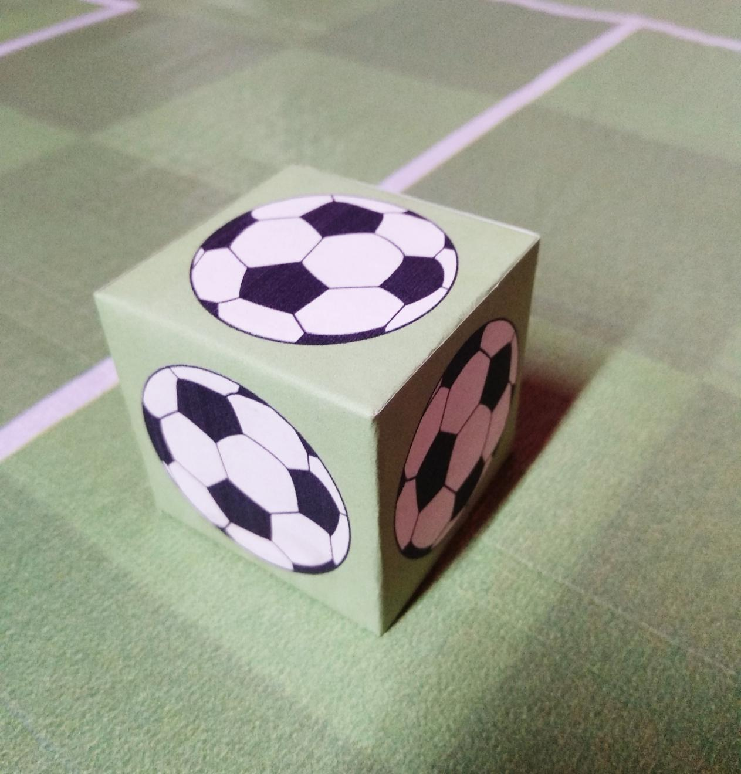

1. **Robot requirements**

The robots and decorative accessories provided by the competition committee shall be used uniformly. The size of the decorated robots shall not exceed 17cm*13cm*12cm. The time of decoration is included in the duration of the competition

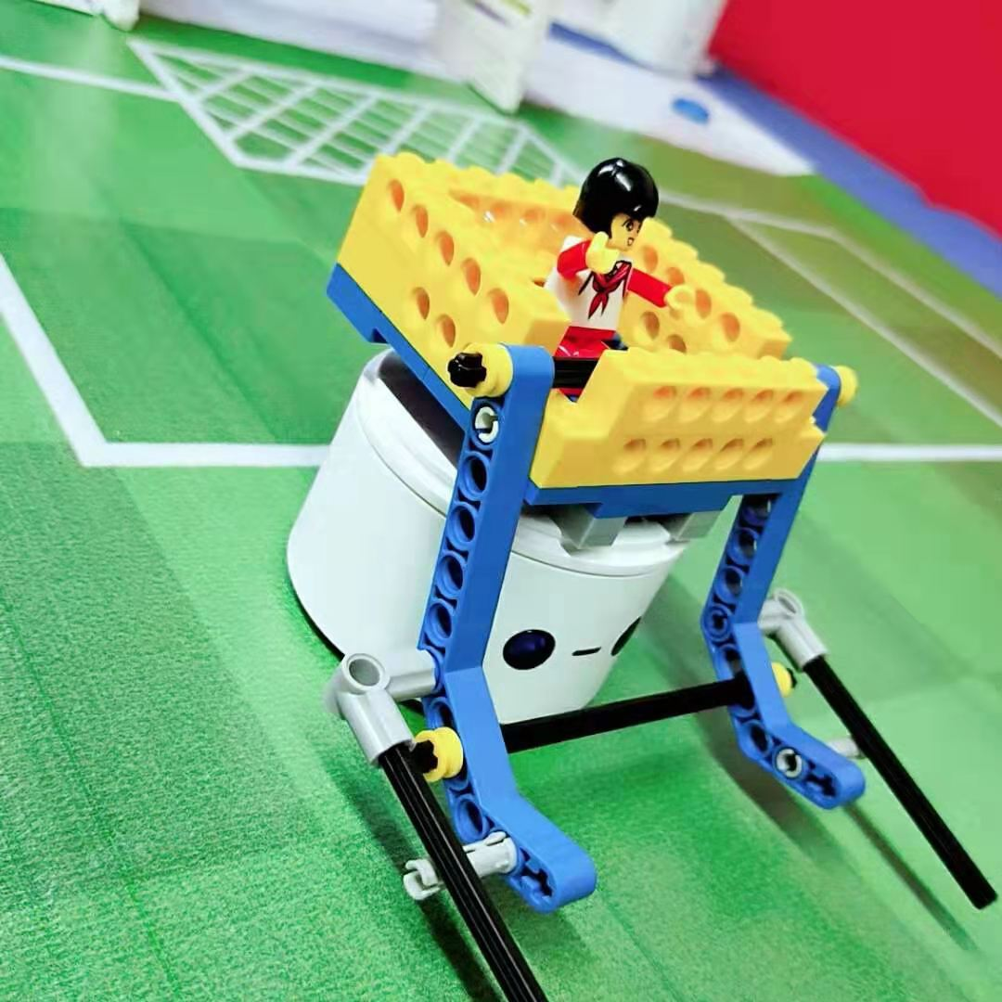

**4. Rules**

**4.1** Play in groups and the fastest wins. Each group has 4 players. Two players are responsible for building the football players. The other two players design the route as well as program two MatataBots.

**4.2** Draw lots to determine the location of the soccer and robots. The placements of robots and football are done by the organizing committee staff. The robots and soccer placements plan will be announced by committee before the competition.

**4.3** Two robots in the same group will be numbered by the committee staff. No.1 robot should get the soccer first and pass it to NO.2 robot. The No.2 robot can only goal after that. When passing the ball, No.1 robot needs to pass the ball to any square adjacent to the square of the No. 2 robot, otherwise the passing is fail.

**4.4** Two robots in the same group can be programmed simultaneously to improve efficiency.

**4.5** During the competition, two robots in the same group cannot have limb collisions. If there is a collision, robots must go back to the starting position and players start the game again. (Still counting during this process) When returning to the starting positions, the committee staff manually puts the robots and soccer back to the starting positions.

**4.6** If the decoration is dropped during the competition, robots as well as soccer must go back to the starting positions and players should reassemble the decoration and restart the game. (Still counting during this process) When returning to the starting positions, the committee staff manually puts the robots and football back to the starting positions.

**4.7** If the robot is out of bounds due to programming errors during the competition, robots as well as soccer must go back to the starting positions to restart the game (Still counting during this process) and committee staff should add 5 seconds to the competition time. When returning to the starting positions, the committee staff manually puts the robots and soccer back to the starting positions.

**4.8** The game is ranked according to the time spent.

1. **Team requirement**

Preschool children who have reached the age of five