Lab Report 03

# Problem

How many chocolate bars can someone buy with a certain amount of dollars if they get a coupon for each bar? Six coupons give one bar.

# Proposed Solution

Create a program that takes user entered number and by doing simple math outputs the number of chocolate bars the user can get and how many coupons will be left

# of Bars & Coupons Left

Simple Math

User Entered Dollars

# Tests and ResultsProblems Encountered

To me trial and error to get the math correct.

# Conclusions and Discussion

The lab taught to use math in Java and allowed for a deeper understanding of variables. To my knowledge and on what other things I have seen, this seems to be the best solution.

# Additional Questions

1. In the proposed solution section, draw a flowchart to represent your solution.

**Did it!**

1. Is this code problem free? If yes, write the generated output, if not, identify the error: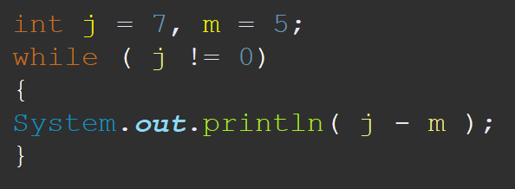

The code first declares j as 7 and m as 5, then says that if j does not equal 0 then output what j – m equal. Since j is a non-changing variable it will loop the program within while.

