Lab Report 07

# Problem

Write a program that keeps track of a concerts information and stats.

# Proposed Solution

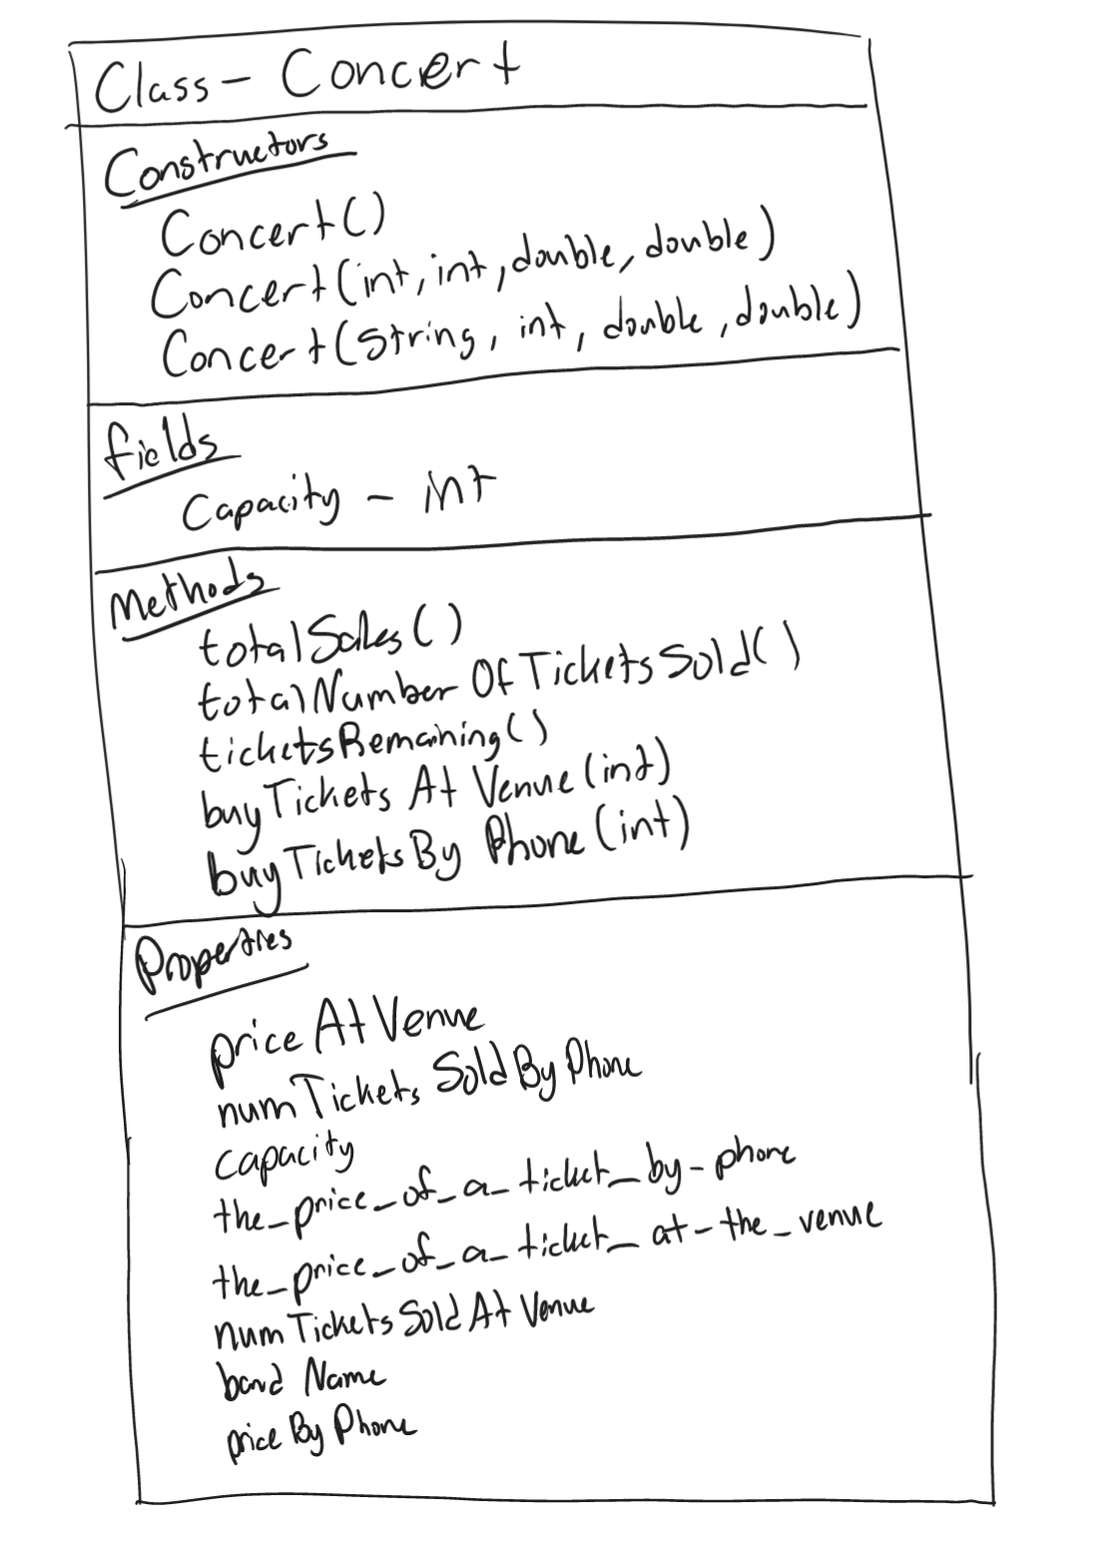`

# Tests and Results

# Problems Encountered

With so much code I kept forgetting to add semi colons. I also had a slight struggle with the names of variables.

# Conclusions and Discussion

This lab strengthened my understanding of classes and how two different programs can be integrated.

# Additional Questions

1. Draw a UML diagram to represent the Concert class in the proposed solution section.

**DONE!**

2. How can you distinguish 2 overloaded methods?

Signatures are used to distinguish overloaded methods. A signature is a combination of the method’s *name* and the *number*, *types* and *order* of its parameters