**Google Stock Price Visualization**

**Overview**

This project aims to visualize Google stock prices using historical data. It reads stock price data from a CSV file, extracts the necessary information, and plots the stock price trend over time.

**Prerequisites**

Ensure you have the following Python libraries installed before running the script:

* numpy
* matplotlib
* pandas

You can install them using:



pip install numpy matplotlib pandas

**Dataset**

The project uses the Google_Stock_Price_Train.csv file, which contains historical stock prices of Google. Make sure the dataset is present in the working directory.

**Code Explanation**

**Import required libraries:**

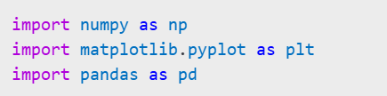

**Load the dataset:**

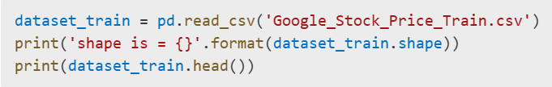

**Extract the stock price values:**

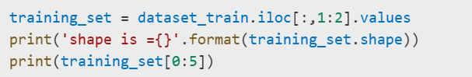

**Plot the stock price trend:**

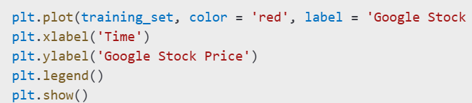

**Usage**

1. Place Google_Stock_Price_Train.csv in the same directory as the script.
2. Run the script in a Python environment.
3. The stock price trend will be displayed as a graph.

**Future Improvements**

* Add data preprocessing for better analysis.
* Implement machine learning models for stock price prediction.
* Include interactive visualizations.

**License**

This project is for educational purposes. You are free to modify and distribute it as needed.