***Assignment –1***

Creating sample tables and inserting values.

Create the following tables with the given structures and insert sample data as specified: -

1. *SALESPEOPLE*

Snum int(4)

Sname varchar(10)

City varchar(10)

Comm float(3,2)

1. *CUSTOMERS*

Cnum int(4)

Cname varchar(10)

City varchar(10)

Rating int(4)

Snum int(4)

1. *ORDERS*

Onum int(4)

Amt float(7,2)

Odate date

Cnum int(4)

Snum int(4)

A)

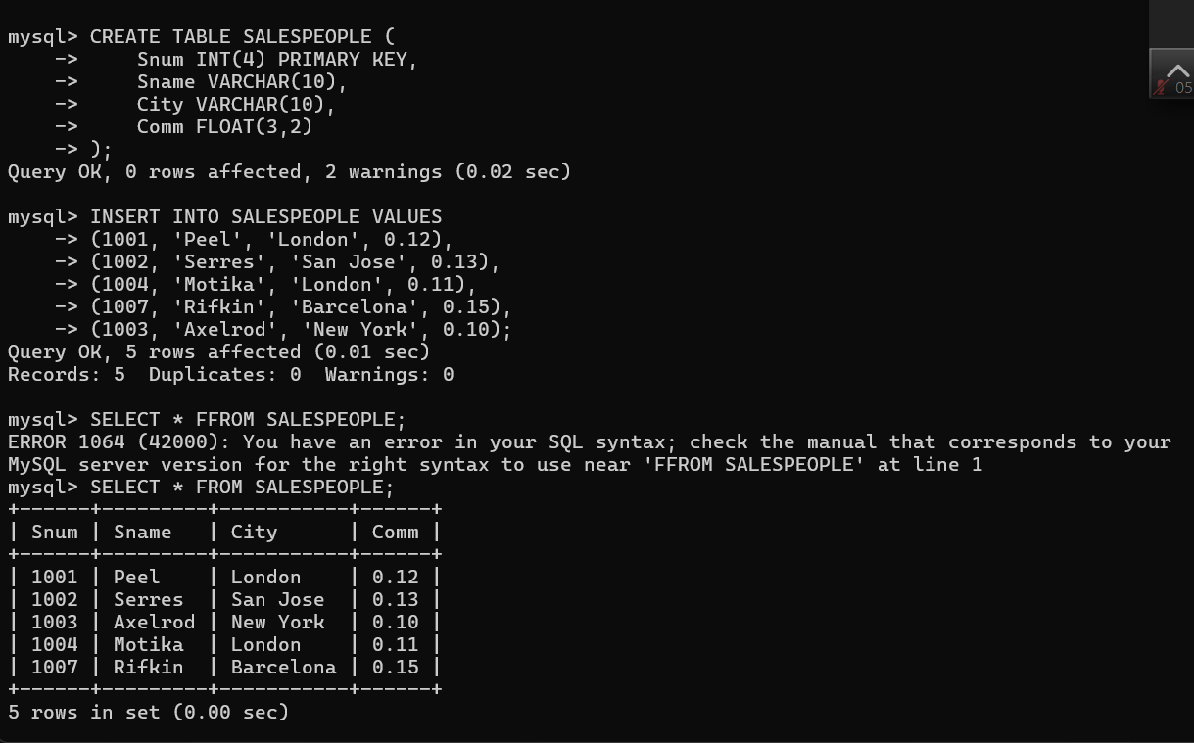

B)

C)  
