***Assignment –5* Relational and Logical Operators.**

1. Write a query that will give you all orders for more than Rs. 1,000.

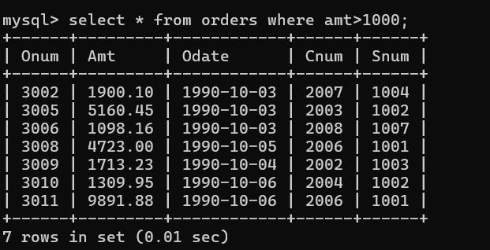

1. Write a query that will give you the names and cities of all salespeople in London with a commission above .10.

1. Write a query on the Customers table whose output will exclude all customers with a rating <= 100, unless they are located in Rome.

1. What will be the output from the following query?

Select \* from Orders

where (amt < 1000 OR

NOT (odate = ‘1990-10-03’ AND cnum > 2003));

1. What will be the output of the following query?

Select \* from Orders

where NOT ((odate = ‘1990-10-03’ OR snum

>1006) AND amt >= 1500);

1. What is a simpler way to write this query?

Select snum, sname, city, comm From Salespeople where (comm > .12 OR comm <.14);  
