PROJECT REPORT

Diabetes Onset Prediction

An End-to-End Machine Learning Pipeline for Binary Classification

Prepared by
Priyanshu Pal
Data Science Portfolio Project • August 2026

Table of Contents

— Executive Summary
— 1. Problem Statement
— 2. Dataset
— 3. Approach & Methodology
— 4. Algorithms Used
— 5. Final Results
— 6. Confusion Matrix Findings
— 7. Limitations
— 8. Conclusion

Executive Summary

This project builds and evaluates a complete machine learning pipeline to predict diabetes onset from routine diagnostic measurements, using the Pima Indians Diabetes dataset (768 patients, 8 clinical features). The work was carried out in three stages — data cleaning, feature engineering and modelling, and final evaluation — with every modelling decision validated on a held-out test set that was never used during development.
Four classification algorithms were trained, tuned, and compared: Logistic Regression, K-Nearest Neighbours (KNN), Decision Tree, and Random Forest. On the final, untouched test set of 154 patients, KNN was the strongest model on both Accuracy (0.747) and ROC-AUC (0.821), correctly identifying 59% of diabetic patients and 83% of healthy patients.

1. Problem Statement

Diabetes is a chronic condition where early detection meaningfully improves patient outcomes, but diagnosis typically requires lab testing that isn't always immediately available. The goal of this project is to explore whether a set of routine diagnostic measurements — glucose level, BMI, age, blood pressure, insulin, and similar — can support a predictive screening signal for diabetes risk.
This is framed as a binary classification problem: given a patient's diagnostic measurements, predict whether they have diabetes (Outcome = 1) or not (Outcome = 0). The dataset reflects a real, clinically relevant challenge: it is moderately imbalanced (roughly 65% non-diabetic, 35% diabetic), which mirrors realistic population screening scenarios and requires careful choice of evaluation metrics beyond just Accuracy.

2. Dataset

The Pima Indians Diabetes dataset consists of 768 female patients of Pima Indian heritage, aged 21 and older, described by 8 diagnostic features and a binary Outcome label.
- 768 rows, 8 features: Pregnancies, Glucose, Blood Pressure, Skin Thickness, Insulin, BMI, Diabetes Pedigree Function (family history score), and Age.
- Target class balance: approximately 65% non-diabetic, 35% diabetic — a moderate imbalance that shaped both modelling and evaluation choices throughout the project.
- Data quality issue identified early: five features (Glucose, Blood Pressure, Skin Thickness, Insulin, BMI) contain biologically impossible zero values — Insulin was 48.7% zero and Skin Thickness was 29.6% zero — which were treated as missing data rather than true measurements.

3. Approach & Methodology

The project was structured as three sequential modules, each building on validated outputs from the one before it, with the test set held out and untouched until the final evaluation stage.
3.1 Module 1 — Data Cleaning & Exploratory Analysis
- Train/test split (80/20, stratified, random_state=42) performed before any imputation, to prevent testset information from leaking into cleaning decisions.
- Zero values in the five affected columns were treated as missing and imputed using the median, fit on the training set only. Binary “was-missing” indicator flags were added for Insulin and Skin Thickness, since missingness itself carried signal (nearly half of Insulin readings were missing).
- Outliers were capped using the IQR method, with bounds computed only from originally observed (pre-imputation) values — an early version of this step incorrectly computed bounds after imputation, which inflated the apparent outlier count in Insulin from 17 to 253 by treating the imputed median mass itself as anomalous. This was caught and corrected.
3.2 Module 2 — Feature Engineering & Modelling
- Four algorithms were trained as a baseline: Logistic Regression, KNN, Decision Tree, and Random Forest.
- Two scaling strategies (Min-Max and Standardization) were compared; Standard Scaling gave the better average performance across models and was adopted.
- The top 5 features (Glucose, BMI, Age, Diabetes Pedigree Function, Insulin) were selected using a combination of correlation with the target and Random Forest feature importance.
- All four models were tuned via 5-fold GridSearchCV, and a separate experiment tested class-weight balancing to address the dataset's imbalance directly.
- The class-weighting experiment surfaced an important methodological lesson: an early version of this comparison accidentally let Decision Tree's depth revert to unconstrained while adding class weights, which produced a misleading result (higher Accuracy, collapsed ROC-AUC). Isolating class weighting as the only changed variable produced a smaller, more believable effect and is reflected in the final notebook.

3.3 Module 3 — Final Evaluation
The four tuned models were evaluated exactly once against the untouched 154-patient test set. This is the only stage in the project where the test set was used, and no decisions made afterwards fed back into modelling — the results below are that evaluation, unmodified.

4. Algorithms Used

- Logistic Regression — a linear baseline that estimates the probability of diabetes as a weighted combination of the input features; included as an interpretable reference point.
- K-Nearest Neighbors (KNN) — classifies a patient by majority vote among the most similar patients in the training set; sensitive to feature scaling, which is why the scaling comparison in Module 2 mattered most for this model.
- Decision Tree — splits the data on threshold rules over individual features; easy to interpret but prone to overfitting when depth is not constrained, a risk that showed up directly during the class-weighting experiment.
- Random Forest — an ensemble of many decision trees trained on bootstrapped samples with randomized feature subsets; generally, more robust than a single tree, and the most consistent performer alongside KNN in this project.

5. Final Results

All numbers below come from the single held-out test set (154 patients), evaluated once in Module 3.
Model | Accuracy | ROC-AUC | Precision | Recall | F1
KNN | 0.747 | 0.821 | 0.653 | 0.593 | 0.621
Random Forest | 0.740 | 0.818 | 0.659 | 0.537 | 0.592
Logistic Regression | 0.721 | 0.795 | 0.628 | 0.500 | 0.557
Decision Tree | 0.688 | 0.764 | 0.636 | 0.259 | 0.368
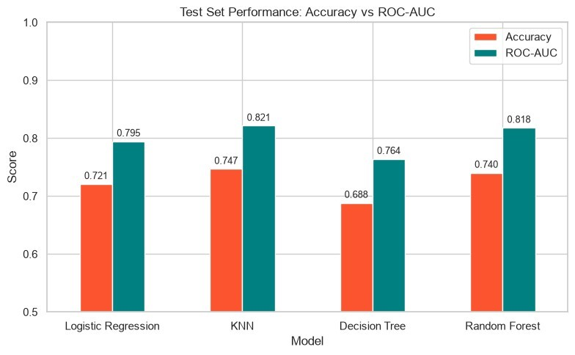

KNN was selected as the final model: it is the strongest performer on both Accuracy and ROC-AUC, which is a cleaner result than it might have been, since Module 2's hyperparameter tuning optimized specifically for Accuracy and the two metrics were not guaranteed to agree. In its classification report, KNN correctly identifies 32 of 54 diabetic patients (59% Recall) and 83 of 100 healthy patients (83% Recall on the negative class).

6. Confusion Matrix Findings

Accuracy, Precision, Recall, and F1 are all summaries of the same underlying object: the confusion matrix. Looking at the four raw matrices side by side, rather than only their summary metrics, is what actually explains why the models rank the way they do.

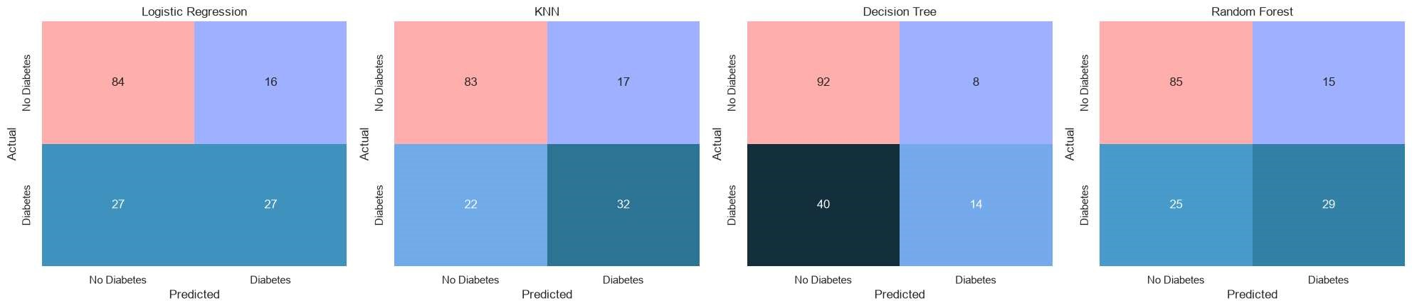

Model | True Neg. | False Pos. | False Neg. | True Pos.
KNN (Final Model) | 83 | 17 | 22 | 32
Random Forest | 85 | 15 | 25 | 29
Logistic Regression | 84 | 16 | 27 | 27
Decision Tree | 92 | 8 | 40 | 14

Findings stand out from these matrices:
- KNN's advantage over Random Forest is entirely in the False Negative column (22 vs. 25) — it catches 3 more diabetic patients, at the cost of 2 more false alarms (17 vs. 15 False Positives). That is a genuine trade in the right direction for a screening tool, and it's the reason KNN edges out Random Forest on Recall (0.593 vs. 0.537) despite both having very similar overall Accuracy.
- Decision Tree's True Negative count (92) is the highest of any model — it is, in fact, the best model here at correctly clearing healthy patients. That is what makes its 0.688 Accuracy look reasonable. But its False Negative count (40) is more than double every other models, which is invisible in the Accuracy figure and only shows up once the matrix is split by class.
- Across all four models, False Negatives consistently outnumber False Positives. Every model here is more likely to miss a diabetic patient than to wrongly flag a healthy one — a systematic bias in one direction, not a symmetric error pattern.

7. Limitations

- 154 test patients is a small evaluation set — a Recall of 0.59 represents 32 correct detections out of 54, and a swing of just 2-3 patients would move that number noticeably. These results describe this specific split, not a guaranteed real-world rate.
- None of the four models are adequate as a standalone diagnostic tool. A miss rate above 40% on the positive class is too high for that; the appropriate framing is a secondary screening signal to prioritise further testing, not a replacement for clinical diagnosis.
- The dataset is drawn from a single population (female patients of Pima Indian heritage), which limits how far these specific results generalise to other populations.
- Random Forest results were found to be sensitive to the exact scikit-learn version used, even with an identical random seed, data, and code — a reminder that reproducibility claims for tree-ensemble methods should specify the library version alongside the seed.
- Decision Tree and KNN differ by only 0.059 in Accuracy (0.688 vs. 0.747) — a gap that looks minor. However, according to their confusion matrices, Decision Tree misses 40 diabetic patients out of 54, KNN misses 22.

8. Conclusion

This project delivers a complete, validated machine learning pipeline for diabetes risk prediction — from raw data with real quality issues (missing values disguised as zeros, imbalanced classes) through to a final model evaluated honestly on data it never influenced. KNN is the project's final model, selected on evidence rather than assumption, with its specific weaknesses documented rather than hidden behind a single aggregate score.
The most valuable outcome of this project is not the 0.747 Accuracy figure on its own, but the discipline behind it: leak-safe preprocessing, a scaling and feature-selection process grounded in measured effects rather than convention, hyperparameter tuning validated against a held-out set, and an error analysis that identifies exactly which patients the model is least reliable for.

