**NAME:- Gajera Pal**

* **Create Tables**

CREATE TABLE OfficeDetails (

office_id NUMBER PRIMARY KEY,

office_name VARCHAR2(100),

office_city VARCHAR2(100)

);

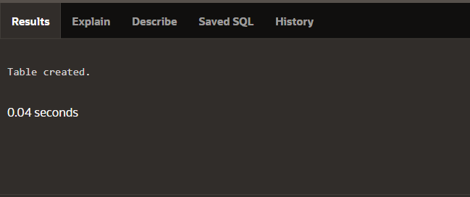

CREATE TABLE UserProfile (

user_id NUMBER PRIMARY KEY,

acc_number VARCHAR2(50) UNIQUE,

user_name VARCHAR2(100),

city VARCHAR2(100),

balance NUMBER(15,2),

created_date DATE DEFAULT SYSDATE

);



CREATE TABLE UserProfile (

user_id NUMBER PRIMARY KEY,

acc_number VARCHAR2(50) UNIQUE,

user_name VARCHAR2(100),

city VARCHAR2(100),

balance NUMBER(15,2),

created_date DATE DEFAULT SYSDATE

);



* **Insert Data**

INSERT INTO OfficeDetails VALUES (1, 'Main Office', 'New York');

INSERT INTO OfficeDetails VALUES (2, 'Downtown Office', 'Chicago');

INSERT INTO OfficeDetails VALUES (3, 'Uptown Office', 'New York');

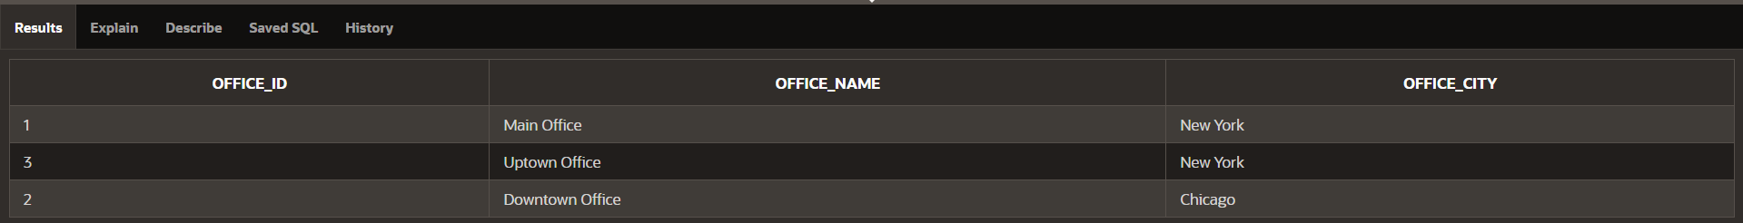

INSERT INTO UserProfile VALUES (1, 'A001', 'John Doe', 'New York', 5000.00, TO_DATE('2024-01-10', 'YYYY-MM-DD'));

INSERT INTO UserProfile VALUES (2, 'B002', 'Alice Smith', 'New York', 3200.00, TO_DATE('2024-01-20', 'YYYY-MM-DD'));

INSERT INTO UserProfile VALUES (3, 'C003', 'Bob Martin', 'Chicago', 4100.00, TO_DATE('2024-01-16', 'YYYY-MM-DD'));

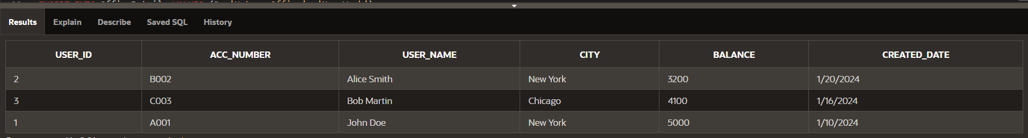

INSERT INTO FinancialRecords VALUES (101, 1, 1, 10000.00);

INSERT INTO FinancialRecords VALUES (102, 2, 2, 7500.00);



* **Transfer $100 from A001 to B002**

UPDATE UserProfile

SET balance = balance - 100

WHERE acc_number = 'A001';

UPDATE UserProfile

SET balance = balance + 100

WHERE acc_number = 'B002';

COMMIT;

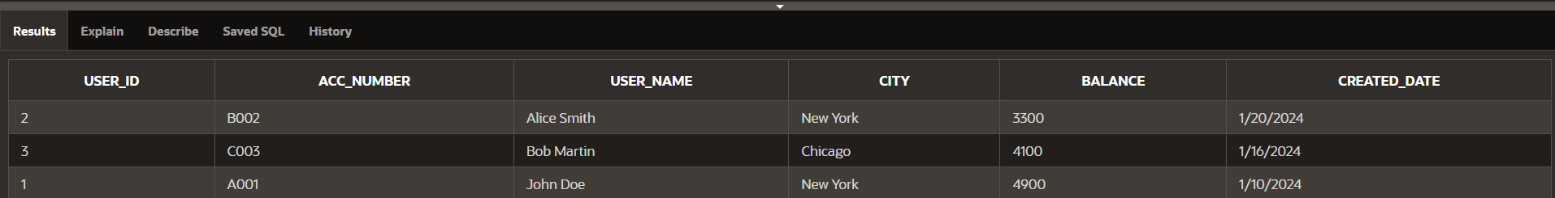

**Updated Queries**

SELECT *

FROM UserProfile U1

WHERE EXISTS (

SELECT 1 FROM UserProfile U2

WHERE U1.city = U2.city

GROUP BY U2.city

HAVING COUNT(*) > 1

);

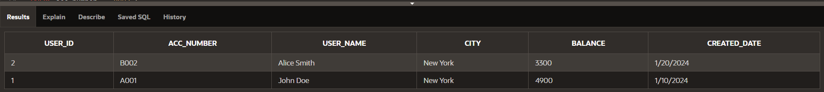

SELECT acc_number, user_name

FROM UserProfile

WHERE EXTRACT(DAY FROM created_date) > 15;

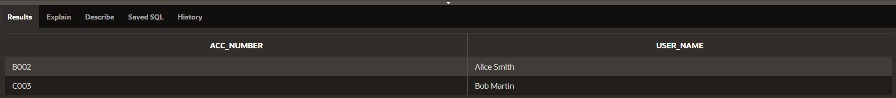

SELECT office_city, COUNT(office_id) AS total_offices

FROM OfficeDetails

GROUP BY office_city;

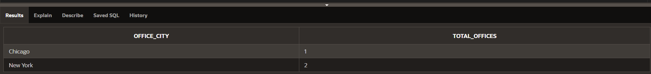

SELECT

UP.user_id,

UP.user_name,

FR.office_id,

FR.amount

FROM UserProfile UP

JOIN FinancialRecords FR

ON UP.user_id = FR.user_id;

