1. **Write a vb.net program simple calculator with +,-,*,/ button.**

Public Class calc

Dim num_1, num_2 As Double

Private Sub add_Click(ByVal sender As System.Object, ByVal e As System.EventArgs) Handles add.Click

symbol.Text = "+"

num_1 = CDbl(num1.Text)

num_2 = CDbl(num2.Text)

ans.Text = num_1 + num_2

End Sub

Private Sub subs_Click(ByVal sender As System.Object, ByVal e As System.EventArgs) Handles subs.Click

symbol.Text = "-"

num_1 = CDbl(num1.Text)

num_2 = CDbl(num2.Text)

ans.Text = num_1 - num_2

End Sub

Private Sub multi_Click(ByVal sender As System.Object, ByVal e As System.EventArgs) Handles multi.Click

symbol.Text = "*"

num_1 = CDbl(num1.Text)

num_2 = CDbl(num2.Text)

ans.Text = num_1 * num_2

End Sub

Private Sub div_Click(ByVal sender As System.Object, ByVal e As System.EventArgs) Handles div.Click

symbol.Text = "/"

num_1 = CDbl(num1.Text)

num_2 = CDbl(num2.Text)

ans.Text = num_1 / num_2

End Sub

Private Sub clear_Click(ByVal sender As System.Object, ByVal e As System.EventArgs) Handles clear.Click

symbol.Text = ""

num1.Clear()

num2.Clear()

ans.Clear()

End Sub

End Class

* **Output:**

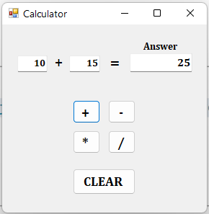

1. **Write a vb.net program to perform enumeration.**

Imports System.Windows.Forms.VisualStyles.VisualStyleElement.Button

Public Enum Direction

Top '= 1

Left '=2

Right '=3

Bottom '=4

End Enum

Public Class Form1

Public Sub Interact(ByVal dir As Direction)

If dir = Direction.Top Then

CheckBox1.Checked = Not CheckBox1.Checked

ElseIf dir = Direction.Left Then

CheckBox2.Checked = Not CheckBox2.Checked

ElseIf dir = Direction.Right Then

CheckBox3.Checked = Not CheckBox3.Checked

ElseIf dir = Direction.Bottom Then

CheckBox4.Checked = Not CheckBox4.Checked

End If

End Sub

Private Sub Button1_Click(ByVal sender As System.Object, ByVal e As System.EventArgs) Handles Button1.Click

Interact(Direction.Top)

End Sub

Private Sub Button2_Click(ByVal sender As System.Object, ByVal e As System.EventArgs) Handles Button2.Click

Interact(Direction.Left)

End Sub

Private Sub Button3_Click(ByVal sender As System.Object, ByVal e As System.EventArgs) Handles Button3.Click

Interact(Direction.Right)

End Sub

Private Sub Button4_Click(ByVal sender As System.Object, ByVal e As System.EventArgs) Handles Button4.Click

Interact(Direction.Bottom)

End Sub

End Class

* **Output:**

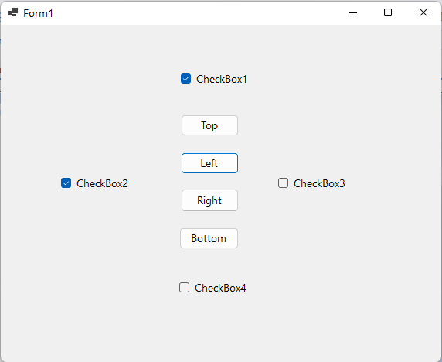

1. **Write a vb.net program that perform data type conversion function.**

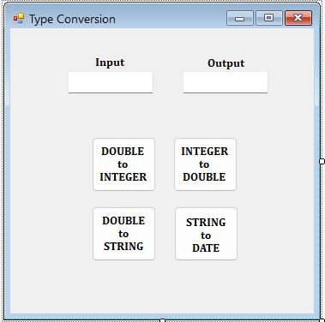

Public Class Form1

Private Sub int_type_Click(ByVal sender As System.Object, ByVal e As System.EventArgs) Handles int_type.Click

Dim input1 As Double = input.Text

Dim finalint As Integer

finalint = CType(input1, Integer)

output.Text = finalint

End Sub

Private Sub dbl_type_Click(ByVal sender As System.Object, ByVal e As System.EventArgs) Handles dbl_type.Click

Dim input1 As Integer = input.Text

Dim finalint As Double

finalint = CType(input1, Double)

output.Text = finalint

End Sub

Private Sub str_type_Click(ByVal sender As System.Object, ByVal e As System.EventArgs) Handles str_type.Click

Dim input1 As Double = input.Text

Dim finalint As String

finalint = CType(input1, String)

output.Text = finalint

End Sub

Private Sub date_type_Click(ByVal sender As System.Object, ByVal e As System.EventArgs) Handles date_type.Click

'Dim input1 As String = input.Text

'Dim finalint As Date

'finalint = CType(input1, Date)

If (IsDate(input.Text)) Then

output.Text = input.Text

Else

MsgBox("1. Please enter a value in this format :

DD/MM/YYYY or DD-MM-YYYY." & vbNewLine &

"2. Please enter valid Date,Month or Year.", ,

"Error")

End If

End Sub

Private Sub Form1_Load(ByVal sender As System.Object, ByVal e As System.EventArgs) Handles MyBase.Load

End Sub

End Class

* **Output**:

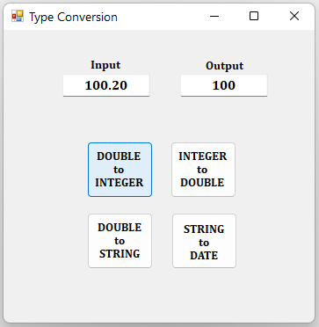

Imports System

Module Module1

Sub Main()

Dim a As Double = 726.3

Dim b As Integer = CInt(a)

Console.WriteLine(b)

Dim c As String = "11/02/2023"

Dim d As Date = CDate(c)

Console.WriteLine(d)

Dim e As Double = "726.3"

Dim f As String = CStr(e)

Console.WriteLine(f)

Dim g As String = "42.34"

Dim h As Integer = CType(g, Integer)

Console.WriteLine(b)

Console.ReadLine()

End Sub

End Module

* **Output:**

726

11-02-2023 00:00:00

726.3

726

1. **Write a program that performs following operation on Date.**

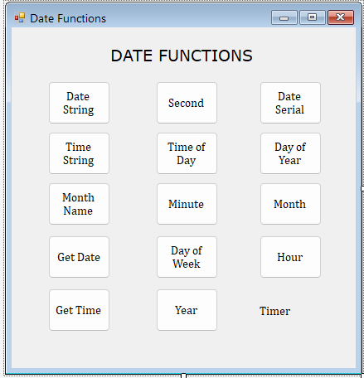

Public Class Form1

Private Sub Button1_Click(ByVal sender As System.Object, ByVal e As System.EventArgs) Handles Button1.Click

Label1.Text = DateString

End Sub

Private Sub Button2_Click(ByVal sender As System.Object, ByVal e As System.EventArgs) Handles Button2.Click

Label1.Text = Date.Now.Second

End Sub

Private Sub Button3_Click(ByVal sender As System.Object, ByVal e As System.EventArgs) Handles Button3.Click

Label1.Text = DateSerial(2023, 2, 11)

End Sub

Private Sub Button4_Click(ByVal sender As System.Object, ByVal e As System.EventArgs) Handles Button4.Click

Label1.Text = TimeString

End Sub

Private Sub Button5_Click(ByVal sender As System.Object, ByVal e As System.EventArgs) Handles Button5.Click

Label1.Text = TimeOfDay

End Sub

Private Sub Button6_Click(ByVal sender As System.Object, ByVal e As System.EventArgs) Handles Button6.Click

Label1.Text = Date.Now.DayOfYear

End Sub

Private Sub Button7_Click(ByVal sender As System.Object, ByVal e As System.EventArgs) Handles Button7.Click

Label1.Text = Date.Now.ToString("MMMM")

End Sub

Private Sub Button8_Click(ByVal sender As System.Object, ByVal e As System.EventArgs) Handles Button8.Click

Label1.Text = Date.Now.Minute

End Sub

Private Sub Button9_Click(ByVal sender As System.Object, ByVal e As System.EventArgs) Handles Button9.Click

Label1.Text = Date.Now.ToString("MM")

End Sub

Private Sub Button10_Click(ByVal sender As System.Object, ByVal e As System.EventArgs) Handles Button10.Click

Label1.Text = Date.Today.ToString("dd/MM/yyyy")

End Sub

Private Sub Button11_Click(ByVal sender As System.Object, ByVal e As System.EventArgs) Handles Button11.Click

Label1.Text = Date.Now.DayOfWeek

End Sub

Private Sub Button12_Click(ByVal sender As System.Object, ByVal e As System.EventArgs) Handles Button12.Click

Label1.Text = Date.Now.Hour

End Sub

Private Sub Button13_Click(ByVal sender As System.Object, ByVal e As System.EventArgs) Handles Button13.Click

Label1.Text = DateAndTime.TimeOfDay

End Sub

Private Sub Button14_Click(ByVal sender As System.Object, ByVal e As System.EventArgs) Handles Button14.Click

Label1.Text = Date.Now.Year

End Sub

End Class

* **Output:**

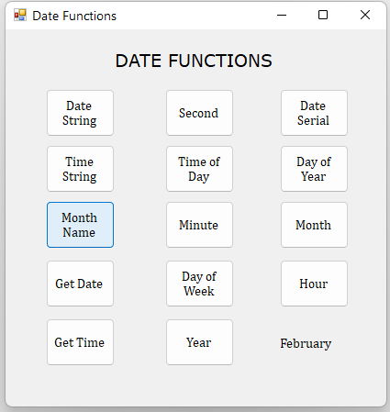

1. **Write a vb.net program to create job application as follow:**

Public Class Form1

Private Sub submit_Click(ByVal sender As System.Object, ByVal e As System.EventArgs) Handles submit.Click

'to print first and last name

Dim first, last As String

first = fname.Text

last = lname.Text

ListBox1.Items.Add("Name : " + first + " " + last)

ListBox1.Items.Add(vbNewLine)

'to print hobbies

Dim checkboxes As CheckBox() = {CheckBox1, CheckBox2, CheckBox3, CheckBox4}

Dim cb1 = CheckBox1.Text, cb2 = CheckBox2.Text, cb3 = CheckBox3.Text, cb4 = CheckBox4.Text

Dim cbvalues As String() = {cb1, cb2, cb3, cb4}

ListBox1.Items.Add("Hobbies : ")

For i As Integer = 0 To checkboxes.Length - 1

If checkboxes(i).Checked Then

ListBox1.Items.Add(cbvalues(i))

End If

Next

ListBox1.Items.Add(vbNewLine)

'to print date of birth

Dim day1, month1, year1 As String

day1 = day.SelectedItem

month1 = month.SelectedItem

year1 = year.SelectedItem

ListBox1.Items.Add("Date of Birth : " + vbNewLine + day1 + ", " + month1 + ", " + year1)

End Sub

Private Sub exit_bt_Click(ByVal sender As System.Object, ByVal e As System.EventArgs) Handles exit_bt.Click

Dim result As DialogResult = MessageBox.Show("Do you want to EXIT?", "Exit", MessageBoxButtons.YesNo, MessageBoxIcon.Question)

If result = DialogResult.Yes Then

Me.Close()

End If

End Sub

Private Sub clear_Click(ByVal sender As System.Object, ByVal e As System.EventArgs) Handles clear.Click

Dim result As DialogResult = MessageBox.Show("Do you want to CLEAR?", "Clear", MessageBoxButtons.YesNo, MessageBoxIcon.Question)

If result = DialogResult.Yes Then

fname.Clear()

lname.Clear()

CheckBox1.Checked = False

CheckBox2.Checked = False

CheckBox3.Checked = False

CheckBox4.Checked = False

ListBox1.Items.Clear()

End If

End Sub

Private Sub ok_Click(ByVal sender As System.Object, ByVal e As System.EventArgs) Handles ok.Click

MsgBox("Your Datails Submitted Successfully", MsgBoxStyle.Information, "Info")

End Sub

End Class

* **Output:**

1. **Write a program to print weekday in listbox using array.**

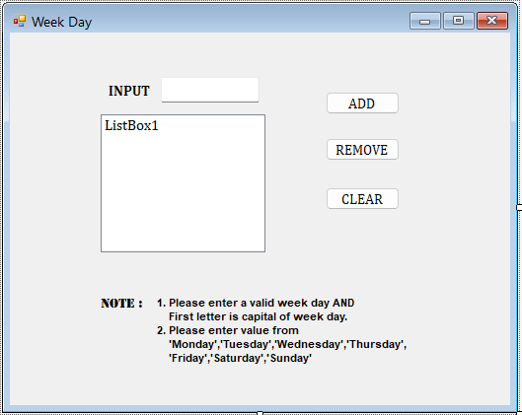

Public Class Form1

Dim weekdays As String() = {"Monday", "Tuesday", "Wednesday", "Thursday", "Friday", "Saturday", "Sunday"}

Private Sub Button1_Click(ByVal sender As System.Object, ByVal e As System.EventArgs) Handles Button1.Click

For i As Integer = 0 To weekdays.Length - 1

If (TextBox1.Text = weekdays(i)) Then

ListBox1.Items.Add(TextBox1.Text)

TextBox1.Clear()

End If

Next

End Sub

Private Sub Button2_Click(ByVal sender As System.Object, ByVal e As System.EventArgs) Handles Button2.Click

ListBox1.Items.Remove(ListBox1.SelectedItem)

End Sub

Private Sub Button3_Click(ByVal sender As System.Object, ByVal e As System.EventArgs) Handles Button3.Click

ListBox1.Items.Clear()

TextBox1.Clear()

End Sub

End Class

* **Output:**

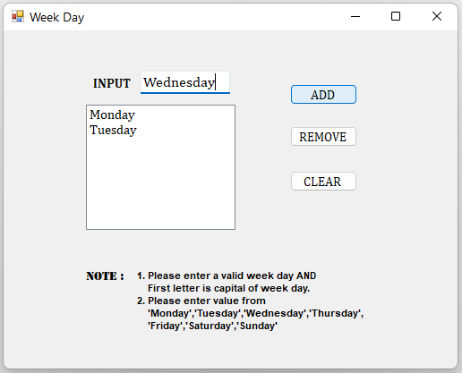

1. **write a vb.net program to print monthname in listbox using array.**

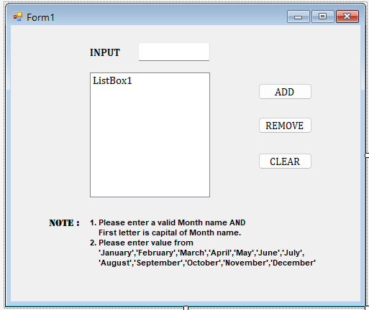

Public Class Form1

Dim month_name As String() = {"January", "February", "March", "April", "May", "June", "July", "August", "September", "October", "November", "December"}

Private Sub Button1_Click(ByVal sender As System.Object, ByVal e As System.EventArgs) Handles Button1.Click

For i As Integer = 0 To month_name.Length - 1

If (TextBox1.Text = month_name(i)) Then

ListBox1.Items.Add(TextBox1.Text)

TextBox1.Clear()

End If

Next

End Sub

Private Sub Button2_Click(ByVal sender As System.Object, ByVal e As System.EventArgs) Handles Button2.Click

ListBox1.Items.Remove(ListBox1.SelectedItem)

End Sub

Private Sub Button3_Click(ByVal sender As System.Object, ByVal e As System.EventArgs) Handles Button3.Click

ListBox1.Items.Clear()

TextBox1.Clear()

End Sub

End Class

* **Output:**

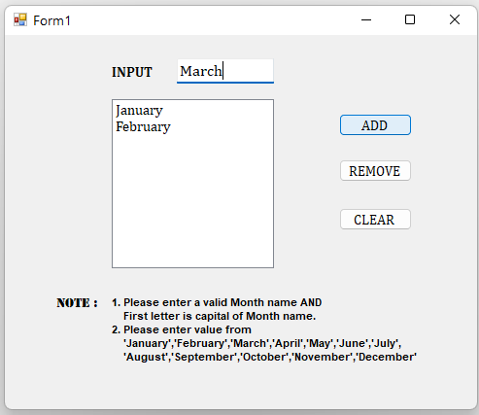

1. **Write a program following task Arraylist.**

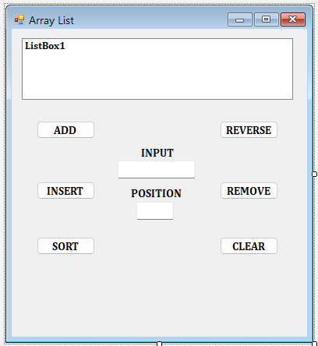

Public Class Form1

Dim array_list As New ArrayList()

Private Sub Button1_Click(ByVal sender As System.Object, ByVal e As System.EventArgs) Handles Button1.Click

array_list.Add(TextBox1.Text)

ListBox1.Items.Add(TextBox1.Text)

TextBox1.Clear()

TextBox2.Clear()

End Sub

Private Sub Button2_Click(ByVal sender As System.Object, ByVal e As System.EventArgs) Handles Button2.Click

'here,INDEX start from 0 so same as POSITION should be start from 0...

Dim pos As Integer = CInt(TextBox2.Text) - 1

array_list.Insert(pos, TextBox1.Text)

ListBox1.Items.Insert(pos, TextBox1.Text)

TextBox1.Clear()

TextBox2.Clear()

End Sub

Private Sub Button3_Click(ByVal sender As System.Object, ByVal e As System.EventArgs) Handles Button3.Click

array_list.Sort()

ListBox1.Sorted = True

End Sub

Private Sub Button4_Click(ByVal sender As System.Object, ByVal e As System.EventArgs) Handles Button4.Click

array_list.Reverse()

ListBox1.Items.Clear()

For i As Integer = 0 To array_list.Count - 1

ListBox1.Items.Add(array_list(i))

Next

End Sub

Private Sub Button5_Click(ByVal sender As System.Object, ByVal e As System.EventArgs) Handles Button5.Click

ListBox1.Items.Remove(ListBox1.SelectedItem)

array_list.Remove(ListBox1.SelectedItem)

End Sub

Private Sub Button6_Click(ByVal sender As System.Object, ByVal e As System.EventArgs) Handles Button6.Click

ListBox1.Items.Clear()

TextBox1.Clear()

TextBox2.Clear()

array_list.Clear()

End Sub

End Class

* **Output:**

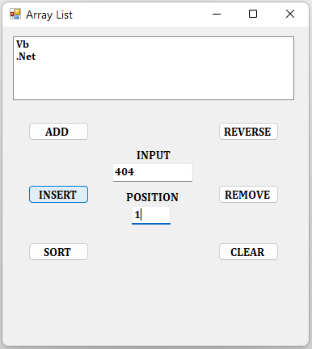

1. **Create VB.NET application to maintain company Employees Information.**

**Create following table:**

**tblEmployeeInfo(EmpNo,EmpName,City,DOJ,Department,Salary).Design proper form and make necessary Validation.Provide search facility on EmpNo.Generate report in DataGridView to view details of those employees who works in Sales department and salary is less than 10000.**

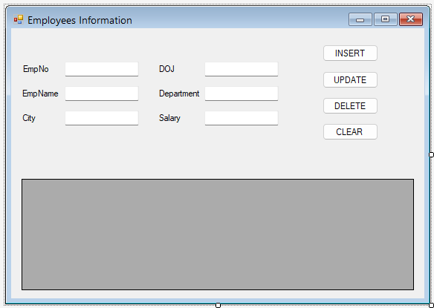

Imports System.Data.SqlClient

Public Class form1

Dim con As New SqlConnection

Dim cmd As New SqlCommand

Private Sub form1_Load(ByVal sender As System.Object, ByVal e As System.EventArgs) Handles MyBase.Load

Try

con.ConnectionString = "Data Source=.\SQLEXPRESS;AttachDbFilename=D:\Sem-4\.Net\net practical assignment (1)\project_10_emp\project_10_emp\Database1.mdf;Integrated Security=True;User Instance=True"

cmd.Connection = con

Catch ex As Exception

MsgBox(ex.Message)

End Try

display()

End Sub

Sub display()

Try

cmd.CommandText = "select * from emp"

Dim da As New SqlDataAdapter(cmd)

Dim dt As New DataTable

da.Fill(dt)

DataGridView1.DataSource = dt

Catch ex As Exception

MsgBox(ex.Message)

End Try

End Sub

Private Sub insert_btn_Click(ByVal sender As System.Object, ByVal e As System.EventArgs) Handles insert_btn.Click

If eid.Text = "" Or ename.Text = "" Or city.Text = "" Or doj.Text = "" Or dept.Text = "" Or salary.Text = "" Then

MsgBox("please enter the required fields.")

Else

Try

cmd.CommandText = "insert into emp values(" & eid.Text & ",'" & ename.Text & "','" & city.Text & "','" & doj.Text & "','" & dept.Text & "'," & salary.Text & ")"

con.Open()

cmd.ExecuteNonQuery()

con.Close()

MsgBox("Inserted Successfully", MsgBoxStyle.Information, "Info")

clear_text()

Catch ex As Exception

MsgBox(ex.Message)

End Try

End If

display()

End Sub

Private Sub update_btn_Click(ByVal sender As System.Object, ByVal e As System.EventArgs) Handles update_btn.Click

If eid.Text = "" Then

MsgBox("please enter the EmpNo.")

Else

Try

cmd.CommandText = "update emp set EmpName='" & ename.Text & "',City='" & city.Text & "',DOJ='" & doj.Text & "',Department='" & dept.Text & "',Salary=" & salary.Text & " where EmpNo=" & eid.Text & ""

con.Open()

cmd.ExecuteNonQuery()

con.Close()

MsgBox("Updated Successfully", MsgBoxStyle.Information, "Info")

clear_text()

Catch ex As Exception

MsgBox(ex.Message)

End Try

display()

End If

End Sub

Private Sub delete_btn_Click(ByVal sender As System.Object, ByVal e As System.EventArgs) Handles delete_btn.Click

If eid.Text = "" Then

MsgBox("please enter the EmpNo.")

Else

Try

cmd.CommandText = "delete from emp where EmpNo=" & eid.Text & ""

con.Open()

cmd.ExecuteNonQuery()

con.Close()

MsgBox("Deleted Successfully", MsgBoxStyle.Information, "Info")

clear_text()

Catch ex As Exception

MsgBox(ex.Message)

End Try

display()

End If

End Sub

Private Sub clear_btn_Click(ByVal sender As System.Object, ByVal e As System.EventArgs) Handles clear_btn.Click

Dim result As DialogResult = MessageBox.Show("Do you want to clear all Textboxes?", "Info", MessageBoxButtons.YesNo)

If result = DialogResult.Yes Then

clear_text()

End If

End Sub

Sub clear_text()

eid.Clear()

ename.Clear()

city.Clear()

salary.Clear()

doj.Clear()

dept.Clear()

End Sub

End Class

* **Output:**

1. **Create VB.NET application to maintain products Information.Create following table:**

**Tblproduct(pno,pname,qty,cost_price,sell_price)**

**Perform Insert,Delete and update operations on it and also generate report in data gridview for those pno whose cost_price is less than sell_price.**

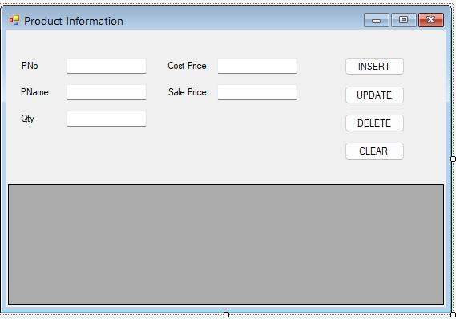

Imports System.Data.SqlClient

Public Class form1

Dim con As New SqlConnection

Dim cmd As New SqlCommand

Private Sub form1_Load(ByVal sender As System.Object, ByVal e As System.EventArgs) Handles MyBase.Load

Try

con.ConnectionString = "Data Source=.\SQLEXPRESS;AttachDbFilename=C:\Users\meetk\AppData\Local\Temporary Projects\program_11_product\Database1.mdf;Integrated Security=True;User Instance=True"

cmd.Connection = con

Catch ex As Exception

MsgBox(ex.Message)

End Try

display()

End Sub

Sub display()

Try

cmd.CommandText = "select * from tblproduct"

Dim da As New SqlDataAdapter(cmd)

Dim dt As New DataTable

da.Fill(dt)

DataGridView1.DataSource = dt

Catch ex As Exception

MsgBox(ex.Message)

End Try

End Sub

Private Sub insert_btn_Click(ByVal sender As System.Object, ByVal e As System.EventArgs) Handles insert_btn.Click

If pno.Text = "" Or pname.Text = "" Or qty.Text = "" Or cost_price.Text = "" Or sale_price.Text = "" Then

MsgBox("please enter the required fields.")

Else

Try

cmd.CommandText = "insert into tblproduct values(" & pno.Text & ",'" & pname.Text & "','" & qty.Text & "','" & cost_price.Text & "','" & sale_price.Text & "')"

con.Open()

cmd.ExecuteNonQuery()

con.Close()

MsgBox("Inserted Successfully", MsgBoxStyle.Information, "Info")

clear_text()

Catch ex As Exception

MsgBox(ex.Message)

End Try

End If

display()

End Sub

Private Sub update_btn_Click(ByVal sender As System.Object, ByVal e As System.EventArgs) Handles update_btn.Click

If pno.Text = "" Then

MsgBox("please enter the PNo.")

Else

Try

cmd.CommandText = "update tblproduct set PName='" & pname.Text & "',Qty='" & qty.Text & "',Cost_Price='" & cost_price.Text & "',Sale_Price='" & sale_price.Text & "' where PNo=" & pno.Text & ""

con.Open()

cmd.ExecuteNonQuery()

con.Close()

MsgBox("Updated Successfully", MsgBoxStyle.Information, "Info")

clear_text()

Catch ex As Exception

MsgBox(ex.Message)

End Try

display()

End If

End Sub

Private Sub delete_btn_Click(ByVal sender As System.Object, ByVal e As System.EventArgs) Handles delete_btn.Click

If pno.Text = "" Then

MsgBox("please enter the PNo.")

Else

Try

cmd.CommandText = "delete from tblproduct where PNo=" & pno.Text & ""

con.Open()

cmd.ExecuteNonQuery()

con.Close()

MsgBox("Deleted Successfully", MsgBoxStyle.Information, "Info")

clear_text()

Catch ex As Exception

MsgBox(ex.Message)

End Try

display()

End If

End Sub

Private Sub clear_btn_Click(ByVal sender As System.Object, ByVal e As System.EventArgs) Handles clear_btn.Click

Dim result As DialogResult = MessageBox.Show("Do you want to clear all Textboxes?", "Info", MessageBoxButtons.YesNo)

If result = DialogResult.Yes Then

clear_text()

End If

End Sub

Sub clear_text()

pno.Clear()

pname.Clear()

qty.Clear()

cost_price.Clear()

sale_price.Clear()

End Sub

End Class

* **Output:**