|  |  |  |  |
| --- | --- | --- | --- |
| **Sr no** | **Program Definition** | **Page**  **No.** | **Sign** |
| 1. | Create a VB.NET application to maintain information of Medicine in following table. tblMedicine (MID, Name, Type[tablet, capsule, syrup], company, rate) Perform Insert, Delete and Update operations on it and also generate report in data gridview for those medicine which are syrup and rate less than 500 |  |  |
| 2. | Create VB.NET application to maintain Products Information. Create following table : Tblproduct(pno,pname,qty,cost_price,sell_price) Perform Insert, Delete and Update operations on it and also generate report in data gridview for those pno whose cost_price is less than sell_price |  |  |
| 3. | Create VB.NET application to maintain Company Employees Information.  Create following table:  tblEmployeeInfo(EmpName,City,DOJ,Department,Salary).Design proper form and make necessary validation.Provide insert,update and dalete facility for above table.Also provide search facility on EmpNo.Gnerate report in DataGridview to View details of those employees who works in Sales department and salary is less than 10000. |  |  |
| 4. | Create VB.NET application to maintain cricketplayers’ record and display the players’ information according to country wise.  Create following table:  tblcricketInfo(playerId,PlayerName,Country,No of Matches,No of Runs).Design proper form.Provide insert,update,delete and Display operations on it and also generate report in data gridview. |  |  |
| 5. | Create VB.NET application to maintain students Information. Create following table (April/May 2017) Tblstudent(RollNo, Name, Markl, Mark2, Mark3) Design proper form and make necessary validation. Provide insert, update and delete operation for above table. Generate report in DataGridView to display student information that gets percentage greater than 75%. |  |  |

1.Create a VB.NET application to maintain information of Medicine in following table. (March/April2018) tblMedicine (MID, Name, Type[tablet, capsule, syrup], company, rate) Perform Insert, Delete and Update operations on it and also generate report in data gridview for those medicine which are syrup and rate less than 500

ANS:-

Imports System.Data.SqlClient

Public Class Form1

Dim cmd As New SqlCommand

Dim cn As New SqlConnection

Private Sub Form1_Load(ByVal sender As System.Object, ByVal e As System.EventArgs) Handles MyBase.Load

Try

cn.ConnectionString = "Data Source=.\SQLEXPRESS;AttachDbFilename=D:\jigisha\vb.net Demo_sy6\p1\p1\Database1.mdf;Integrated Security=True;User Instance=True"

cmd.Connection = cn

Catch ex As Exception

MsgBox(ex.Message)

End Try

display()

End Sub

Private Sub Button1_Click(ByVal sender As System.Object, ByVal e As System.EventArgs) Handles Button1.Click

Try

Dim type As String

If CheckBox1.Checked Then

type = CheckBox1.Text

End If

If CheckBox2.Checked Then

type = type + CheckBox2.Text

End If

If CheckBox3.Checked Then

type = type + CheckBox3.Text

End If

cmd.CommandText = "insert into tbl values('" + TextBox1.Text + "','" + TextBox2.Text + "','" + type + "','" + TextBox3.Text + "'," + TextBox4.Text + ")"

cn.Open()

cmd.ExecuteNonQuery()

cn.Close()

Catch ex As Exception

MsgBox(ex.Message)

End Try

display()

End Sub

Sub display()

cmd.CommandText = "select * from tbl where Rate < 500"

Dim ad As New SqlDataAdapter(cmd)

Dim dt As New DataTable

ad.Fill(dt)

DataGridView1.DataSource = dt

End Sub

Private Sub Button2_Click(ByVal sender As System.Object, ByVal e As System.EventArgs) Handles Button2.Click

Dim type As String

Try

If CheckBox1.Checked Then

type = CheckBox1.Text

End If

If CheckBox2.Checked Then

type = type + CheckBox2.Text

End If

If CheckBox3.Checked Then

type = type + CheckBox3.Text

End If

cmd.CommandText = "update tbl set name = '" & TextBox2.Text & "' where mid = " & TextBox1.Text & ""

cn.Open()

cmd.ExecuteNonQuery()

cn.Close()

Catch ex As Exception

MsgBox(ex.Message)

End Try

display()

End Sub

Private Sub Button3_Click(ByVal sender As System.Object, ByVal e As System.EventArgs) Handles btndelete.Click

' Dim type As String

Try

cmd.CommandText = "delete from tbl where mid = " & TextBox1.Text & " "

cn.Open()

cmd.ExecuteNonQuery()

cn.Close()

Catch ex As Exception

MsgBox(ex.Message)

End Try

display()

End Sub

End Class

Output:

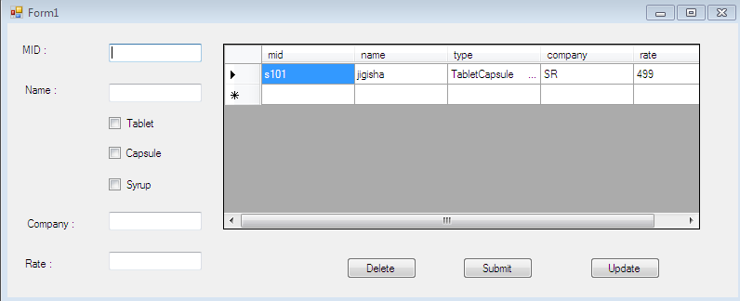

2} Create VB.NET application to maintain Products Information. Create following table :Tblproduct(pno,pname,qty,cost_price,sell_price) Perform Insert, Delete and Update operations on it and also generate report in data gridview for those pno whose cost_price is less than sell_price

ImportsSystem.Data.SqlClient

PublicClassForm1

Dim con AsNewSqlConnection

DimcmdAsNewSqlCommand

PrivateSub Form1_Load(ByVal sender AsSystem.Object, ByVal e AsSystem.EventArgs) HandlesMyBase.Load

Try

con.ConnectionString = "Data Source=.\SQLEXPRESS;AttachDbFilename=C:\Users\JAY\AppData\Local\Temporary Projects\Product_Information\ProductDatabase.mdf;Integrated Security=True;User Instance=True"

cmd.Connection = con

Catch ex AsException

MsgBox(ex.Message)

EndTry

DisplayData()

EndSub

SubDisplayData()

Try

cmd.CommandText = "select * from ProductTable"

Dim da AsNewSqlDataAdapter(cmd)

Dim dt AsNewDataTable

da.Fill(dt)

DataGridView1.DataSource = dt

Catch ex AsException

MsgBox(ex.Message)

EndTry

EndSub

PrivateSubbtninsert_Click(ByVal sender AsSystem.Object, ByVal e AsSystem.EventArgs) Handlesbtninsert.Click

Try

cmd.CommandText = "insert into ProductTable values("&txtpno.Text&" , '"&txtpname.Text&"' , "&txtqty.Text&" , "&txtcostprice.Text&" , "&txtsellprice.Text&")"

con.Open()

cmd.ExecuteNonQuery()

con.Close()

MsgBox("Data Inserted")

Catch ex AsException

MsgBox(ex.Message)

EndTry

DisplayData()

EndSub

PrivateSubbtnupdate_Click(ByVal sender AsSystem.Object, ByVal e AsSystem.EventArgs) Handlesbtnupdate.Click

Try

cmd.CommandText = "update ProductTable set Pname='"&txtpname.Text&"' , QTY="&txtqty.Text&" , CostPrice="&txtcostprice.Text&" , SellPrice="&txtsellprice.Text&" where PNo="&txtpno.Text&" "

con.Open()

cmd.ExecuteNonQuery()

con.Close()

MsgBox("Data Updated")

Catch ex AsException

MsgBox(ex.Message)

EndTry

DisplayData()

EndSub

PrivateSubbtndelete_Click(ByVal sender AsSystem.Object, ByVal e AsSystem.EventArgs) Handlesbtndelete.Click

Try

cmd.CommandText = "delete Producttable where PNo="&txtpno.Text&" "

con.Open()

cmd.ExecuteNonQuery()

con.Close()

MsgBox("Data Deleted")

Catch ex AsException

MsgBox(ex.Message)

EndTry

DisplayData()

EndSub

EndClass

Output :-

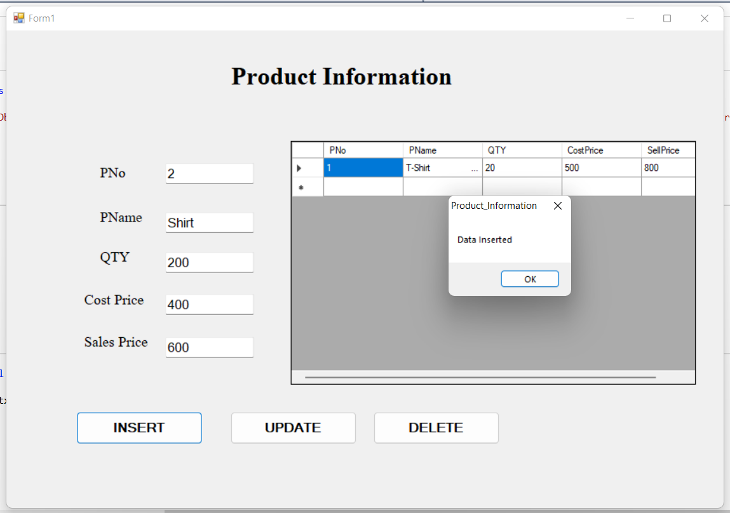

3} Create VB.NET application to maintain Company Employees Information.

Create following table:

tblEmployeeInfo(EmpName,City,DOJ,Department,Salary).Design proper form and make necessary validation.Provideinsert,update and dalete facility for above table.Also provide search facility on EmpNo.Gnerate report in DataGridview to View details of those employees who works in Sales department and salary is less than 10000.

ImportsSystem.Data.SqlClient

PublicClassForm1

Dim con AsNewSqlConnection

DimcmdAsNewSqlCommand

PrivateSub Form1_Load(ByVal sender AsSystem.Object, ByVal e AsSystem.EventArgs) HandlesMyBase.Load

Try

con.ConnectionString = "Data Source=.\SQLEXPRESS;AttachDbFilename=C:\Users\JAY\documents\visual studio 2010\Projects\Employee_Information\Employee_Information\EmployeeDataBase.mdf;Integrated Security=True;User Instance=True"

cmd.Connection = con

Catch ex AsException

MsgBox(ex.Message)

EndTry

display()

EndSub

Subdisplay()

Try

cmd.CommandText = "select * from TableEmployee"

Dim da AsNewSqlDataAdapter(cmd)

Dim dt AsNewDataTable

da.Fill(dt)

DataGridView1.DataSource = dt

Catch ex AsException

MsgBox(ex.Message)

EndTry

EndSub

PrivateSub Button1_Click(ByVal sender AsSystem.Object, ByVal e AsSystem.EventArgs) Handles Button1.Click

Try

cmd.CommandText = "insert into TableEmployee values ("&empno.Text&" , '"&empname.Text&"' , '"&empcity.Text&"' , '"&empdoj.Text&"' , '"&empdepartment.Text&"' , "&empsalary.Text&" )"

con.Open()

cmd.ExecuteNonQuery()

con.Close()

MsgBox("Data Inserted")

Catch ex AsException

MsgBox(ex.Message)

EndTry

display()

EndSub

PrivateSub Button3_Click(ByVal sender AsSystem.Object, ByVal e AsSystem.EventArgs) Handles Button3.Click

Try

cmd.CommandText = " delete TableEmployee where EmpNo = "&empno.Text&" "

con.Open()

cmd.ExecuteNonQuery()

con.Close()

MsgBox("Data Deleted")

Catch ex AsException

MsgBox(ex.Message)

EndTry

display()

EndSub

PrivateSub Button2_Click(ByVal sender AsSystem.Object, ByVal e AsSystem.EventArgs) Handles Button2.Click

Try

cmd.CommandText = " update TableEmployee set EmpName = '"&empname.Text&"' , City = '"&empcity.Text&"' , DOJ='"&empdoj.Text&"' , Department='"&empdepartment.Text&"' , Salary="&empsalary.Text&" where EmpNo = "&empno.Text&" "

con.Open()

cmd.ExecuteNonQuery()

con.Close()

MsgBox("Data Updated")

Catch ex AsException

MsgBox(ex.Message)

EndTry

display()

EndSub

EndClass

Output :-

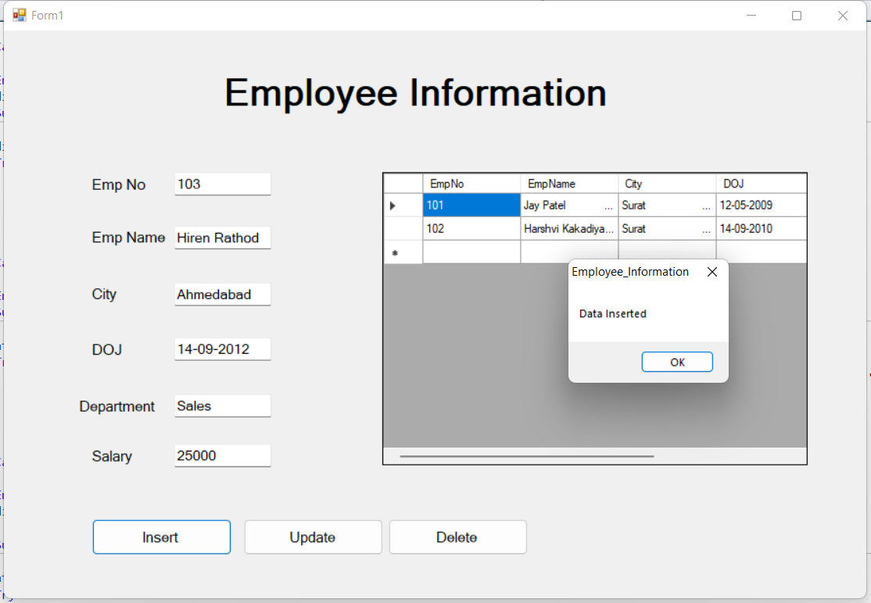

4} Create VB.NET application to maintain cricketplayers’ record and display the players’ information according to country wise.

Create following table:

tblcricketInfo(playerId,PlayerName,Country,No of Matches,No of Runs).Design proper form.Provideinsert,update,delete and Display operations on it and also generate report in data gridview.

ImportsSystem.Data.SqlClient

PublicClassForm1

Dim con AsNewSqlConnection

DimcmdAsNewSqlCommand

PrivateSub Form1_Load(ByVal sender AsSystem.Object, ByVal e AsSystem.EventArgs) HandlesMyBase.Load

Try

con.ConnectionString = "Data Source=.\SQLEXPRESS;AttachDbFilename=C:\Users\JAY\AppData\Local\Temporary Projects\CricketPlayer_Information\PlayersDatabase.mdf;Integrated Security=True;User Instance=True"

cmd.Connection = con

Catch ex AsException

MsgBox(ex.Message)

EndTry

ViewData()

EndSub

SubViewData()

Try

cmd.CommandText = "select * from PlayersTable"

Dim da AsNewSqlDataAdapter(cmd)

Dim dt AsNewDataTable

da.Fill(dt)

DataGridView1.DataSource = dt

Catch ex AsException

MsgBox(ex.Message)

EndTry

EndSub

PrivateSubbtninsert_Click(ByVal sender AsSystem.Object, ByVal e AsSystem.EventArgs) Handlesbtninsert.Click

Try

cmd.CommandText = "insert into PlayersTable values("&txtpid.Text&" , '"&txtpname.Text&"' , '"&txtcountry.Text&"' , "&txtnoofmatch.Text&" , "&txtnoofrun.Text&")"

con.Open()

cmd.ExecuteNonQuery()

con.Close()

MsgBox("Data Inserted")

Catch ex AsException

MsgBox(ex.Message)

EndTry

ViewData()

EndSub

PrivateSubbtnupdate_Click(ByVal sender AsSystem.Object, ByVal e AsSystem.EventArgs) Handlesbtnupdate.Click

Try

cmd.CommandText = "update PlayersTable set PlayerName='"&txtpname.Text&"' , Country='"&txtcountry.Text&"' , NoOfMatches="&txtnoofmatch.Text&" , NoOfRuns="&txtnoofrun.Text&" where PlayerID="&txtpid.Text&" "

con.Open()

cmd.ExecuteNonQuery()

con.Close()

MsgBox("Data Updated")

Catch ex AsException

MsgBox(ex.Message)

EndTry

ViewData()

EndSub

PrivateSubbtndelete_Click(ByVal sender AsSystem.Object, ByVal e AsSystem.EventArgs) Handlesbtndelete.Click

Try

cmd.CommandText = "delete Playerstable where PlayerID="&txtpid.Text&" "

con.Open()

cmd.ExecuteNonQuery()

con.Close()

MsgBox("Data Deleted")

Catch ex AsException

MsgBox(ex.Message)

EndTry

ViewData()

EndSub

EndClass

Output :-

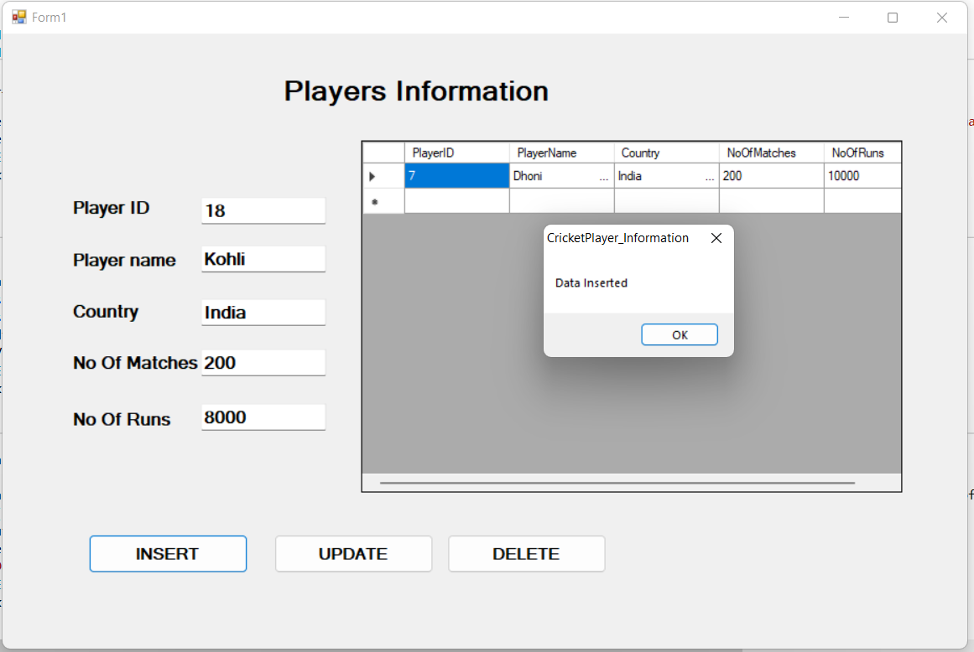

5} Create VB.NET application to maintain students Information. Create following table (April/May 2017) Tblstudent(RollNo, Name, Markl, Mark2, Mark3) Design proper form and make necessary validation. Provide insert, update and delete operation for above table. Generate report in DataGridView to display student information that gets percentage greater than 75%.

ImportsSystem.Data.SqlClient

PublicClassForm1

Dim con AsNewSqlConnection

DimcmdAsNewSqlCommand

PrivateSub Form1_Load(ByVal sender AsSystem.Object, ByVal e AsSystem.EventArgs) HandlesMyBase.Load

Try

con.ConnectionString = "Data Source=.\SQLEXPRESS;AttachDbFilename=C:\Users\JAY\documents\visual studio 2010\Projects\Student_Information\Student_Information\StudentDatabase.mdf;Integrated Security=True;User Instance=True"

cmd.Connection = con

Catch ex AsException

MsgBox(ex.Message)

EndTry

Display()

EndSub

SubDisplay()

Try

cmd.CommandText = "select * from StudentTable"

Dim da AsNewSqlDataAdapter(cmd)

Dim dt AsNewDataTable

da.Fill(dt)

DataGridView1.DataSource = dt

Catch ex AsException

MsgBox(ex.Message)

EndTry

EndSub

PrivateSubbtninsert_Click(ByVal sender AsSystem.Object, ByVal e AsSystem.EventArgs) Handlesbtninsert.Click

Try

cmd.CommandText = "insert into StudentTable values("&txtrno.Text&" , '"&txtname.Text&"' , "& txtmarks1.Text &" , "& txtmarks2.Text &" , "& txtmarks3.Text &")"

con.Open()

cmd.ExecuteNonQuery()

con.Close()

MsgBox("Data Inserted")

Catch ex AsException

MsgBox(ex.Message)

EndTry

Display()

EndSub

PrivateSubbtnupdate_Click(ByVal sender AsSystem.Object, ByVal e AsSystem.EventArgs) Handlesbtnupdate.Click

Try

cmd.CommandText = "update StudentTable set Name='"&txtname.Text&"' , Marks1="& txtmarks1.Text &" , Marks2="& txtmarks2.Text &" , Marks3="& txtmarks3.Text &" where RollNo="&txtrno.Text&" "

con.Open()

cmd.ExecuteNonQuery()

con.Close()

MsgBox("Data Updated")

Catch ex AsException

MsgBox(ex.Message)

EndTry

Display()

EndSub

PrivateSubbtndelete_Click(ByVal sender AsSystem.Object, ByVal e AsSystem.EventArgs) Handlesbtndelete.Click

Try

cmd.CommandText = "delete StudentTable where RollNo="&txtrno.Text&" "

con.Open()

cmd.ExecuteNonQuery()

con.Close()

MsgBox("Data Deleted")

Catch ex AsException

MsgBox(ex.Message)

EndTry

Display()

EndSub

EndClass

Output :-

