1. Dia

* Login, Register, Finalize Registration, Verification
* Search in available books
* User’s reservations
* User’s borrowings

1. Dia

React router:

* useLocation
* useNavigate
* createContext

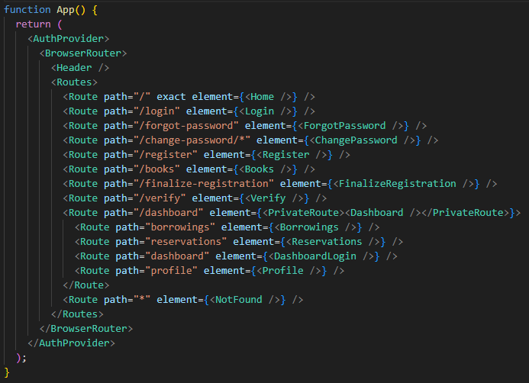

1. Dia

AuthProvider:



* Managing user activities
* Decoding token

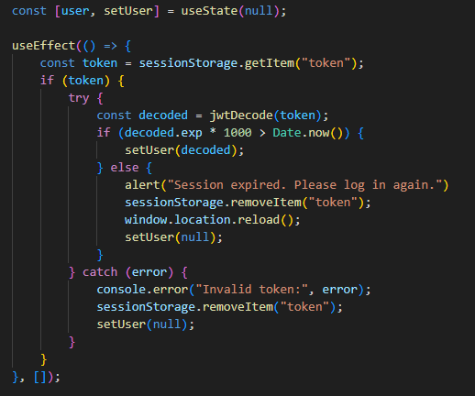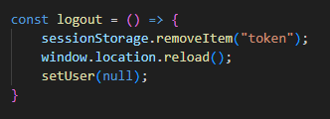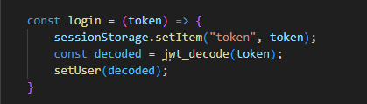

1. Dia

Login

* jwt-webtoken for authorization
* set token in sessionStorage
* forgot password
* axios get method

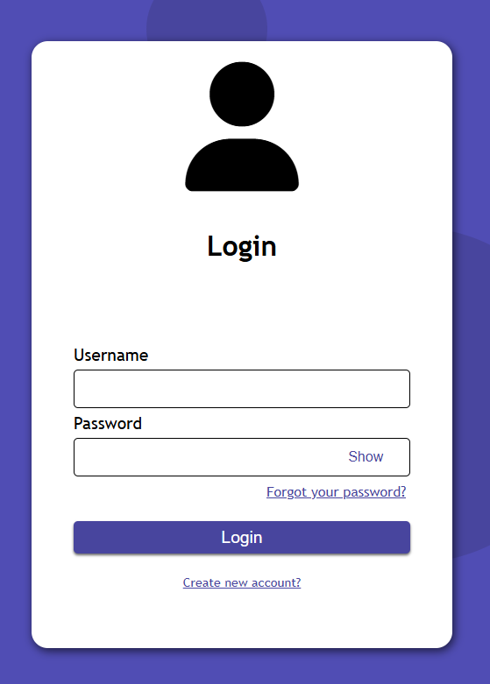

1. Dia

Registration

* axios post method
* finalize registration
* verification

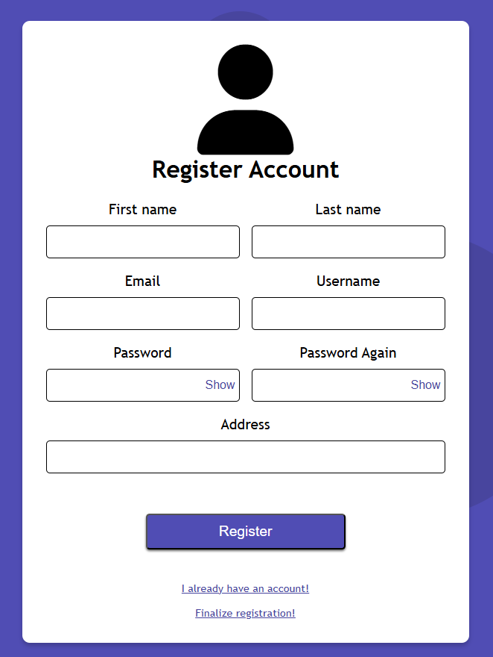s

1. Dia

* Live search
* Filter books
* Reserving (if logged in)

