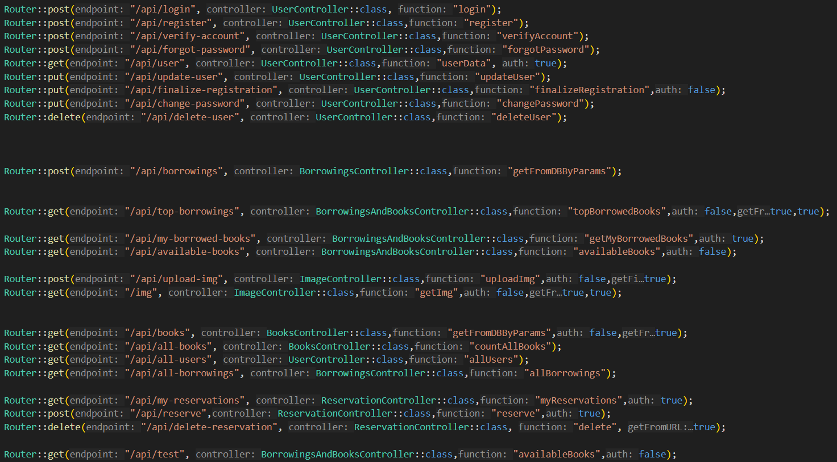
Ez lehet egy dia:

There are 4 different methods that i used:
GET
POST
PUT
DELETE
Response can be json or image

Kövi:
MVC – (Model-View-Controller)

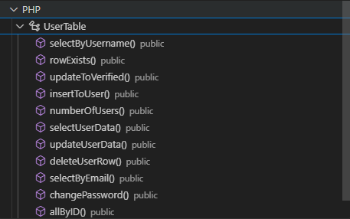
Models:
Most of the tables have a query which is the model in the projekt
By the queries the backend can select, insert, update and delete from the database
Every model inherit from table that contains these functions like
select
joins
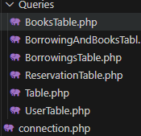
execute

Kövi:

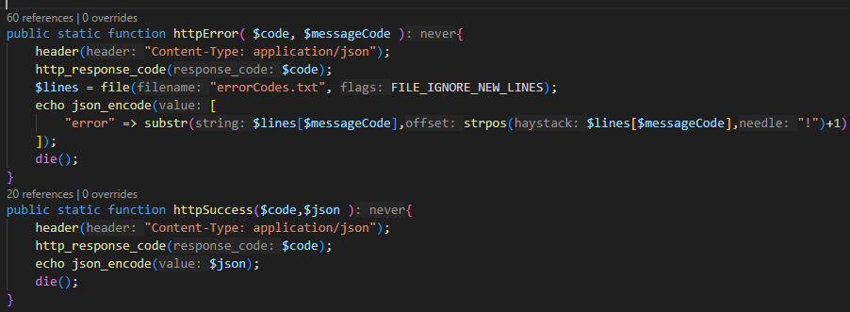
View:
The backend can make 2 different responses
Error
Success
Error:
The error messages are stored in a txt fájl.
Parameters:
code is the response status that is returned
messageCode is the line that should be returned from the txt
Success:
retruns the code as status code and the json as a string

Kövi:
Controllers:
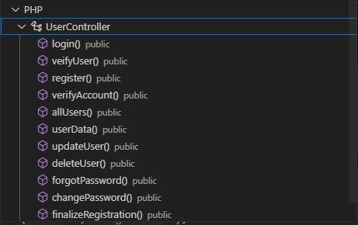
Most of the controllers work with the request body.
The parameters are given in an associative array.
Controllers verify the given array values.
The verification functions are in another class.


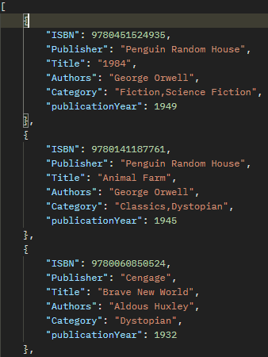

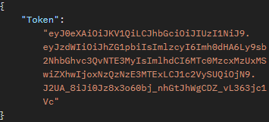
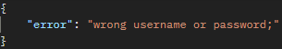
Examples:
Kövi:

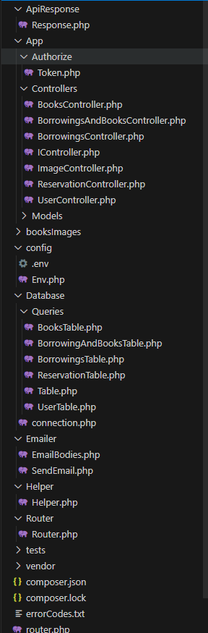
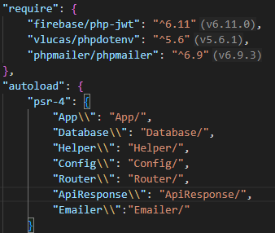
composer:
JWT
dotenv
phpmailer
autoloader

