Editing instructions for UCAs

<https://csci-1301.github.io/about#authors>

August 16, 2021 (03:15:08 PM)

Table of Contents

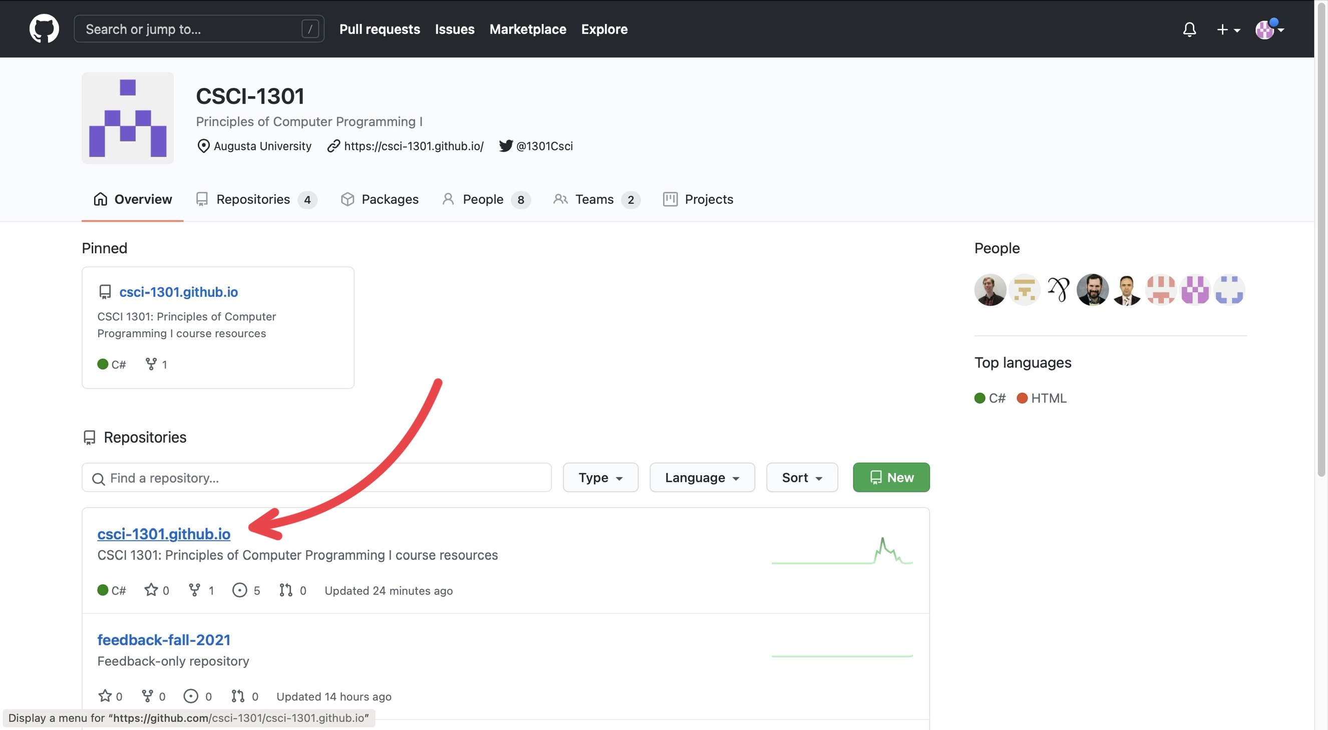

“Navigating repositories”

GitHub is separated into many “repositories”. The **csci-1301.github.io** contains most of the resources that will be used (so it will be where you will navigate to the most), while the **feedback-fall-2021** contains feedback submitted by students/users.

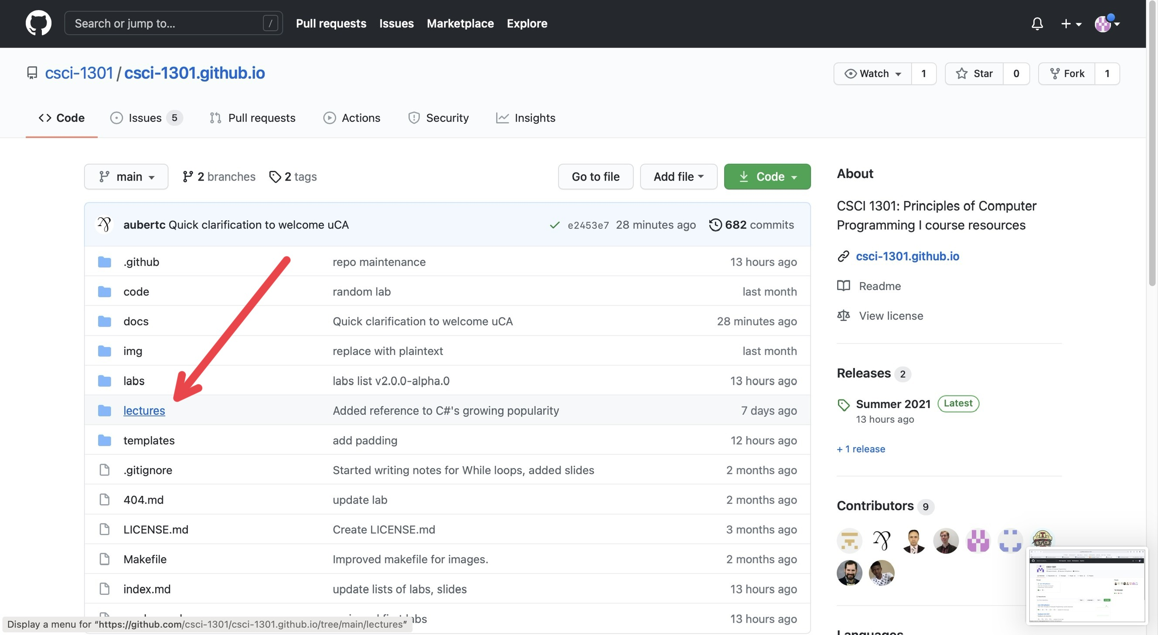

“Navigating folders”

Under the **Code** section (next to Issues, Pull Requests, Actions, etc.), you will find various folders containing documents for the website. Typically, if there is some error or mistake in the lecture notes, so that will be where you will navigate to the most.

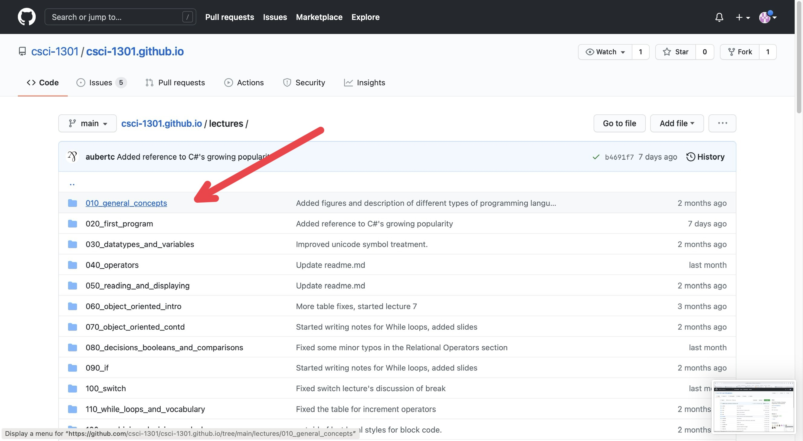

“Navigating documents”

For this example, I just clicked on the first chapter, “General Concepts”.

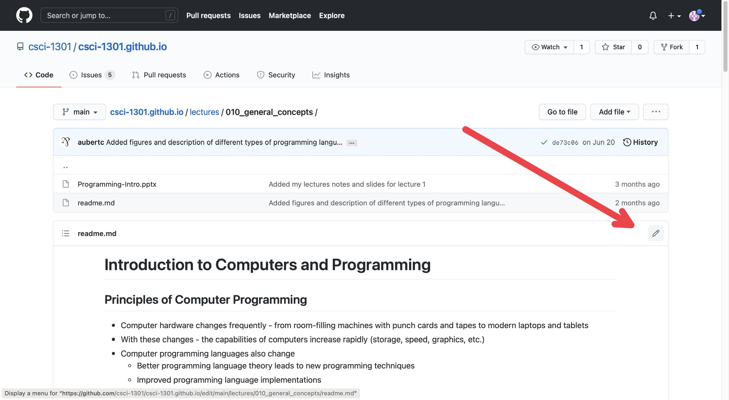

“Editing Mode”

On this page, you can see the edit history of that specific document you clicked on. In the corner above the document and below the edit history, there is a pencil icon that will put you into editing mode for that document.

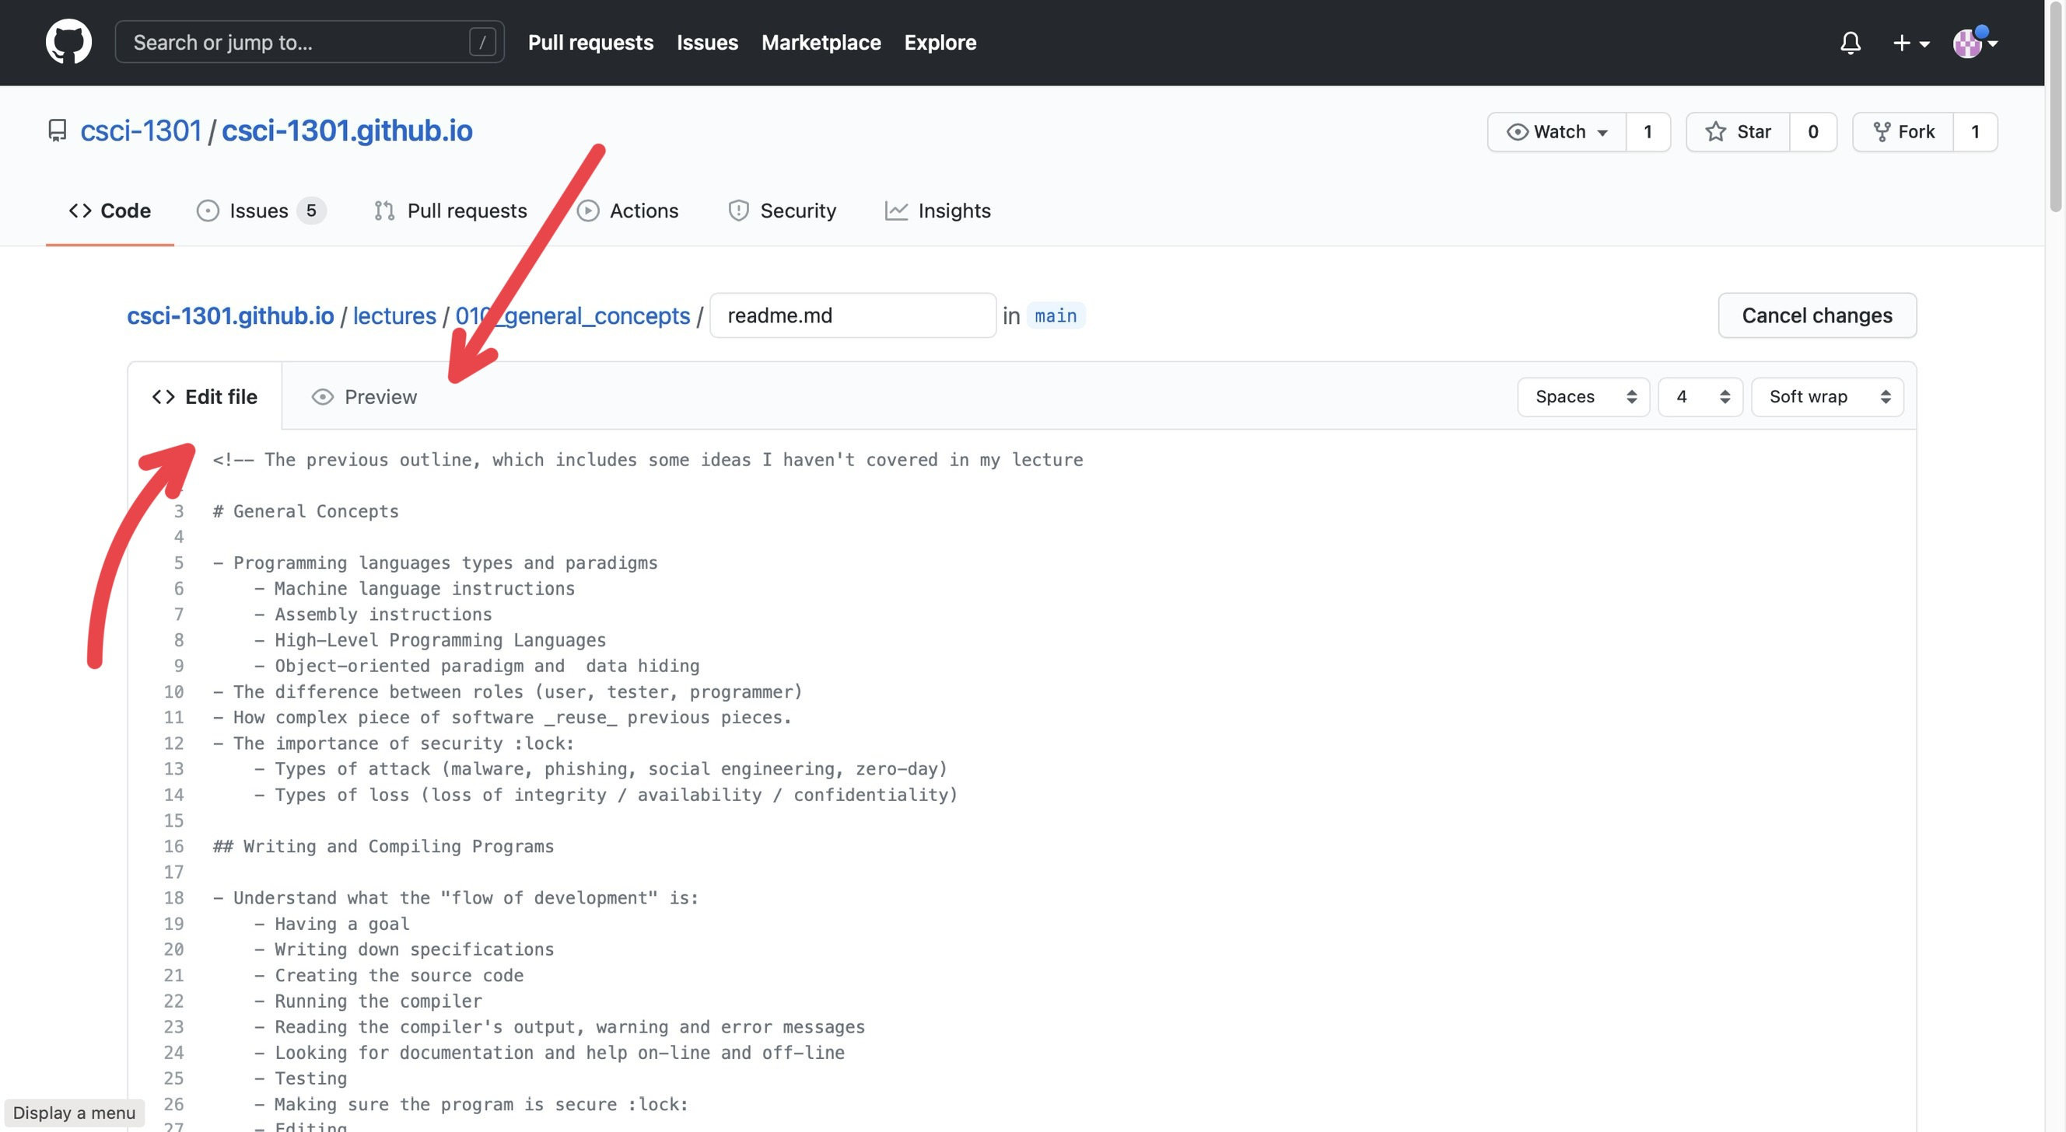

“Editing vs Previewing”

On this page, you will see the document in strange formatting (the formatting is called Markdown) with two sections at the top of the document: *Edit file* and *Preview*. If you have *Edit file* selected, then you will see the “code” version of the document whereas if you click on the *Preview* button, you will see the document in its “final” form, or how the website users should see it, without the “code”. To edit, make sure you have *Edit file* selected.

* For a quick syntax guide in Markdown, I recommend this website: https://www.markdownguide.org/basic-syntax/

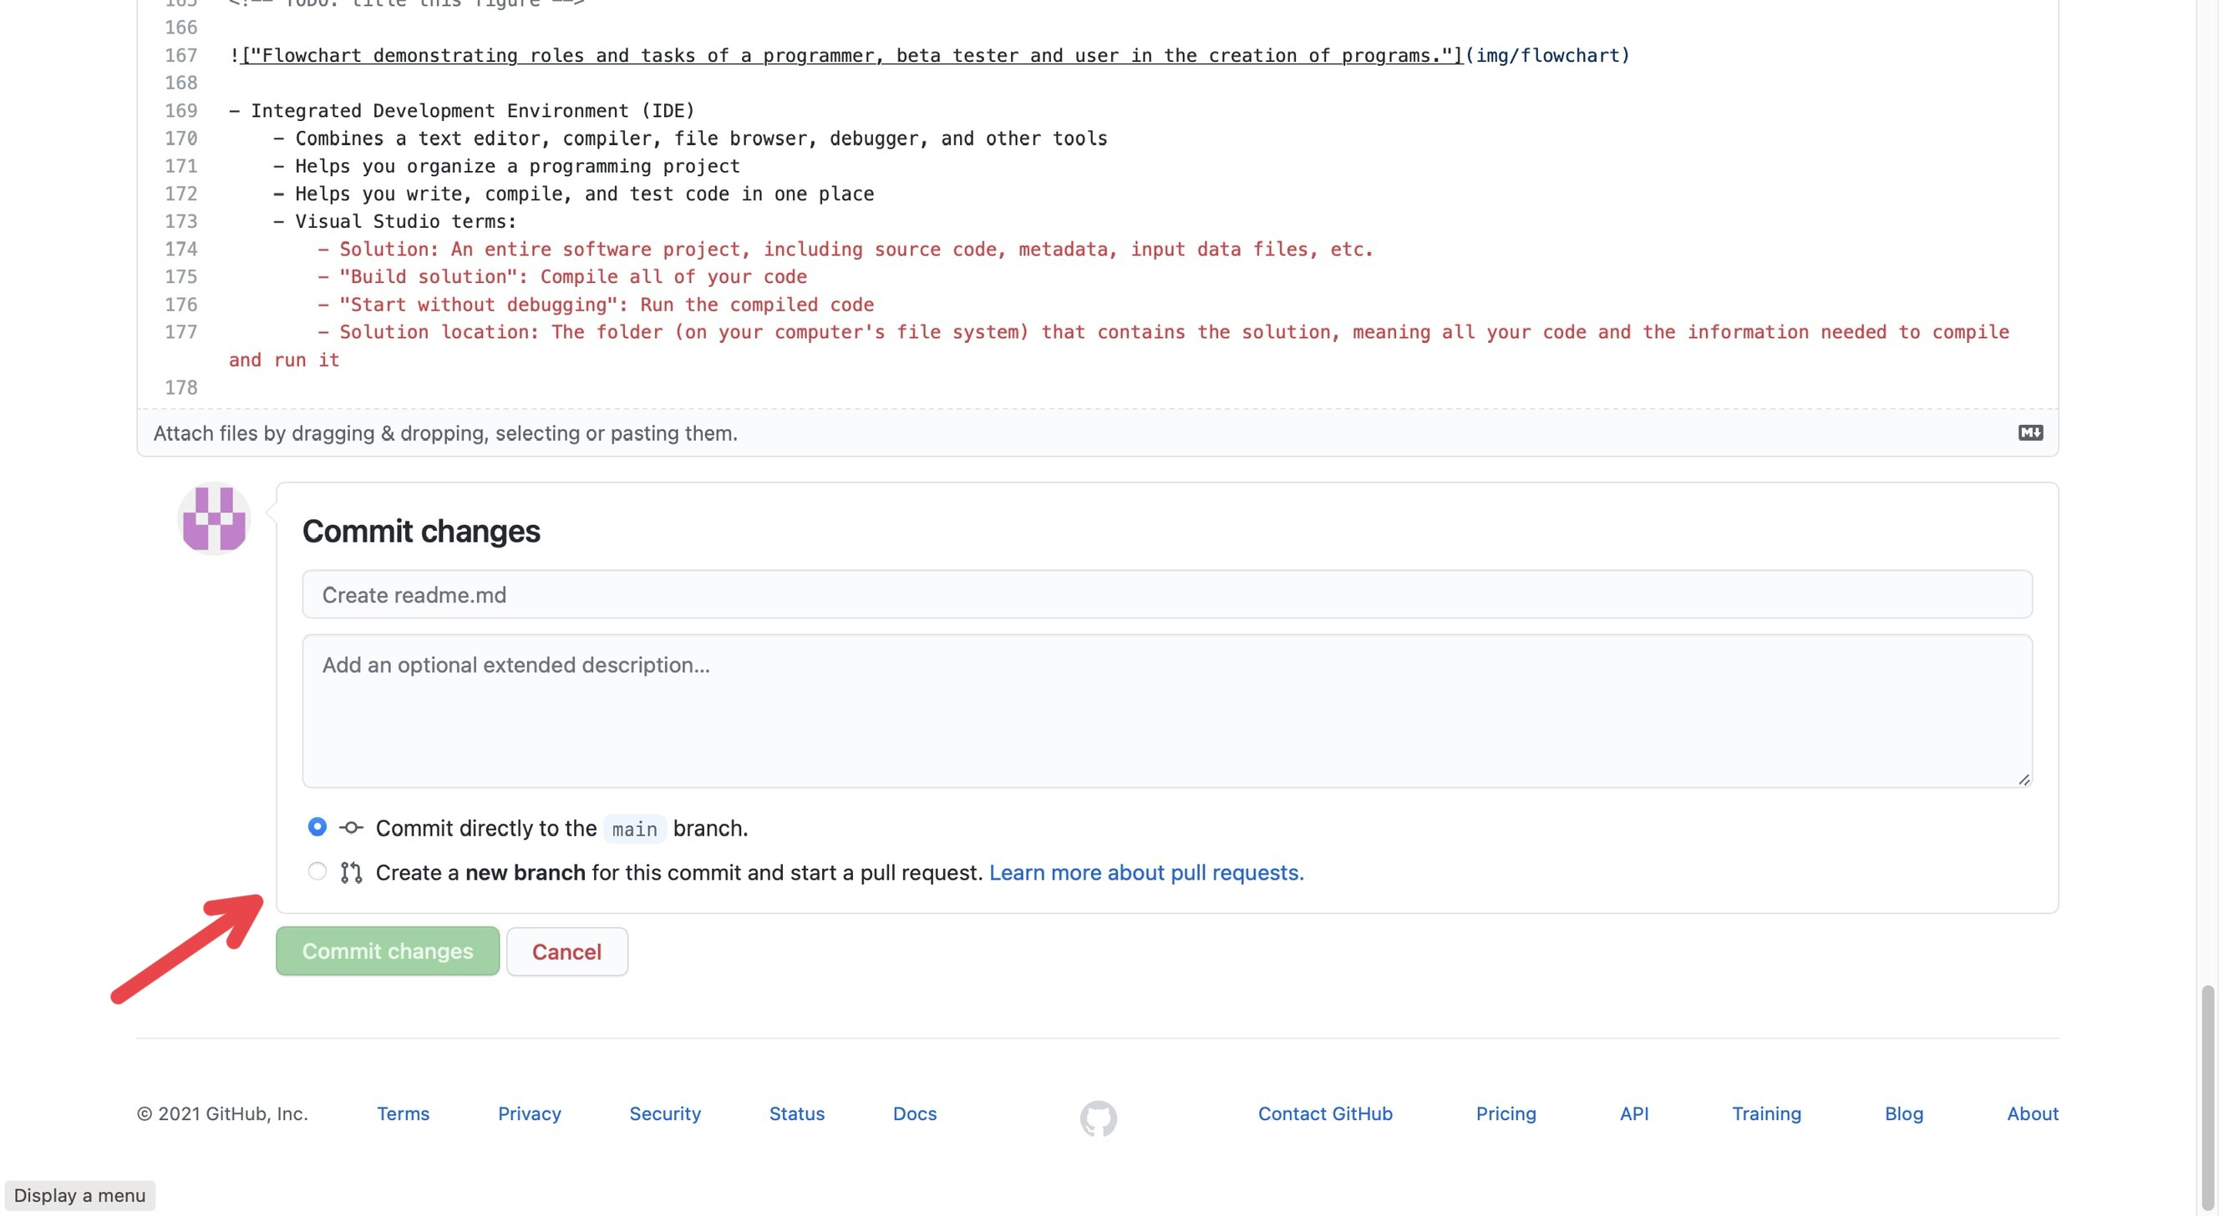

“Committing”

Once you have made the edits you wanted, you need to “commit” them; just like how you may write a paper, you need to submit it to the professor for them to see it. At the bottom of the page, there is a header box and a description box for you to describe what you did so others will know the changes you did (you don’t need to go into *every* detail; just describe it generally, like “I fixed grammatical issues” or “Fixed code error”). There is also two buttons: **Commit directly to** main **branch** and **Create a new branch for this commit and start a pull request**.

* **Commit directly to** main **branch** submits your edits directly into the document.
* **Create a new branch for this commit and start a pull request** creates a “pull request” (which can be found in the *Pull Requests* tab at the top of the page) which essentially notifies others “you edited this document and you want them to check it”. Others can check the changes you make, improve them, change them, and can submit them for you.

As a UCA, I would recommend just sticking to **Create a new branch for this commit and start a pull request** so others can double check your edits.