**Virtual Voting System Using Blockchain Technology**

Ms. Akanksha1*, Utkarsh Mishra1, Surya Pratap Singh2, and Adrika Tripathi2

1Department of Computer Science, KIET Group of Institutions,

Delhi-NCR, Ghaziabad, India

akanksha.cs@kiet.edu

utkarshm402@gmail.com

suryapratapsingh0833@gmail.com

tripathiadrika@gmail.com

**Abstract.** Election-making by governments is crucial in the modern world of government by the people. Elections play a significant role in determining who will be in charge of a country or organization, or, as it is sometimes said, is a circumstance that determines the fate of any country. Even the biggest democracies in the world, including India and the United States, nevertheless have unreliable voting procedures. The main problems with the existing voting system include vote rigging, EVM hacking, election manipulation, and polling booth capturing.

The blockchain is a new, decentralized, and distributed technology that has the potential to improve several elements of numerous sectors. The issue with the current e-voting system might be resolved by expanding it using blockchain technology. The blockchain with smart contracts stands out as a strong contender to be used in the creation of safer, more affordable, more secure, more transparent, and simpler electronic voting systems. We used the Ethereum platform and the Solidity programming language to create and test a virtual voting application as a smart contract for the Ethereum network. Ethereum and its network are among the best because of their stability, extensive use, and supply of smart contracts logic. A secure electronic voting process prevents duplicate votes, is completely visible, and safeguards the attendees' privacy.

This research paper offers a solution to the problems with traditional elections. The purpose of this study is to create a decentralized, as opposed to centralized, virtual voting system that assures voter identity security, data transmission privacy, and variability through an open and transparent voting process.

***Keywords***— **Blockchain, Ethereum, Smart Contracts, Decentralized, Solidity.**

# Introduction

In an era characterized by unprecedented technological advancements, the traditional methods of conducting elections have come under increasing scrutiny. The digital age has ushered in the potential for innovation in the electoral process, promising greater transparency, security, and accessibility. One groundbreaking development that has garnered significant attention is the integration of blockchain technology into the realm of voting, giving rise to what is commonly referred to as "virtual voting." Blockchain, originally conceived as the underlying technology for cryptocurrencies like Bitcoin, has demonstrated its ability to revolutionize various industries, and elections are no exception.

The concept of virtual voting using blockchain technology is both revolutionary and disruptive. It offers the promise of a democratic system that is more secure, transparent, and efficient. This novel approach combines the security features of blockchain, such as decentralization and cryptographic protection, with the accessibility and convenience of a virtual voting platform. As a result, it has the potential to address longstanding concerns related to electoral integrity, voter fraud, and accessibility.

This research paper explores the integration of blockchain technology into the electoral process and its potential to reshape the way we conduct elections in the 21st century. We will delve into the core concepts and advantages of virtual voting, analyze the challenges and concerns that arise, examine relevant case studies, and consider the legal and regulatory framework that governs its implementation. Additionally, we will explore emerging trends and innovations in this field, shedding light on the transformative potential of blockchain-based virtual voting systems.

* 1. **Technologies used**

*Blockchain*- Blockchain is a distributed, decentralized digital ledger technology that records and verifies transactions across multiple computers. It enables secure, transparent, and tamper-proof data storage and transfer, making it valuable for applications like cryptocurrencies, supply chain management, and more. Transactions are grouped into "blocks" and linked together in a "chain," with each block containing a cryptographic reference to the previous one, ensuring data integrity and trust. It eliminates the need for intermediaries, such as banks, and has the potential to transform various industries.

*Ethereum*- Ethereum is a decentralized, open-source blockchain platform that enables developers to build and deploy decentralized applications (DApps). It's known for its smart contract functionality, allowing self-executing agreements to be coded directly into the blockchain. Ether(ETH) is the native cryptocurrency of the Ethereum network, used for transaction fees and as a store of value. Ethereum has played a crucial role in the growth of the decentralized finance (DeFi) and non-fungible token (NFT) sectors, offering a wide range of applications beyond just cryptocurrency.

*Smart contracts*- Smart contracts are self-executing, code-based agreements that run on blockchain technology. They automatically enforce the terms and conditions of a contract when predefined conditions are met. Smart contracts eliminate the need for intermediaries, such as lawyers or banks, and facilitate trust and transparency in various fields, including finance, real estate, and supply chain management. They execute actions and manage assets securely and autonomously once the conditions specified in the contract's code are fulfilled.

*Solidity*- Solidity is a programming language specifically designed for writing smart contracts on the Ethereum blockchain. It enables developers to create and deploy self-executing agreements and decentralized applications (DApps) on the Ethereum network. Solidity is known for its focus on security and ease of use, making it a popular choice for Ethereum-based development. It allows developers to define the rules and functions of smart contracts to ensure secure and transparent execution on the blockchain.

# Literature Overview

***2.1. Votereum: An Ethereum-based E-voting system* :**

Linh Vo-Cao-Thuy, Khoi Cao-Minh, Chuong Dang-Le-Bao and Tuan A.Nguyen,2019,"Votereum: An Ethereum-based Electronic Voting System," Vietnam National University, Faculty of Information Technology Vietnam's HCMC examines the prerequisites before suggesting Votereum, a digital voting platform that makes use of blockchain technologies. The suggested framework is enabled by the Ethereum platform, which comprises one server. oversees the entire system, while the other takes care of everything requests pertaining to blockchain.[1]

***2.2. Online Voting: Voting System Using Blockchain:***Vaibhav Anasune, Pradeep Choudhari, Madhura Kelapure and Pranali Shirke Prasad Halgaonkar,“Online Voting: Voting System Using B-chain”,2019, article provides a brief overview of the several voting methods now in use. The study will assist in developing a system that will overcome current and future obstacles and eliminate shortcomings from these earlier systems.[2]

***2.3. Decentralized Voting Platform Based on Ethereum Blockchain:*** **David Khoury,Elie F. Kfoury, Ali Kassem and Hamza Harb,2018 "Decentralized Voting Platform Based on Ethereum Blockchain," American University of Science and Technology, Department of Computer Science, We provide a unique method for a decentralized trustless voting platform that uses blockchain technology to address trust concerns. This system's primary characteristics include guaranteeing data** integrity and transparency and imposing a single, secure vote per cell phone number for each poll. The Blockchain runtime environment for this is the Ethereum Virtual Machine (EVM).[3]

***2.4. Survey on Blockchain Based E-Voting Recording System Design:*** G Bhavan,i“Survey on Blockchain-Based E-Voting Recording System Design”,2018, One of the forms of database manipulation fraud can be minimized by implementing blockchain technology in the database distribution process on electronic voting systems. The data obtained from the fingerprint sensor will be encrypted using the AES method. This study addresses the use of blockchain technology to record vote results from each polling location.[4]

***2.5. Blockchain-Based E-Voting System:***

Friðrik Þ. Hjálmarsson , Gunnlaugur K . Hreiðarsson, “Blockchain-Based E-Voting System”,2018, This paper, from the School of Computer Science at Reykjavik University in Iceland, assesses the potential of distributed ledger technologies by describing a case study that involves the election process and the implementation of a blockchain-based application that lowers the cost and increases security for holding a national election.[5]

***2.6. Blockchain Based E-Voting Recording System Design:*** Rifa Hanifatunnisa and Budi Rahardjo,2017,The "Blockchain Based E-Voting Recording System Design" starts recording as soon as the vote is over. One potential answer to the issues that frequently arise in the election system is blockchain technology. This recording technique is more secure because it uses hash values to record the voting results of each polling place that is connected. It is also more dependable since it uses digital signatures. Considering that in an electoral system where voter data and numbers are clear and voters are not permitted to select more than once, the use of the sequence proposed in the blockchain creation process in this system ensures that all nodes that are legally connected and capable of avoiding collision in transportation.[6]

***2.7.“How to Leak a Secret: Theory and Applications of Ring Signatures”*:** BlockVote is a system that was created using the Ring Signature method and the Bitcoin network. The Ring Signature technique enables the confirmation of someone's membership in a group without revealing their identity. However, the protocol has a limitation, as it works well only for less than 3,000 users, as stated in the paper. Additionally, Bitcoin was not developed for application development, as it was initially created as an online payment mechanism. Therefore, in the BlockVote system, the critical tasks, including the tallying stage, are managed by the system servers. This may have a significant impact on the outcome and increase the risk of fraud.

***2.8. ‘Decentralized EVoting Systems Based on Blockchain Technology”* :** Hsiao JH, Tso R, Chen CM, Wu ME. ‘Decentralized EVoting Systems Based on the Blockchain Technology ” 2018, Use decentralized blockchain technology and smart contracts for electronic voting in their efforts to encourage all voters to cast and record ballots. It lowers the abuse of election funds and boosts voter confidence.[8]

***2.9. Towards secure e-voting using ethereum blockchain:*** Emre Yavuz; Ali Kaan Koç ; Umut Can Çabuk ; Gökhan Dalkılıç (2018) Towards secure e-voting using ethereum blockchain. The blockchain and Ethereum network architecture. At this point, Ethereum and smart contracts—one of the most groundbreaking innovations since the blockchain itself—helped to dispel the misconception that blockchain is only a cryptocurrency or coin. Instead, they transformed blockchain into a more comprehensive set of solutions for a variety of contemporary Internet-related problems, and they may even pave the way for blockchain's widespread application. [9]

***2.10. An anonymous distributed electronic voting system using Zerocoin:*** Y. Takabatake, D. Kotani, and Y. Okabe, “An anonymous distributed electronic voting system using Zerocoin” One public database is Bitcoin. An administrator can link voters to vote if it just uses bitcoin. That is a concern, however we utilize one of the bitcoin laundry systems, zerocoin, to address the privacy problems that arise with bitcoin. Because of this, an administrator or other third party can confirm that the person is a voter, but they are unable to identify them. Furthermore, this system can adjust the voter pool before the voting phase, making it more difficult for the administrator to spoof votes.

**Table 1: The summary table of the references mentioned in the literature review**

|  |  |  |  |
| --- | --- | --- | --- |
| **S. No.** | **Author**  **(Publishing Year)** | **Technology** | **Remarks** |
| 1 | Linh Vo-Cao-Thuy, Khoi Cao-Minh, Chuong Dang-Le-Bao and Tuan A. Nguyen,2019[1] | 1. External Personal Account(EOA)  2. Contract Account  3. Votereum | A digital voting platform that makes use of blockchain technologies. The suggested framework is enabled by the Ethereum platform, which comprises one server. |
| 2 | Vaibhav Anasune, Pradeep Choudhari,MadhuraKelapure and Pranali Shirke Prasad Halgaonkar,“Online Voting: Voting System Using B-chain”,2019 [2] | 1.Cryptographic verification  2.Homomorphic Encryption Technique: | Article provides a brief overview of the several voting methods now in use. The study will assist in developing a system that will overcome current and future obstacles and eliminate shortcomings from these earlier systems.[2] |
| 3 | David Khoury,Elie F. Kfoury, Ali Kassem and Hamza Harb,2018 "Decentralized Voting Platform Based on Ethereum Blockchain, | 1.HTML5 web-app compiled using Apache Cordova  2.Ethereum network | This system's primary characteristics include guaranteeing data integrity and transparency and imposing a single, secure vote per cell phone number for each poll. The Blockchain runtime environment for this is the Ethereum Virtual Machine (EVM).[3] |
| 4 | G Bhavani“Survey on Blockchain Based E-Voting Recording System Design”,2018 | 1.AES algorithm | The data obtained from the fingerprint sensor will be encrypted using the AES method. This study addresses the use of blockchain technology to record vote results from each polling location.[4] |
| 5 | Friðrik Þ. Hjálmarsson , Gunnlaugur K . Hreiðarsson, “Blockchain-Based E-Voting System”,2018 | 1.Quorum  2.Geth: Go-Ethereum | Assesses the potential of distributed ledger technologies by describing a case study that involves the election process and the implementation of a blockchain-based application that lowers the cost and increases security for holding a national election.[5]. |
| 6 | Rifa Hanifatunnisa and Budi Rahardjo,2017,The "Blockchain Based E-Voting Recording System Design | 1.ECDSA(Elliptic Curve Digital Signature Algorithm)  2. SHA-256 algorithm | This recording technique is more secure because it uses hash values to record the voting results of each polling place that is connected to one another. It is also more dependable since it uses digital signatures. Considering that in an electoral system where voter data and numbers are clear and voters are not permitted to select more than once, the use of the sequence proposed in the blockchain creation process in this system ensures that all nodes that are legally connected and capable of avoiding collision in transportation.[6] |
| 7 | R. L. Rivest, A. Shamir, and Y. Tauman, “How to Leak a Secret: Theory and Applications of Ring Signatures | 1. Ring signature scheme 2. Bitcoin | Function well for less than 3000 people and might raise the likelihood of fraud.[7] |
| 8 | Hsiao JH, Tso R, Chen CM, Wu ME. ‘Decentralized EVoting Systems Based on the Blockchain Technology’ | 1. Smart Contracts 2. Immutable ledger | By utilizing the transparency of smart contracts, our solution makes it possible for every voter to take part in the recording and verification of ballots. It lowers election resource waste and increases voter trust.[8] |
| 9 | Emre Yavuz ; Ali Kaan Koç ; Umut Can Çabuk ; Gökhan Dalkılıç (2018) Towards secure e-voting using ethereum blockchain | 1.Immutable hash chains  2.Ethereum network  3.Smart Contracts | There are also some properties that cannot be addressed solely using the blockchain, for example authentication of voters (on the personal level, not on the account level) [9] |
| 10 | Y. Takabatake, D. Kotani, and Y. Okabe, “An anonymous distributed electronic voting system using Zerocoin | 1. Zerocoin 2. Minting 3. Spending | System has problems with its processing speed because it relies on bitcoin’s or zerocoin’s processing speed. |

# Research Methodology

The Waterfall Model is a traditional and linear approach to software development that was one of the earliest methodologies used in the field of software engineering. It was first introduced by Dr. Winston W. Royce in a paper published in 1970. The Waterfall Model is characterized by a sequential and non-iterative process that consists of several distinct phases, each of which must be completed before the next one begins. The Waterfall Model is often represented as a linear, cascading sequence of these phases, where each phase must be completed before the next one begins. It's a highly structured and document-heavy approach to software development, and it was widely used in the early days of software engineering. The Waterfall Model is a traditional software development approach with sequential phases, including requirements gathering, design, implementation, testing, deployment, and maintenance, and are illustrated below.

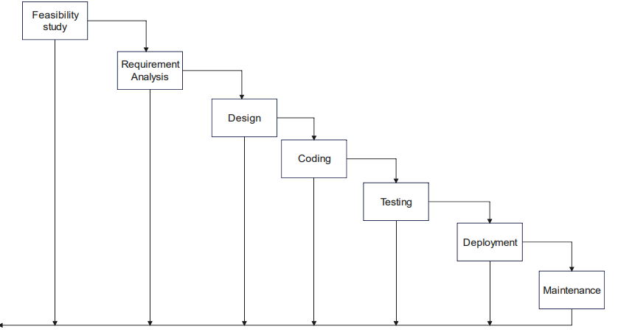

**Fig. 1.** The Waterfall Model - Sequential Phases in Software Development

**3.1 System Design**

The system design phase aims to create a complete and detailed design of the software system before development begins. Once the design is finalized and approved, the project can move on to the implementation phase, where the actual coding and development of the software takes place. We created many diagrams to construct the operative development model such as a data flow diagram, use case diagram, and DFDs. This tailored system design process reflects the integration of ReactJS for the frontend and Ethereum for smart contracts in the development of the voting system. Designed the Ethereum smart contracts that will govern the e-voting process. This includes contracts for voter registration, ballot creation, voting, and result tabulation. Implemented secure coding practices and conducted thorough code reviews to identify and address potential vulnerabilities. The system design process includes Truffle as the Ethereum development tool ensures that the design aligns with the specific workflows and considerations of Truffle-based development. Truffle is a development framework for Ethereum that simplifies the process of building and deploying smart contracts. Ganache is used in the development and testing phases of an e-voting system based on Ethereum smart contracts. Ganache is a personal blockchain for Ethereum development that allows developers to create a local and private blockchain environment for testing their smart contracts.

**Software Requirements**

* Truffle framework
* React JS
* MetaMask
* Ganache
* Windows OS

**User Requirements**

* Add candidate.
* Import voter account.
* Account authentication.
* Voters can vote once
* Win with maximum vote.

**3.2 Flow Chart**

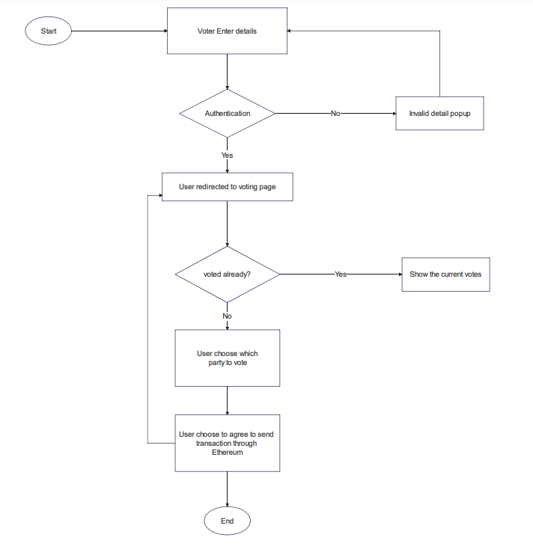

**Fig. 2.** Flow Chart for Virtual voting system

The first thing that we need to start the project is to run a local blockchain by starting up Ganache. After setting up the ganache there will be not any transaction as we have not done any transactions yet. As we can see from the snapshot below there is no transaction. Now we use the truffle framework to transfer the smart contract to the blockchain by giving commands on the command line. We have also used the NPM directory by cmd. This flowchart outlines a secure and transparent e-voting system utilizing blockchain technology, ensuring the integrity of the voting process and providing a reliable platform for users to cast their votes. The process begins when a user accesses the e-voting system's interface. The user enters personal details for authentication, ensuring a secure and verifiable process. The entered details are authenticated against a secure database to ensure the user's eligibility to vote. If authentication fails, the user is prompted to enter the correct details. Upon successful authentication, the user is directed to the voting page. The voting page displays the list of candidates with relevant information to help users make informed decisions. The user selects the candidate of their choice through the user-friendly interface. Once the user finalizes their vote, the system prompts the user to confirm the decision. Upon confirmation, the system initiates a blockchain transaction using Ethereum smart contracts. The Ethereum network processes the transaction, ensuring its validity and authenticity. Smart contracts validate the user's eligibility, the chosen candidate, and the integrity of the transaction. After successful verification, the system confirms the completion of the transaction to the user. The user is then redirected to the voting page for further actions. If the user has not voted before, the system updates the overall vote count for the selected candidate. If the user has already voted, a message is displayed indicating that the vote has been previously cast. The system provides feedback to the user, confirming the successful completion of the voting process. Users are given the option to view overall voting results if desired. All interactions, including user details, votes, and transactions, are securely logged on the blockchain for transparency and auditability.

**3.3 User Interface**

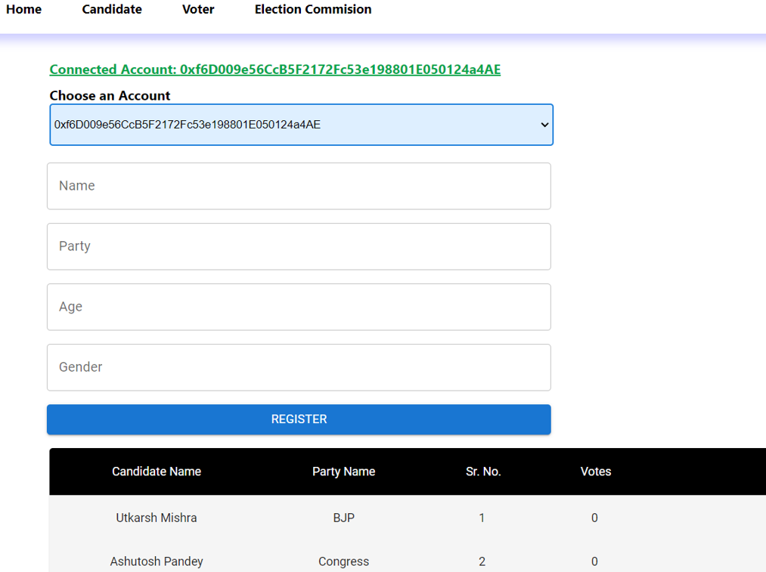

**Fig. 3.** Candidate registration

Candidate registration is a critical aspect of the electoral process, allowing individuals to formally declare their candidacy and participate in elections. This section explores the various steps involved in candidate registration, including accessing the registration interface, providing personal information, verification and eligibility checks, confirmation, and approval by election authorities. Additionally, it discusses the challenges and opportunities associated with candidate registration in virtual voting systems, such as ensuring the integrity of candidate information and streamlining the approval process.

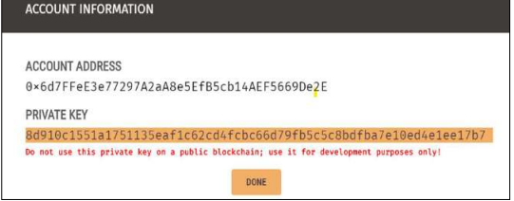

**Fig. 4.** Private Key

After the user has logged in, the main screen comes up with zero vote, the user cannot vote until they import their account by entering the private key.

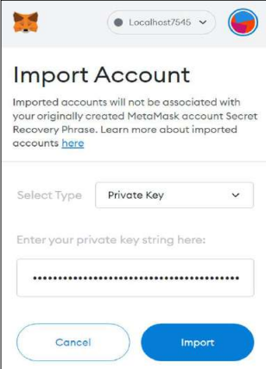

**Fig. 5.** Importing account

Voters import their accounts by entering the private key. Importing voter accounts by entering the private key is a crucial aspect of voter authentication in virtual voting systems leveraging blockchain technology. Electorates choose a candidate of their choice, and the MetaMask pop-up opens when click on a vote to confirm the transaction.

# Result

In this project, we proposed an electronic voting system based on blockchain that makes use of smart contracts to enable safe and affordable elections while ensuring the privacy of voters. We've demonstrated that using blockchain technology provides a new opportunity to remove the restrictions and adoption obstacles to computerized voting machines that assure election results establishing trust and a foundation for transparency. The system incorporates mechanisms to prevent double voting, ensuring the accuracy and fairness of the electoral results. An Ethereum account within Ganache is designated to handle the winner declaration process that is done by the Election Commission.

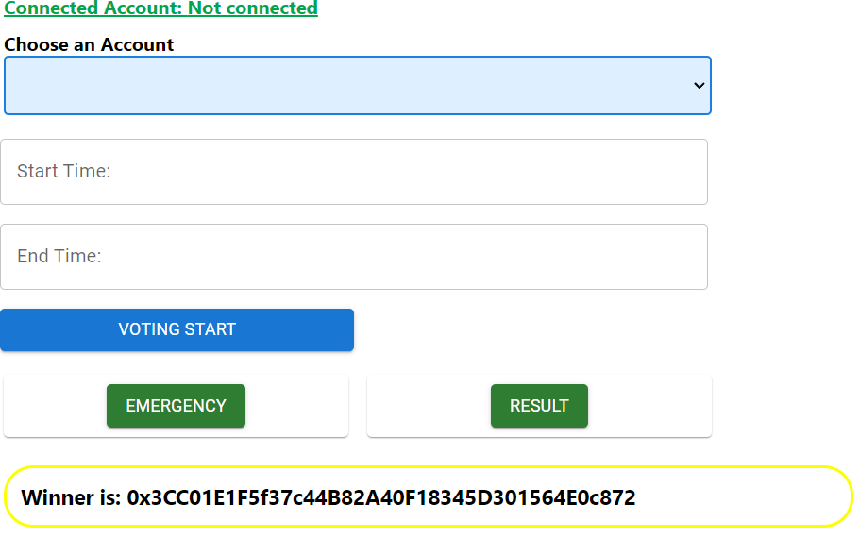

**Fig. 6.**  Winner Declaration

# Conclusion and future scope

Hundreds of transactions per second might be sent using every component of the smart contract and the blockchain. Because of the blockchain's openness, elections may be more thoroughly audited and understood. These characteristics are some of what a voting system must have. These decentralized networks provide properties that can bring forth more democratic electoral procedures, especially to control electoral processes. To make e-voting more popular a possible open, transparent, and independently auditable Its foundation should be blockchain technology. This initiative investigates blockchain's possibilities and technology's role in the electronic voting system. The Blockchain will be widely dispersed and publicly verified such that it cannot be tampered with by anyone.

To reduce the blockchain's workload for nations with a larger population, further precautions would be required to enable higher transaction throughput per second. Making the system more secure. Integrating biometric authentication i.e. fingerprint, an iris scan, and a retina scan for better authentication. It is essential to continually assess and improve the security features of blockchain systems to stay ahead of emerging threats and ensure the continued trust of the electorate.

# References

1. Linh Vo-Cao-Thuy, Khoi Cao-Minh, Chuong Dang-Le-Bao and Tuan A. Nguyen,(2019), Votereum: An Ethereum-based E-voting system. doi: 10.1109/RIVF.2019.8713661
2. Vaibhav Anasune, Pradeep Choudhari , Madhura Kelapure and Pranali Shirke Prasad Halgaonkar,“Online Voting: Voting System Using B-chain”,(2019), Online Voting: Voting System Using Blockchain. https://dx.doi.org/10.2139/ssrn.3648870
3. David Khoury,Elie F. Kfoury, Ali Kassem and Hamza Harb,(2018), Decentralized Voting Platform Based on Ethereum Blockchain. http://dx.doi.org/10.1109/IMCET.2018.8603050
4. G Bhavan,i ,(2018) ,“Survey on Blockchain Based E-Voting Recording System Design” . DOI:10.15680/IJIRSET.2018.0711013
5. Friðrik Þ. Hjálmarsson , Gunnlaugur K . Hreiðarsson, ,(2018)“Blockchain-Based E-Voting System”
6. Muhammad Shoaib Farooq 1, Usman Iftikhar 2, And Adel Khelifi 3(2022). "A Framework to Make Voting System Transparent Using Blockchain Technology"
7. Aishwarya Indapwar1, Manoj Chandak2,Amit Jain3 (2020), "E-Voting system using Blockchain technology ”
8. Tanwar, S., Gupta, N., Kumar, P. *et al.* Implementation of blockchain-based e-voting system. *Multimed Tools Appl* **83**, 1449–1480 (2024). <https://doi.org/10.1007/s11042-023-15401-1>
9. Emre Yavuz ; Ali Kaan Koç ; Umut Can Çabuk ; Gökhan Dalkılıç (2018) Towards secure e-voting using ethereum blockchain . <https://doi.org/10.1016/j.eij.2024.100447>
10. Y. Takabatake, D. Kotani, and Y. Okabe, “An anonymous distributed electronic voting system using Zerocoin
11. Venkata Naga Rani B, Akshay S, Arun kumar M , Ishwar Kumar M A , (2019) , Decentralized E-Voting System,International Research Journal of Engineering and Technology
12. ]Hoyul Choi, Hyunsoo Kwon, Junbeom Hur, (2015) ,“A secure OTP algorithm using a smartphone application”, Seventh International Conference on Ubiquitous and Future Networks, Sapporo, Japan.
13. G. Wood,[2014] "Ethereum: a secure decentralised generalised transaction ledger", Ethereum Project Yellow Paper,
14. G. Verma A Secure Framework for E-Voting Using Blockchain (2022) Second International Conference on Computer Science, Engineering and Applications (ICCSEA) (2022)
15. U. Jafar, M.J.A. Aziz, Z. Shukur “Blockchain for the electronic voting system—review and open research challenges" Sensors, 21 (2021)
16. A.L.I. Benabdallah, A. Audras, L. Coudert, N.E.L. Madhoun, M. Badra Analysis of blockchain solutions for e-voting: a systematic literature review IEEE Access, 10 (2022)
17. Y. Kho and S. Heng, “A Review of Cryptographic Electronic Voting,” Symmetry (Basel), 2022
18. C.A. Hassan, M. Hammad, J. Iqbal, S. Hussain, S.S. Ullah, H. AlSalman, *et al.* A Liquid Democracy Enabled Blockchain-Based Electronic Voting System Sci Program, 2022 (2022),
19. K.V. Rao, S.K. Panda Secure electronic voting (e-voting) system based on blockchain on various platforms Comput Commun Netw IoT (2022)
20. Y. Guo, C. Zhang, C. Wang, X. Jia Towards public verifiable and forward-privacy encrypted search by using blockchain IEEE Trans Dependable Secure Comput 20 (3) (2023)

.