REAL TIME MULTITHREADING SIMULATOR REPORT
in partial fulfillment for the award of the degree
of
BTECH
IN
COMPUTER SCIENCE


Lovely Professional University, Punjab
DECEMEBER & 2025

Submitted by:
1) Bhumi Singh-12406674
2)Joshua Samuel-12408527
3)Palak Mor-12410837
TABLE OF CONTENTS

CHAPTER NO. | CHAPTER NAME | PAGE NO.
 | Title Page | 1
 | Table of Content | 2
1 | PROJECT OVERVIEW | 3
2 | MODULE-VISE-BREAKDOWN | 4
3 | FUNCTIONALITIES | 11
4 | TECHNOLOGIES USED | 15
5 | FLOW DIAGRAM | 15
6 | REVISION TRACKING(GITHUB) | 16
7 | CONLCUSION AND FUTURE SCOPES | 17
8 | AI GENERATED BREAKDOWN | 20
9 | PROBLEM STATEMENT | 22
10 | COMPLETE SOURCE CODE | 22

Real-Time Multi-threaded Application Simulator - Project Report

1. Project Overview
The Real-Time Multi-threaded Application Simulator is an educational and analytical tool designed to demonstrate how modern operating systems manage threads, schedule CPU time, and synchronize access to shared resources. In contemporary computing, concurrency plays a crucial role in enhancing performance, responsiveness, and resource utilization. However, understanding how threads actually behave internally—how they transition between states, how they compete for CPU time, and how they synchronize critical sections—is often abstract and difficult for learners. This project addresses that gap by providing a clear, step-by-step, real-time simulation of thread operations.
The simulator replicates real-world multithreading models, including Many-to-One, One-to-One, and Many-to-Many mappings between user threads and kernel threads. Each model demonstrates different approaches used by operating systems such as Linux, Solaris, and older Java Virtual Machine implementations. By running these models side-by-side within the simulator, learners can directly observe how concurrency levels, parallelism, and resource allocation differ under each design. This comparison helps build a stronger conceptual foundation for understanding OS-level multithreading strategies.
At the core of the simulator is a detailed implementation of synchronization mechanisms using monitors (locks) and semaphores, both of which are essential components in operating systems to prevent race conditions and maintain data consistency. Through real-time logs, the simulator shows how threads wait, acquire locks, enter critical sections, get blocked, and eventually complete execution. These visual traces help demystify the behavior of synchronization primitives, which are otherwise difficult to visualize in actual OS environments.
Another key component of the project is the simulation of thread life-cycle transitions. Each thread progresses through states such as NEW, READY, RUNNING, BLOCKED, and TERMINATED, mirroring the real scheduling behavior in operating systems. These states are printed in the console to provide a chronological view of thread execution flow. This not only reinforces theoretical learning but also makes it easier to understand how the OS scheduler interacts with threads during execution.
The expected outcome of the project is a fully functional, console-based real-time simulator that accurately demonstrates concurrency, synchronization, and scheduling concepts in a simplified yet realistic manner. It helps learners visualize how tasks share CPU time, how shared variables may be affected by simultaneous access, and how synchronization ensures the correctness of multi-threaded programs. By observing different threading models in action, users develop an intuition for selecting appropriate models for real-world applications.
Finally, the project lays the groundwork for future improvements such as graphical user interface (GUI) integration, advanced scheduling algorithms, deadlock detection modules, and Gantt chart-based timeline visualization. Overall, this simulator acts as a hands-on laboratory tool that transforms theoretical OS concepts into tangible, observable behavior, making it ideal for students, educators, and anyone studying operating systems or concurrent programming.

2. Module-Wise Breakdown
The project is divided into three major modules:
Module 1:
Module 1 focuses on the interaction layer of the simulator—how the user starts the simulation, selects threading models, observes outputs, and controls execution. Even though this project uses a console-based interface, the responsibilities of Module 1 remain equivalent to a GUI-driven application. The module ensures users can navigate the simulator smoothly, execute models independently, and clearly visualize internal thread behaviors. Below are expanded details and responsibilities of Module 1.
- 1.1 Simulation Initialization
This component handles the setup required before executing any threading model. It prepares the shared resource, resets the counter, defines thread configurations, and ensures all structures are in a valid state. Initialization ensures that each execution of Many-to-One, One-to-One, or Many-to-Many starts with fresh, isolated data.
- 1.2 Model Selection Interface
The user must be able to choose which threading model to run. In the console version, this is done through predefined function calls, but conceptually this module would allow:
- Selecting Many-to-One
- Selecting One-to-One
- Selecting Many-to-Many
- Running all models simultaneously for comparison
This helps users understand how each model behaves differently under identical conditions.
-1.3 Console Output Rendering
Since this is a console-based simulator, clear output formatting is critical. This module organizes logs in a readable format, including:
- Thread creation messages
- State transitions
- Synchronization events
- Blocked vs running states
- Final counter results
This structured printing ensures users can understand the sequence of operations without confusion.
-1.4 Thread State Visualization
Module 1 is responsible for displaying real-time thread states:
- NEW – Thread created
- READY – Waiting for CPU
- RUNNING – Actively executing
- BLOCKED – Waiting for semaphore/lock
- TERMINATED – Finished execution
The module prints these transitions in order, allowing the user to observe how scheduling works behind the scenes.
-1.5 Error Handling & User Feedback
This module handles exceptions such as:
- Thread interruption
- Synchronization interruption
- Resource unavailability
It ensures the user receives meaningful feedback instead of raw errors, improving usability.
-1.6 Synchronization Activity Display
Whenever a thread waits for or acquires a lock/semaphore, the module prints:
- Which thread is waiting
- Which thread holds the lock
- When the lock is released
- Counter updates
This makes invisible synchronization mechanisms visible to the user.
-1.7 Sequential and Parallel Execution Control
Module 1 also ensures correct execution behavior:
- In Many-to-One, tasks must run sequentially
- In One-to-One, tasks must run concurrently
- In Many-to-Many, the thread pool must restrict concurrency
The module triggers the correct execution pattern depending on user choice.
-1.8 Simulation Lifecycle Management
This component handles:
- Start of simulation
- Execution of selected model
- Cleanup and reset
- Printing final results
It ensures each run is independent and consistent.
Module 2:
This module contains the logic that controls access to shared data and ensures the correctness of multithreaded execution. Without synchronization, multiple threads accessing the same variable can lead to race conditions, inconsistent results, or corrupted data.
Module 2 demonstrates real OS synchronization mechanisms using Python constructs such as locks (monitors) and semaphores, which simulate low-level OS concepts.
-2.1 Shared Resource Initialization
The shared resource contains:
- A shared counter
- A monitor lock (threading.Lock)
- A semaphore (threading.Semaphore)
Both synchronization mechanisms are essential for demonstrating different approaches used by actual operating systems.
-2.2 Critical Section Management
A “critical section” is part of the code where shared data is accessed or modified. Module 2 ensures that:
- Only one thread enters at a time
- Data consistency is maintained
- Race conditions are prevented
The module simulates how OS kernels protect shared memory regions.
-2.3 Monitor-Based Synchronization (Lock)
Using a Lock(), threads must request access before entering:
- If the lock is free → thread enters immediately
- If the lock is busy → thread becomes BLOCKED
This simulates:
- Java synchronized methods
- Python with lock: behavior
- OS monitor constructs
Monitors automatically control entry and exit around the critical section.
-2.4 Semaphore-Based Synchronization
Semaphores allow more flexible synchronization. In this project:
- A binary semaphore (value = 1) is used
- A thread must call acquire() to enter
- A thread must call release() when done
Semaphores simulate low-level OS primitives like:
- Counting semaphores
- Mutex semaphores
- Blocking queues inside OS schedulers
-2.5 Blocking & Unblocking Threads
Module 2 visually demonstrates:
- When a thread is blocked because another thread holds a lock
- When a blocked thread becomes READY again
-2.6 Consistent Counter Updates
Every time a thread enters a critical section:
- It reads the shared counter
- Increments it
- Updates it safely
The final counter value confirms that synchronization is working correctly.
-2.7 Protection Against Race Conditions
This module ensures correct behavior even under high concurrency:
- No thread overwrites another’s work
- No partial execution occurs
- All updates are atomic
-2.8 Abstraction of OS-Level Synchronization
Though implemented in Python, the logic models real OS behavior:
- Spinlocks
- Blocking semaphores
- Monitor queues
- Mutex locks
Module 3:
Synchronization and Thread Models
This module handles the creation, execution, scheduling, and management of user threads within different OS-level threading models. It demonstrates how modern operating systems map user-level threads to kernel-level threads and allocate CPU time.
-3.1 Thread Creation and Lifecycle
Each thread is represented by a SimulatedTask object and has:
- A name
- Thread state
- Synchronization mode
- Execution function
This module simulates the entire lifecycle:
- NEW
- READY
- RUNNING
- BLOCKED
- TERMINATED
-3.2 Many-to-One Thread Model
In this model:
- Multiple user threads map to one kernel thread
- Only one can run at a time
- No parallelism
The module executes tasks sequentially inside a single thread, replicating the behavior of early thread libraries.
-3.3 One-to-One Thread Model
Here:
- Each user thread → one kernel thread
- True parallel execution (if CPU cores are available)
This model represents POSIX threads (pthreads), Windows threads, and modern Java threads.
Module 3 ensures:
- Independent thread creation
- Parallel execution
- Proper synchronization on shared resource
-3.4 Many-to-Many Thread Model
This model is implemented using a ThreadPoolExecutor:
- Many user threads are created
- Limited number of kernel threads execute them
- Scheduler selects which tasks run concurrently
This simulates:
- Solaris threads
- Java old green-thread + kernel-thread hybrids
- OS-level multiplexing
-3.5 CPU Scheduling Simulation
Although simplified, Module 3 demonstrates:
- Task submission
- CPU time allocation
- Blocking behavior
- Context-switch simulation through sleep delays
The console logs show a clear representation of scheduling flow.
-3.6 Integration with Synchronization Module
The execution module calls:
- work_with_monitor()
- work_with_semaphore()
depending on thread configuration, demonstrating how scheduling interacts with synchronization
-3.7 Thread Pool Behavior (Kernel Thread Limitation)
Module 3 ensures:
- Only a limited number of threads run at a time
- Excess threads wait in the queue
- Once a kernel thread finishes, the next is scheduled
This clearly demonstrates how OS multiplexes multiple user threads.
-3.8 Final Counter Validation
After all thread executions, Module 3 prints the final counter value to show:
- Whether synchronization succeeded
- How many threads completed execution

3. Functionalities
The simulator includes the following key functionalities:
1)Thread State Visualization
The simulator provides a real-time display of how threads move through different execution phases, making abstract OS concepts easier to understand. The following transitions are clearly shown in the console:
1.1 NEW State
- The thread object is created but has not yet started.
- The system logs indicate that the thread is initialized and ready to join the scheduling workflow.
1.2 READY State
- The thread is prepared to run and waiting for CPU assignment.
- This simulates how real operating systems place threads in the ready queue.
1.3 RUNNING State
- The thread is actively executing its assigned task.
- The user can observe when a thread has been scheduled and is currently processing instructions.
1.4 BLOCKED State
- A thread enters this state when it is waiting for a synchronization mechanism (Lock or Semaphore).
- The simulator clearly displays messages like “WAITING for semaphore” or “WAITING for monitor,” helping the user understand why and when threads get blocked.
1.5 TERMINATED State
- When a thread finishes its execution, it transitions to TERMINATED.
- The simulator logs this completion to show the end of its lifecycle.
Purpose:
This functionality helps users visualize how thread states evolve during execution—something typically hidden inside an operating system.
2. Synchronization Demonstrations
2.1 Monitor-Based Locking (threading.Lock)
- Uses Python’s Lock to represent a monitor (mutual exclusion mechanism).
- Only one thread can enter the critical section at a time.
- If another thread tries to enter when the lock is held, it becomes BLOCKED.
- After completing work, the thread automatically releases the lock, allowing the next waiting thread to run.
What this teaches:
- How monitors enforce mutual exclusion
- How threads queue up when trying to enter critical sections
- Why race conditions are prevented

2.2 Semaphore-Based Access Control (threading.Semaphore)
- Uses a binary semaphore (value = 1) to regulate access to shared resources.
- Threads must explicitly call acquire() to enter and release() when done.
- If the semaphore is already acquired, new threads are BLOCKED until release.
- This simulates low-level kernel mechanisms used for signaling and resource control.
What this teaches:
- Difference between Lock and Semaphore
- Blocking behavior when semaphore count is zero
- How semaphores manage concurrency beyond simple locking
3. Thread Model Simulations
3.1 Many-to-One Model
- Multiple user-level tasks are executed by a single kernel thread.
- Tasks run sequentially in a fixed order—no parallelism.
- Demonstrates limitations:
  - Slow execution for CPU-bound tasks
  - No utilization of multi-core processors
  - Blocking one task blocks all others
Educational Value:
Shows why early thread libraries were inefficient and why modern OSes moved away from this model.

3.2 One-to-One Model
- Each user task is mapped to a separate OS-level thread.
- Allows true parallel execution if multiple CPU cores exist.
- Tasks run independently with their own system-managed thread stack.
Strengths shown by simulator:
- High concurrency
- Efficient CPU core utilization
- Less blocking interference among tasks
Downside demonstrated:
- Higher overhead because each thread needs OS resources.

3.3 Many-to-Many Model
- User threads are mapped onto a limited pool of kernel threads.
- The simulator uses a ThreadPoolExecutor to mimic OS-level thread multiplexing.
- More scalable than One-to-One because:
  - Only a fixed number of kernel threads are created
  - User tasks are scheduled dynamically onto available workers
Benefits observed:
- Balanced performance
- Reduced overhead
- Controlled concurrency
- More realistic representation of how enterprise servers handle thousands of tasks
Educational insight:
Shows how modern hybrid threading systems work (e.g., Solaris threads).

4. Technology Used
Programming Language: Python 3
Libraries: threading, concurrent.futures, enum, time
Other Tools: GitHub for version control, Python-docx for documentation
The use of Python's threading library enables easy demonstration of monitors and semaphores, while ThreadPoolExecutor simulates kernel thread pools.

5. Flow Diagram

Thread State Transition Diagram
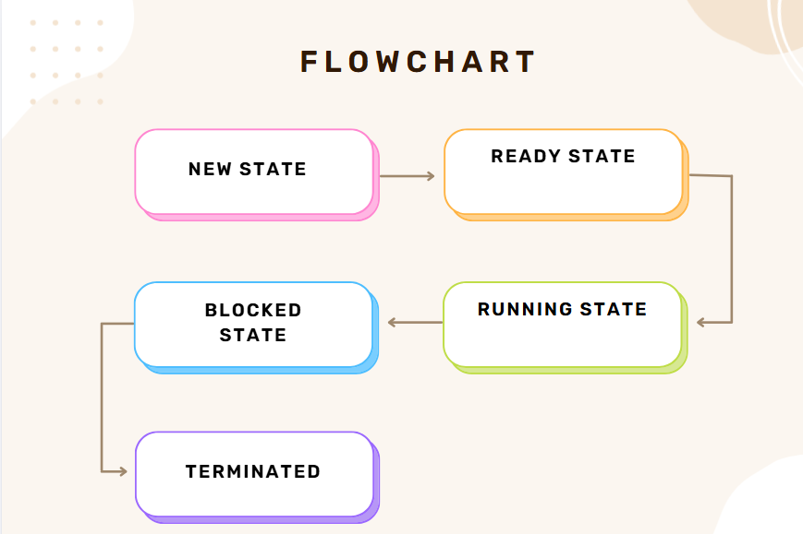

Multithreading Model Diagram
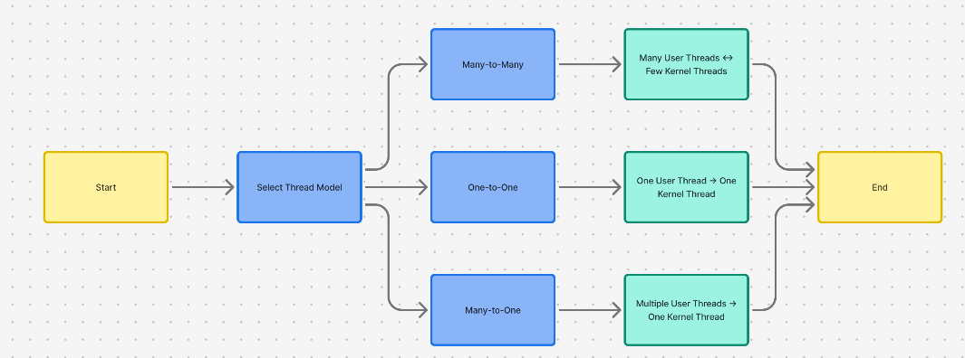

Program Flow Diagram
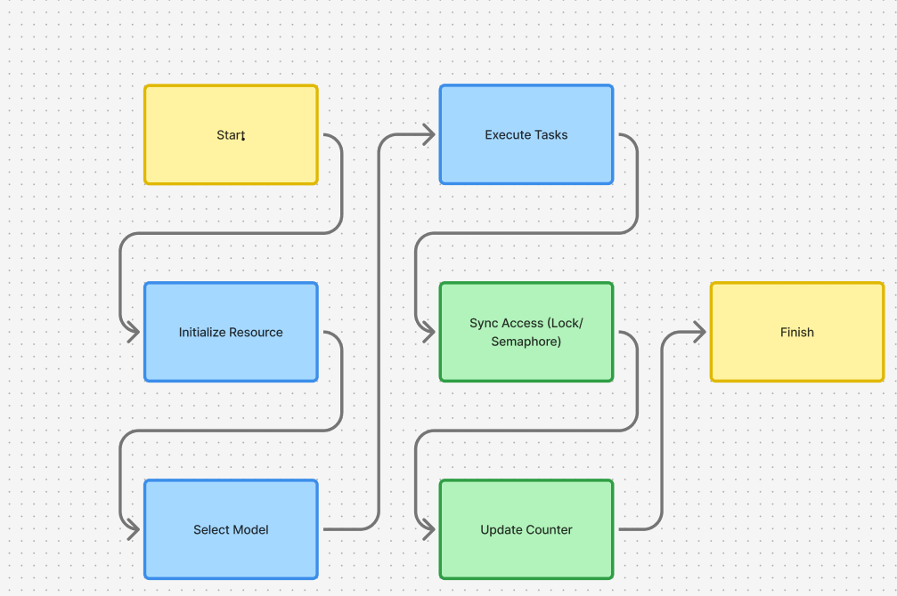

6. Revision Tracking on GitHub
Repository Name: Multithreaded-Simulator
GitHub Link: https://github.com/joshua338/Multithreaded-Simulator
Repository Name: OS_CA2
GitHub Link: https://github.com/Palak-hub-ai/OS_CA2

7. Conclusion and Future Scope
The Real-Time Multi-Threaded Application Simulator successfully demonstrates how multithreading works in an operating system environment by modeling three thread-mapping architectures: Many-to-One, One-to-One, and Many-to-Many. The project accurately simulates thread behavior, state transitions, and synchronization mechanisms using monitors (Locks) and semaphores, providing a practical understanding of how concurrency is managed at the system level.
Through real-time console output, the simulator clearly visualizes key concepts such as thread creation, state changes (NEW → READY → RUNNING → BLOCKED → TERMINATED), controlled access to shared resources, and the difference between sequential execution, parallel execution, and thread pooling. The final counter values verify that synchronization is correctly implemented, preventing race conditions even when multiple threads attempt to access the same resource.
Overall, the simulator meets all project objectives by offering a simple yet powerful environment to observe the internal workings of multithreading models and synchronization primitives. It serves as an effective educational tool for understanding OS-level thread management and concurrent programming basics.
1. Add a Graphical User Interface (GUI)
A GUI (using Tkinter, PyQt, or Kivy) can be added to visualize:
- Thread states in real time using colored nodes
- Shared resource access animations
- Thread queues and blocked queues
- Execution timelines
This would make the simulator more interactive and visually appealing.

2. Add More Synchronization Mechanisms
Currently, only Lock and Semaphore are implemented.
Future additions may include:
- Mutex
- Condition Variables
- Reader–Writer Locks
- Barriers
This can expand the simulation to cover more OS-level concurrency tools.

3. Deadlock Detection & Simulation
Enhancements could include:
- Simulating deadlock with multiple shared resources
- Visualizing circular wait conditions
- Implementing deadlock prevention or detection algorithms
This would help users understand complex real-world issues.

4. Add CPU Scheduling Algorithms
You can extend the simulator to demonstrate:
- First-Come First-Serve (FCFS)
- Shortest Job First (SJF)
- Round Robin (RR)
- Priority scheduling
Including timeline/Gantt charts would make this highly educational.

5. Real-Time Performance Metrics
Add features like:
- Execution time measurement
- Thread wait time
- Throughput comparison between models
- CPU utilization simulation
This helps students analyze performance differences more deeply.

6. User Input for Dynamic Simulation
Allow the user to specify:
- Number of threads
- Synchronization method
- Delay values
- Number of worker tasks
- Thread mapping model
This makes the simulator fully customizable.

7. Export Logs or Visualization
The program could store:
- Thread transition logs
- Counter update logs
- Synchronization events
These logs can be exported as:
- Text
- JSON
- CSV
for documentation or debugging.

8. Integration With a Web Interface
Using Flask/Streamlit, the simulator can be made accessible through a browser with:
- Dashboard visualizations
- Live updates
- Interaction controls
This modernizes the project for practical demonstrations.

8. Appendix A: AI-Generated Breakdown
A.1 Project Overview
The initial AI-generated overview described the goal of creating a simulator that demonstrates how operating systems manage multithreading using different threading models and synchronization primitives. The simulator aims to show:
- How threads transition through states such as NEW, READY, RUNNING, BLOCKED, and TERMINATED.
- How synchronization mechanisms like monitors (locks) and semaphores control access to shared resources.
- How thread-mapping models (Many-to-One, One-to-One, Many-to-Many) affect execution behavior.
This conceptual foundation guided the development of the final Python-based console simulator.

A.2 Module Breakdown
The AI divided the project into three conceptual modules:
Module 1 — Simulation Control & Thread Model Execution
Handles the execution of threading models, manages thread creation, state transitions, and mapping between user threads and kernel threads.
Module 2 — Synchronization Management
Defines how threads safely access a shared resource using Lock (monitor) and Semaphore mechanisms, demonstrating mutual exclusion and blocking behavior.
Module 3 — Console-Based Visualization
Responsible for displaying state transitions, synchronization events, and execution flow in real time through console output.
These modules served as structural design guidelines, even though the final implementation remains console-based without a GUI.

A.3 Functionalities
The AI-provided functionality list included:
- Thread State Visualization
Displaying transitions between all major states based on thread activity.
- Synchronization Demonstration
Implementing lock-based and semaphore-based access control.
- Thread Model Simulation
Running Many-to-One, One-to-One, and Many-to-Many thread mapping structures.
These functionalities align with the final Python code and represent the core educational elements of the simulator.

A.4 Recommended Technologies
Although multiple technologies were suggested, the final implementation used:
- Python 3.x — main programming language
- threading module — for threads, locks
- concurrent.futures — for thread pool model
- time module — for delay simulation
- enum — for clean thread state representation
The AI suggestions helped select simple, effective tools for building the simulator.

A.5 Execution Plan
The AI-generated execution steps included:
- Define thread state structure
- Implement shared resource and synchronization mechanisms
- Create simulated tasks and lifecycle transitions
- Develop Many-to-One, One-to-One, and Many-to-Many behaviors
- Print clear execution logs for visualization
- Run all models sequentially
This plan was followed closely in building the final working Python program.

9. Appendix B: Problem Statement
Develop a simulator to demonstrate multithreading models (e.g., Many-to-One, One-to-Many, Many-to-Many) and thread synchronization using semaphores and monitors. The simulator should visualize thread states and interactions, providing insights into thread management and CPU scheduling in multithreaded environments.

10. Appendix C: Complete Source Code
The full Python implementation of the Real-Time Multi-threaded Application Simulator is included here.
# ======================================================================
# REAL-TIME MULTI-THREADED APPLICATION SIMULATOR
# ======================================================================
# This program demonstrates:
# ✔ Thread lifecycle states (NEW → READY → RUNNING → BLOCKED → TERMINATED)
# ✔ Synchronization using Monitor (Lock) and Semaphore
# ✔ Three threading models:
# 1. Many-to-One
# 2. One-to-One
# 3. Many-to-Many
#
# The goal is to visualize real-time thread execution, resource sharing,
# and the impact of different threading models on performance.
# ======================================================================

import threading
import time
from concurrent.futures import ThreadPoolExecutor
from enum import Enum

# ======================================================================
# SECTION 1: THREAD STATE ENUMERATION
# ======================================================================
# This Enum represents the lifecycle states of a thread.
# Each simulated task transitions through these.
# NEW → READY → RUNNING → BLOCKED (if waiting) → TERMINATED
# ======================================================================
class ThreadState(Enum):
NEW = "NEW"
READY = "READY"
RUNNING = "RUNNING"
BLOCKED = "BLOCKED"
TERMINATED = "TERMINATED"

# ======================================================================
# SECTION 2: SHARED RESOURCE WITH SYNCHRONIZATION MECHANISMS
# ======================================================================
# This class represents a critical shared resource accessed by threads.
# Includes:
# ✔ Lock (Monitor)
# ✔ Semaphore
#
# Both synchronization techniques control access to the shared counter.
# ======================================================================
class SharedResource:
def __init__(self):
self.counter = 0
self.lock = threading.Lock() # Monitor
self.semaphore = threading.Semaphore(1) # Semaphore with 1 permit

# ------------------- Monitor-Locking Method ------------------------
# Demonstrates mutual exclusion using a MONITOR (Lock).
def work_with_monitor(self, name):
print(f"{name} waiting for MONITOR | State: BLOCKED")
with self.lock:
print(f"{name} entered MONITOR | State: RUNNING")
local = self.counter
time.sleep(0.1) # Simulated workload
local += 1
self.counter = local
print(f"{name} exiting MONITOR | counter = {self.counter}")

# ------------------- Semaphore Synchronization ---------------------
# Demonstrates controlled access using a SEMAPHORE.
def work_with_semaphore(self, name):
print(f"{name} waiting for SEMAPHORE | State: BLOCKED")
self.semaphore.acquire()
try:
print(f"{name} acquired SEMAPHORE | State: RUNNING")
local = self.counter
time.sleep(0.1)
local += 1
self.counter = local
print(f"{name} releasing SEMAPHORE | counter = {self.counter}")
finally:
self.semaphore.release()

# ======================================================================
# SECTION 3: SIMULATED USER THREAD / TASK
# ======================================================================
# This class models a user-level thread.
# Each task transitions through thread states and performs work using
# either monitor-based or semaphore-based synchronization.
# ======================================================================
class SimulatedTask:
def __init__(self, name, resource, use_semaphore):
self.name = name
self.resource = resource
self.use_semaphore = use_semaphore
self.state = ThreadState.NEW

# ------------------- Thread Execution Logic ------------------------
def run(self):
self.state = ThreadState.READY
print(f"{self.name} is READY")

self.state = ThreadState.RUNNING
print(f"{self.name} is RUNNING")

# Choose sync mechanism
if self.use_semaphore:
self.resource.work_with_semaphore(self.name)
else:
self.resource.work_with_monitor(self.name)

self.state = ThreadState.TERMINATED
print(f"{self.name} is TERMINATED\n")

# ======================================================================
# SECTION 4: MANY-TO-ONE THREADING MODEL
# ======================================================================
# Description:
# • Multiple user-level threads
# • ONE kernel-level thread executes them sequentially
# • No true parallelism
# ======================================================================
def demo_many_to_one():
print("\n===== Many-to-One Model =====")
resource = SharedResource()

tasks = [
SimulatedTask("UserThread-1", resource, False),
SimulatedTask("UserThread-2", resource, False),
SimulatedTask("UserThread-3", resource, False),
]

# One OS thread executing all tasks
def run_all():
for task in tasks:
task.run()

kernel_thread = threading.Thread(target=run_all, name="KernelThread-1")
kernel_thread.start()
kernel_thread.join()

print("Final Counter (Many-to-One):", resource.counter)

# ======================================================================
# SECTION 5: ONE-TO-ONE THREADING MODEL
# ======================================================================
# Description:
# • Each user-level thread maps to ONE kernel thread
# • True parallelism possible depending on CPU cores
# ======================================================================
def demo_one_to_one():
print("\n===== One-to-One Model =====")
resource = SharedResource()

threads = []
for i in range(1, 4):
task = SimulatedTask(f"UserThread-{i}", resource, True)
t = threading.Thread(target=task.run)
threads.append(t)
t.start()

for t in threads:
t.join()

print("Final Counter (One-to-One):", resource.counter)

# ======================================================================
# SECTION 6: MANY-TO-MANY THREADING MODEL
# ======================================================================
# Description:
# • Multiple user-level threads
# • Mapped onto a limited pool of kernel threads (Thread Pool)
# • Balanced: avoids overhead but still supports concurrency
# ======================================================================
def demo_many_to_many():
print("\n===== Many-to-Many Model =====")
resource = SharedResource()

with ThreadPoolExecutor(max_workers=2) as executor:
for i in range(1, 6):
task = SimulatedTask(f"UserThread-{i}", resource, True)
executor.submit(task.run)

print("Final Counter (Many-to-Many):", resource.counter)

# ======================================================================
# SECTION 7: MAIN EXECUTION FUNCTION
# ======================================================================
# Runs all three threading model demonstrations sequentially.
# ======================================================================
if __name__ == "__main__":
print("Real-Time Multi-threaded Application Simulator (Python)\n")

demo_many_to_one()
demo_one_to_one()
demo_many_to_many()

print("\nSimulation Completed.")

Sample output:
Real-Time Multi-threaded Application Simulator (Python)

===== Many-to-One Model =====
UserThread-1 is READY
UserThread-1 is RUNNING
UserThread-1 waiting for MONITOR | State: BLOCKED
UserThread-1 entered MONITOR | State: RUNNING
UserThread-1 exiting MONITOR | counter = 1
UserThread-1 is TERMINATED

UserThread-2 is READY
UserThread-2 is RUNNING
UserThread-2 waiting for MONITOR | State: BLOCKED
UserThread-2 entered MONITOR | State: RUNNING
UserThread-2 exiting MONITOR | counter = 2
UserThread-2 is TERMINATED

UserThread-3 is READY
UserThread-3 is RUNNING
UserThread-3 waiting for MONITOR | State: BLOCKED
UserThread-3 entered MONITOR | State: RUNNING
UserThread-3 exiting MONITOR | counter = 3
UserThread-3 is TERMINATED

Final Counter (Many-to-One): 3

===== One-to-One Model =====
UserThread-1 is READY
UserThread-1 is RUNNING
UserThread-1 waiting for SEMAPHORE | State: BLOCKED

UserThread-2 is READY
UserThread-2 is RUNNING
UserThread-2 waiting for SEMAPHORE | State: BLOCKED

UserThread-3 is READY
UserThread-3 is RUNNING
UserThread-3 waiting for SEMAPHORE | State: BLOCKED

UserThread-1 acquired SEMAPHORE | State: RUNNING
UserThread-1 releasing SEMAPHORE | counter = 1
UserThread-1 is TERMINATED

UserThread-2 acquired SEMAPHORE | State: RUNNING
UserThread-2 releasing SEMAPHORE | counter = 2
UserThread-2 is TERMINATED

UserThread-3 acquired SEMAPHORE | State: RUNNING
UserThread-3 releasing SEMAPHORE | counter = 3
UserThread-3 is TERMINATED

Final Counter (One-to-One): 3

===== Many-to-Many Model =====
UserThread-1 is READY
UserThread-1 is RUNNING
UserThread-1 waiting for SEMAPHORE | State: BLOCKED

UserThread-2 is READY
UserThread-2 is RUNNING
UserThread-2 waiting for SEMAPHORE | State: BLOCKED

UserThread-1 acquired SEMAPHORE | State: RUNNING
UserThread-1 releasing SEMAPHORE | counter = 1
UserThread-1 is TERMINATED

UserThread-3 is READY
UserThread-3 is RUNNING
UserThread-3 waiting for SEMAPHORE | State: BLOCKED

UserThread-2 acquired SEMAPHORE | State: RUNNING
UserThread-2 releasing SEMAPHORE | counter = 2
UserThread-2 is TERMINATED

UserThread-4 is READY
UserThread-4 is RUNNING
UserThread-4 waiting for SEMAPHORE | State: BLOCKED

UserThread-3 acquired SEMAPHORE | State: RUNNING
UserThread-3 releasing SEMAPHORE | counter = 3
UserThread-3 is TERMINATED

UserThread-5 is READY
UserThread-5 is RUNNING
UserThread-5 waiting for SEMAPHORE | State: BLOCKED

UserThread-4 acquired SEMAPHORE | State: RUNNING
UserThread-4 releasing SEMAPHORE | counter = 4
UserThread-4 is TERMINATED

UserThread-5 acquired SEMAPHORE | State: RUNNING
UserThread-5 releasing SEMAPHORE | counter = 5
UserThread-5 is TERMINATED

Final Counter (Many-to-Many): 5

Simulation Completed.

