Microservices Hands on
Creating Microservices for Account and Loan
Objective
The objective of this exercise is to create two independent Spring Boot RESTful microservices:
- Account Microservice
- Loan Microservice
Each microservice is an independent Maven project with its own pom.xml, source code, and configuration.

What is a Microservice?
A microservice is a small, independent application that performs a single business function.
Advantages:
- Independent deployment
- Easy maintenance
- Better scalability
- Separate development and testing
- Failure of one service does not stop other services

Account Microservice
Purpose
Returns account details for a given account number.

Loan Microservice
Purpose
Returns loan details for a given loan number.

Project structure
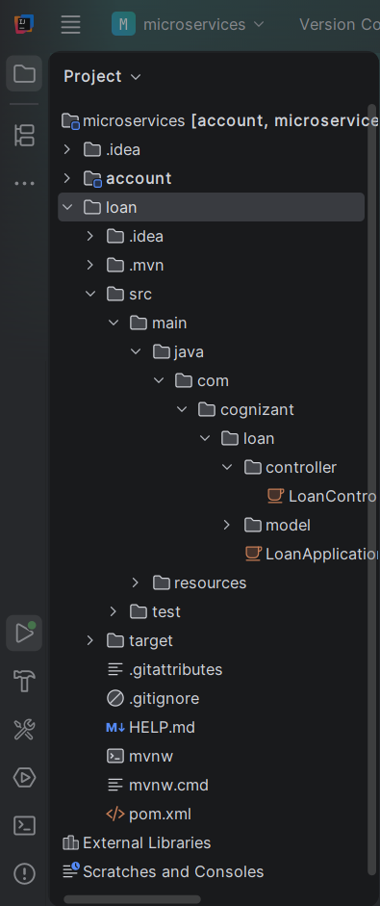
Account.java

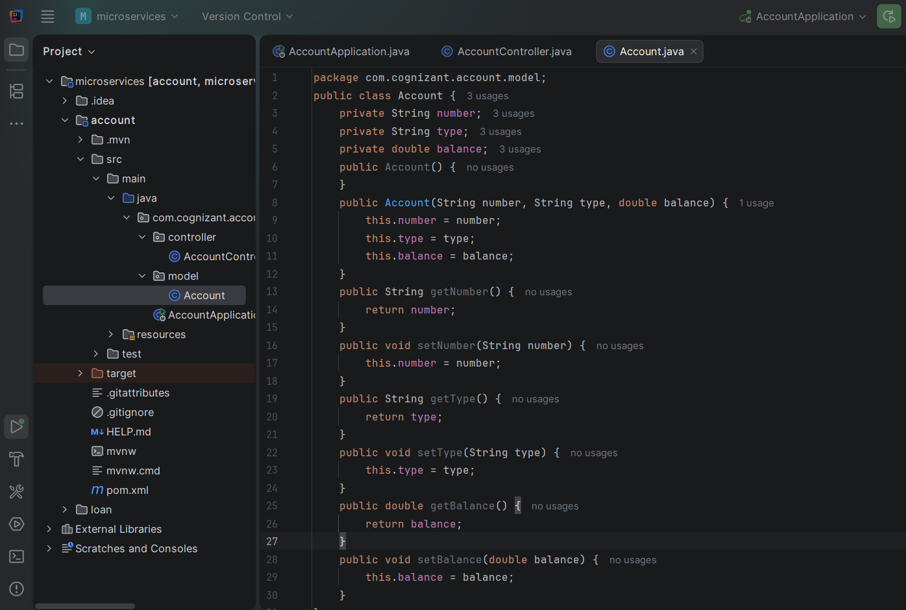
AccountController.java
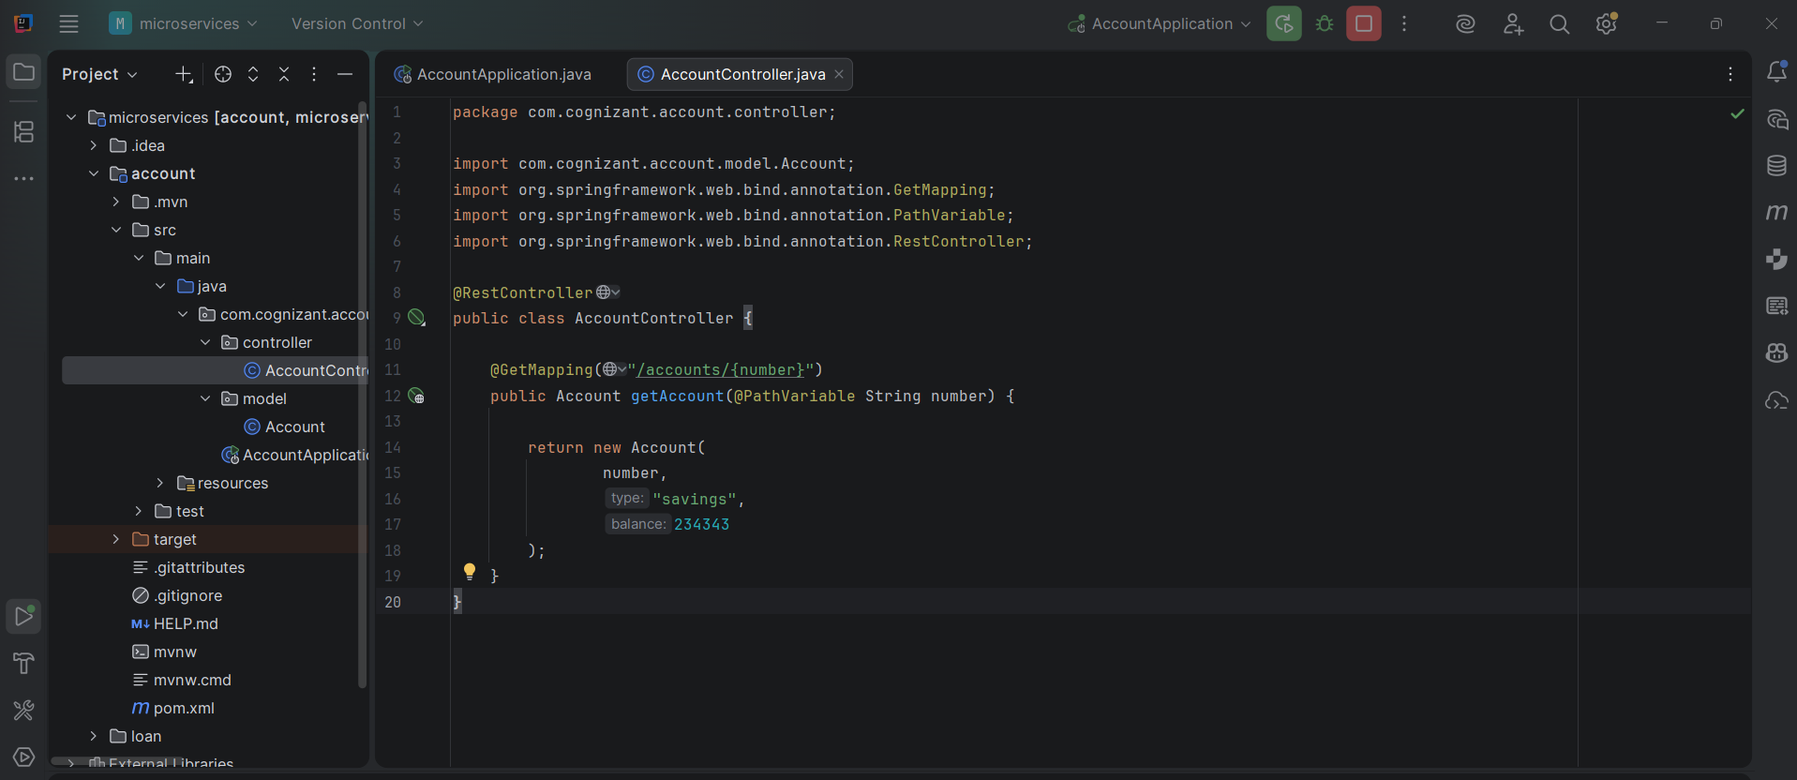
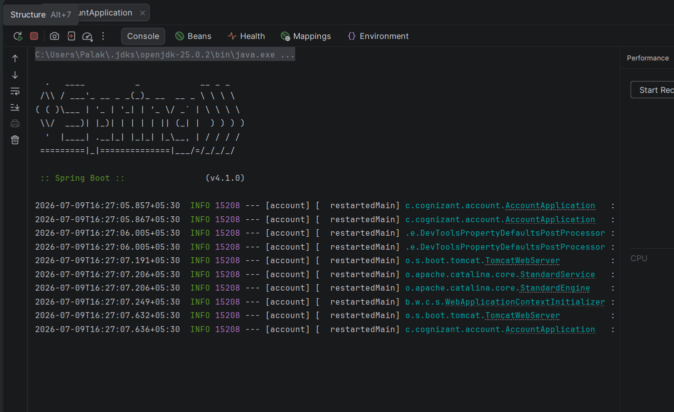
Loan.java
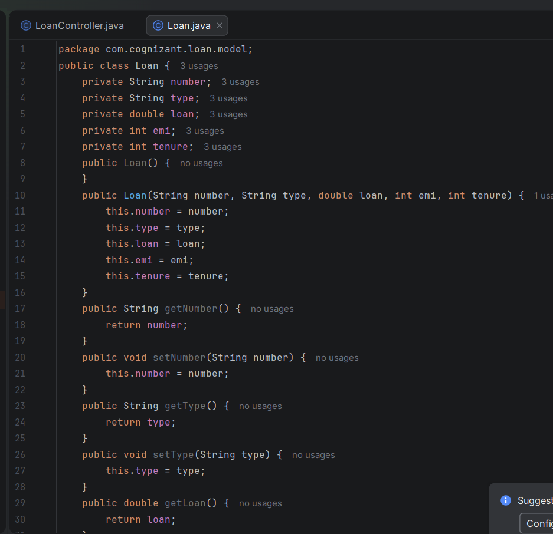
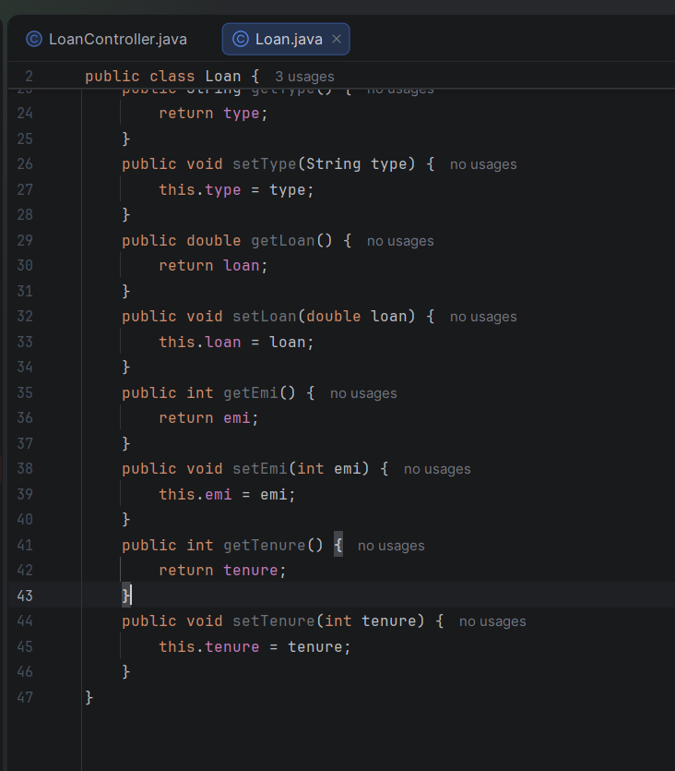

LoanController.java
