Spring Core and Maven
Exercise 1: Configuring a Basic Spring Application
Scenario:
Your company is developing a web application for managing a library. You need to use the Spring Framework to handle the backend operations.
Steps:
- Set Up a Spring Project:
  - Create a Maven project named LibraryManagement.
  - Add Spring Core dependencies in the pom.xml file.
- Configure the Application Context:
  - Create an XML configuration file named applicationContext.xml in the src/main/resources directory.
  - Define beans for BookService and BookRepository in the XML file.
- Define Service and Repository Classes:
  - Create a package com.library.service and add a class BookService.
  - Create a package com.library.repository and add a class BookRepository.
- Run the Application:
  - Create a main class to load the Spring context and test the configuration.

pom.xml
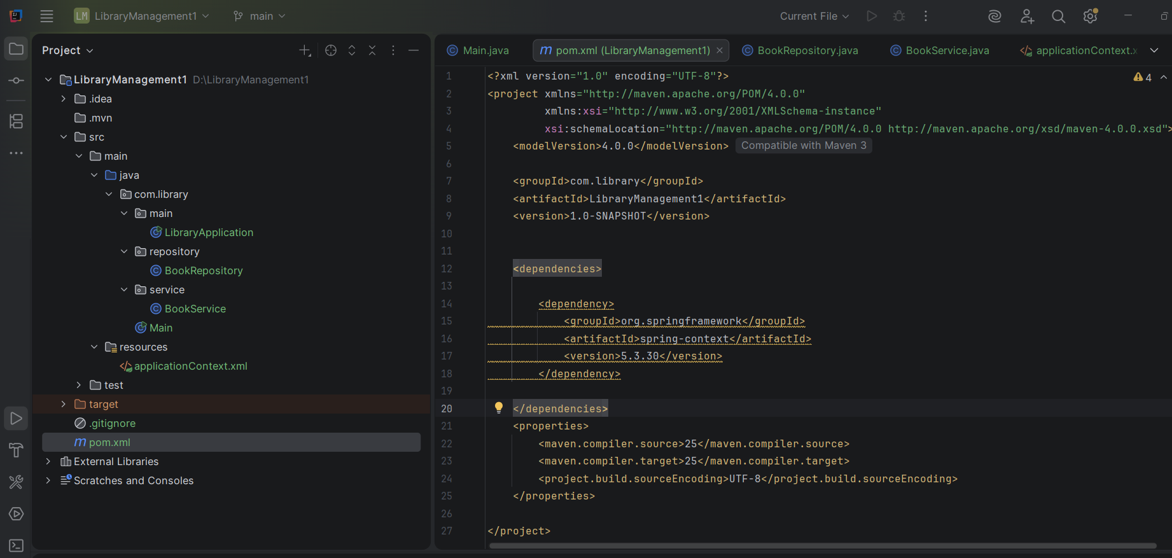

LibraryApplication.java
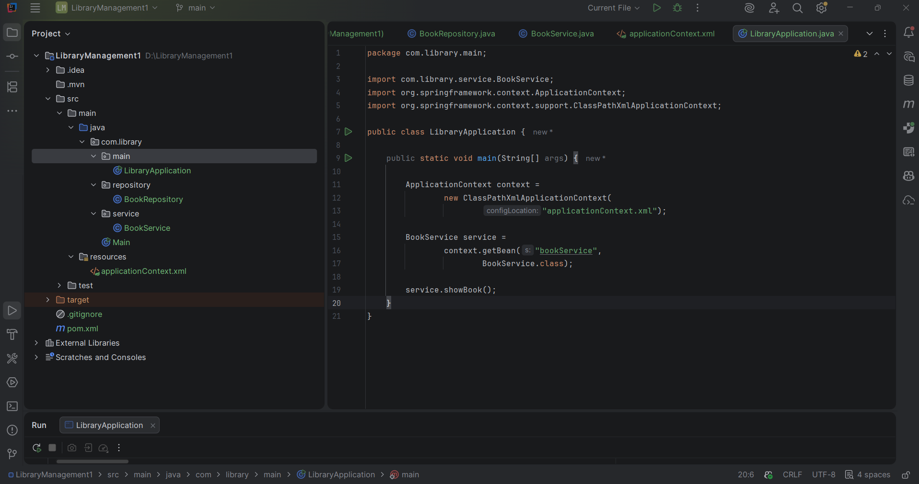
applicationContext.xml
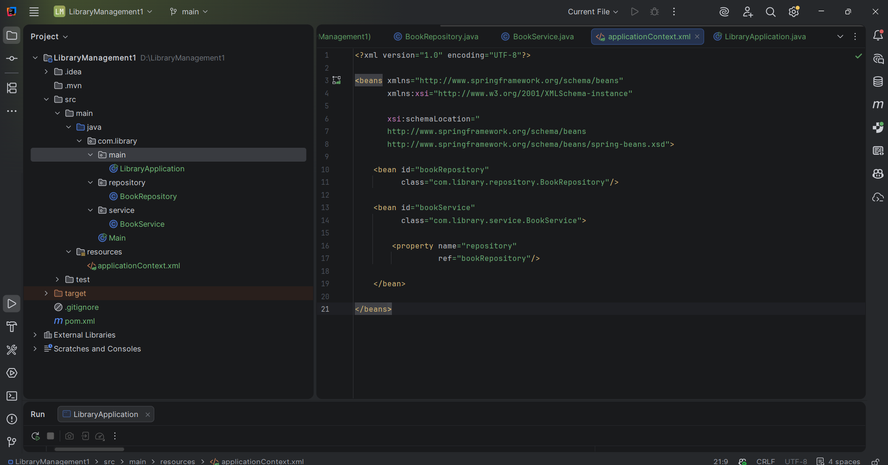

BookRepository.java
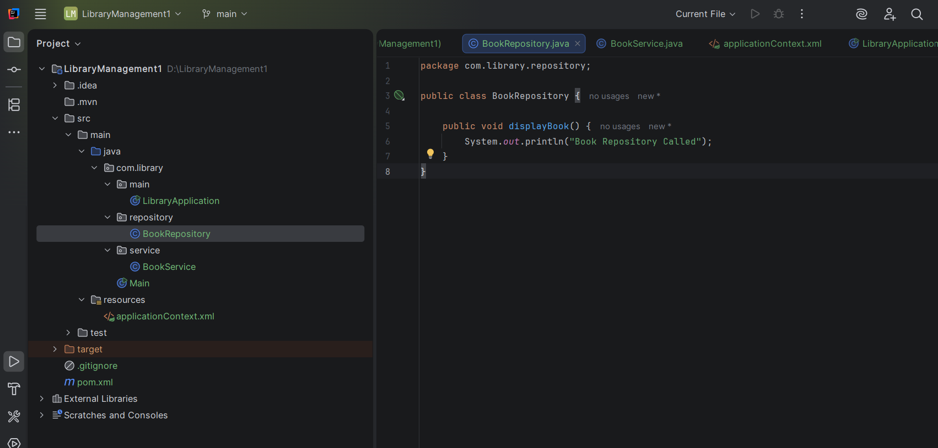
BookService.java
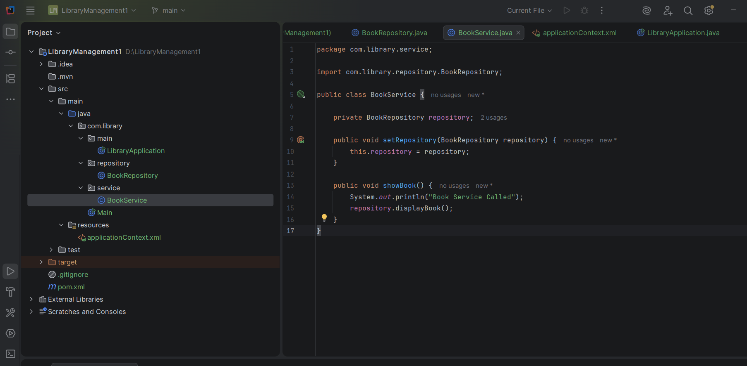
Output:
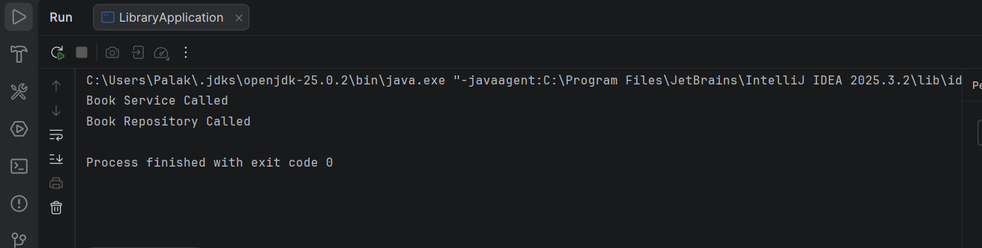

I created a simple Library Management application using Spring Core. The application contains a BookService class and a BookRepository class. Instead of creating objects manually using the new keyword, I configured both classes as beans in applicationContext.xml. Spring's ApplicationContext container loads the XML file, creates the bean objects, and injects the BookRepository dependency into BookService using setter injection. Finally, I retrieved the BookService bean using getBean() and called its method.

First, the main class creates an ApplicationContext object. The container loads applicationContext.xml, creates the beans defined in it, injects dependencies, and stores them in the IoC container. When I call getBean(), Spring returns the already created object.
Exercise 2: Implementing Dependency Injection
Scenario:
In the library management application, you need to manage the dependencies between the BookService and BookRepository classes using Spring's IoC and DI.
Steps:
- Modify the XML Configuration:
  - Update applicationContext.xml to wire BookRepository into BookService.
- Update the BookService Class:
  - Ensure that BookService class has a setter method for BookRepository.
- Test the Configuration:
  - Run the LibraryManagementApplication main class to verify the dependency injection.

In this exercise, the same BookService and BookRepository classes created in Exercise 1 are used. The main objective is to establish a dependency between these classes using Spring's Dependency Injection mechanism.
BookService depends on BookRepository to perform repository-related operations. Instead of creating the BookRepository object manually using the new keyword, Spring creates and manages the object through its IoC Container.
The dependency is configured in the applicationContext.xml file using the <property> tag:
<property name="repository" ref="bookRepository"/>
Here, Spring injects the bookRepository bean into the BookService bean through the setter method setRepository().
This approach provides:
- Loose Coupling
- Better Maintainability
- Easier Testing
- Centralized Object Management
When the application starts, the ApplicationContext loads the XML configuration, creates both beans, injects the dependency, and makes the BookService object ready for use.
Thus, Dependency Injection is successfully implemented using Setter Injection in Spring Framework.
So the code is same as above exercise

Exercise 4: Creating and Configuring a Maven Project
Scenario:
You need to set up a new Maven project for the library management application and add Spring dependencies.
Steps:
- Create a New Maven Project:
  - Create a new Maven project named LibraryManagement.
- Add Spring Dependencies in pom.xml:
  - Include dependencies for Spring Context, Spring AOP, and Spring WebMVC.
- Configure Maven Plugins:
  - Configure the Maven Compiler Plugin for Java version 1.8 in the pom.xml file.

