Aim:
To understand the need for styling React components using CSS Modules and inline styles, and to apply styles to React components using the className and style properties.

Theory:
React provides multiple ways to style components. In this lab, CSS Modules were used to define reusable styles that are scoped to a specific component, preventing style conflicts with other components. A CSS class named box was created to style the cohort details card by setting its width, margin, padding, border, and border radius. The <dt> elements were also styled using a CSS tag selector to make their text semi-bold.
The CSS Module was imported into the CohortDetails component and applied using the className={styles.box} property. Additionally, inline styling was used on the <h3> element to dynamically change the text color based on the cohort's status. If the currentStatus is "Ongoing", the heading is displayed in green; otherwise, it is displayed in blue. This demonstrates how React allows both static and dynamic styling to create visually appealing and responsive user interfaces.

CohertDetails.js
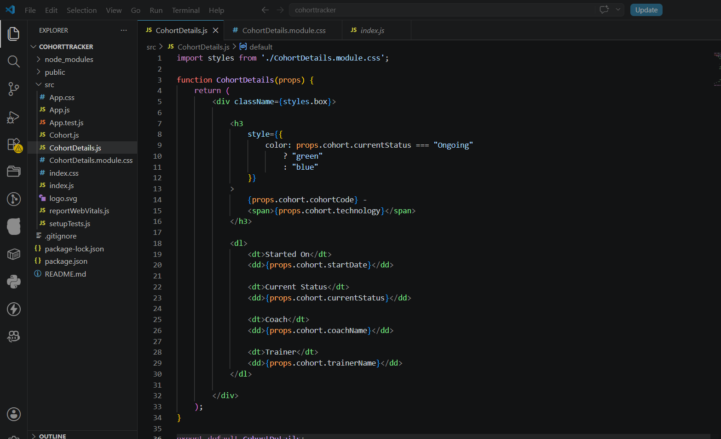
CohortDetails.module.css
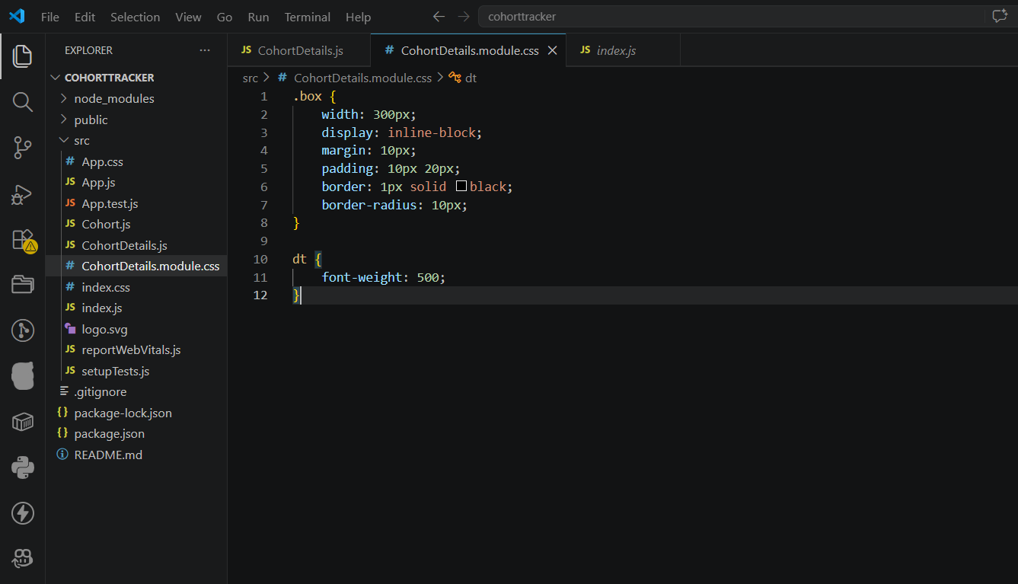

Output:
