Hands on 1
Create a Spring Web Project using Maven
Follow steps below to create a project:
- Go to https://start.spring.io/
- Change Group as “com.cognizant”
- Change Artifact Id as “spring-learn”
- Select Spring Boot DevTools and Spring Web
- Create and download the project as zip
- Extract the zip in root folder to Eclipse Workspace
- Build the project using ‘mvn clean package -Dhttp.proxyHost=proxy.cognizant.com -Dhttp.proxyPort=6050 -Dhttps.proxyHost=proxy.cognizant.com -Dhttps.proxyPort=6050 -Dhttp.proxyUser=123456’ command in command line
- Import the project in Eclipse "File > Import > Maven > Existing Maven Projects > Click Browse and select extracted folder > Finish"
- Include logs to verify if main() method of SpringLearnApplication.
- Run the SpringLearnApplication class.

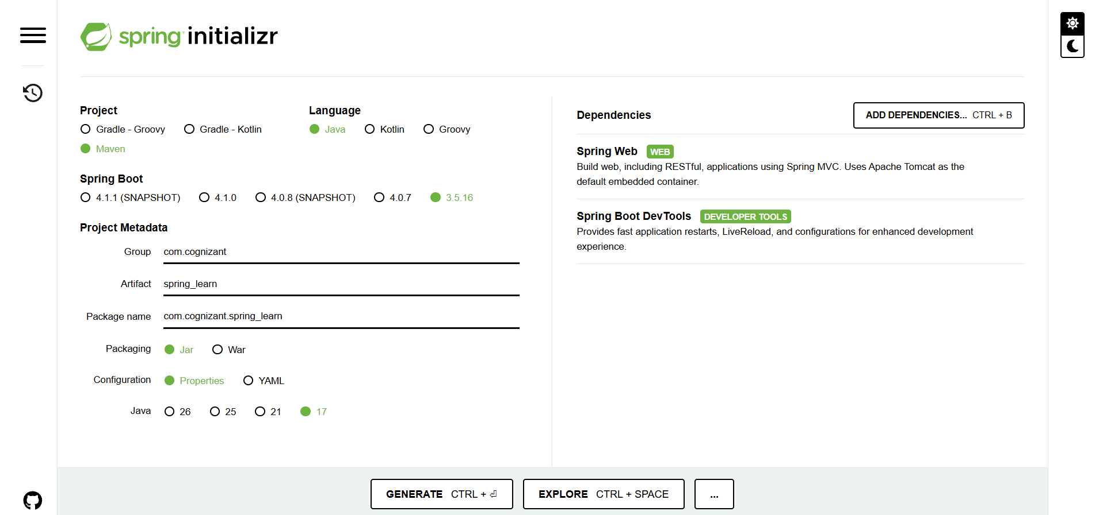
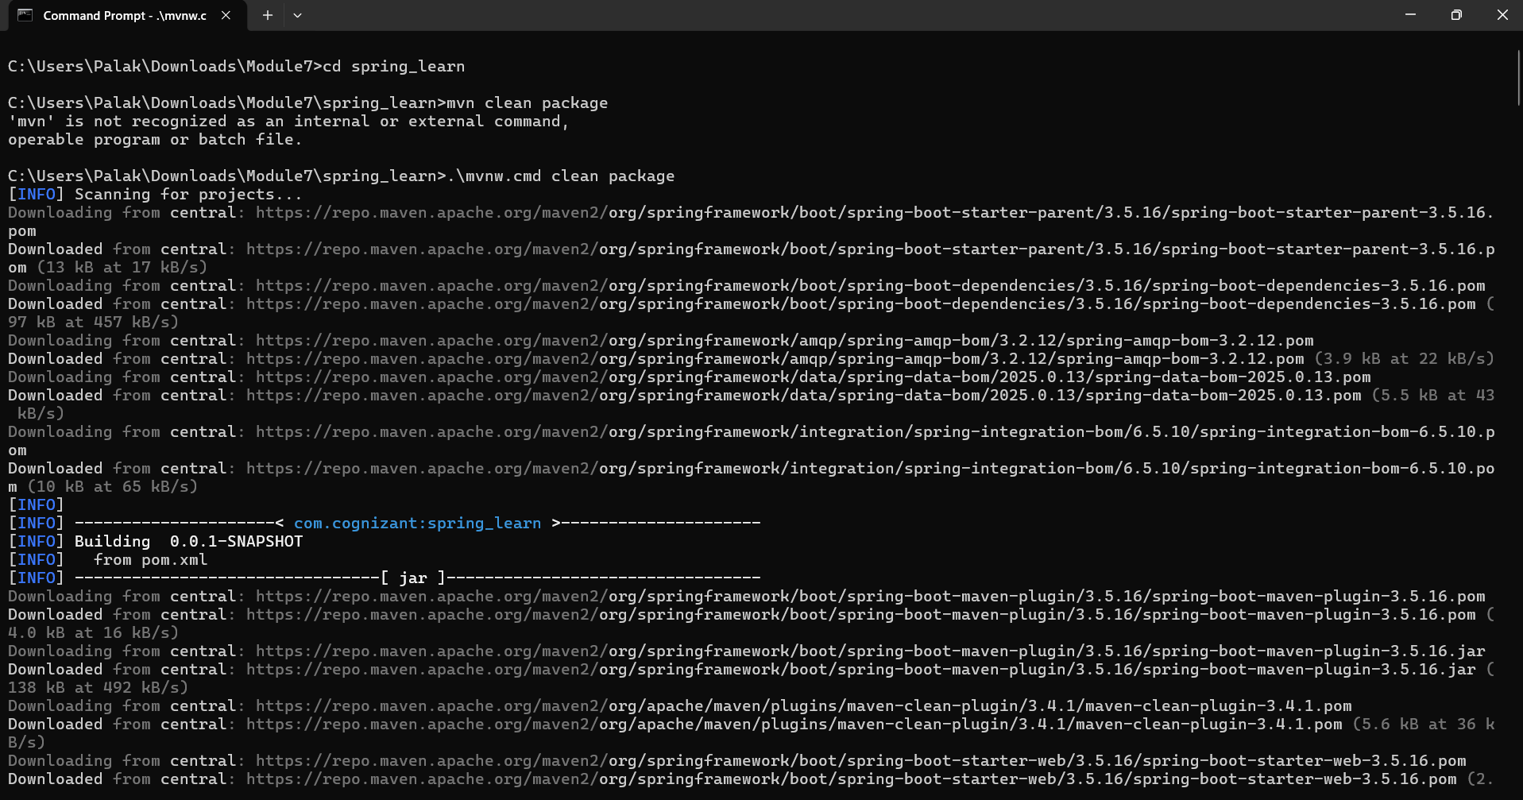
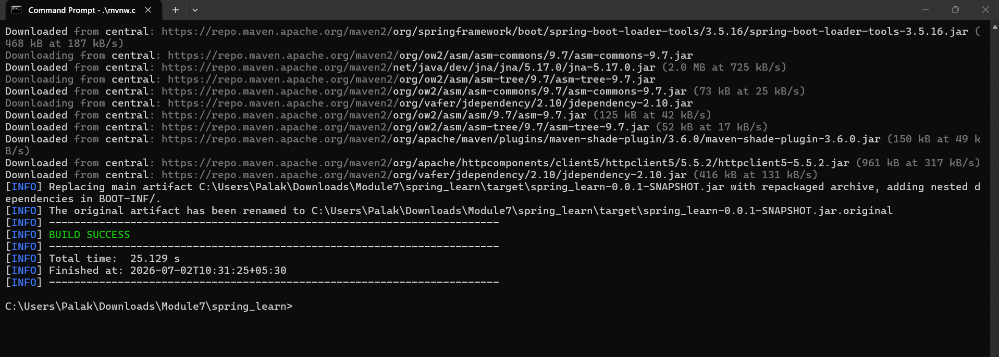
Project structure
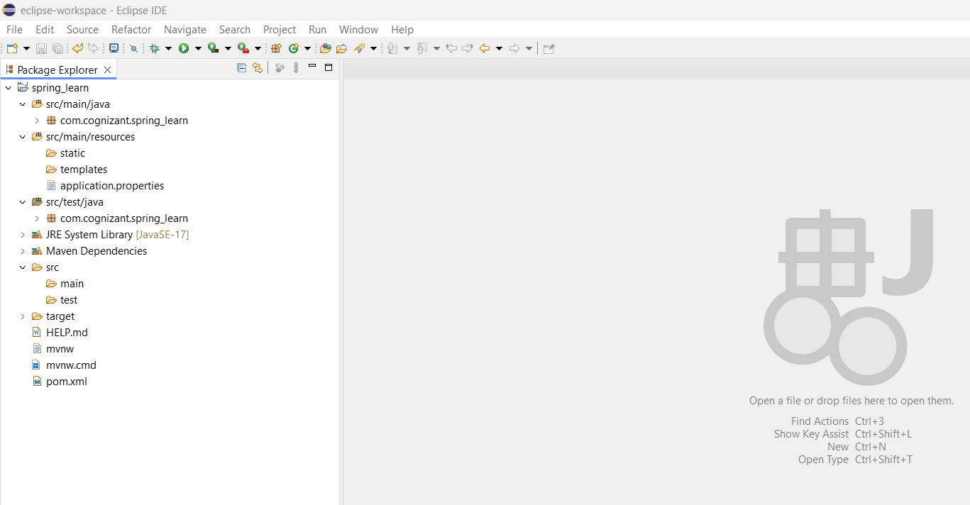
1. src/main/java
The src/main/java folder contains the complete Java source code of the application. It includes the main application class, controllers, services, repositories, entities, models, and configuration classes. This is the folder where the business logic of the application is developed. In this project, the SpringLearnApplication.java file is present in this folder, which serves as the entry point of the Spring Boot application.

2. src/main/resources
The src/main/resources folder contains all configuration files and application resources. The most important file in this folder is application.properties, which is used to configure application settings such as the server port, application name, database connection, logging configuration, and other Spring Boot properties. This folder can also contain static resources (CSS, JavaScript, images) and HTML templates.

3. src/test/java
The src/test/java folder contains the test classes used to test the application. These tests are generally written using JUnit and Mockito. This folder helps developers verify that the application's functionality works correctly before deployment.

SpringLearnApplication.java
SpringLearnApplication.java is the main class of the Spring Boot application. It contains the main() method, which acts as the entry point of the application.

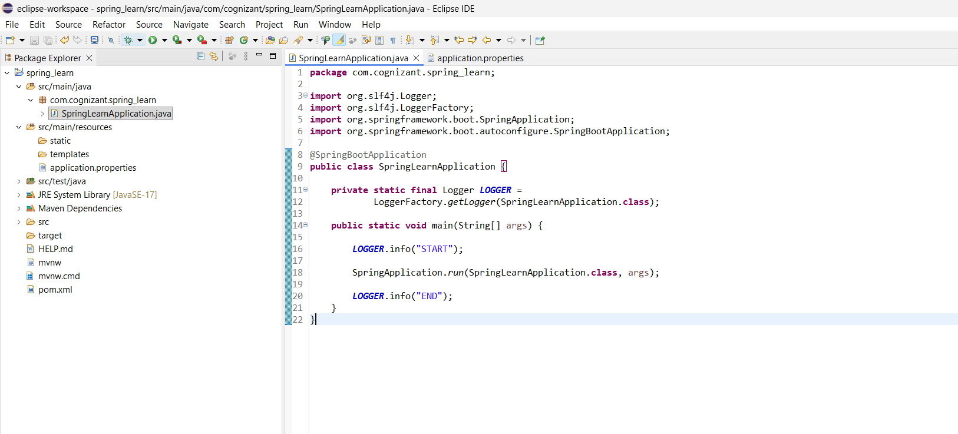
The LOGGER.info("START") statement prints a log message indicating that the application startup process has begun.
The SpringApplication.run() method starts the Spring Boot application. It creates the Spring IoC Container, performs component scanning, applies auto-configuration, initializes all Spring beans, and starts the embedded Tomcat web server.
After the application starts successfully, the LOGGER.info("END") statement prints another log message indicating that the application has been initialized successfully.
Purpose of @SpringBootApplication
@SpringBootApplication is the primary annotation used in every Spring Boot application. It combines three important annotations into one:
1. @Configuration
Marks the class as a configuration class. It allows Spring to register beans and manage application configuration.
2. @EnableAutoConfiguration
Automatically configures Spring Boot based on the dependencies available in the project. For example, since the project includes the Spring Web dependency, Spring Boot automatically configures the embedded Tomcat server, DispatcherServlet, and Spring MVC components.
3. @ComponentScan
Automatically scans the current package and its sub-packages for Spring components such as @Controller, @Service, @Repository, and @Component, and registers them as Spring Beans.
Thus, @SpringBootApplication simplifies application configuration by combining these three annotations.
Application Execution
When the application is executed, the following sequence occurs:
- The main() method is invoked.
- The START log message is printed.
- SpringApplication.run() creates the Spring IoC Container.
- Component scanning and auto-configuration are performed.
- The embedded Tomcat server starts on the configured port.
- The application is initialized successfully.
- The END log message is printed.
The successful execution is verified by the console output:

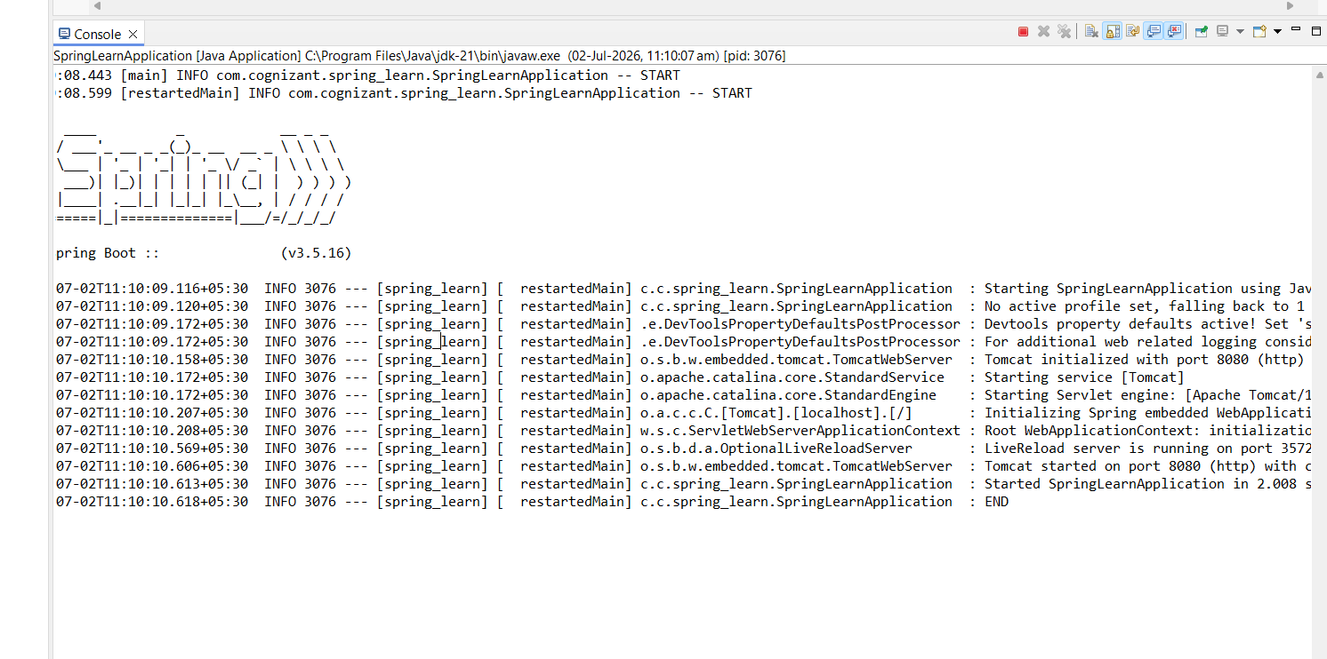pom.xml
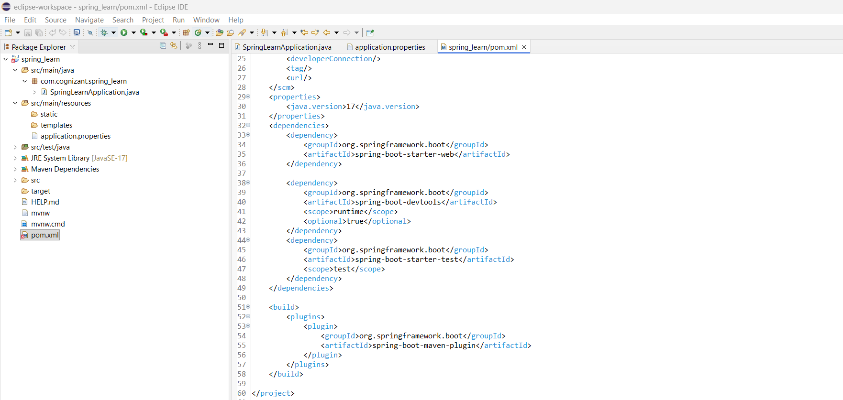

Hands on 4
Spring Core – Load Country from Spring Configuration XML
An airlines website is going to support booking on four countries. There will be a drop down on the home page of this website to select the respective country. It is also important to store the two-character ISO code of each country.
Code | Name
US | United States
DE | Germany
IN | India
JP | Japan
Above data has to be stored in spring configuration file. Write a program to read this configuration file and display the details.
Steps to implement
- Pick any one of your choice country to configure in Spring XML configuration named country.xml.
- Create a bean tag in spring configuration for country and set the property and values
<bean id="country" class="com.cognizant.springlearn.Country">
<property name="code" value="IN" />
<property name="name" value="India" />
</bean>
- Create Country class with following aspects:
  - Instance variables for code and name
  - Implement empty parameter constructor with inclusion of debug log within the constructor with log message as “Inside Country Constructor.”
  - Generate getters and setters with inclusion of debug with relevant message within each setter and getter method.
  - Generate toString() method
- Create a method displayCountry() in SpringLearnApplication.java, which will read the country bean from spring configuration file and display the country details. ClassPathXmlApplicationContext, ApplicationContext and context.getBean(“beanId”, Country.class). Refer sample code for displayCountry() method below.
ApplicationContext context = new ClassPathXmlApplicationContext("country.xml");
Country country = (Country) context.getBean("country", Country.class);
LOGGER.debug("Country : {}", country.toString());

- Invoke displayCountry() method in main() method of SpringLearnApplication.java.
- Execute main() method and check the logs to find out which constructors and methods were invoked.

pom.xml
The pom.xml file is the Maven Project Object Model file that manages the entire project. It contains the project information such as project name, version, Java version, dependencies, and build plugins. Maven reads this file to download all the required libraries automatically from the Maven Repository. In this hands-on, the project uses the Spring Boot Parent, which provides default configurations and manages compatible dependency versions. The spring-boot-starter-web dependency provides web-related features and an embedded Tomcat server, spring-context provides the Spring IoC Container and XML configuration support, spring-boot-devtools enables automatic restart during development, and spring-boot-starter-test provides testing libraries like JUnit and Mockito. The Spring Boot Maven Plugin is used to build and run the application as an executable JAR.

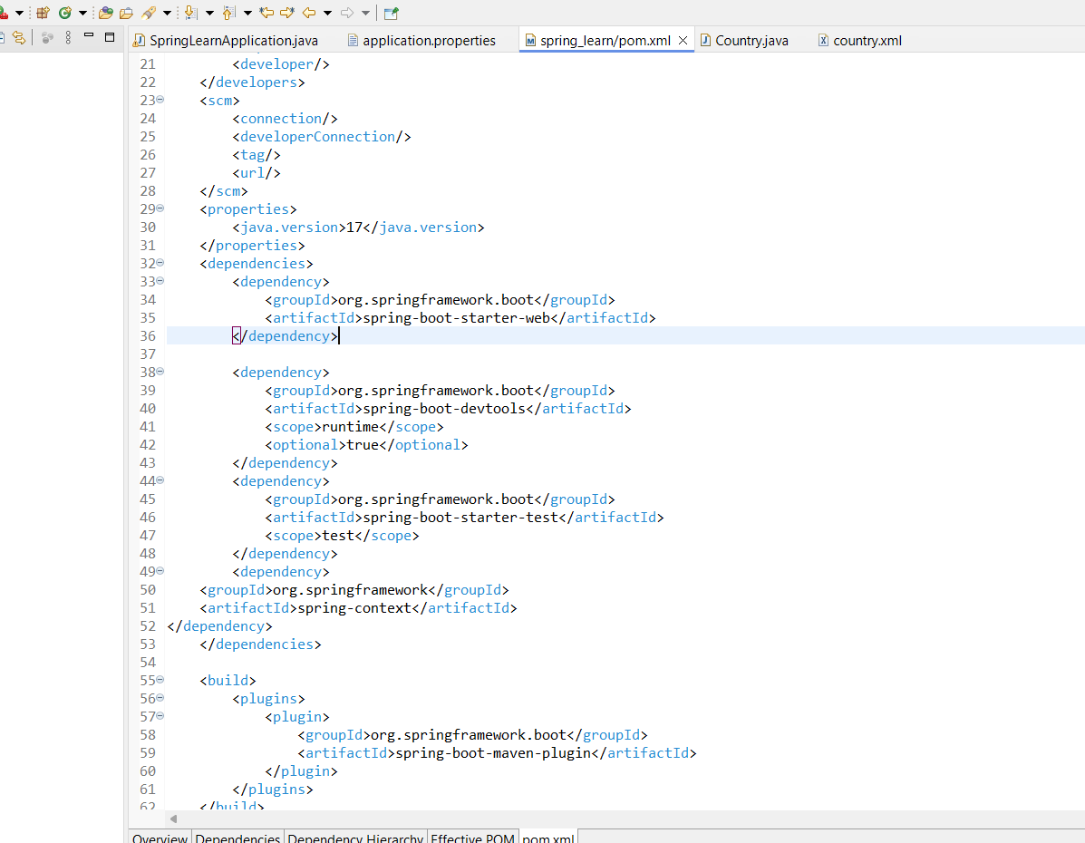
application.properties
The application.properties file is the main configuration file of a Spring Boot application. It stores application-level settings such as the application name, server port, logging level, database configuration, and many other properties. In this hands-on, the application name is configured using spring.application.name, which helps identify the application in the logs. The server port specifies the port on which the embedded Tomcat server runs. The logging level is configured as DEBUG so that debug messages from the Country class and the application are displayed in the console during execution. This file separates configuration from the application code, making the application easier to maintain.
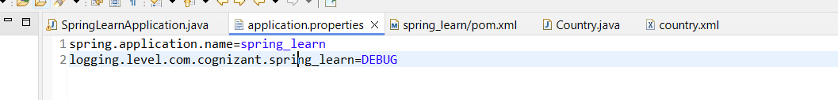

Country.java
The Country class is a simple Java Bean (POJO) that represents a country. It contains two instance variables, code and name, which store the ISO country code and the country name. The class includes a default constructor, getter methods, setter methods, and a toString() method. The constructor logs a debug message when the object is created by the Spring IoC Container. The setter methods also log debug messages whenever Spring injects values into the object. The toString() method returns the country details in a readable format. This class does not create its own object; instead, the Spring framework creates and manages the object using the configuration provided in country.xml.

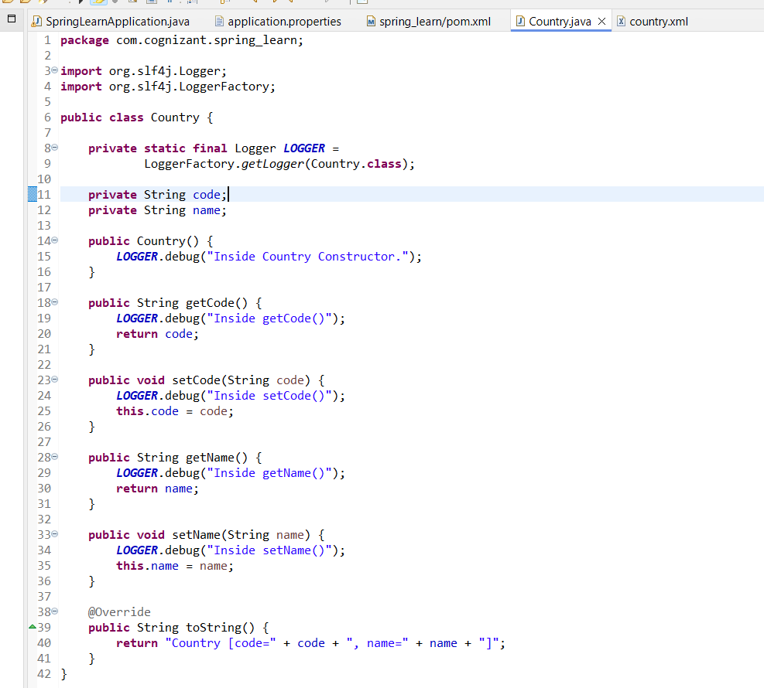
country.xml
The country.xml file is the Spring XML configuration file used to define and configure Spring Beans. It contains a bean definition for the Country class. The bean has a unique identifier (id) and specifies the fully qualified class name so that Spring knows which object to create. The property elements define the values that should be injected into the object's fields. During application startup, Spring reads this XML file, creates an object of the Country class, and injects the configured values into the object's properties using the setter methods. This approach demonstrates XML-based Dependency Injection, where object creation and configuration are handled by Spring instead of being hardcoded in Java.

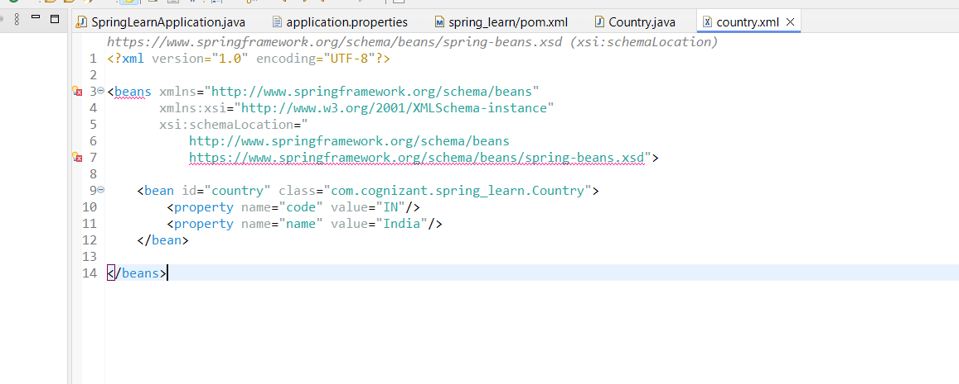
SpringLearnApplication.java is the main class of the Spring Boot application and acts as the entry point of the program. It is annotated with @SpringBootApplication, which enables auto-configuration, component scanning, and configuration support in Spring Boot. The main() method starts the Spring application and logs the start and end of the execution. Inside the displayCountry() method, an ApplicationContext object is created using ClassPathXmlApplicationContext, which loads the country.xml configuration file from the resources folder. The application then retrieves the Country bean using getBean(). When the bean is requested, Spring automatically creates the object, calls the constructor, injects the property values using the setter methods, and returns the fully initialized object. Finally, the application prints the country details using the logger.
