Aim
To understand and implement JSX in React by creating elements, rendering objects and lists, using JavaScript expressions, and applying inline CSS for dynamic styling.

Theory
JSX (JavaScript XML) is a syntax extension for JavaScript that allows developers to write HTML-like code within React components. JSX is converted into React.createElement() calls during compilation, making it easier to create and manage UI elements. In this lab, JSX was used to create headings, display an image, render office details from JavaScript objects, and iterate through a list of office objects using the map() method. Inline CSS was applied using the style attribute to dynamically change the rent color—red when the rent is below ₹60,000 and green otherwise. This demonstrates how JSX combines JavaScript logic with HTML-like syntax to build dynamic and interactive React user interfaces.

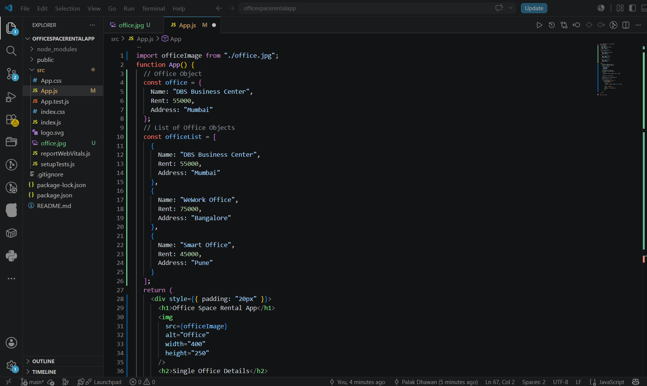
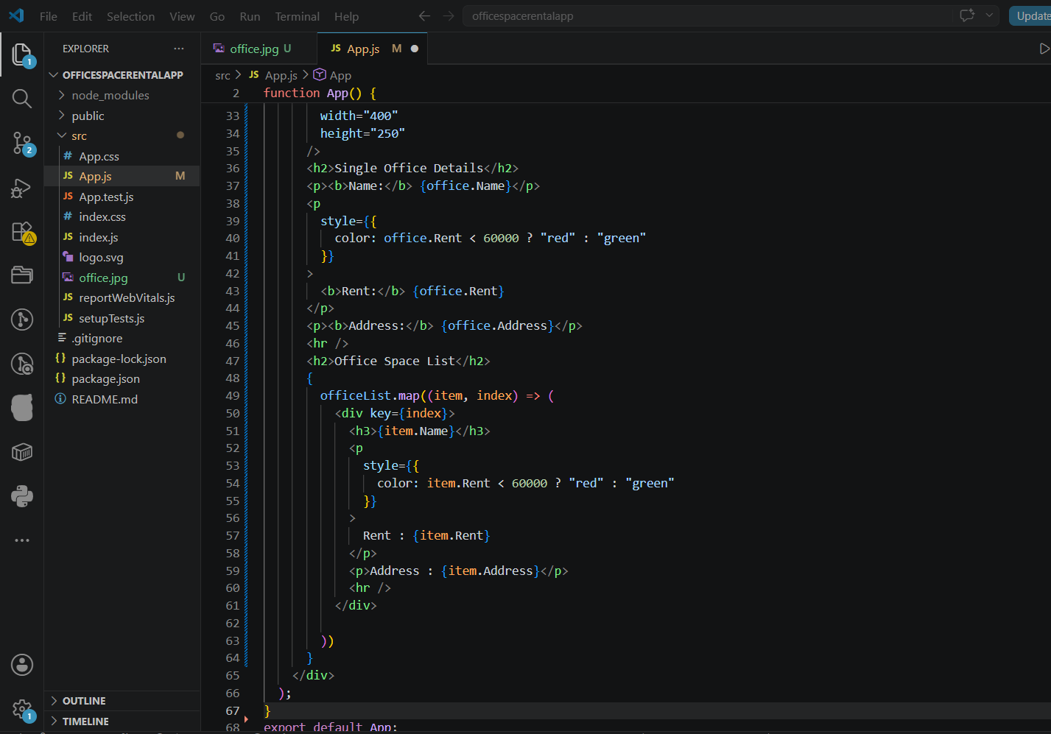
Output:
