Aim
To study and implement event handling in React by handling button click events, passing arguments to event handlers, invoking multiple methods, using Synthetic Events, and performing currency conversion using React state.

Theory
1. Event Handling in React
Event handling in React is the process of responding to user interactions such as button clicks, keyboard input, mouse movements, and form submissions. React uses event handlers to execute specific functions whenever an event occurs. Event names in React follow the camelCase naming convention, such as onClick, onChange, and onSubmit.
2. Event Handlers
An event handler is a JavaScript function that is executed when a particular event is triggered. Event handlers allow developers to define the actions that should be performed in response to user interactions, making React applications interactive and dynamic.
3. Synthetic Events
React uses Synthetic Events, which are wrapper objects around the browser's native events. They provide a consistent interface for handling events across different browsers, ensuring uniform behavior and improving application performance.
4. Passing Arguments to Event Handlers
React allows arguments to be passed to event handler functions. This enables functions to perform operations based on specific values or user input, making event handling more flexible and reusable.
5. React State
State is an object that stores data which may change during the execution of a React application. Whenever the state is updated using the setState() method, React automatically re-renders the component to display the updated information on the user interface.
6. Multiple Function Invocation
A single event in React can invoke multiple functions by calling them within another function. This allows multiple operations, such as updating data and displaying messages, to be performed in response to a single user action.
7. Currency Conversion
The Currency Converter component demonstrates the use of event handling and state management. It accepts user input, processes the conversion when the Convert button is clicked, updates the state with the converted value, and displays the result dynamically without reloading the page.

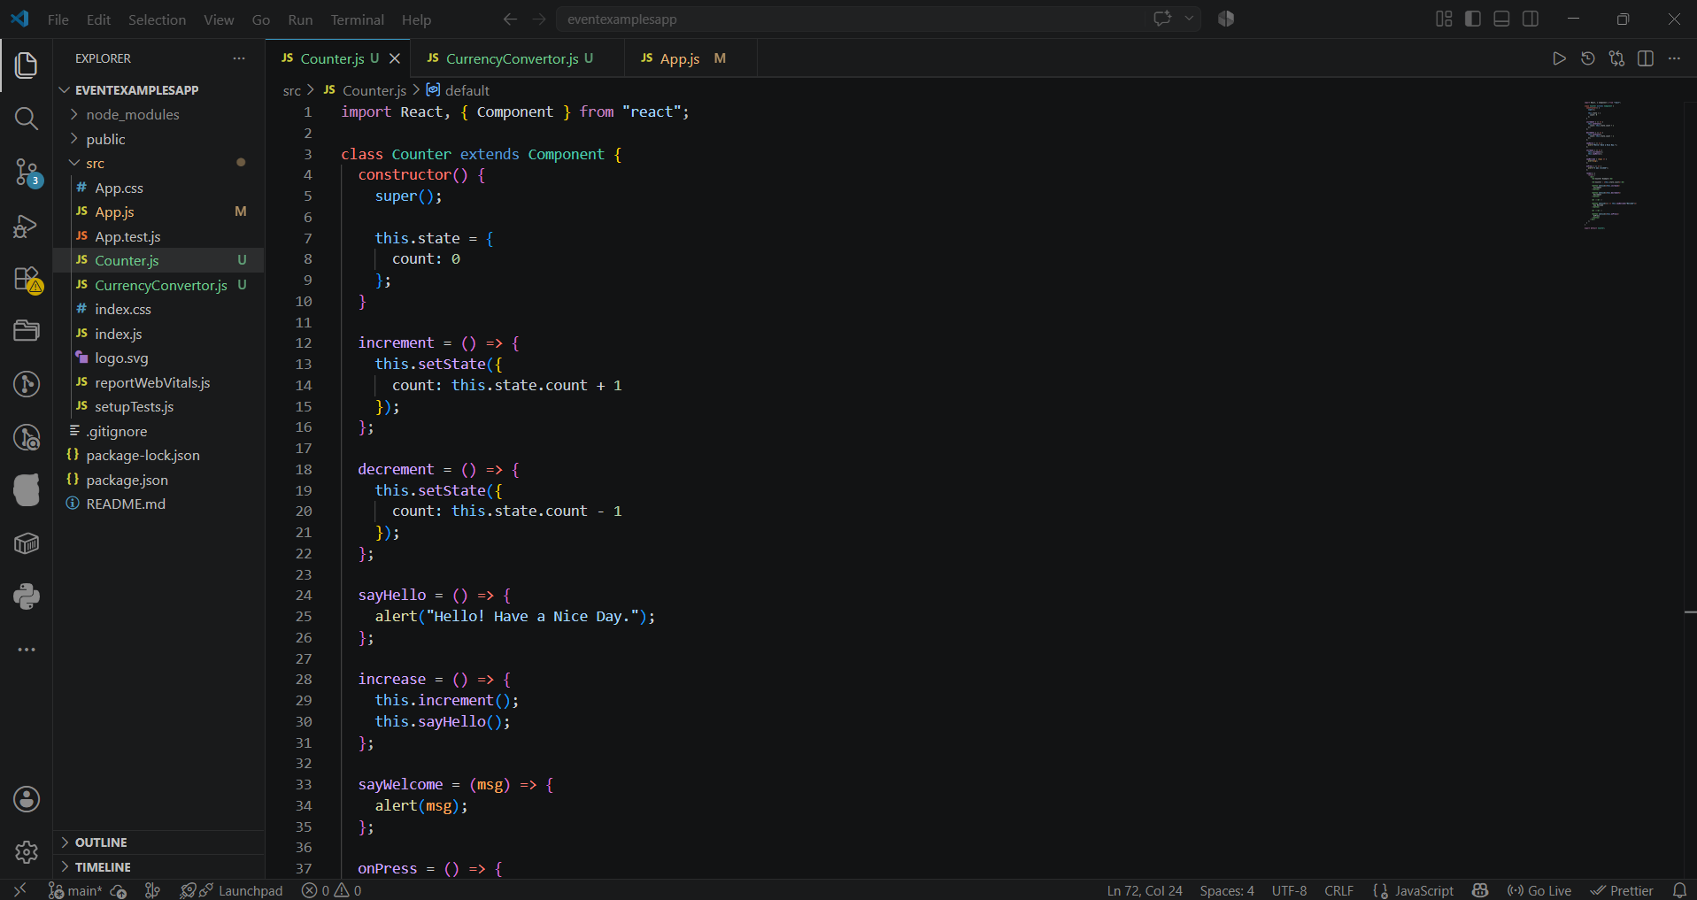
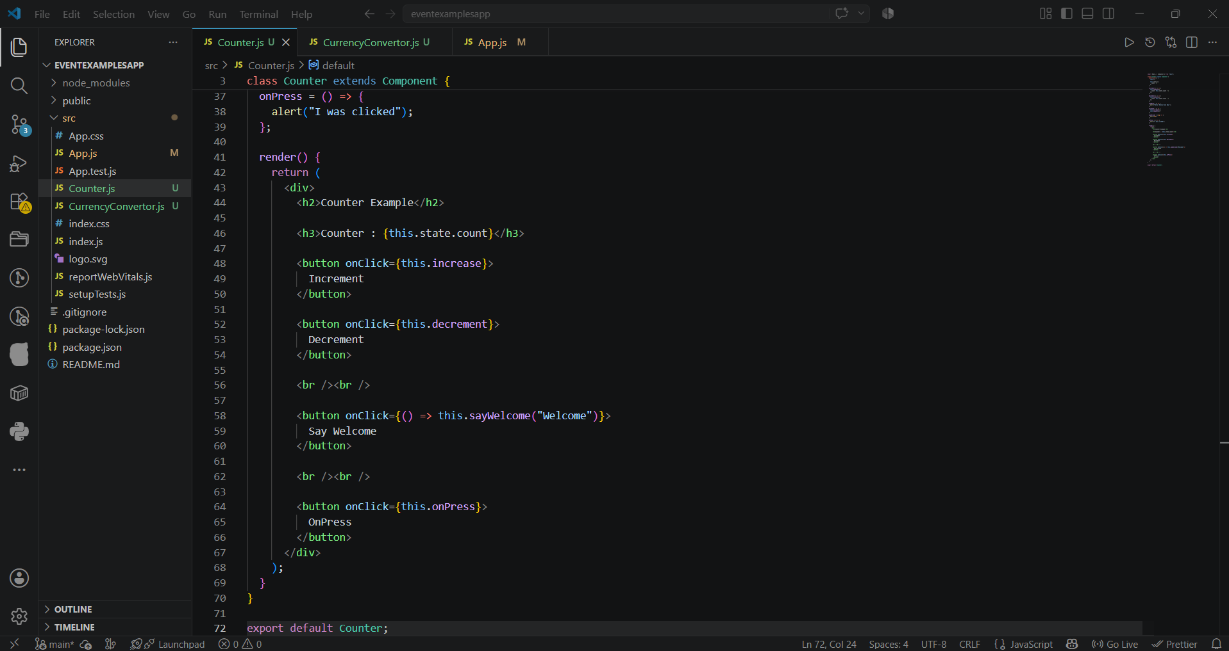
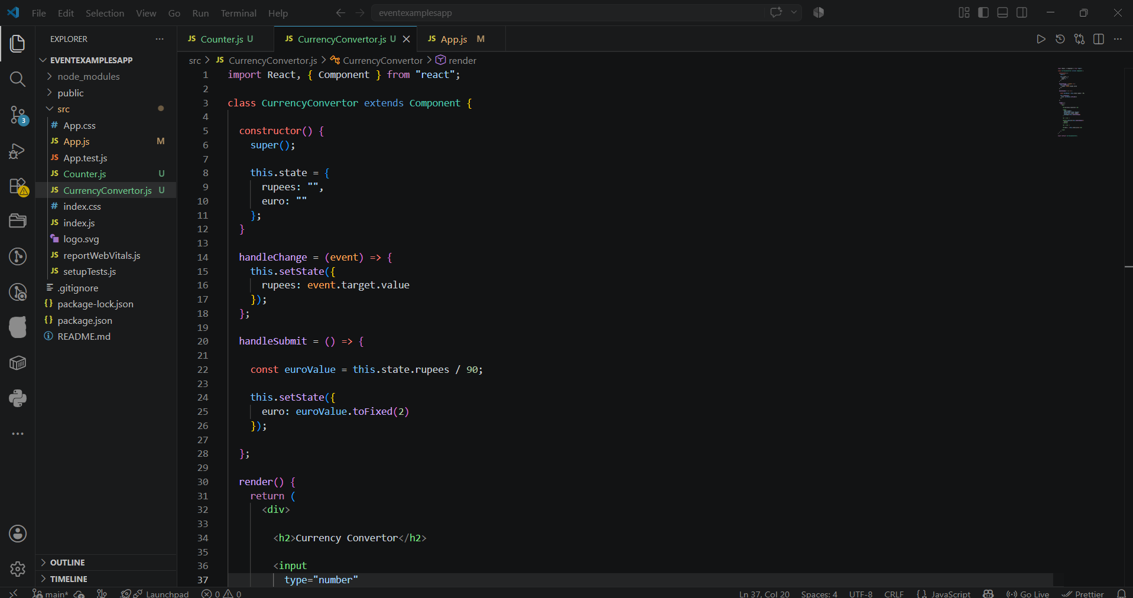
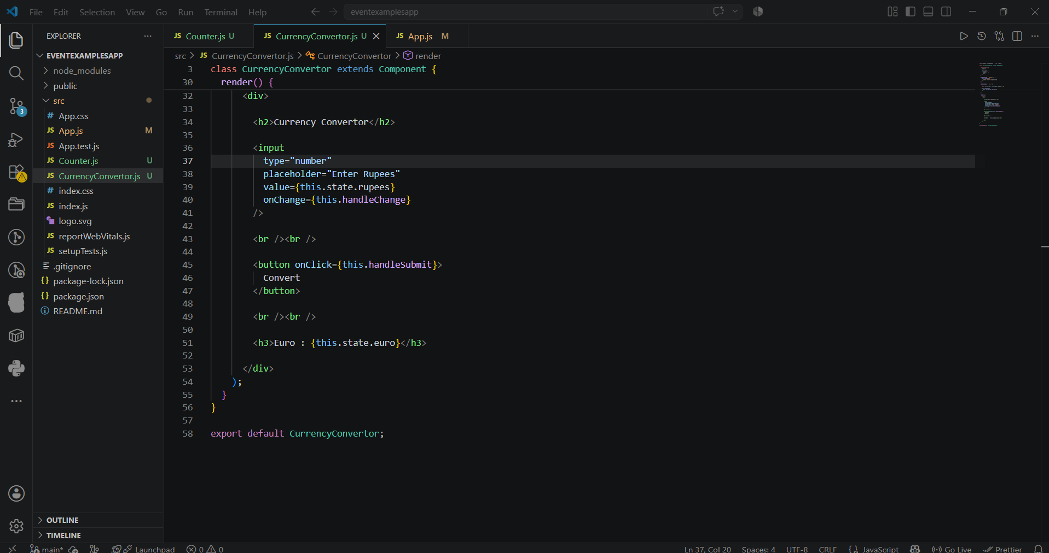
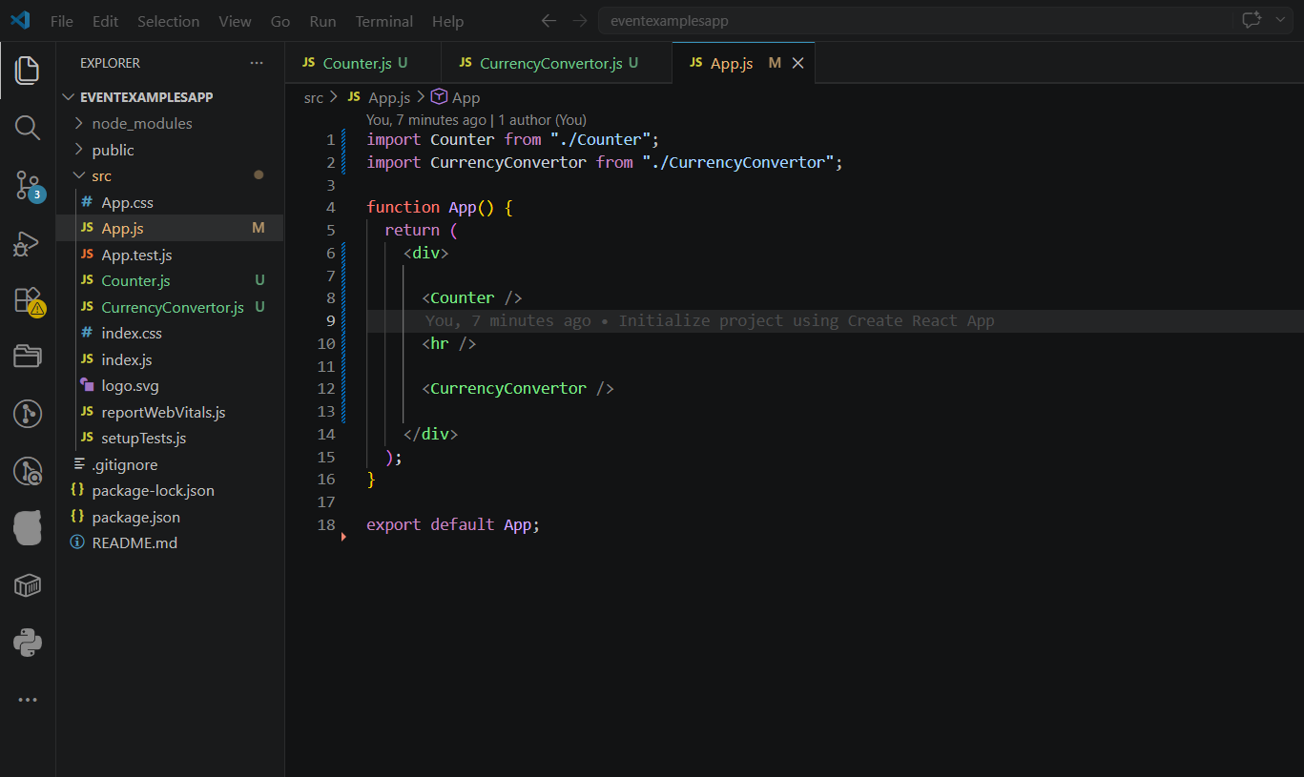
Output:
