Aim:
The aim of this experiment is to implement conditional rendering in a React application by developing a Ticket Booking System. The application displays different pages for guest users and logged-in users using React state, element variables, and conditional rendering techniques. It also demonstrates how components can be rendered or prevented from rendering based on the user's login status.

Theory
- Conditional rendering is a technique used in React to display different UI components based on specific conditions.
- React uses JavaScript conditions such as if-else, ternary (? :), and logical (&&) operators to render components dynamically.
- The useState Hook is used to manage the login status of the user.
- An element variable stores a JSX element and is rendered according to the application's state.
- The Login button changes the state from guest to logged-in user, while the Logout button changes it back.
- Different components (Guest Page and User Page) are displayed based on the current login state.
- Guest users can only view the available flight details.
- Logged-in users can access the ticket booking page and perform booking operations.
- React updates the user interface automatically whenever the state changes, without reloading the page.
- Components can be prevented from rendering by returning null, which displays nothing on the screen.
- This implementation demonstrates React's component-based architecture and efficient UI rendering using state management.

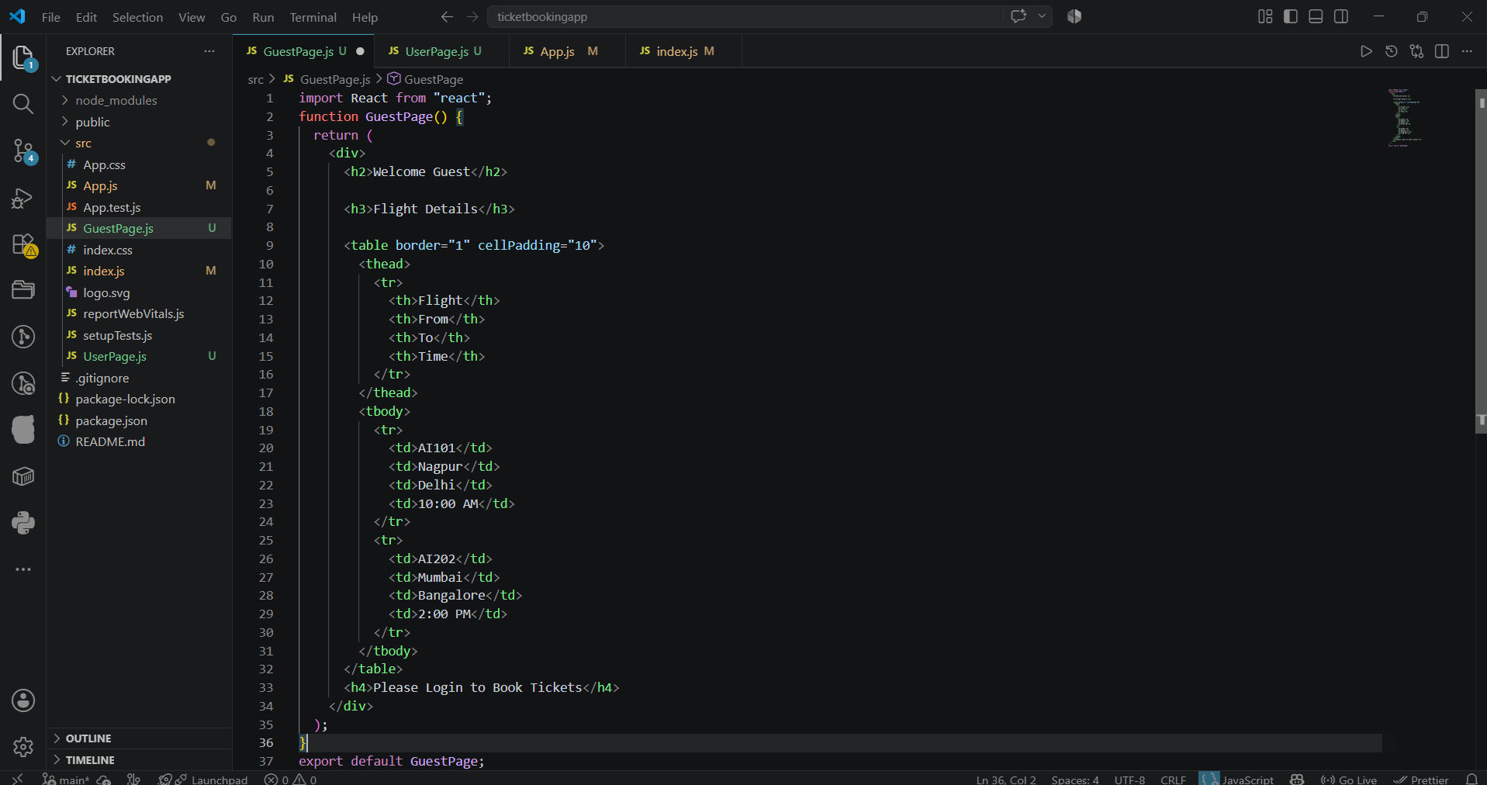
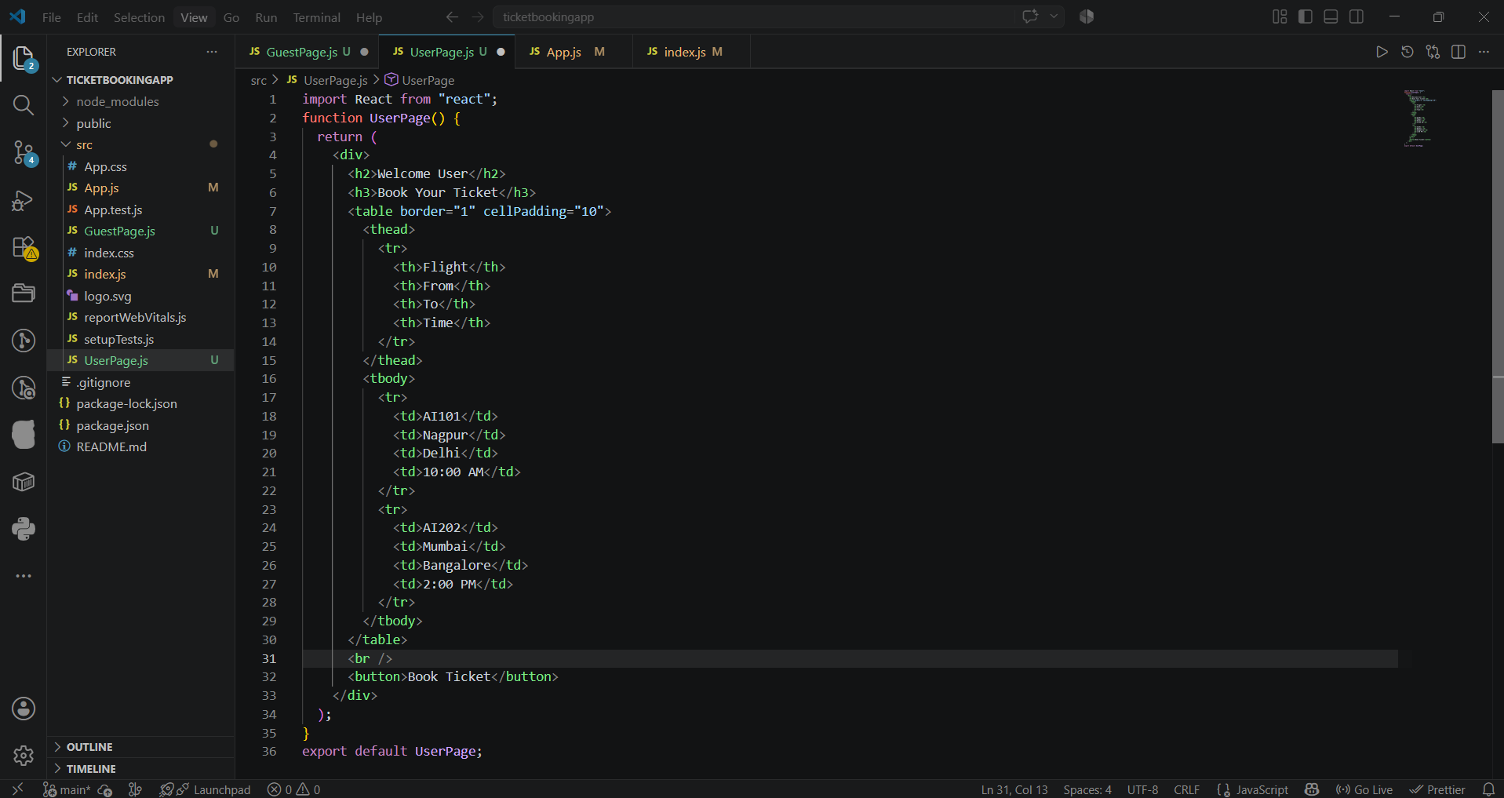
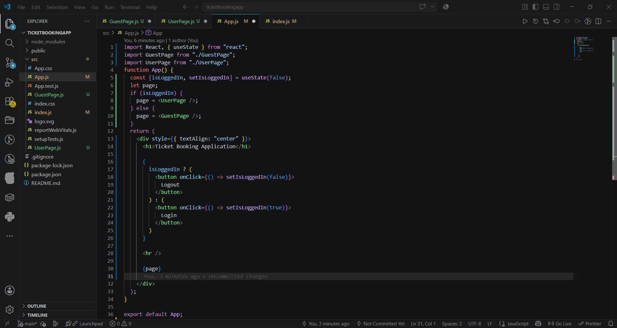
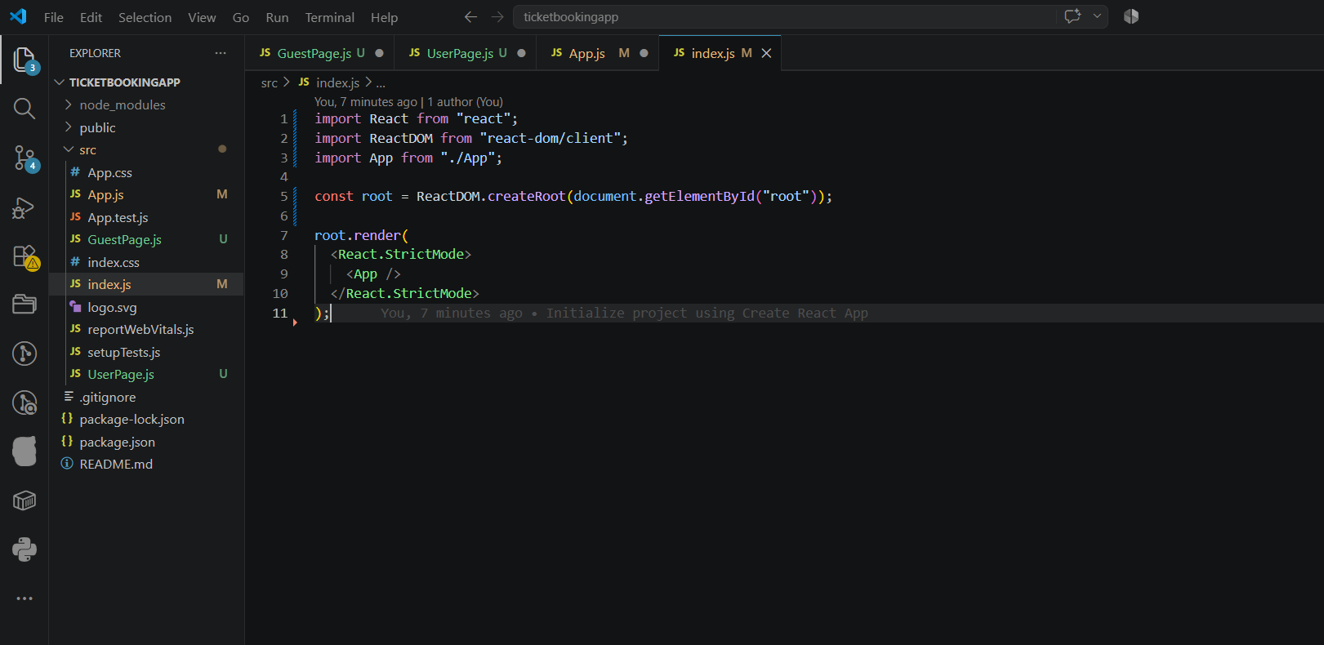
Output:
