Aim
To create a React application named bloggerapp that displays Book Details, Blog Details, and Course Details using different methods of conditional rendering in React.

Theory
Conditional rendering in React allows components or elements to be displayed based on specific conditions. It works similarly to JavaScript conditions and helps render different UI depending on user actions or application state. React supports several approaches for conditional rendering such as if-else statements, element variables, ternary operators, logical && operator, and returning null to prevent rendering. Lists of data can also be rendered efficiently using the map() function, where each rendered element is assigned a unique key to help React identify changes and update the UI efficiently.

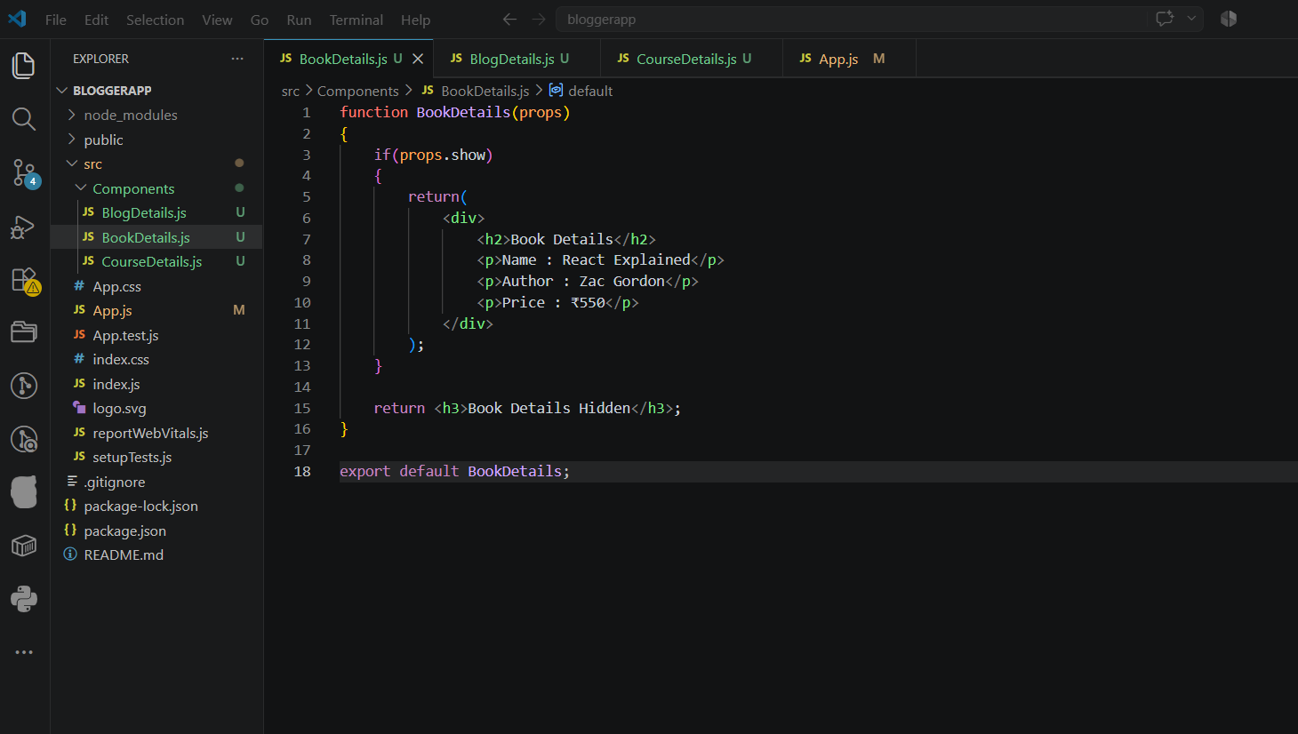
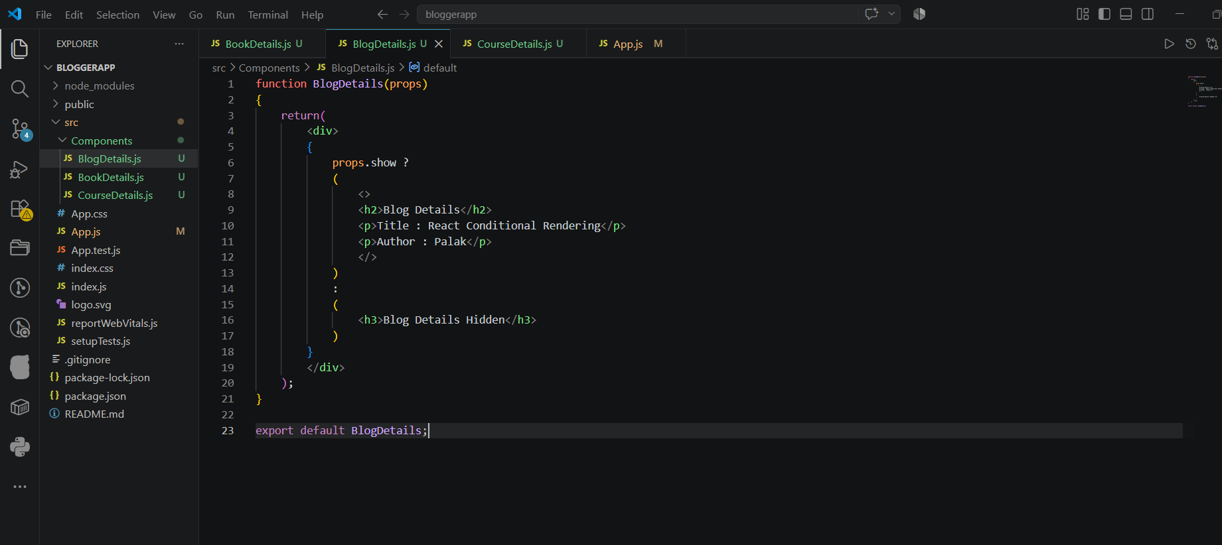
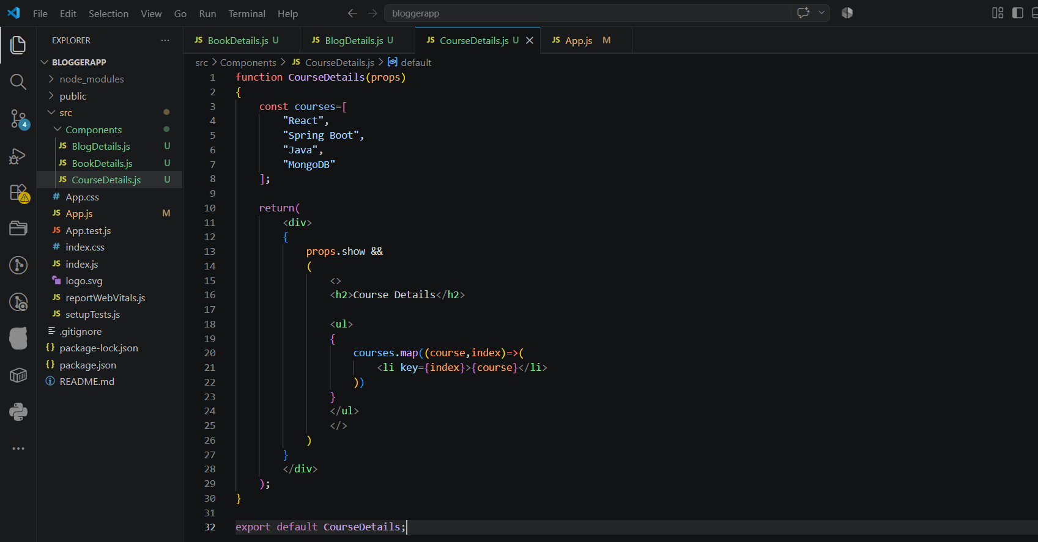
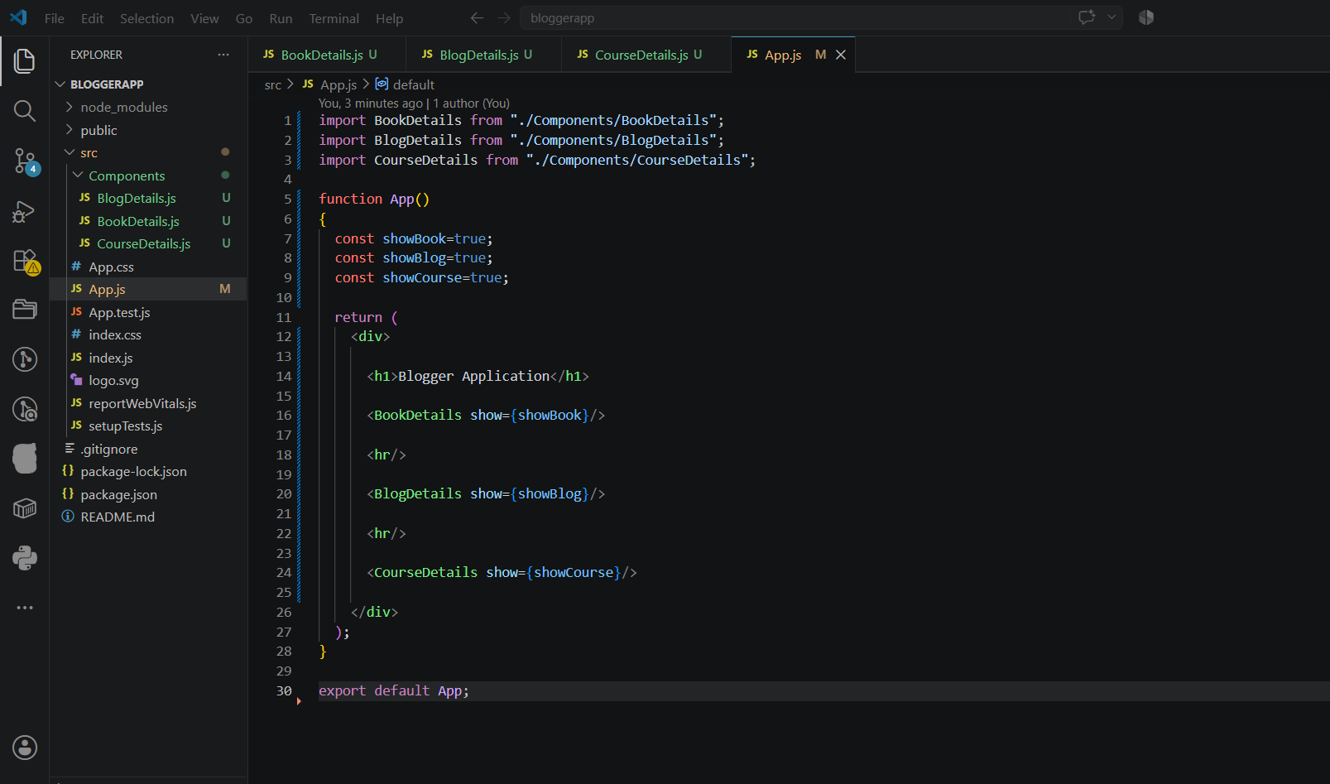

Output:
