Aim
To understand and implement the ES6 features such as map(), filter(), arrow functions, destructuring, and the spread (merge) operator in a React application.

Theory
ECMAScript 6 (ES6) introduced several powerful features that simplify JavaScript development. In this lab, the map() method was used to display a list of cricket players, while the filter() method along with arrow functions was used to display players whose scores were below 70. Array destructuring was used to separate players into odd and even teams, making array element access simpler and more readable. The spread (...) operator was used to merge two arrays containing T20 and Ranji Trophy players into a single array. Finally, a simple if-else statement with a flag variable was used in the App component to conditionally render either the ListofPlayers component or the IndianPlayers component. This lab demonstrates the practical use of ES6 features in building React applications.

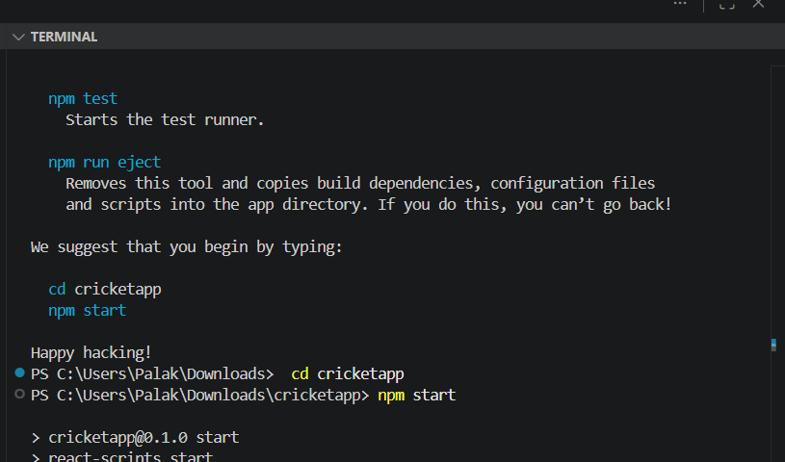
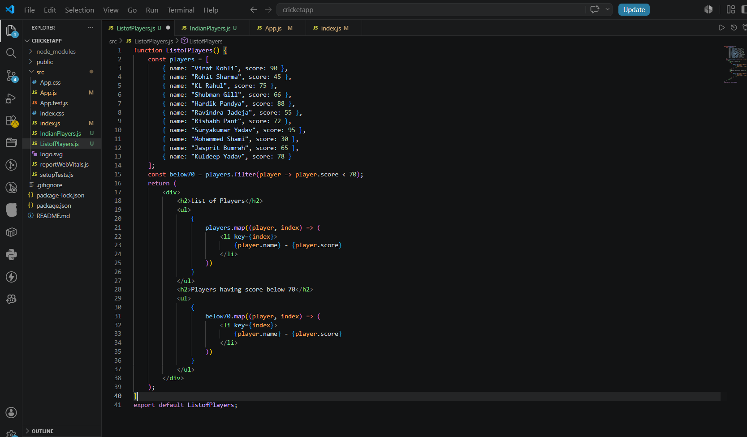
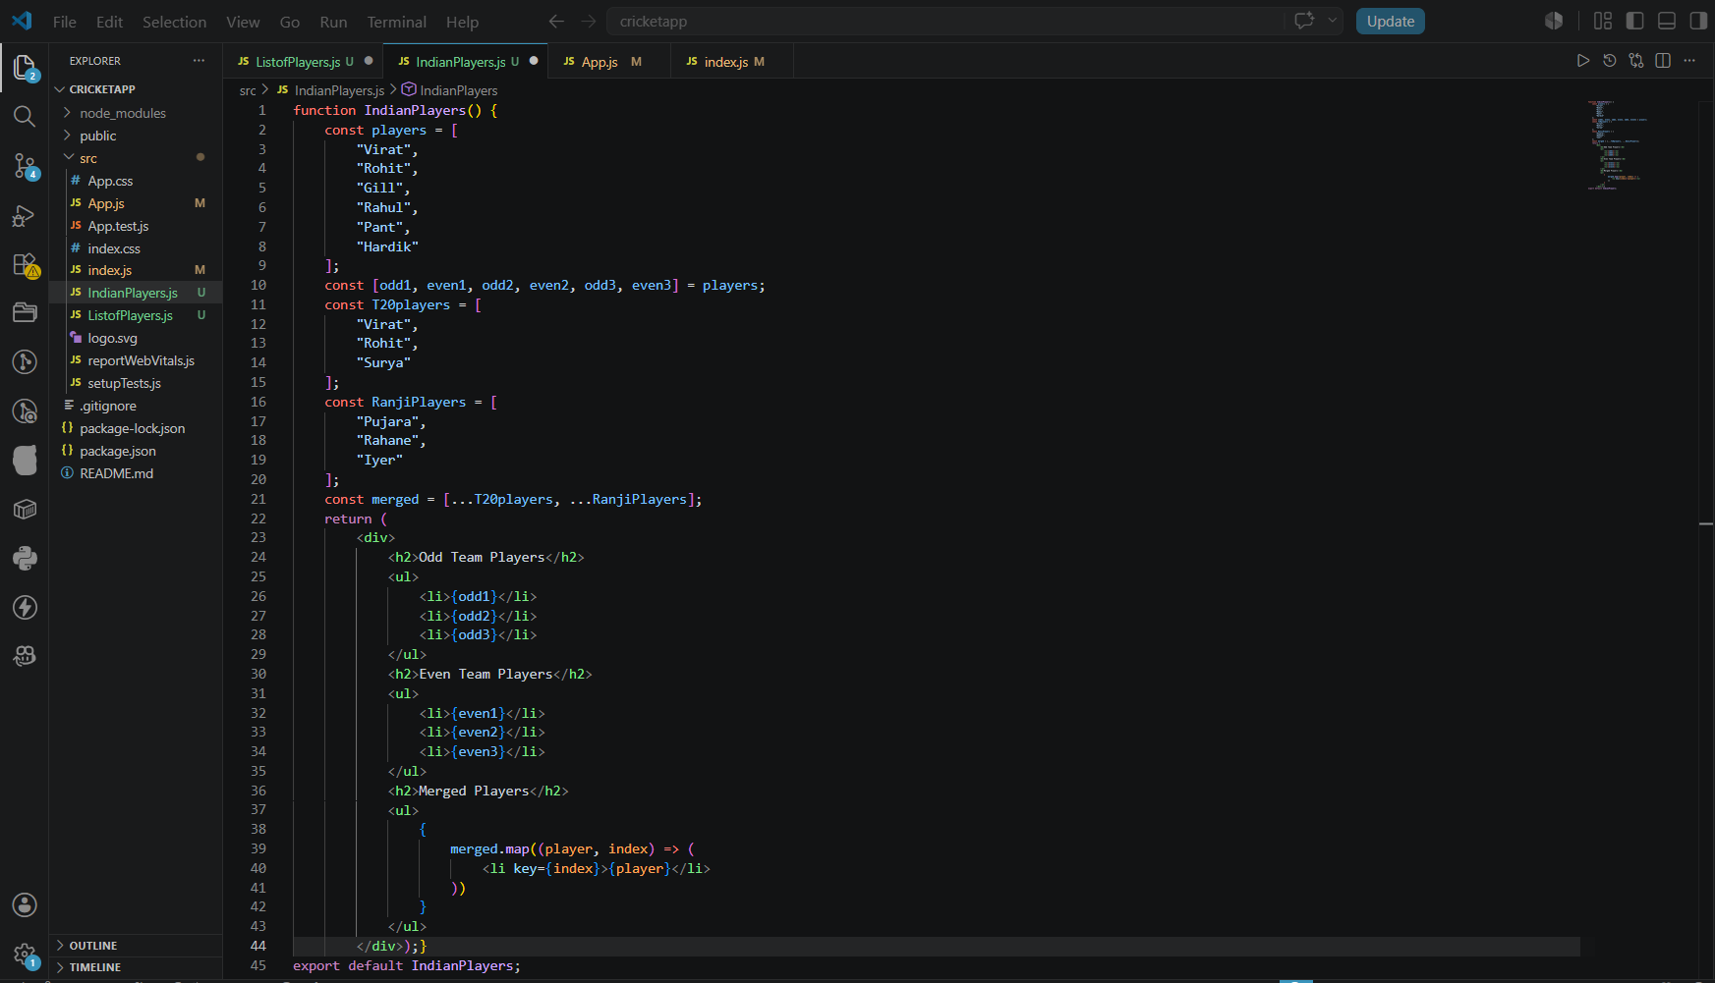
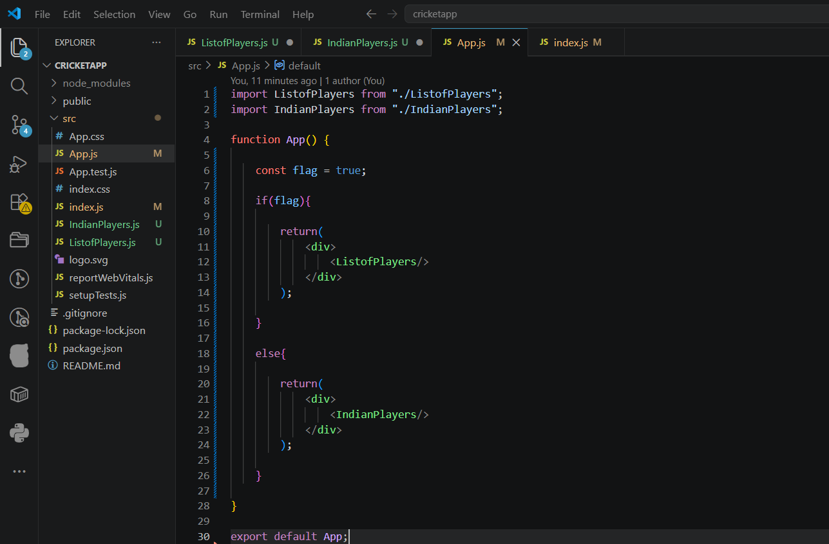
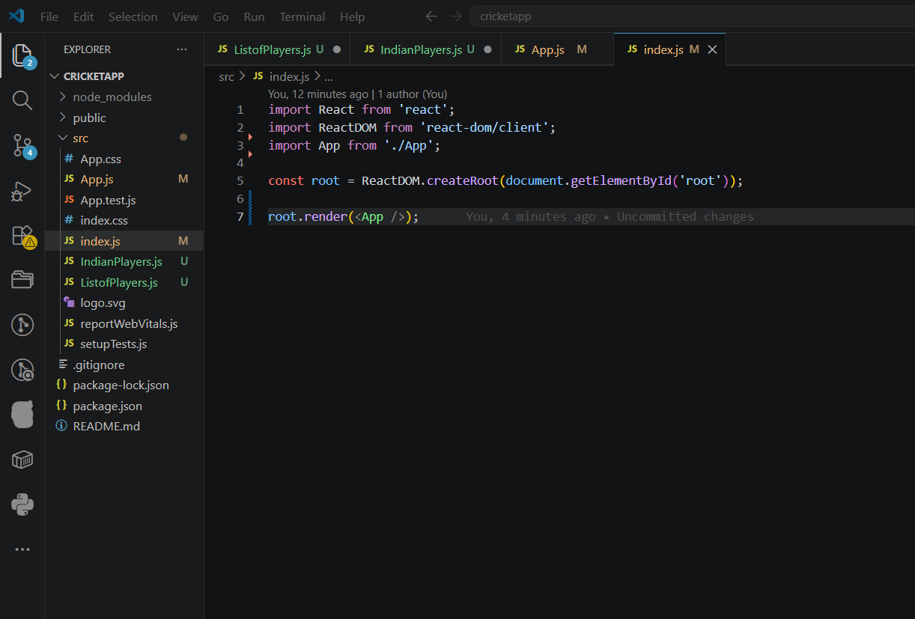
Output:
