Hello World RESTful Web Service
Write a REST service in the spring learn application created earlier, that returns the text "Hello World!!" using Spring Web Framework. Refer details below:
Method: GET
URL: /hello
Controller: com.cognizant.spring-learn.controller.HelloController
Method Signature: public String sayHello()
Method Implementation: return hard coded string "Hello World!!"
Sample Request: http://localhost:8083/hello
Sample Response: Hello World!!
IMPORTANT NOTE: Don't forget to include start and end log in the sayHello() method.
Try the URL http://localhost:8083/hello in both chrome browser and postman.
pom.xml
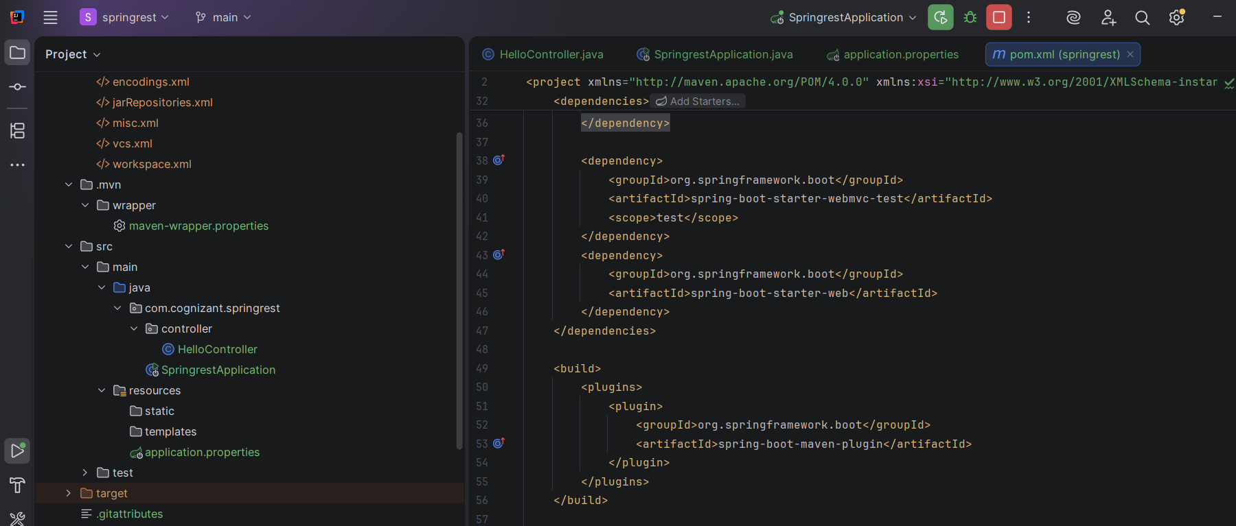
SpringApplication.java
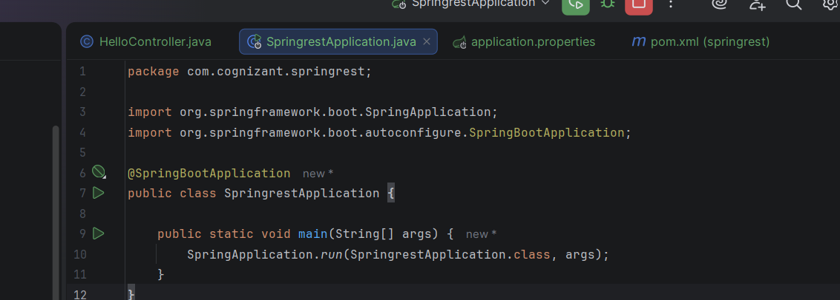

HelloController.java
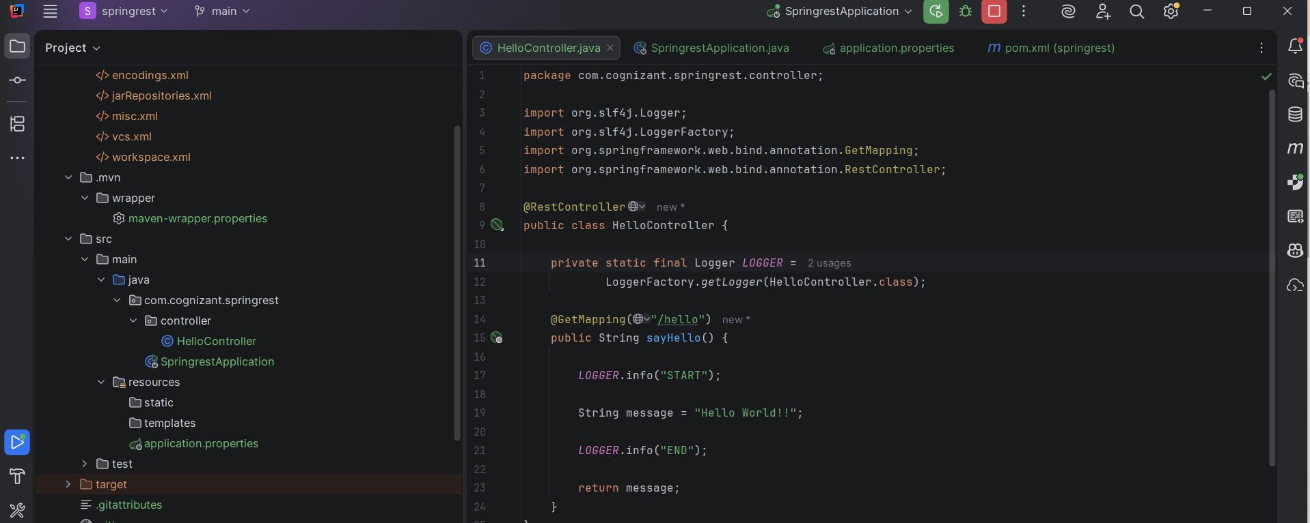

application.properties
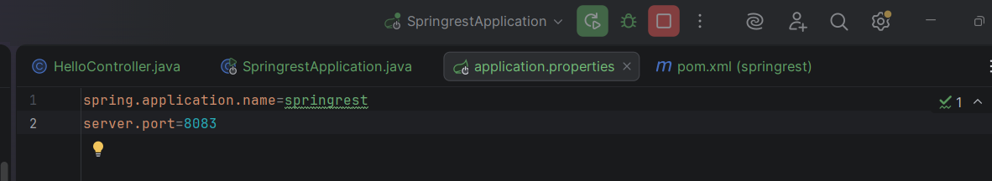
On browser: http://localhost:8083/hello
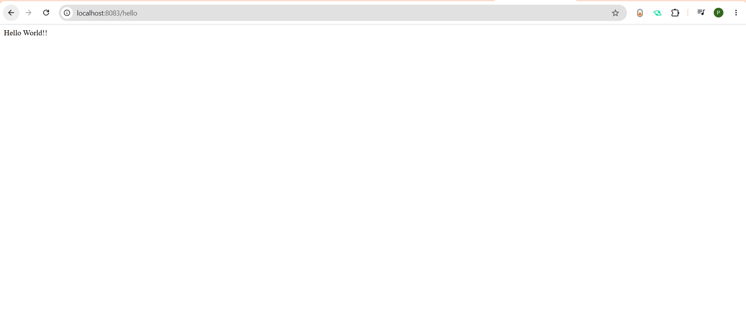

Postman:
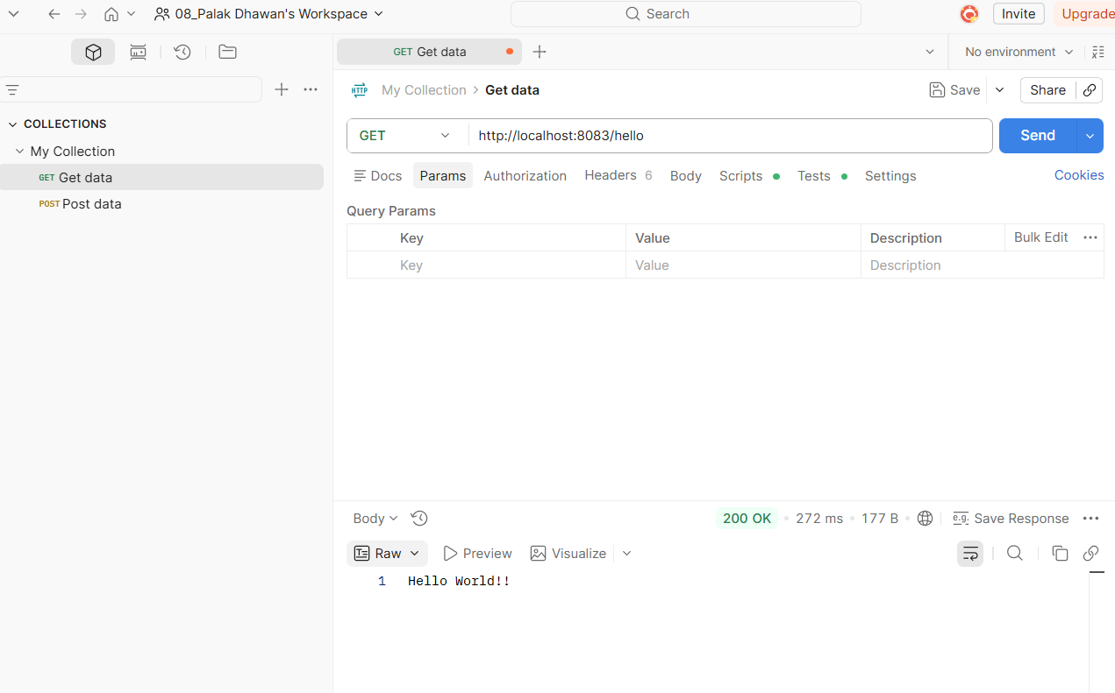
Working of the Application
- The Spring Boot application starts on port 8083.
- The client sends an HTTP GET request to /hello.
- Spring Boot maps the request to the sayHello() method.
- The method logs START.
- The method returns the string "Hello World!!".
- The method logs END.
- The response is sent back to the client.

REST - Country Web Service
Write a REST service that returns India country details in the earlier created spring learn application.
URL: /country
Controller: com.cognizant.spring-learn.controller.CountryController
Method Annotation: @RequestMapping
Method Name: getCountryIndia()
Method Implementation: Load India bean from spring xml configuration and return
Sample Request: http://localhost:8083/country
Sample Response:
{
"code": "IN",
"name": "India"
Country.java
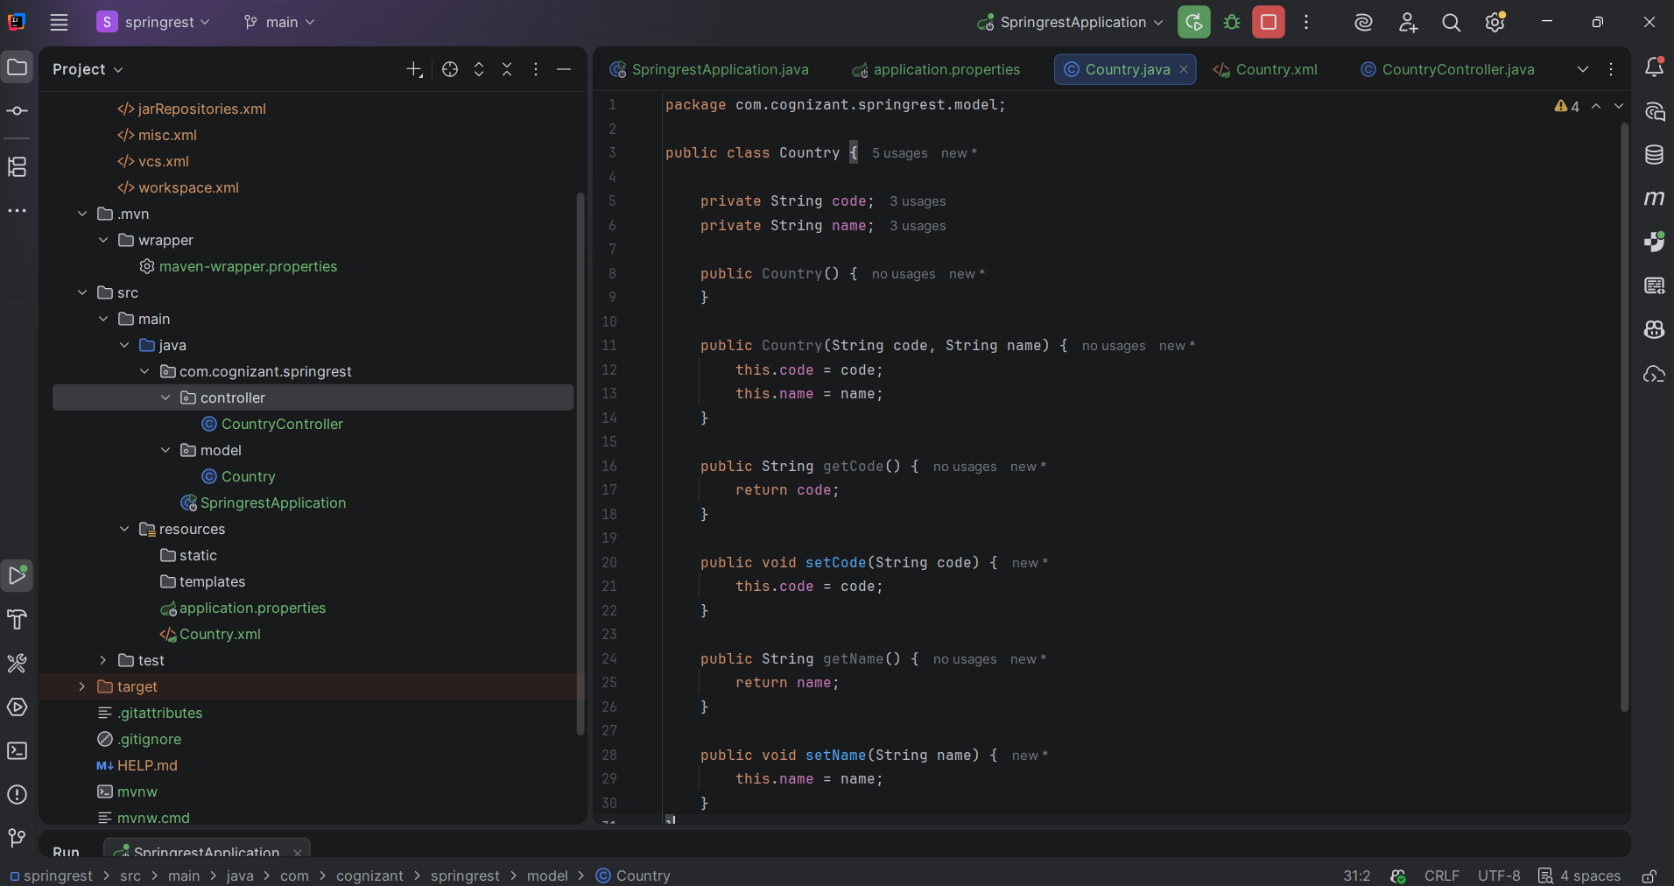

Country.xml
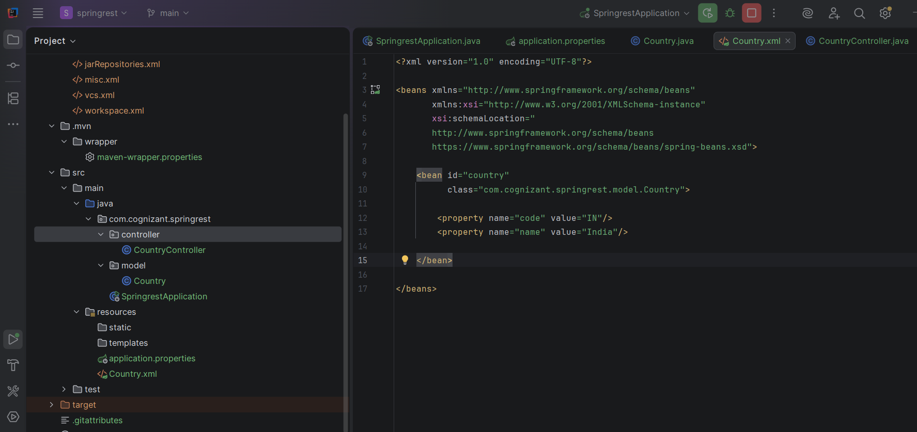
CountryController.java
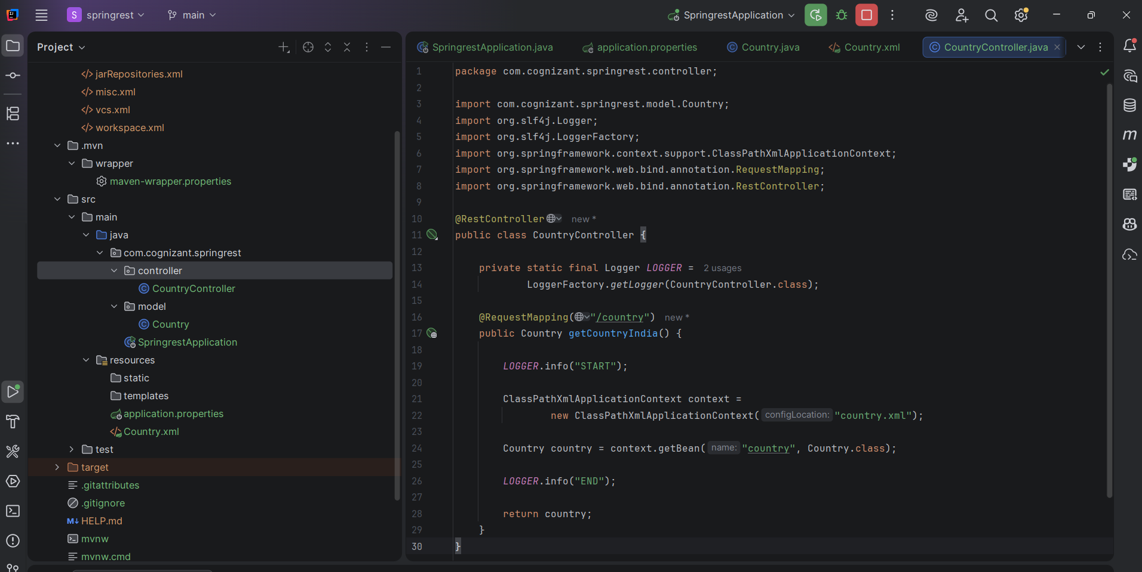
Browser: http://localhost:8083/country

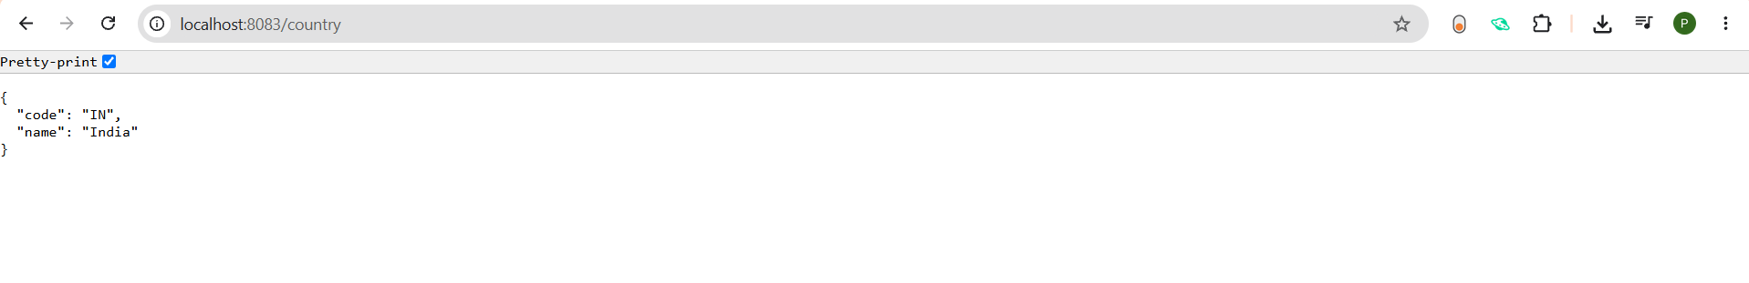Postman: http://localhost:8083/country
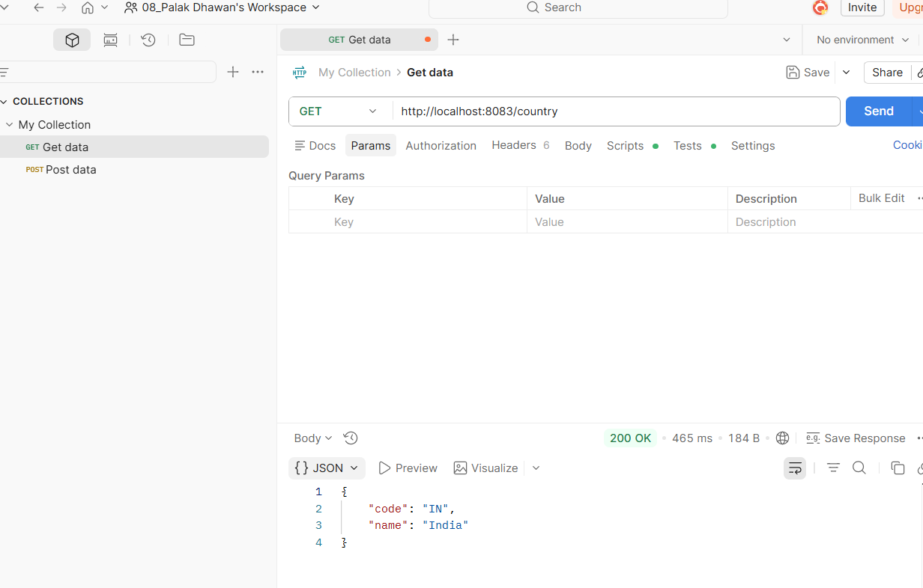
REST - Get country based on country code
Write a REST service that returns a specific country based on country code. The country code should be case insensitive.
Controller: com.cognizant.spring-learn.controller.CountryController
Method Annotation: @GetMapping("/countries/{code}")
Method Name: getCountry(String code)
Method Implemetation: Invoke countryService.getCountry(code)
Service Method: com.cognizant.spring-learn.service.CountryService.getCountry(String code)
Service Method Implementation:
- Get the country code using @PathVariable
- Get country list from country.xml
- Iterate through the country list
- Make a case insensitive matching of country code and return the country.
- Lambda expression can also be used instead of iterating the country list
Sample Request: http://localhost:8083/country/in
Sample Response:
{
"code": "IN",
"name": "India"
}
Country.java
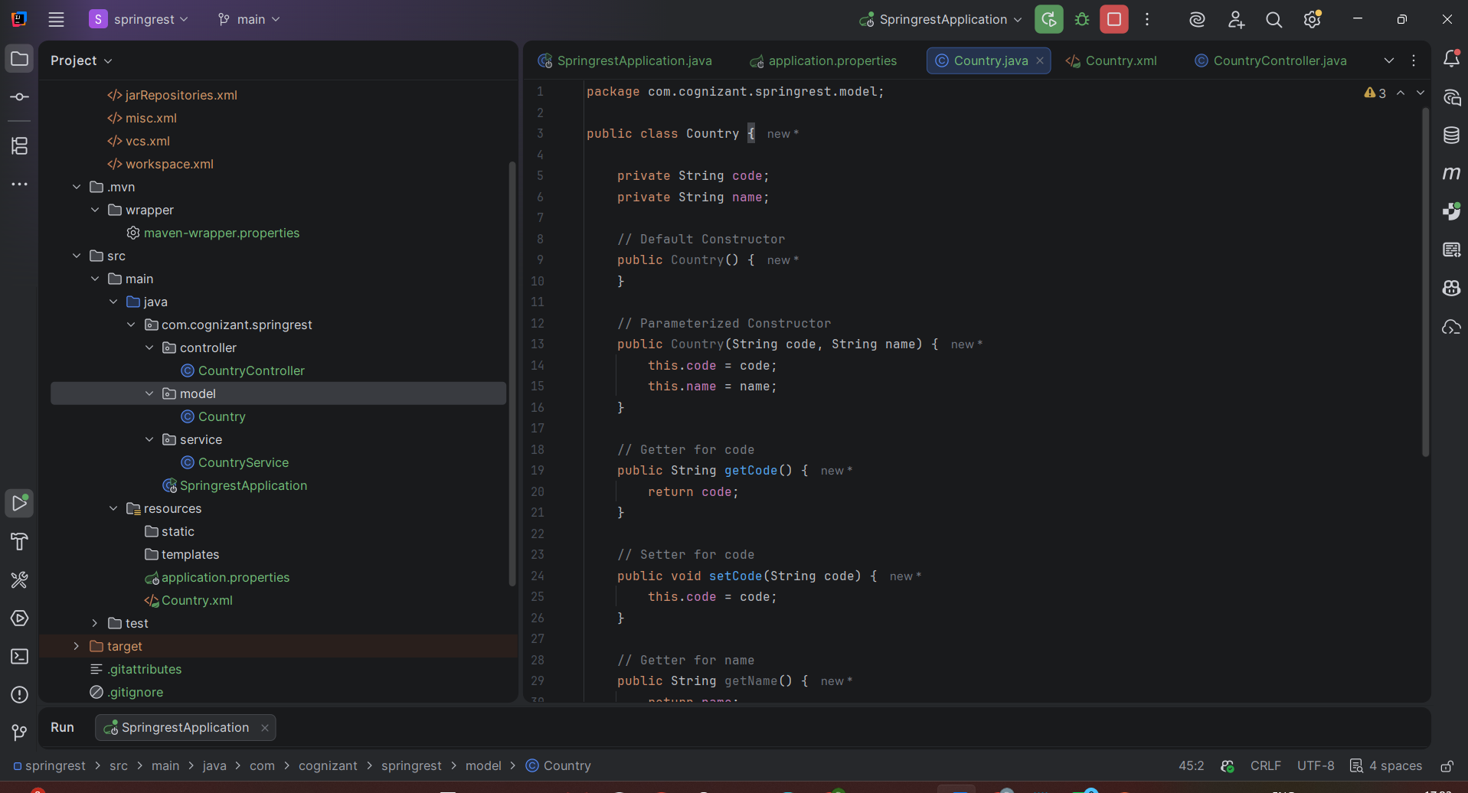
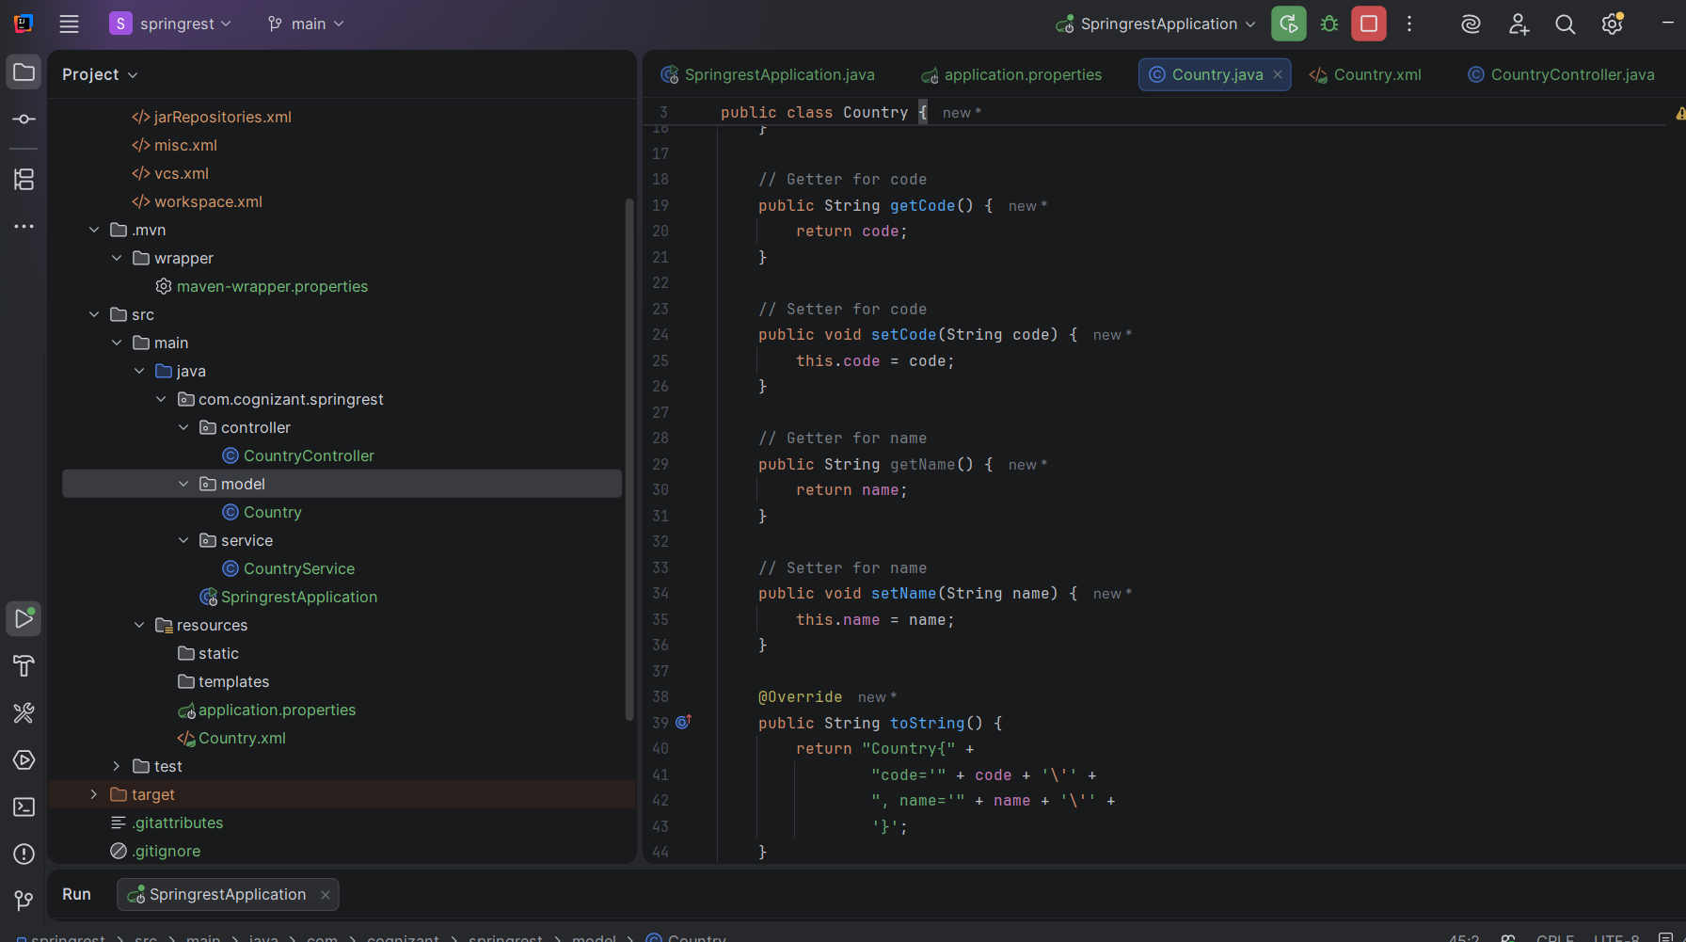

Country.xml
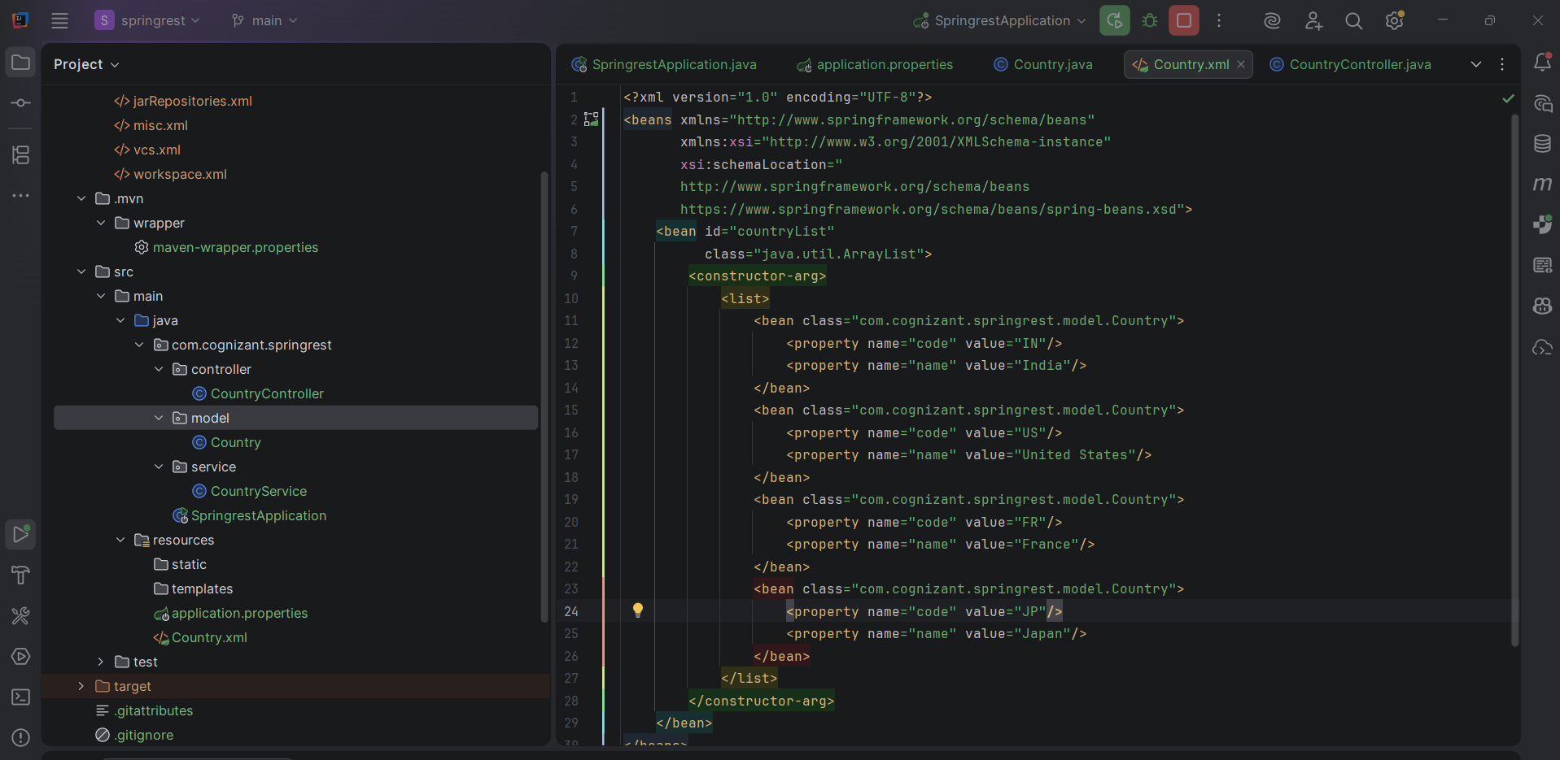
CountryController.java
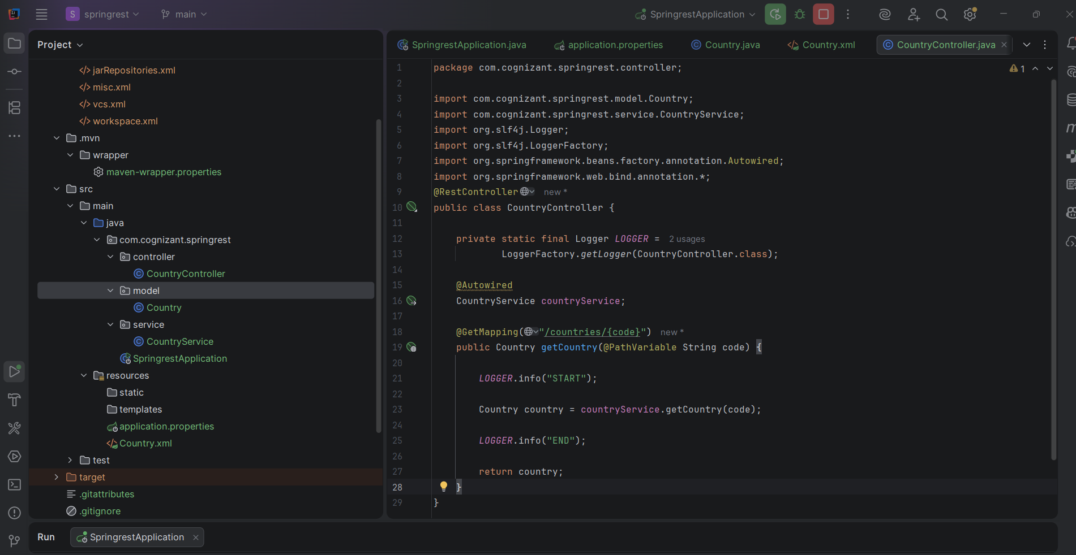

Browser: http://localhost:8083/countries/in
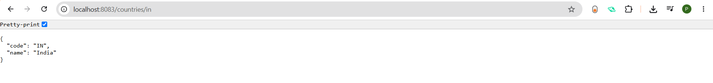

Postman: http://localhost:8083/countries/us
