Exercise 2: E-commerce Platform Search Function
Scenario:
You are working on the search functionality of an e-commerce platform. The search needs to be optimized for fast performance.
Steps:
- Understand Asymptotic Notation:
  - Explain Big O notation and how it helps in analyzing algorithms.
  - Describe the best, average, and worst-case scenarios for search operations.
- Setup:
  - Create a class Product with attributes for searching, such as productId, productName, and category.
- Implementation:
  - Implement linear search and binary search algorithms.
  - Store products in an array for linear search and a sorted array for binary search.
- Analysis:
  - Compare the time complexity of linear and binary search algorithms.
Discuss which algorithm is more suitable for your platform and why.

Part 1: Understanding Asymptotic Notation
What is Asymptotic Notation?
Asymptotic notation is a mathematical way to measure the efficiency of an algorithm as the input size increases.
Instead of measuring execution time in seconds (which depends on computer speed), it measures how the number of operations grows with input size.
If there are n products, asymptotic notation tells us how much work an algorithm performs as n becomes very large.

Big O Notation (O)
Big O represents the Worst Case Time Complexity.
It tells us the maximum amount of time an algorithm may take.
Example:
Searching for a product in an array of 1000 products.
- Best case → First product → 1 comparison
- Worst case → Last product → 1000 comparisons
Worst case = O(n)

Why Big O is Important?
It helps developers
- Compare algorithms
- Choose faster algorithms
- Optimize applications
- Predict performance for large data
Example
Amazon has millions of products.
Searching one by one would be slow.
Binary Search can find products much faster.

Best, Average and Worst Case
Suppose we search Product ID = 105.
Array:
101
102
103
104
105
106
107

Best Case
Product is found immediately.
Comparisons = 1
Time Complexity
O(1)

Average Case
Product is somewhere in the middle.
Comparisons ≈ n/2
Time Complexity
O(n)

Worst Case
Product is last or not present.
Comparisons = n
Time Complexity
O(n)

Part 2: Product Class

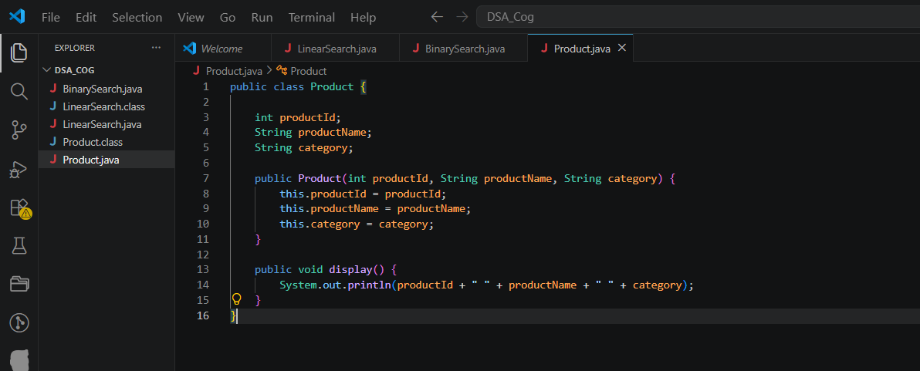

Part 3: Linear Search
Theory
Linear Search checks every element one by one until the desired element is found.
It does not require sorting.

Algorithm
- Start from first product.
- Compare productId.
- If matched, stop.
- Otherwise move to next product.
- Repeat until end.

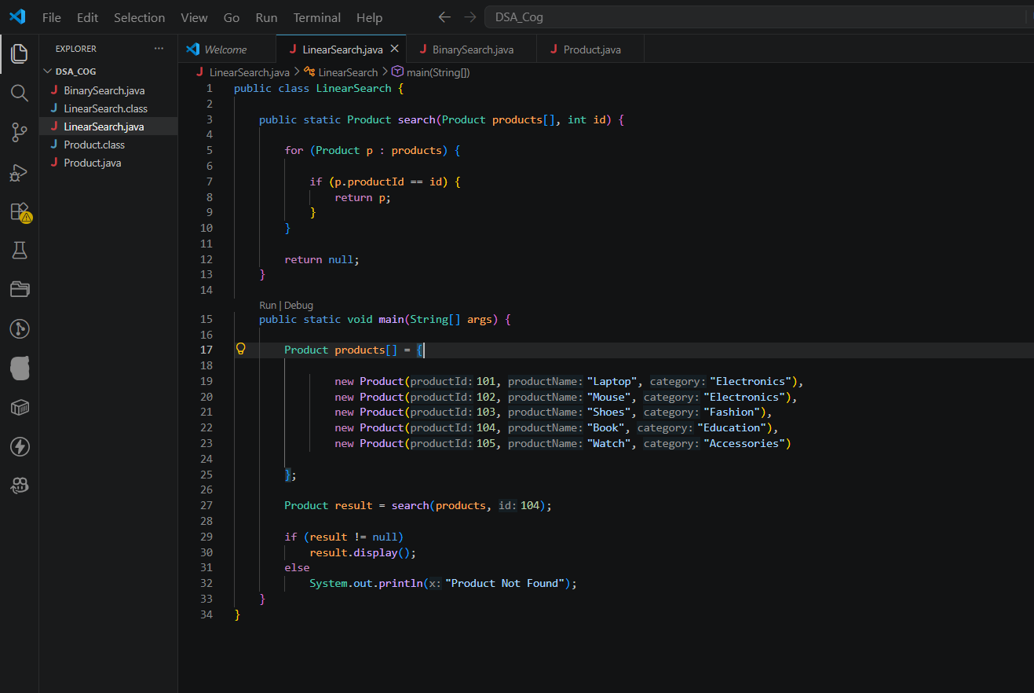

Output:
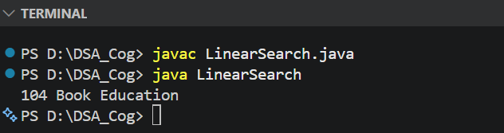
Time Complexity
Best Case: O(1)
Average Case: O(n)
Worst Case: O(n)
Space Complexity: O(1)

Binary Search
Theory
Binary Search repeatedly divides the search space into half.
It works only on sorted arrays.

Suppose Product IDs are
101
102
103
104
105
106
107
Search = 106
Step 1
Middle = 104
106 > 104
Search Right

Step 2
105 106 107
Middle = 106
Found.
Only 2 comparisons.

Algorithm
- Find middle element.
- Compare with target.
- If equal → Found.
- If smaller → Search left half.
- If larger → Search right half.
- Repeat

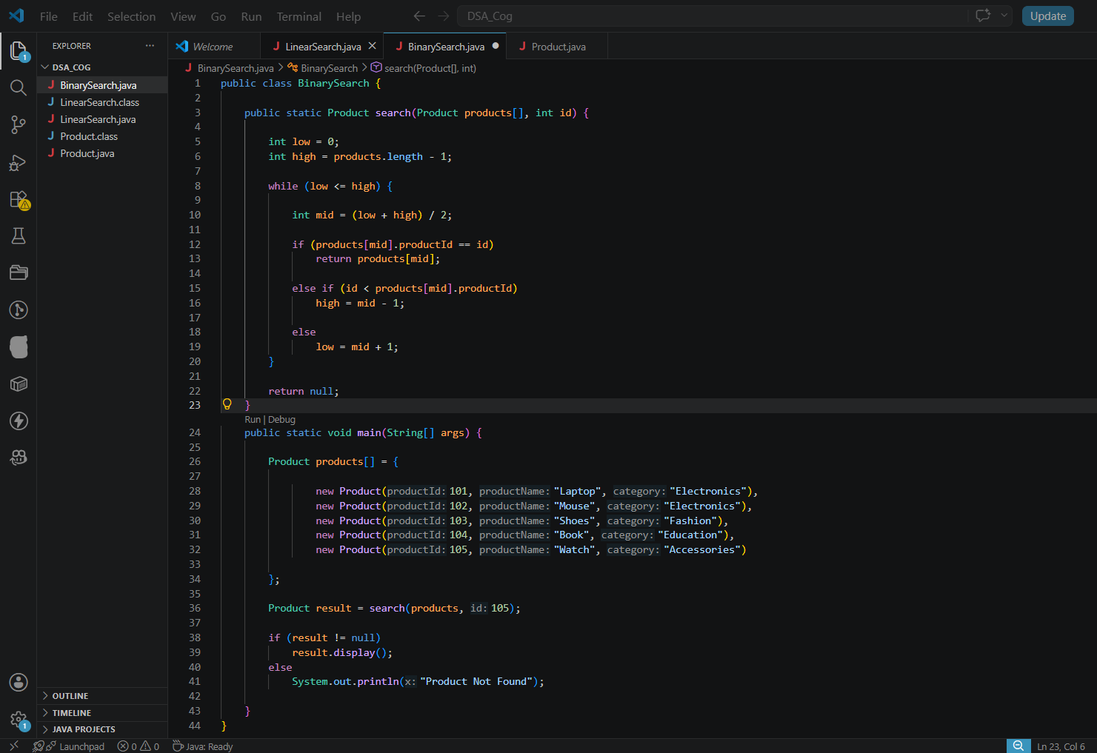
Output:
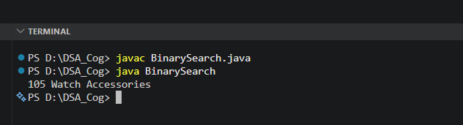
Time Complexity
Best Case:O(1)
Average Case:O(log n)
Worst Case:O(log n)
Space Complexity:O(1)

Comparison of Linear Search and Binary Search
Feature | Linear Search | Binary Search
Data Required | Unsorted | Sorted
Technique | Sequential | Divide and Conquer
Best Case | O(1) | O(1)
Average Case | O(n) | O(log n)
Worst Case | O(n) | O(log n)
Space Complexity | O(1) | O(1)
Suitable for Small Data | Yes | Yes
Suitable for Large Data | No | Yes

Which is Better for an E-commerce Platform?
Binary Search is more suitable because:
- Large number of products.
- Faster searching.
- Reduces response time.
- Improves customer experience.
If products are frequently added or removed and not kept sorted, Linear Search may be simpler, but for large, sorted product catalogs, Binary Search is the preferred choice.

Exercise 7: Financial Forecasting Using Recursion
Scenario
Scenario:
You are developing a financial forecasting tool that predicts future values based on past data.
Steps:
- Understand Recursive Algorithms:
  - Explain the concept of recursion and how it can simplify certain problems.
- Setup:
  - Create a method to calculate the future value using a recursive approach.
- Implementation:
  - Implement a recursive algorithm to predict future values based on past growth rates.
- Analysis:
  - Discuss the time complexity of your recursive algorithm.
Explain how to optimize the recursive solution to avoid excessive computation

Step 1: Understand Recursive Algorithms
What is Recursion?
Recursion is a programming technique in which a method calls itself repeatedly to solve a problem by breaking it into smaller, similar subproblems.
A recursive function always consists of:
- Base Case: The condition that stops the recursion.
- Recursive Case: The part where the function calls itself with a smaller problem.
Why is Recursion Useful?
- Simplifies complex problems.
- Makes the code shorter and easier to understand.
- Commonly used in tree traversal, graph algorithms, divide-and-conquer problems, dynamic programming, and financial forecasting.

Step 2: Setup
Assume an investment grows at a fixed annual growth rate.
The mathematical formula for calculating the future value is:
Future Value = Present Value × (1 + Growth Rate)Years
Instead of using loops or built-in power functions, we calculate the future value recursively by multiplying the previous year's value by (1 + Growth Rate) until the required number of years is reached.

Step 3: Implementation
Java Program
Sample Output
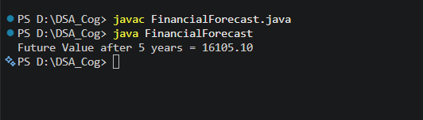
Working of the Algorithm
Suppose:
- Present Value = ₹10,000
- Growth Rate = 10%
- Number of Years = 3
Recursive calls:
futureValue(10000, 0.10, 3)
↓
futureValue(10000, 0.10, 2)
↓
futureValue(10000, 0.10, 1)
↓
futureValue(10000, 0.10, 0)
The base case returns 10000.
While returning from the recursive calls:
- Year 1 = 10000 × 1.10 = 11000
- Year 2 = 11000 × 1.10 = 12100
- Year 3 = 12100 × 1.10 = 13310
Therefore, the predicted future value after 3 years is ₹13,310.

Step 4: Analysis
Time Complexity
The recursive function makes one recursive call for each year.
Therefore, if there are n years, the total number of recursive calls is n.
Time Complexity: O(n)
Explanation
- One recursive call is made for each year.
- The execution time increases linearly with the number of years.

Space Complexity
Each recursive call is stored in the call stack until the base case is reached.
Space Complexity: O(n)

Optimization of the Recursive Solution
1. Memoization
Store previously calculated results so they can be reused instead of being computed again. This reduces unnecessary calculations for problems with overlapping subproblems.
2. Iterative Approach
Replace recursion with a loop.
Advantages:
- Space Complexity becomes O(1).
- Faster execution.
- No risk of stack overflow.
3. Tail Recursion
Tail recursion is a type of recursion where the recursive call is the last operation performed by the function. Some programming languages optimize tail recursion to reduce memory usage. However, Java does not support tail recursion optimization, so it does not improve performance in Java.

Conclusion
A recursive algorithm was implemented to predict the future value of an investment based on a fixed annual growth rate. The solution is simple, easy to understand, and demonstrates the concept of recursion effectively. The algorithm has a Time Complexity of O(n) and a Space Complexity of O(n). For larger inputs, iterative solutions or optimization techniques such as memoization are preferred to improve efficiency.

