Module 4 :Testing
Exercise 1: Setting Up JUnit Scenario: You need to set up JUnit in your Java project to start writing unit tests.
Steps: 1. Create a new Java project in your IDE (e.g., IntelliJ IDEA, Eclipse).
2. Add JUnit dependency to your project. If you are using Maven, add the following to your pom.xml:
3. Create a new test class in your project.
Pom.xml
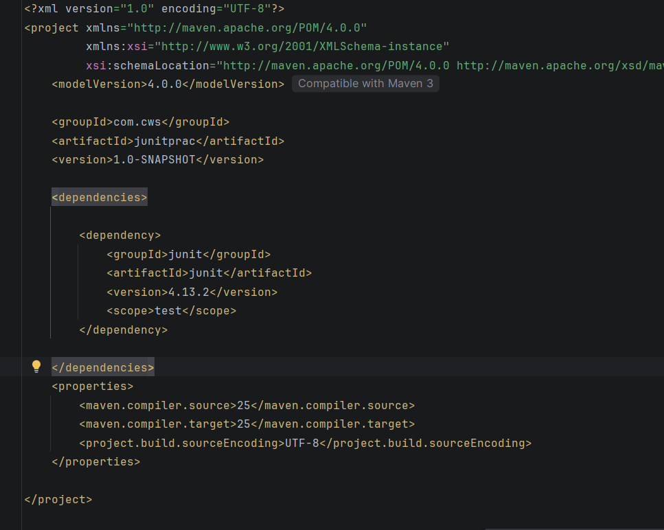

Exercise 3: Assertions in Junit
Scenario: You need to use different assertions in JUnit to validate your test results

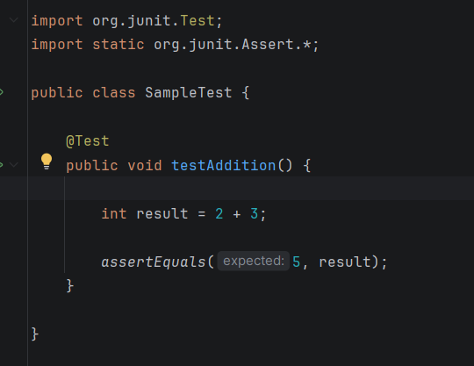
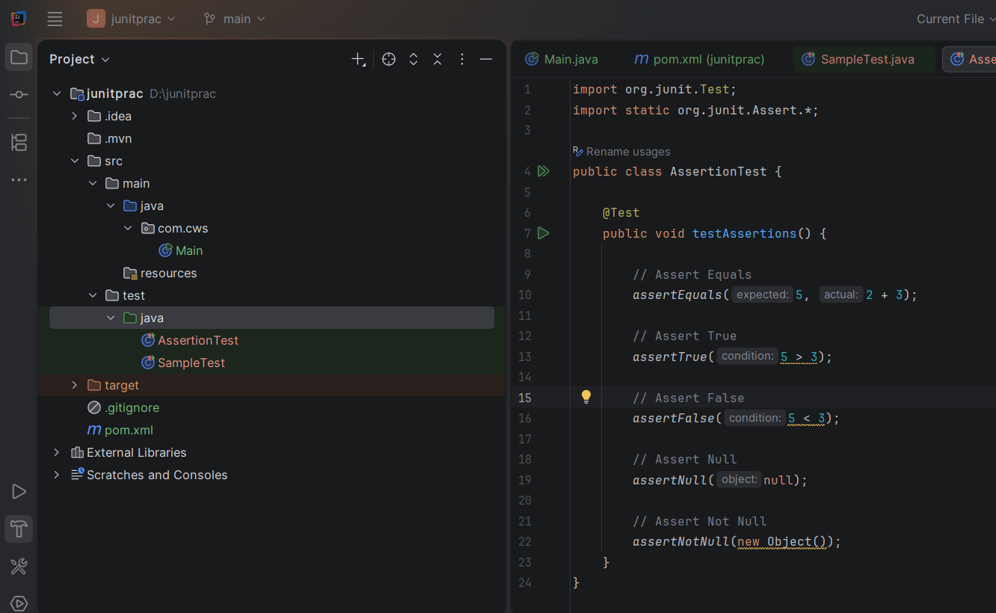

Exercise 4: Arrange-Act-Assert (AAA) Pattern, Test Fixtures, Setup and Teardown Methods in JUnit
Scenario: You need to organize your tests using the Arrange-Act-Assert (AAA) pattern and use setup and teardown methods.
Steps: 1. Write tests using the AAA pattern.
2. Use @Before and @After annotations for setup and teardown methods.

What is the AAA Pattern?
The Arrange-Act-Assert (AAA) pattern is a standard way of writing unit tests. It makes tests easy to understand and maintain.
AAA stands for:
Phase | Meaning | Purpose
Arrange | Prepare the test data and objects | Set up everything needed for the test
Act | Execute the method being tested | Perform the operation
Assert | Verify the result | Check whether the expected result matches the actual result

What are Test Fixtures?
A Test Fixture is the environment required for running a test. It includes:
- Creating objects
- Initializing variables
- Setting test data
- Cleaning up resources after the test
JUnit provides annotations to manage test fixtures automatically.

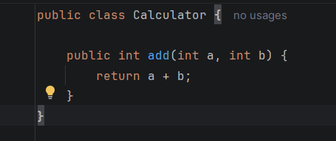

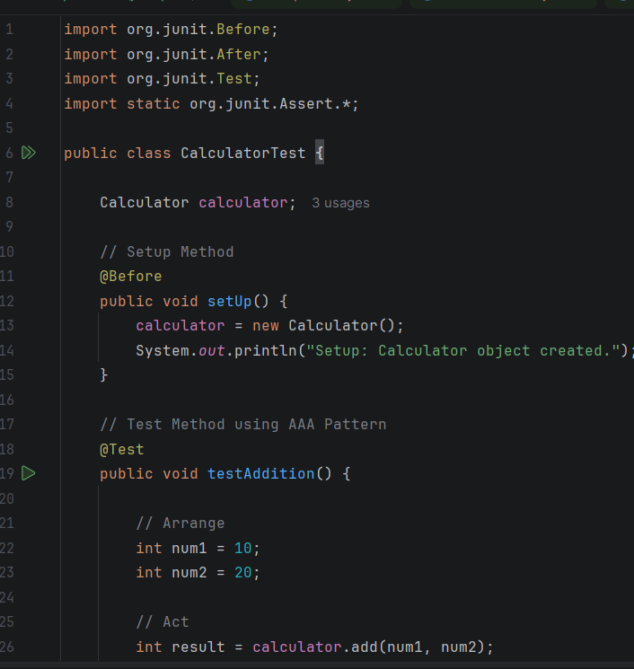
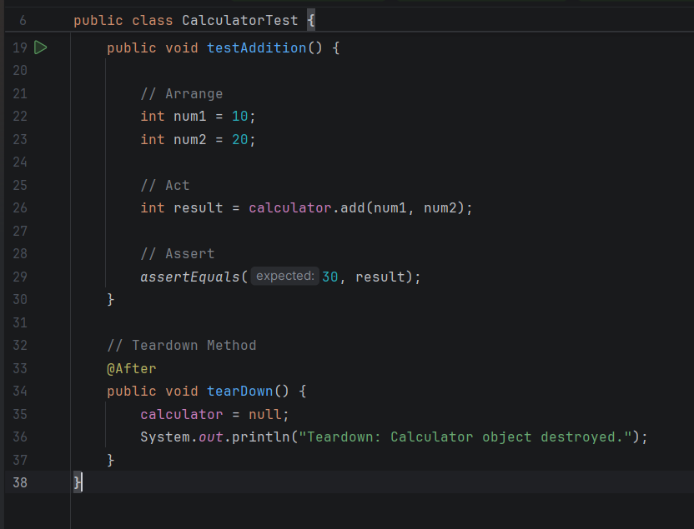

Mockito Hands-On Exercises
Exercise 1: Mocking and Stubbing
Scenario: You need to test a service that depends on an external API. Use Mockito to mock the external API and stub its methods.
Steps: 1. Create a mock object for the external API.
2. Stub the methods to return predefined values.
3. Write a test case that uses the mock object.

Dependencies added:
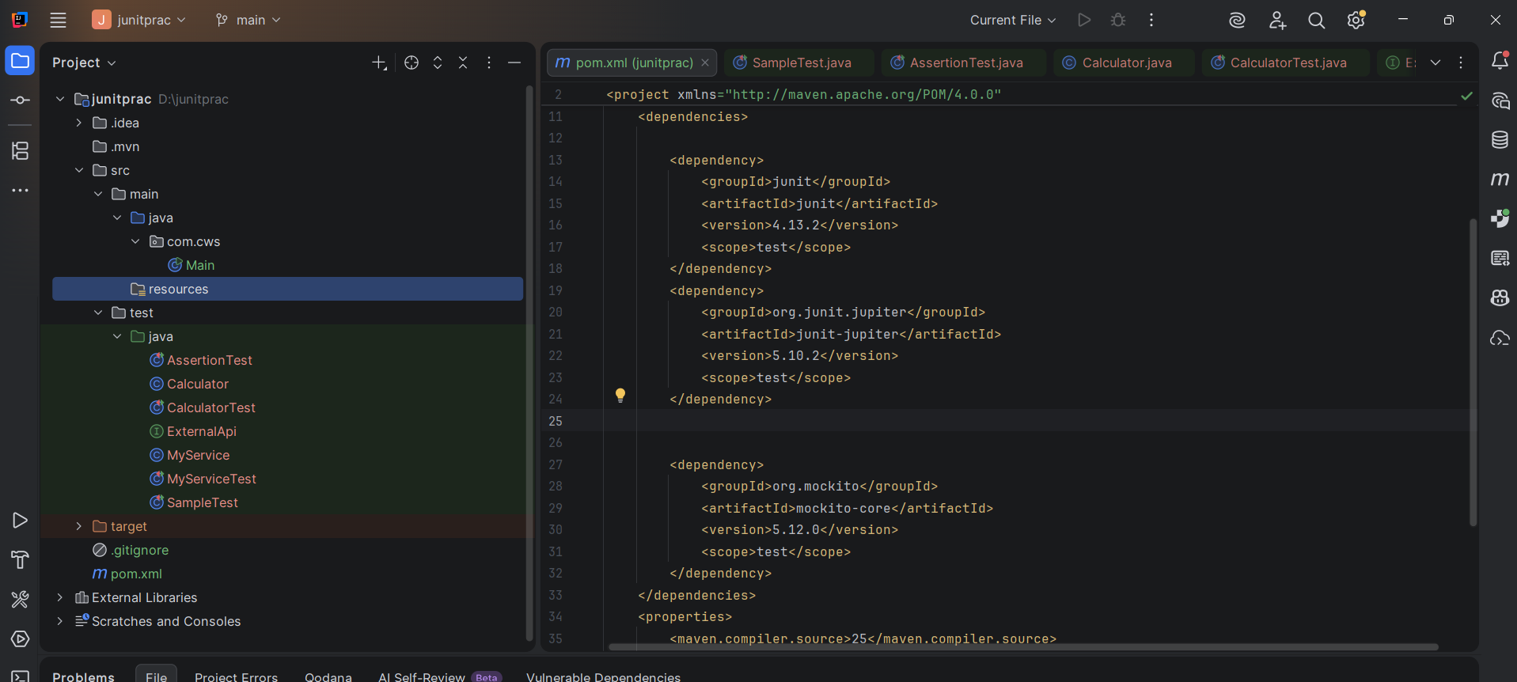

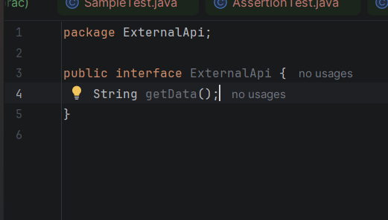
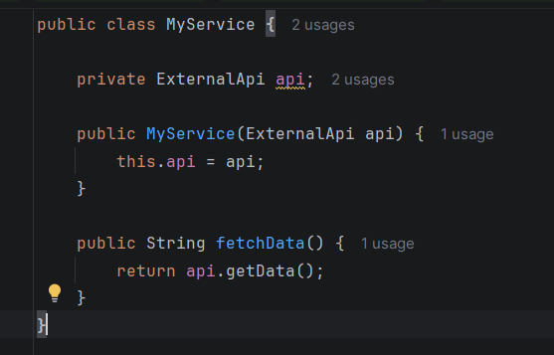

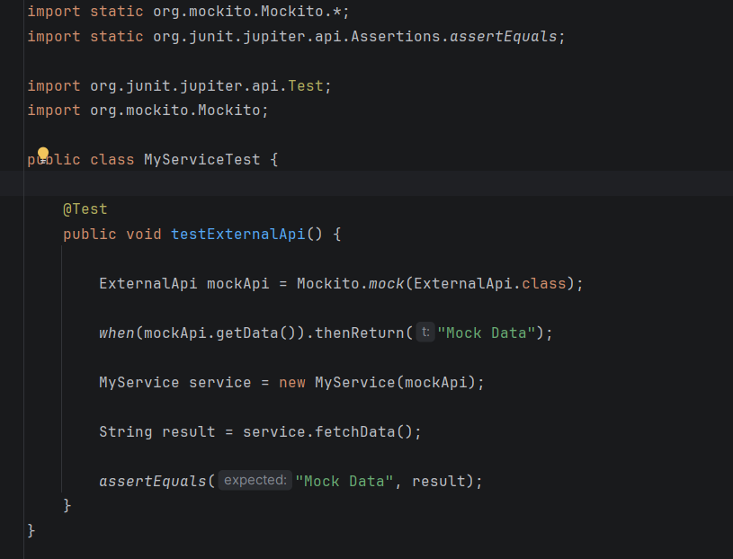
Exercise 2: Verifying Interactions
Scenario: You need to ensure that a method is called with specific arguments.
Steps: 1. Create a mock object.
2. Call the method with specific arguments.
3. Verify the interaction

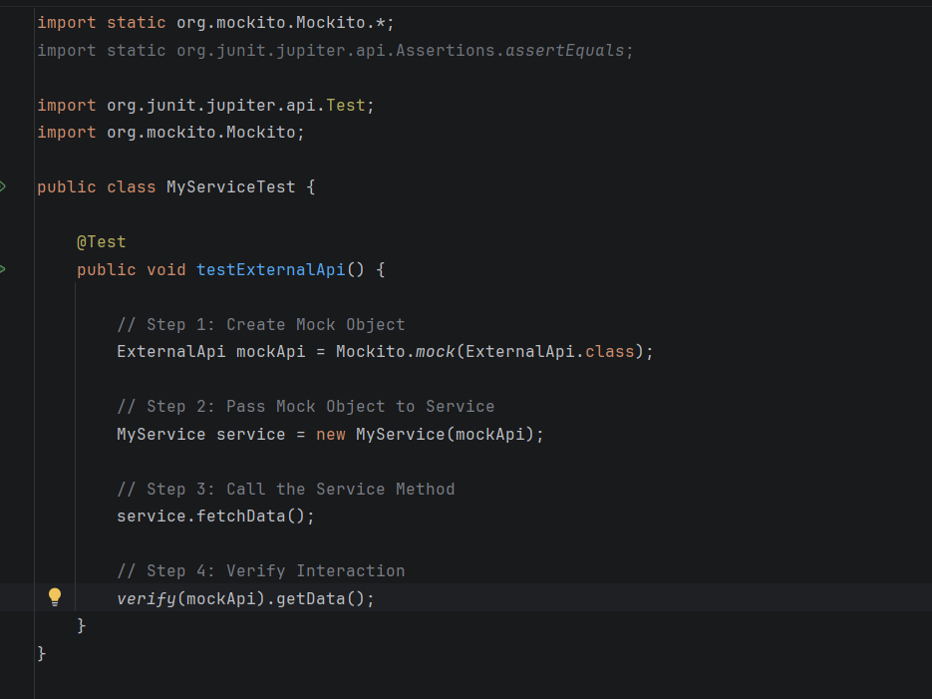

SLF4J Logging Framework
Exercise 1: Logging Error Messages and Warning Levels
Scenario
You are developing a Java application and want to record important events such as errors and warnings. Instead of printing messages using System.out.println(), you use SLF4J (Simple Logging Facade for Java) with Logback because it is a professional logging framework.

