YUVaintern – Week 4 Data Science Internship
Machine Learning Model Development and Evaluation
Predicting High vs Low Life Evaluation Using Logistic Regression

1. Objective
The Week 4 task developed a basic machine learning classification model using the World Happiness Report dataset. The objective was to predict whether an observation belongs to a High Life Evaluation or Low Life Evaluation category.

2. Data Preparation
After selecting the required numerical wellbeing variables and removing missing observations, 1,013 observations remained. The median Life Evaluation value was 5.7140. Observations at or above the median were assigned to the High Life Evaluation class and observations below it to the Low Life Evaluation class.
Predictors: Log GDP per Capita, Social Support, Healthy Life Expectancy, Freedom, Generosity, and Corruption.

3. Model Selection
Logistic Regression was selected because the target is binary. It is an interpretable, efficient baseline classifier and produces probabilities that can be used for ROC-AUC analysis.

4. Training and Preprocessing
The dataset was split into 810 training observations and 203 testing observations using an 80/20 stratified split. StandardScaler was fitted only on the training data and then applied to the test data to avoid data leakage.

5. Evaluation Results
Metric | Result
Training Accuracy | 0.8605
Testing Accuracy | 0.8128
Accuracy | 0.8128
Precision | 0.8137
Recall | 0.8137
F1 Score | 0.8137
ROC-AUC | 0.9241

6. Model Performance
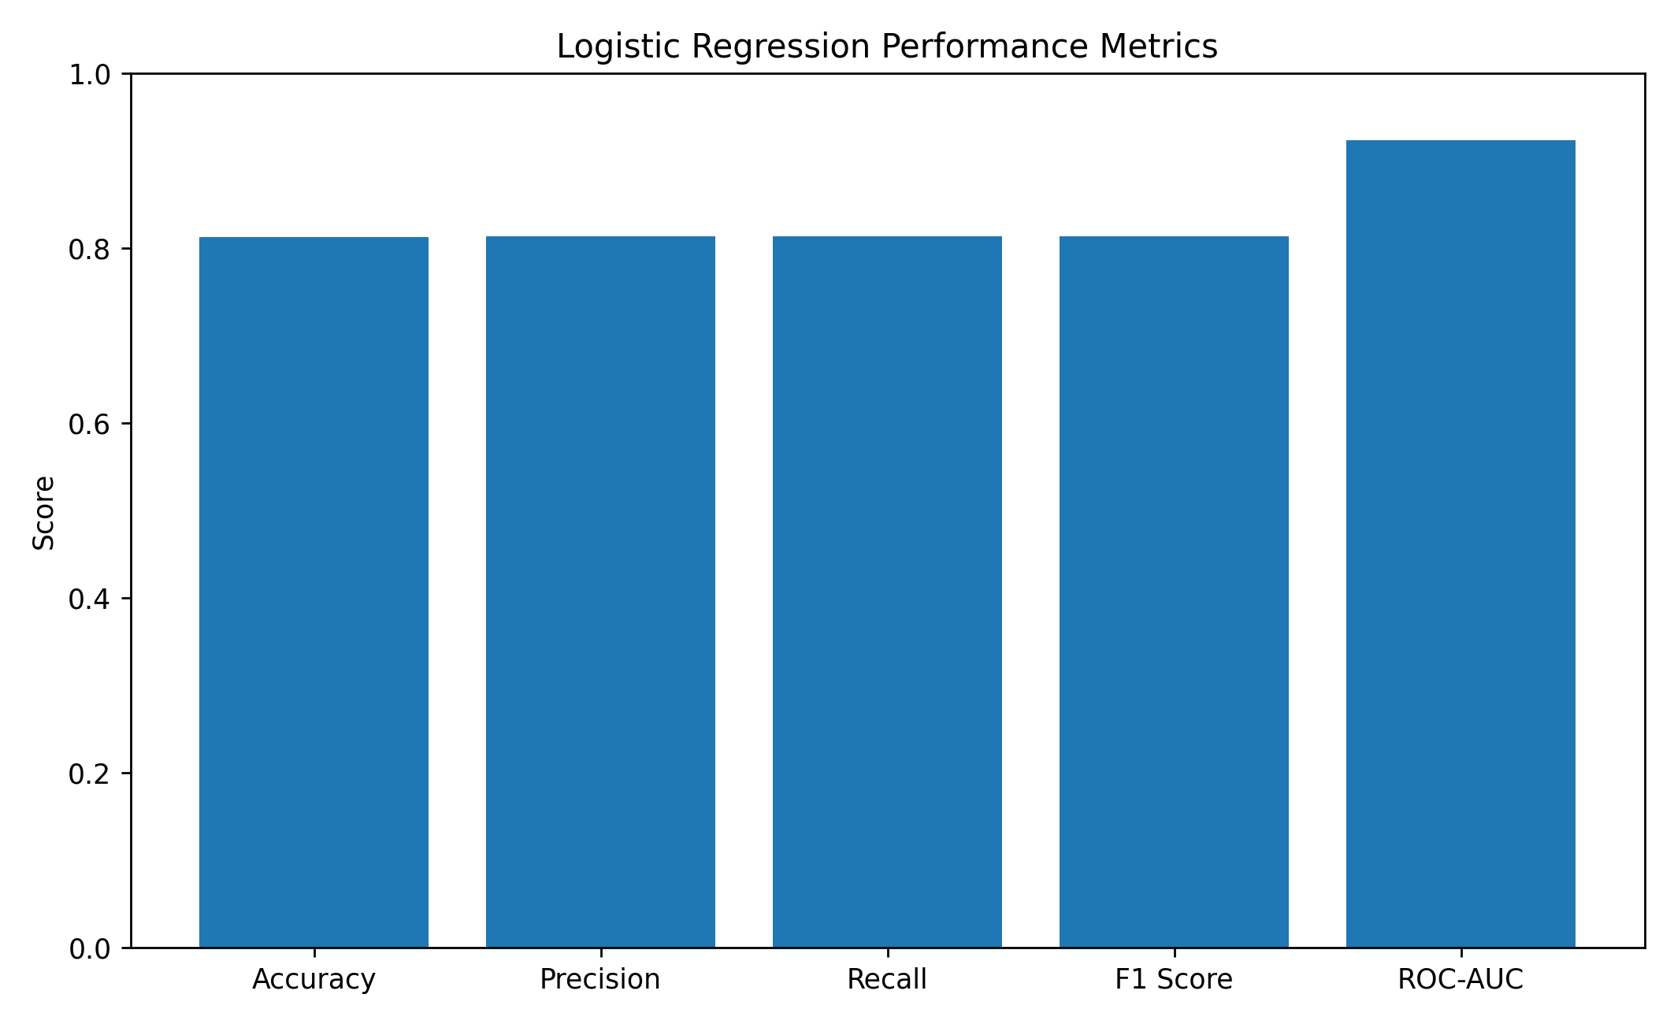
Figure 1. Logistic Regression performance metrics.
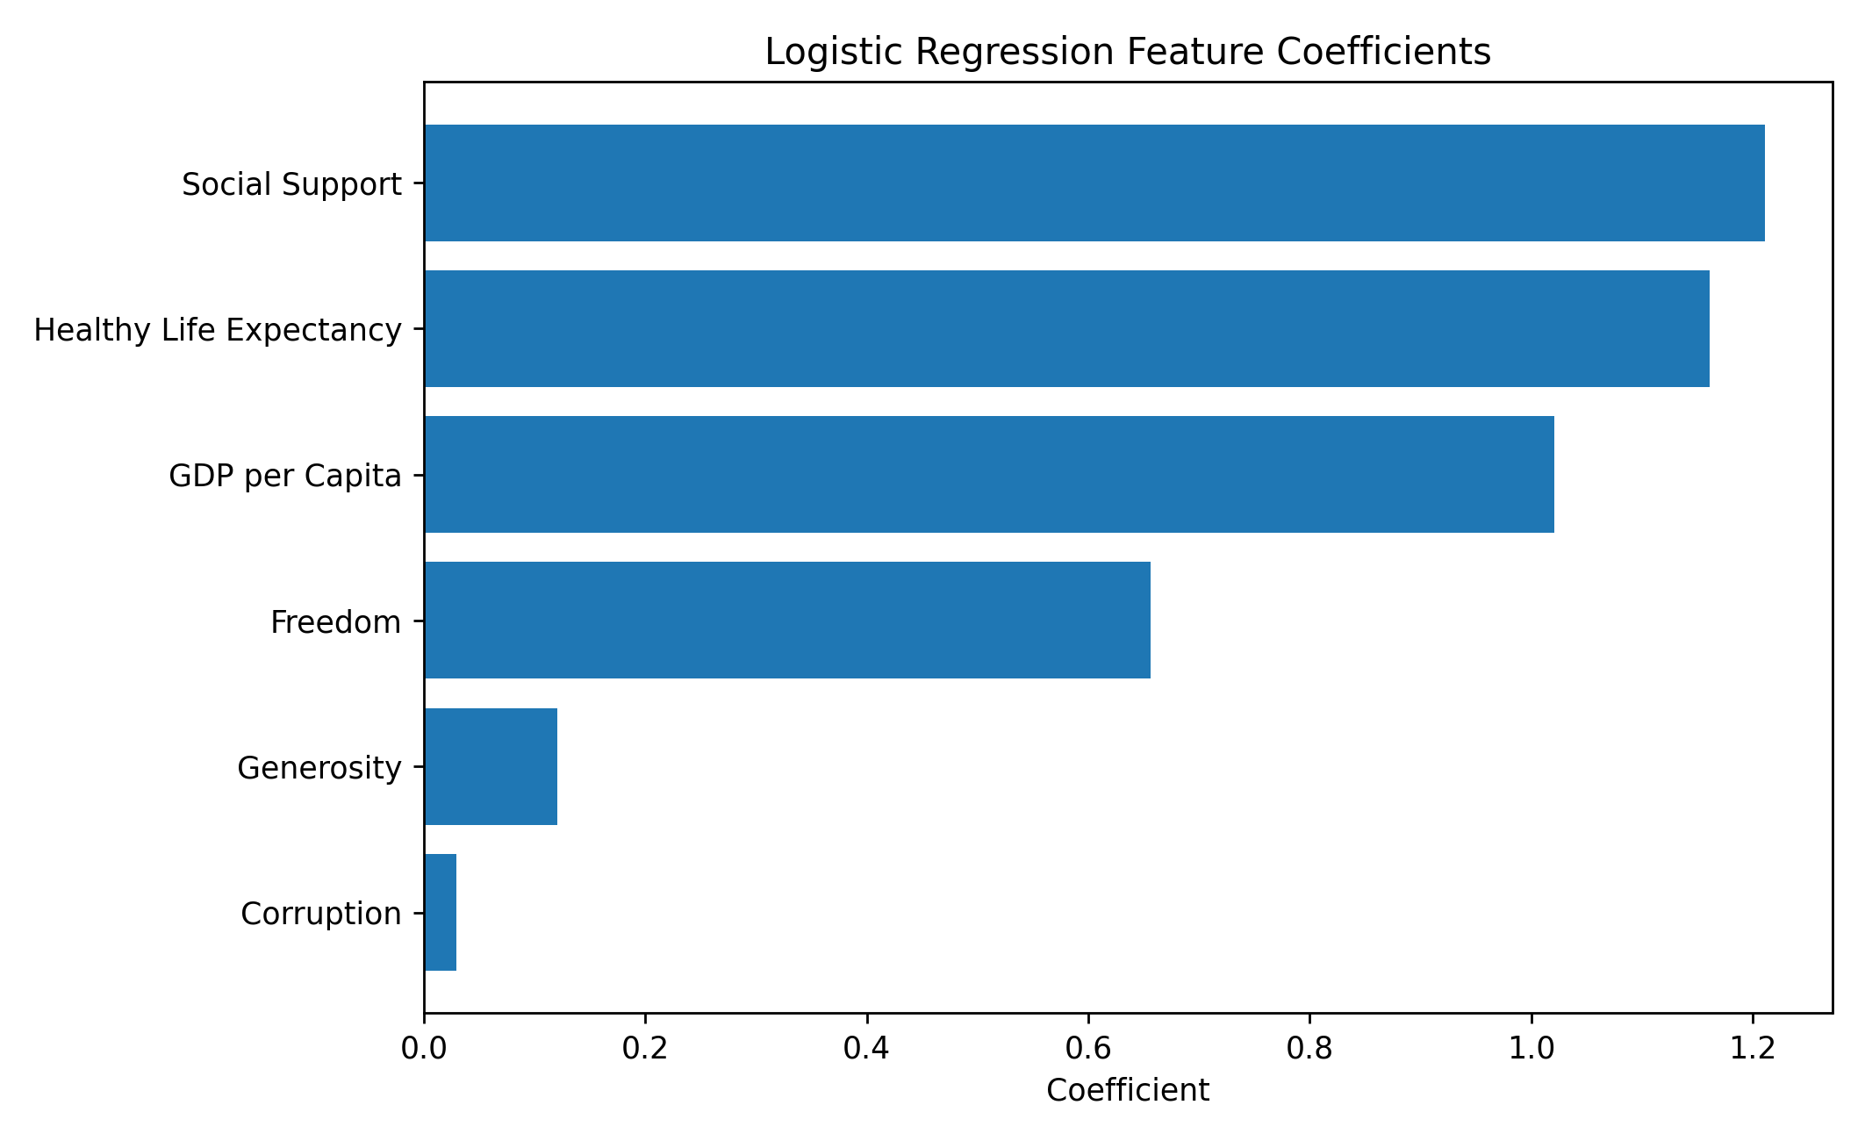
Figure 2. Feature coefficients for the fitted Logistic Regression model.
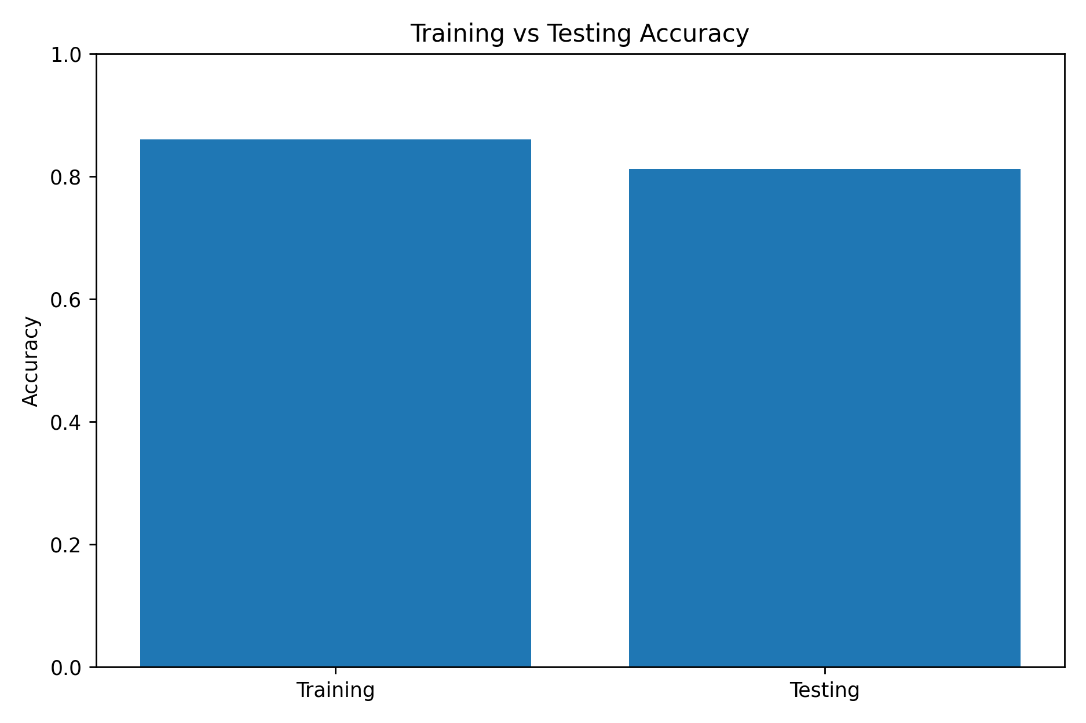
Figure 3. Training versus testing accuracy.

7. Interpretation
The model achieved 81.28% accuracy on unseen test data. Precision, recall, and F1-score were all approximately 81.37%, indicating balanced classification performance. ROC-AUC of 0.9241 indicates strong discriminative ability.
Training accuracy was 86.05% compared with 81.28% testing accuracy, a 4.77 percentage-point gap. This does not indicate severe overfitting based on accuracy alone, although cross-validation would provide a more robust estimate.

8. Feature Interpretation
Social Support: coefficient = 1.2111.
Healthy Life Expectancy: coefficient = 1.1611.
GDP per Capita: coefficient = 1.0210.
Freedom: coefficient = 0.6560.
Generosity: coefficient = 0.1202.
Corruption: coefficient = 0.0294.
All fitted coefficients are positive. Since the features were standardized, coefficient magnitudes are more comparable. Social Support had the largest coefficient, followed by Healthy Life Expectancy and GDP per Capita.

9. Potential Sources of Error
- The median split converts a continuous score into two classes.
- Country-level data do not represent individual-level wellbeing.
- Important explanatory variables may be absent.
- Performance may vary with another split or year.
- The model captures predictive association, not causation.

10. Potential Improvements
- Use k-fold cross-validation.
- Compare with Decision Tree, Random Forest, and Gradient Boosting.
- Tune hyperparameters.
- Use multiple years of data.
- Investigate nonlinear relationships and feature interactions.
- Evaluate alternative target definitions.

11. Conclusion
The Logistic Regression model classified high versus low life evaluation with 81.28% test accuracy and a strong ROC-AUC of 0.9241. The training-test gap was moderate, suggesting reasonable baseline generalization. Social Support, Healthy Life Expectancy, and GDP per Capita were the strongest positive coefficients. Further validation and model comparison would strengthen the analysis.
from sklearn.model_selection import train_test_split
from sklearn.preprocessing import StandardScaler
from sklearn.linear_model import LogisticRegression
from sklearn.metrics import accuracy_score, precision_score, recall_score, f1_score, roc_auc_score
median_life = ml_df["Life_Evaluation"].median()
ml_df["High_Life_Evaluation"] = (
ml_df["Life_Evaluation"] >= median_life
).astype(int)
X = ml_df[features]
y = ml_df["High_Life_Evaluation"]
X_train, X_test, y_train, y_test = train_test_split(
X, y, test_size=0.20, random_state=42, stratify=y
)
scaler = StandardScaler()
X_train_scaled = scaler.fit_transform(X_train)
X_test_scaled = scaler.transform(X_test)
model = LogisticRegression(random_state=42, max_iter=1000)
model.fit(X_train_scaled, y_train)
y_pred = model.predict(X_test_scaled)
y_prob = model.predict_proba(X_test_scaled)[:, 1]
accuracy = accuracy_score(y_test, y_pred)
precision = precision_score(y_test, y_pred)
recall = recall_score(y_test, y_pred)
f1 = f1_score(y_test, y_pred)
auc = roc_auc_score(y_test, y_prob)

