WEEK 3: TASK REPORT
Backend Integration & Database Management — Online Property Tax Payment Portal
System Design, Database Schema, API Integration & Data Management Strategy
Junior Web Developer – E-Governance & Digital Services Internship
Prepared by: Palak Ramtri
Internship Duration: 01 August 2026 – 29 August 2026
Report Date: 27 August 2026

1. Objective
This report plans the back-end functionality of the Online Property Tax Payment Portal introduced in Week 1. It outlines the system architecture, database design, and integration strategy needed to support the front-end screens designed in Week 2, and defines how the platform will manage data securely, remain reliable under load, and integrate cleanly with external services such as the payment gateway.

2. System Design
The backend follows a service-oriented structure behind a single API Gateway, so the front-end (citizen and admin clients) never talks to internal services directly. This keeps authentication, rate-limiting, and routing centralised and makes individual services easier to scale, test, and secure independently.
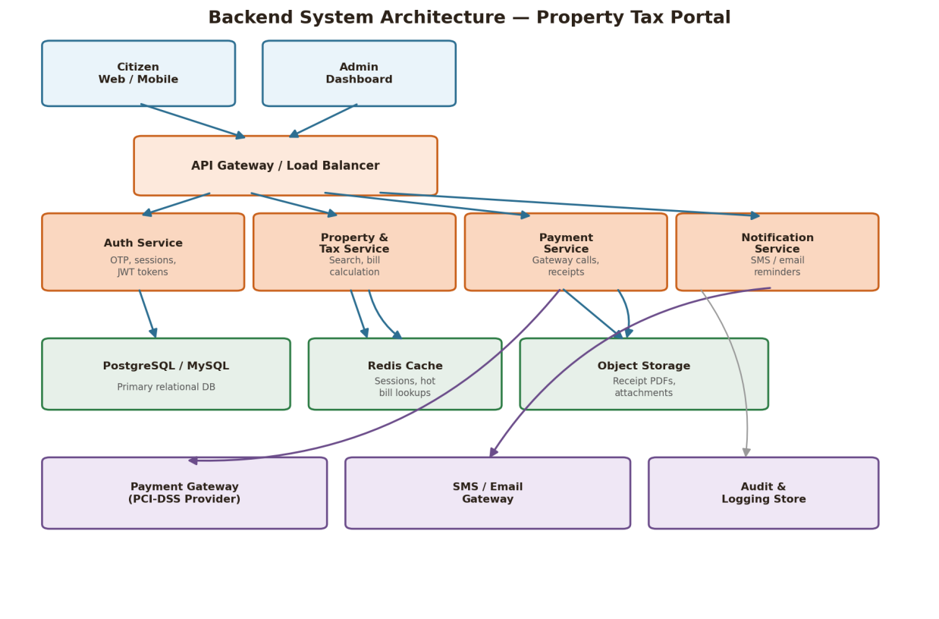
Figure 1: Backend system architecture and data flow

Server Setup
- API Gateway / Load Balancer: terminates HTTPS, validates auth tokens, applies rate-limiting, and routes requests to the correct service.
- Auth Service: issues and validates OTP-based logins and short-lived JWT session tokens.
- Property & Tax Service: handles property lookup and tax/bill calculation logic; reads/writes the core relational database.
- Payment Service: orchestrates calls to the external PCI-DSS payment gateway, records transaction outcomes, and triggers receipt generation.
- Notification Service: sends SMS/email reminders and payment confirmations via an external SMS/email gateway.
- Supporting data stores: a primary relational database (PostgreSQL/MySQL) for core records, a Redis cache for session data and frequently requested bill lookups, object storage for generated receipt PDFs, and a separate audit/logging store.

API Endpoints Overview & Data Flow
A citizen request flows: Client → API Gateway (auth + routing) → relevant service → database/cache/external gateway → response back through the Gateway. For example, a payment request is authenticated at the Gateway, handled by the Payment Service, which calls the external Payment Gateway, updates the tax_records and payments tables, and asynchronously triggers the Notification Service and Receipt generation — matching the process flow defined in Week 1 and the payment screen from Week 2.

3. Database Schema & Relational Model
The schema is normalised around seven core entities. Primary keys (PK) uniquely identify each record; foreign keys (FK) enforce relationships between tables so that, for example, a payment cannot exist without a valid tax assessment and citizen.
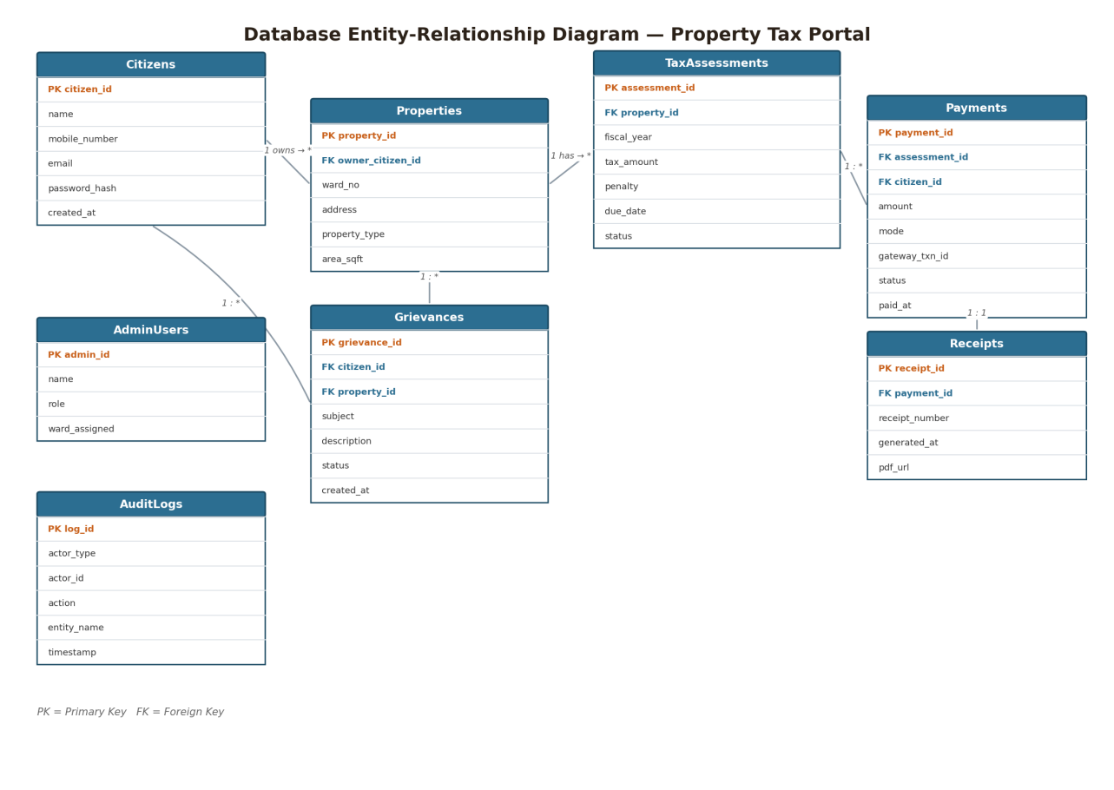
Figure 2: Database entity-relationship diagram
Table | Purpose | Key Relationships
Citizens | Stores registered citizen accounts (property owners). | 1 citizen owns many Properties; 1 citizen raises many Grievances.
Properties | Stores property records (address, type, area, ward). | Belongs to 1 Citizen (owner); has many TaxAssessments.
TaxAssessments | Stores tax due for a property per fiscal year, including penalties and due dates. | Belongs to 1 Property; has many Payments (e.g., partial payments).
Payments | Stores each payment attempt/transaction against a tax assessment. | Belongs to 1 TaxAssessment and 1 Citizen; has exactly 1 Receipt on success.
Receipts | Stores the generated digital receipt for a successful payment. | Belongs to 1 Payment (1:1).
Grievances | Stores citizen-raised queries or disputes linked to a property. | Belongs to 1 Citizen and 1 Property; handled by 1 Admin.
AdminUsers | Stores municipal staff accounts with role and ward assignment. | Handles many Grievances; used for admin-dashboard access control.
AuditLogs | Stores an append-only record of sensitive actions (logins, payments, admin edits). | References actor (citizen or admin) and the affected entity, for traceability.
The model is normalised to third normal form (3NF): each non-key field depends only on its table's primary key, tax and payment history are kept in separate tables rather than duplicated on the Properties table, and receipts reference payments rather than storing amounts redundantly. This avoids update anomalies (e.g., a tax amount changing in one place but not another) and keeps the schema straightforward to extend, for example adding a new fiscal year simply inserts a new TaxAssessments row rather than altering table structure.

4. API Design & Integration
The backend exposes a set of versioned RESTful APIs consumed by the front-end designed in Week 2. All endpoints require an authenticated session except registration, login, and OTP requests.
Method & Endpoint | Description | Key Parameters | Response
POST /api/v1/auth/otp | Request an OTP for a mobile number/email. | mobile_or_email | 202 Accepted, OTP dispatched
POST /api/v1/auth/login | Verify OTP and issue a session (JWT). | mobile_or_email, otp | 200 OK + access_token
GET /api/v1/properties/search | Search properties by ID, owner name, or ward. | query, ward (optional) | 200 OK, list of matching properties
GET /api/v1/properties/{id}/tax | Fetch current tax dues and history for a property. | property_id (path) | 200 OK, tax assessment + history
POST /api/v1/payments | Initiate a payment for a tax assessment. | assessment_id, amount, mode | 201 Created, payment_id + gateway redirect/session
POST /api/v1/payments/{id}/callback | Webhook the payment gateway calls on completion. | payment_id (path), gateway_txn_id, status | 200 OK, internal record updated
GET /api/v1/receipts/{payment_id} | Retrieve/download the digital receipt for a payment. | payment_id (path) | 200 OK, receipt metadata + PDF URL
POST /api/v1/grievances | Raise a grievance linked to a property. | property_id, subject, description | 201 Created, grievance_id
GET /api/v1/admin/collections | Admin: view collection summary by ward/period. | ward, from, to (query) | 200 OK, aggregated collection data
Communication protocol: all endpoints use JSON over HTTPS, follow standard REST conventions (resource-based URLs, correct HTTP verbs, and status codes), and are versioned under /api/v1/ so future changes don't break existing front-end clients. The Payment Service integrates with the external gateway using a server-to-server webhook (payments/{id}/callback) rather than trusting the client's browser redirect alone, so a payment cannot be falsely marked successful by a manipulated client request.

5. Security & Performance Considerations
Concern | Risk | Mitigation
Authentication & Sessions | Stolen/forged tokens could allow account takeover. | Short-lived JWTs with refresh tokens; OTP re-verification before payment; rate-limit login attempts (ties to Week 3-QA TC-05).
SQL Injection | Unsanitised input in search/grievance forms could manipulate queries. | Parameterized queries/ORM only; least-privilege database accounts; input validation at the API layer.
Data in Transit | Interception of citizen/payment data over the network. | Enforce HTTPS/TLS 1.2+ everywhere; HSTS headers; no sensitive data in URL query strings.
Data at Rest | Database breach exposing personal/financial data. | Encrypt sensitive columns (e.g., contact details); never store full card numbers — rely on the PCI-DSS gateway token.
Duplicate/Replayed Payments | A retried gateway callback could double-record a payment. | Idempotent payment references; the callback handler checks gateway_txn_id before updating status.
Read Latency on Bill Lookup | Frequent tax-due lookups could slow down under load. | Cache recent bill lookups in Redis with a short TTL; invalidate cache on payment success.
Peak Load Near Due Dates | Traffic spikes could overwhelm the database (per Week 1 risk register). | Connection pooling, read replicas for search/reporting queries, and horizontal scaling of stateless services behind the load balancer.
Authorization / IDOR | A citizen could attempt to access another citizen's property or payment record. | Enforce ownership checks server-side on every request; never rely on client-supplied IDs alone.

6. Backup, Recovery & Maintenance Strategy
- Automated daily full backups of the primary database, retained for 30 days, with incremental backups every 6 hours during business hours.
- Backups encrypted at rest and stored in a separate region/availability zone from the primary database to protect against regional outages.
- Point-in-time recovery (PITR) enabled so the database can be restored to any point within the retention window, minimising data loss in the event of corruption.
- Quarterly disaster-recovery drills: restore a backup to a staging environment and verify data integrity and application functionality.
- Scheduled maintenance windows (outside peak hours) for schema migrations, index rebuilding, and dependency updates, communicated to citizens in advance via a maintenance banner.
- Continuous monitoring and alerting on database health (replication lag, disk usage, slow queries) with on-call escalation for critical failures.
- The AuditLogs table (Figure 2) is retained separately and immutably, supporting post-incident investigation independent of the main data-recovery process.

7. Conclusion
This backend plan gives the Online Property Tax Payment Portal a clear, service-oriented architecture: a normalised seven-table relational schema, a versioned RESTful API surface that matches the Week 2 front-end flows, and concrete measures for security, performance, and disaster recovery. Together with the requirements from Week 1 and the testing strategy from Week 3 (QA), this forms a complete, implementation-ready backend design for the platform.

