WEEK 3 TASK REPORT
Quality Assurance & Testing Strategy for the Online Property Tax Payment Portal
Evaluation & Testing Phase — Test Plan, Test Cases & Risk Analysis
Junior Web Developer – E-Governance & Digital Services Internship
Prepared by: Palak Ramtri
Internship Duration: 01 August 2026 – 29 August 2026
Report Date: 18 August 2026

1. Objective
With planning (Week 1) and design (Week 2) complete, this week's focus shifts to evaluation and testing. This report defines a comprehensive quality assurance and testing strategy for the Online Property Tax Payment Portal, covering functional, performance, and security testing, so that the platform delivers reliable, accurate, and secure service to citizens before deployment.

2. Test Plan Overview
The testing strategy follows a layered approach, moving from small, fast checks to broad, end-to-end validation. The testing pyramid below shows the proportion of effort recommended at each level.
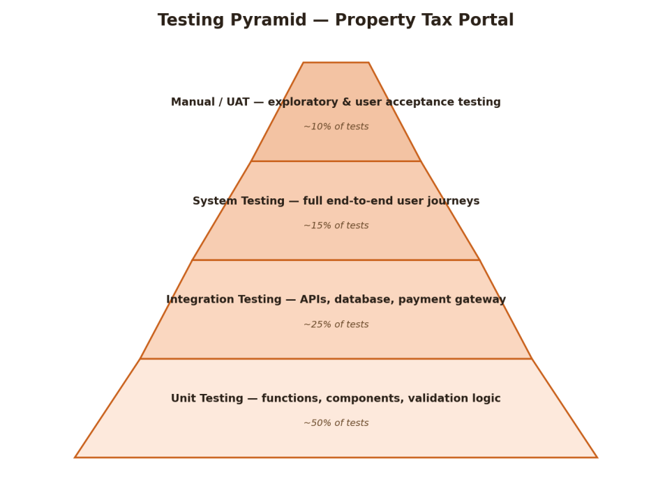
Figure 1: Testing pyramid for the property tax portal

Types of Testing Covered
- Unit Testing: Validates individual functions in isolation — e.g., tax calculation logic, OTP validation, input field validation (property ID format, mobile number format).
- Integration Testing: Verifies that components work together correctly — e.g., the search service correctly queries the property database, and the payment module correctly calls the external payment gateway API.
- System Testing: Validates complete end-to-end user journeys against the flows defined in Week 1 and Week 2 — e.g., login → search → view bill → pay → receive receipt.
- Performance / Stress Testing: Measures how the system behaves under expected and peak load, particularly near tax due dates when traffic spikes (as identified as a risk in Week 1).
- Security Testing: Checks for common vulnerabilities (SQL injection, cross-site scripting, broken authentication, insecure data transmission) given that the portal handles personal and financial data.
- User Acceptance Testing (UAT): A small group of representative citizens (matching the personas from Week 1) test the live-like prototype and confirm it meets their real-world needs.

Manual vs Automated Execution
- Automated: Unit tests and integration tests (via a framework such as Jest/Mocha for Node.js, and Postman/Newman for API testing) run automatically on every code change through a CI pipeline.
- Automated: Core regression scenarios (login, search, payment) are covered by automated end-to-end tests (e.g., Playwright/Cypress) so they can be re-run quickly after each fix.
- Manual: Exploratory testing, UAT, and usability checks (especially for the personas with lower digital literacy, per Week 1) are performed manually, since these rely on human judgement of clarity and ease of use.
- Manual: Security penetration testing is performed manually/by a specialist tool audit before major releases, supplemented by automated vulnerability scanning.

3. Test Cases
The table below defines representative test cases covering the core functionalities of the platform, spanning functional, security and performance testing.
ID | Scenario | Steps | Expected Result | Type
TC-01 | Successful OTP login | 1) Enter registered mobile number. 2) Request OTP. 3) Enter correct OTP. 4) Submit. | User is authenticated and redirected to the dashboard within 3 seconds. | Functional
TC-02 | Property search by Property ID | 1) Log in. 2) Enter a valid Property ID in the search bar. 3) Click Search. | Correct property details and current tax dues are displayed. | Functional
TC-03 | Successful tax payment via UPI | 1) Select a property with pending dues. 2) Click 'Pay Now'. 3) Choose UPI. 4) Complete payment. | Payment succeeds; receipt is generated; municipal record is updated with the new payment status. | Functional / Integration
TC-04 | Failed payment handling | 1) Start a payment. 2) Simulate a gateway timeout or bank decline. | Transaction is marked as failed (not silently lost); no duplicate tax record update; user is shown a clear retry option. | Functional / Negative
TC-05 | Invalid OTP entry | 1) Request OTP. 2) Enter an incorrect OTP three times. | Login is blocked after the configured number of attempts; user sees a clear error and a cooldown/retry message. | Security / Negative
TC-06 | Unauthorized data access attempt | 1) Log in as Citizen A. 2) Attempt to view Citizen B's property record via a manipulated URL/ID. | Access is denied; system logs the attempt; no data belonging to another citizen is exposed. | Security
TC-07 | Peak load during due-date week | 1) Simulate concurrent users (e.g., 500+ simultaneous sessions) searching and paying near the due date. | Average response time stays within the 3-second target (per Week 1 NFR-3); no failed transactions due to server overload. | Performance / Stress
TC-08 | Responsive layout on mobile device | 1) Open the portal on a low-end Android device / narrow viewport. 2) Navigate through login, search and payment. | Layout adapts correctly (single column, hamburger menu, full-width buttons) per the Week 2 responsive wireframes; no broken elements. | Functional / UI

4. Risk Analysis & Mitigation
Building on the project-level risks identified in Week 1, the table below focuses specifically on risks and bugs that could surface during testing and affect user experience or data security.
Risk / Potential Bug | Impact | Mitigation & Contingency
Duplicate payment recorded due to gateway callback retried after a delay | High — citizen may be charged twice or dues may be marked paid incorrectly | Implement idempotent transaction IDs; reconcile gateway callbacks against a unique reference before updating records; manual finance reconciliation as a contingency.
Session left open on a shared/public device (e.g., a CSC kiosk) | Medium — risk of unauthorized access to another citizen's data | Auto-logout after a short inactivity period; require OTP re-verification for payment even within an active session.
Incorrect tax amount displayed due to stale cached data | High — citizen pays wrong amount or disputes the bill | Always fetch live dues at the point of payment rather than relying on cached search results; display a 'last updated' timestamp.
Third-party payment gateway outage during peak hours | High — citizens unable to pay near the deadline | Integrate a secondary backup gateway; queue and retry failed attempts; display a maintenance banner instead of a silent failure.
Cross-site scripting (XSS) via the search or grievance input fields | High — potential data theft or session hijacking | Sanitize and validate all user input on both client and server; use parameterized queries; run automated security scans in CI.
Accessibility regression on mobile after a UI update | Medium — excludes citizens with low digital literacy or older devices | Include a responsive/UI test (TC-08) in every regression cycle; manual usability check with representative personas before release.

5. Test Execution & Automation Workflow
The diagram below shows how testing will be executed across the project lifecycle, from writing test cases through to sign-off, with a repeatable fix-and-retest loop.
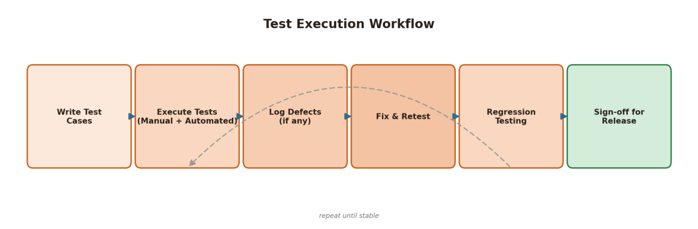
Figure 2: Test execution workflow
Automated unit and integration tests run on every commit via a CI pipeline, giving fast feedback to developers. Automated end-to-end tests for the core payment journey run before each deployment. Manual exploratory testing, UAT with representative citizen personas, and security review are scheduled before major releases, particularly ahead of high-traffic periods such as the tax due-date window.

6. Conclusion
This testing strategy ensures the Online Property Tax Payment Portal is validated at every level — from individual functions to full citizen journeys — before it reaches the public. By combining automated regression coverage for core flows with targeted manual testing for usability and security, and by directly addressing the risks identified in Weeks 1 and 2 (payment reliability, data privacy, peak-load performance, and accessibility), the platform is positioned to deliver a dependable and secure service. This forms the basis for final testing, deployment, and handover in Week 4.

