MANAV RACHNA COLLEGE OF ENGINEERING

DEPARTMENT OF CSE

SYNOPSIS
B.Tech <CSE> 8th Semester Industrial Project

Submitted by
<Palak Agarwal>
<2K10 – MRCE – CSE - 090>

being carried out at
<Indian Petro Group , Shahpur Jat, New Delhi >
under the guidance of
<Mr. Pranabjyoti Nath , Head – IT Department>

Contents:

1. Problem Statement
2. Objective and Scope
3. Methodology
4. Process Description including DFD’s (Level 0/ Level 1)/Use Case Diagrams and ER diagram (if any)
5. Hardware & Software Specifications
6. Your role in the project
7. Planned Testing technologies and Security Mechanisms
8. What contribution would the project make?
9. Limitations/Constraints of the project
10. References and bibliography

- Problem Statement

Countries need to know how many people are born and die each year – and the main causes of their deaths – in order to have well-functioning health systems. Countries that do not have a well-functioning civil registration system only have approximate ideas of the numbers, the longevity and the health of their population. Even to search for a person there should be a proper database with which we can keep a track of the citizens in a country. The only way to count everyone and to track all births and deaths is through civil registration.

- (a) Objective

Civil Registry is a continuous, permanent and compulsory recording of vital events occurring in the life of an individual such as birth, marriage, and death, as well as court decrees, and legal instruments affecting his civil status in appropriate registers as mandated by Act No. 3753, the Civil Registry Law.

The primary objective of this web site is to give awareness about the government or legal documents and its registration details as well as to help to register or apply for those documents. This also acts as a consultancy agency to assist the public. The main purpose of the web site is to reduce the effort by the candidate and save his time and avoid unwanted rushes at the government offices and assure a smooth working schedule at government offices.

(b) Scope
These establish the occurrence of birth, death, or marriage and therefore provide prima facie evidence of facts surrounding these events.
Birth records present many facts about an individual such as the person’s name, date and place of birth, parents, religion, and citizenship, among others. The marriage certificate establishes a change in civil status and the legal spouse while the death certificate records the passing away of an individual.
These records are important in legal and personal transactions, applying for jobs, obtaining passports for travel, entrance to school, claiming insurance benefits, and others.
These records provide data on the number of births, deaths, marriages, fetal deaths, adoptions, and the like, which in turn are essential in development planning.
The project Civil Registry still requires more development of IT solutions and its applications to improve the issuance of copies of government certificates and legal documents. Civil registry team is trying to get more affiliation to government offices and departments.

- Methodology

The Project
This is a system by which a government records the vital events of its citizens and residents. The resulting repository or database is called civil register or registry, or population registry. The primary purpose of civil registration is to create legal documents that are used to establish and protect the civil rights of individuals. A secondary purpose is to create a data source for the compilation of vital statistics. Complete coverage, accuracy and timeliness of civil registration are essential for quality vital statistics. Vital events that are typically recorded include live birth, death, and marriage. Among the legal documents that are derived from civil registration are birth certificates, death certificates, and marriage certificates. Civil registration brings multiple benefits. An individual’s right to be counted at both extremes of life is fundamental to social inclusion. In the absence of insurance or inheritance, death registration and certification are often required prerequisites for burial, remarriage, or the resolution of criminal cases. For health agencies like WHO, civil registration systems are the most reliable source of statistics on births and deaths, and causes of death. Civil registration is the way by which countries keep a continuous and complete record of births, deaths and the marital status of their people.

- Process Description including DFD’s (Level 0/ Level 1)/Use Case Diagrams and ER diagram (if any)

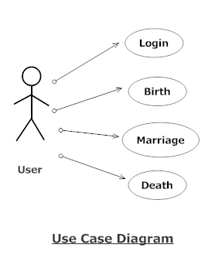

E R Diagram

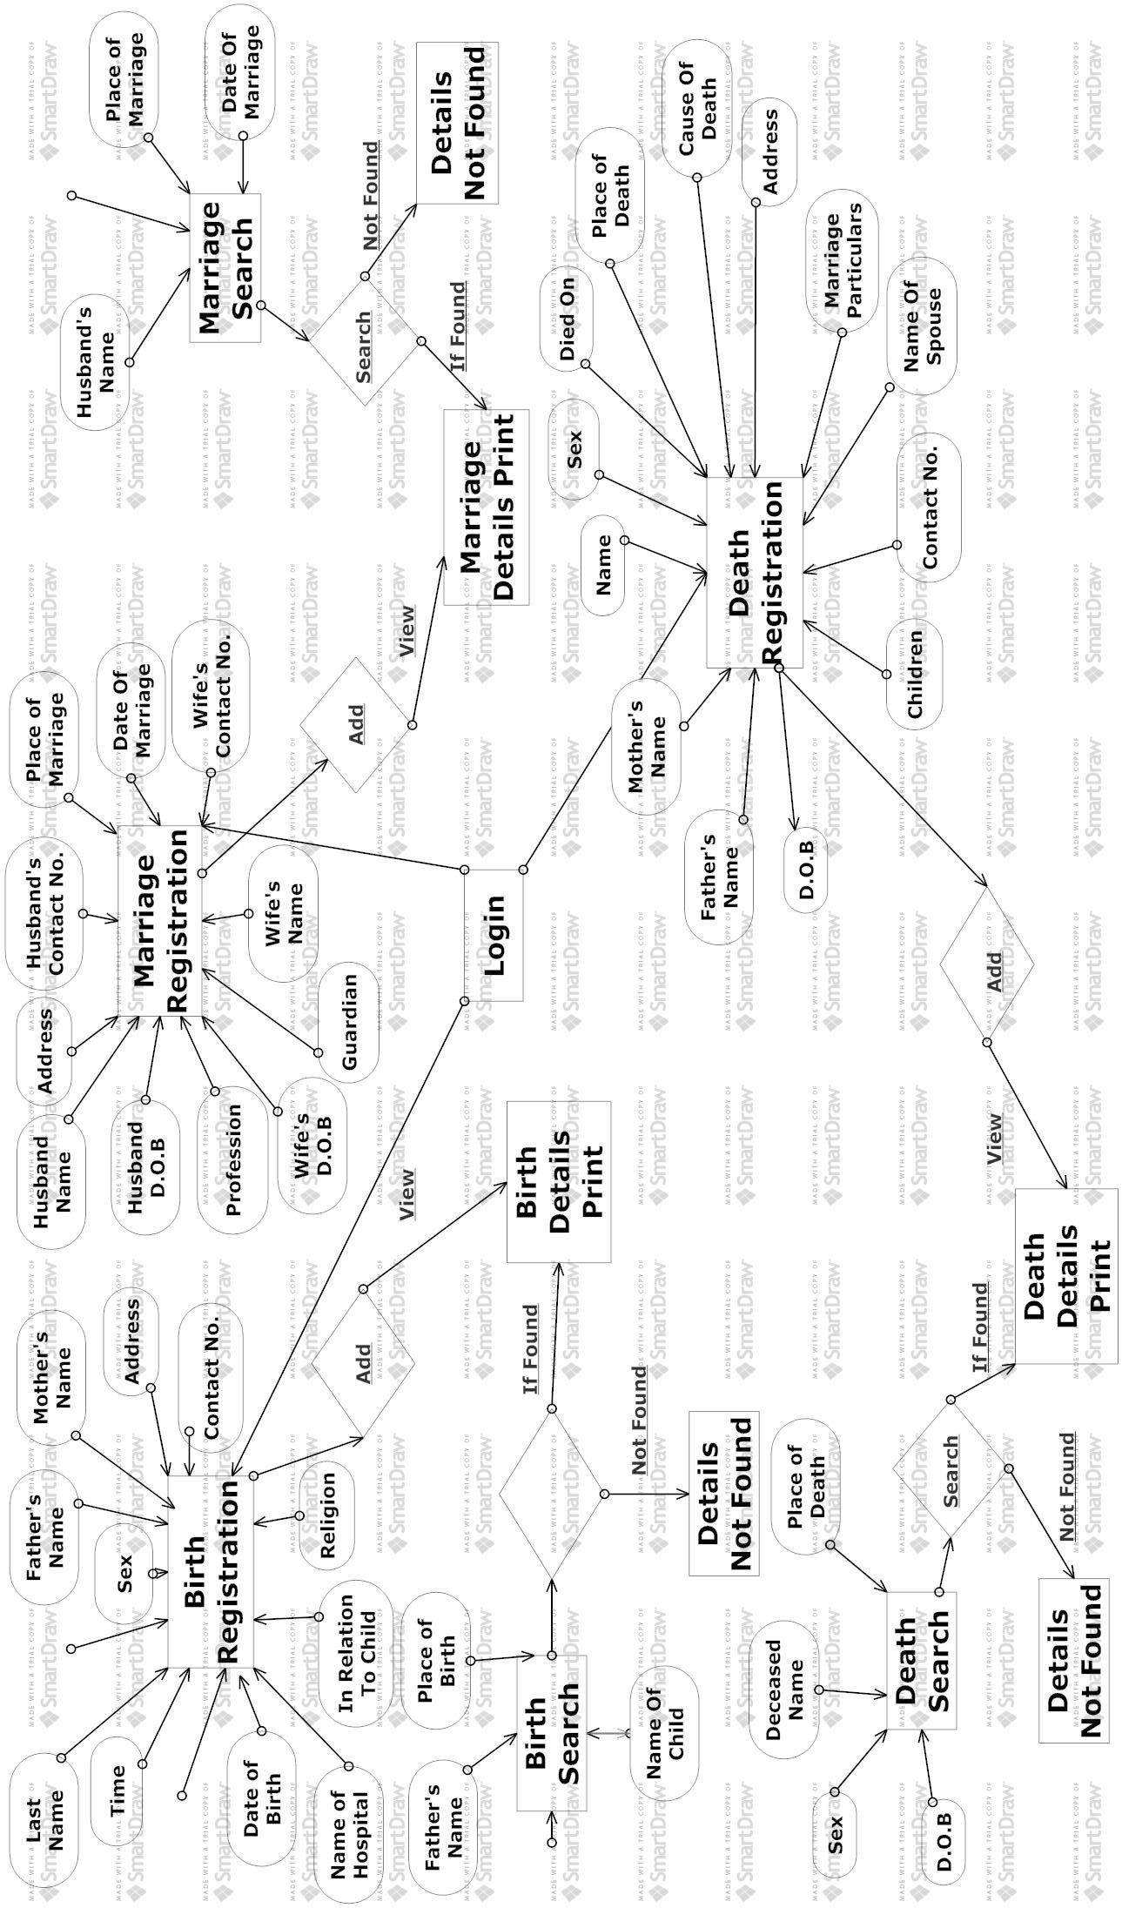

- (a) Software Requirement Specification:

Operating Platform : Microsoft Windows 7 Home Basic
Data Base : HeidiSQL
Software : Apache Tomcat Server (web server)
Back End Tool : MS Access
Programing Language : Java, JSP, HTML, JavaScript
Document Tool : Microsoft Windows 7

(b) Hardware Requirement Specification:

Processor : Intel(R) Core i5
Speed : 233 MHz
System : 64 Bit Operating System
Ram : 4 GB
- Your role in the project

I have created a dynamic website of Civil Registration System where we have three modules namely Birth, Marriage and Death. A newly born child can be registered on the site, Marriage’s can be registered and deaths of deceased be registered. We can even search for persons the site and view their details.

- Planned Testing technologies and Security Mechanisms

Testing is a process to show the correctness of the program. Testing is needed to show completeness, it improve the quality of the software and to provide the maintenance aid. Some testing standards are therefore necessary reduce the testing costs and operation time. Testing software extends throughout the coding phase and it represents the ultimate review of configurations, design and coding. Based on the way the software reacts to these testing, we can decide whether the configuration that has been built is study or not. All components of an application are tested, as the failure to do so many results in a series of bugs after the software is put to use.
Blackbox Testing
Blackbox testing also called behavioral testing, focuses on the functional requirements of software. This testing approach enables the software engineer to derive the input conditions that will fully exercise all requirements for a program. Blackbox testing attempts to find the errors like
- Incorrect or missing functions
- Interface errors
- Errors in data structures or external database access
- Behavior or performance errors
- Initialization and termination errors
In Blackbox testing software is exercised over a full range of inputs and outputs are observed for correctness.
Whitebox Testing
Whitebox testing is also called Glassbox testing is a test case design control; structure of the procedural design to derive test cases using Whitebox testing method, the software engineer can derive the test cases that guarantee that all independent paths within the module have been exercised at least once. Exercise all logic decisions on their true or false sides. Execute all loops at their boundaries and within their operational bounds. Exercise internal data structure to ensure their validity.
Software Testing Strategies
Testing involves
· Unit testing
· Integration testing
· Acceptance testing

The first level of test is unit testing. The purpose of unit testing is to ensure that each program is fully tested. The second step is integration testing. In this individual program units or programs are integrated and tested as a complete system to ensure that the software requirements are met.
Acceptance Testing involves planning and the execution of various types of tests in order to demonstrate that the implemented software system satisfies the requirements. Finally our project meets the requirements after going through all the levels of testing.
SECURITY
The system security problem can be divided into four related issues: security, integrity, privacy and confidentiality. They determine the file structure, data structure and access procedures. System security refers to the technical innovations and procedures applied to the hardware and operating systems to protect against deliberate or accidental damage from a defined threat. In contrast, data security is the protection of data from loss, disclosure, modifications and destruction.
System integrity refers to the proper functioning of programs, appropriate physical security and safety against external threats such as eavesdropping and wiretapping. In comparison, data integrity makes sure that do not differ from original from others and how the organization can be protected against unwelcome, unfair or excessive dissemination of information about it. The term confidentiality is a special status given to sensitive information in a data base to minimize the possible invasion of privacy. It is an attribute of information that characterizes its need for protection. System security is the technical means of providing such protection. In contrast privacy is largely a procedural matter of how information is used.
- What contribution would the project make?

Civil registration brings multiple benefits. An individual’s right to be counted at both extremes of life is fundamental to social inclusion. In the absence of insurance or inheritance, death registration and certification are often required prerequisites for burial, remarriage, or the resolution of criminal cases. For health agencies like WHO, civil registration systems are the most reliable source of statistics on births and deaths, and causes of death. Civil registration is the way by which countries keep a continuous and complete record of births, deaths and the marital status of their people.
- Limitations/Constraints of the project

It is generally based on a national citizen identification number, allowing various databases to be linked together. Countries that do not use national citizen identification numbers would find it far more difficult to create a civil registry with a high level of currency, accuracy and completeness;
In a civil registry database, care must be taken in maintaining the data needed for the management and the production of the citizen’s list.
If the ministry responsible for maintaining the civil registry is either unwilling or unable to keep it current, accurate or complete to acceptable, pre-determined standards, the authority is forced to start with poor data as the basis for the citizen’s welfare.

- References and bibliography

- Java – 2 Complete Reference
Author: Patrice Norton & Herbert Child Publisher: Tata McGraw Hill
- System Analysis & Designing
Author: James A. Senn
Publisher: Tata McGraw Hill
- Software Engineering Concepts
Author: Fairley
Publisher: (TATA MC-GRAW Hill publication, Third Edition)
- Software engineering principles
Author: pressman
- Java Server Pages
Author: James good will Pubishentechmedia
- Google Search Engine

