Data Collection, Cleaning, and Preprocessing for Logistics Analysis

Prepared By
Palak Bhargav
Project Domain: Logistics & Supply Chain Analytics
Tools Used: Python, Pandas, NumPy, Matplotlib
Dataset: Brazilian E-Commerce Public Dataset by Olist

1. Introduction
Data collection and preprocessing are important steps in logistics and supply chain analytics. The quality of the input data directly affects the reliability of analysis and decision-making.
For this task, a publicly available Brazilian E-Commerce dataset by Olist was selected as the reference logistics dataset. The dataset contains customer and geographic information that can be used to understand customer distribution across different cities and states.
The preprocessing workflow was implemented using Python and Pandas. It included data inspection, missing-value checking, duplicate detection, data-type correction, ZIP-code validation, text standardization, exploratory analysis, and final data-quality verification.
The Olist dataset was also selected in the earlier project planning because its customer, location, order, seller, freight, and delivery-related information provides a suitable foundation for logistics analysis.

2. Objectives
The main objectives of this task were:
- To collect and understand a publicly available logistics-related dataset.
- To inspect the structure and quality of the dataset.
- To identify missing values and duplicate records.
- To identify and correct inappropriate data types.
- To validate geographic ZIP-code information.
- To standardize inconsistent text values.
- To perform exploratory analysis of customer distribution.
- To understand the importance of outlier detection and normalization.
- To create a clean dataset suitable for further logistics analysis.
- To document the complete preprocessing process using Python.

3. Dataset Collection

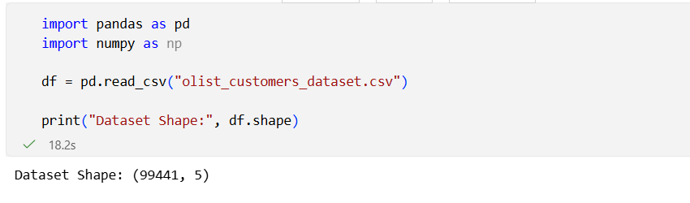Figure 1: Initial Dataset Loading and Shape

3.1 Dataset Selected
The Brazilian E-Commerce Public Dataset by Olist was selected for this project.
The dataset is publicly available and contains information related to Brazilian e-commerce operations. It includes customer, order, seller, product, payment, freight, review, and geographic information.
For this preprocessing task, the Olist Customers Dataset was used.
Dataset file: olist_customers_dataset.csv
Source: Olist Brazilian E-Commerce Public Dataset
Reference: Kaggle – Brazilian E-Commerce Public Dataset by Olist

4. Dataset Characteristics
The selected customer dataset initially contained:
- Total Records: 99,441
- Total Columns: 5
- Missing Values: 0
- Duplicate Records: 0
The five columns were:
Column | Description
customer_id | Customer identifier
customer_unique_id | Unique customer identifier
customer_zip_code_prefix | Customer ZIP-code prefix
customer_city | Customer city
customer_state | Customer state code

The dataset mainly contains categorical and identifier-based information. Therefore, preprocessing techniques were selected according to the meaning of each variable rather than applying numerical transformations blindly.

5. Tools and Technologies Used
The following tools were used:

Python
Used as the primary programming language for data preprocessing and analysis.

Pandas
Used for:
- Reading CSV data
- Data inspection
- Missing-value analysis
- Duplicate detection
- Data transformation
- Data cleaning
- Saving the cleaned dataset

NumPy
Imported for numerical/data-processing support.

Matplotlib
Used to create visualizations for exploratory data analysis.

Jupyter Notebook in VS Code
Used to execute and document the complete preprocessing workflow.

6. Data Collection and Initial Inspection
The dataset was loaded using Pandas.
import pandas as pd
import numpy as np
df = pd.read_csv("olist_customers_dataset.csv")
print("Dataset Shape:", df.shape)
The dataset shape was:
(99441, 5)

The first few records, column names, data types, missing values, and duplicate records were then inspected.
display(df.head())

print("Column Names:")
print(df.columns.tolist())

print("\nData Types:")
print(df.dtypes)

print("\nMissing Values:")
print(df.isnull().sum())

print("\nDuplicate Rows:", df.duplicated().sum())

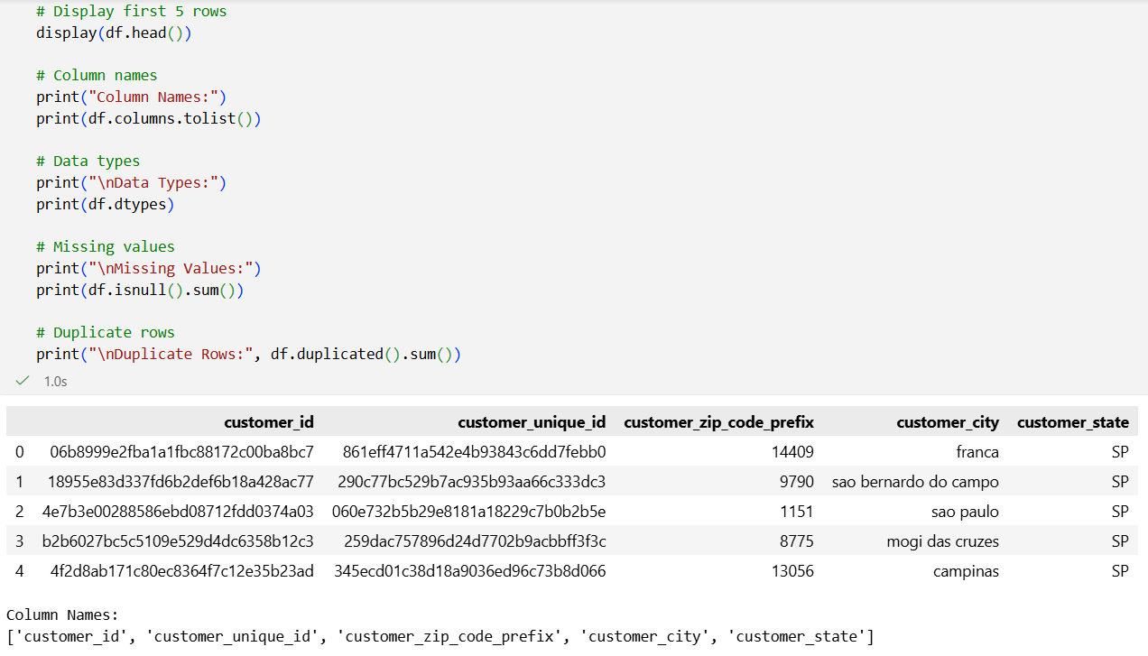

Figure 2: Initial Dataset Records

Initial Findings
- The dataset contained 99,441 records.
- There were 5 columns.
- No missing values were detected.
- No duplicate rows were detected.
- ZIP-code prefix was initially stored as an integer.
- City and state information was stored as text.

7. Data Quality Issues Identified
The dataset was checked for common data-quality issues.
The following areas were considered:
- Missing values
- Duplicate records
- Incorrect data types
- Invalid ZIP-code formats
- Leading/trailing spaces
- Empty text values
- Inconsistent text formatting
- Outliers
- Normalization requirements
Although some common problems were considered during preprocessing, the actual dataset did not contain missing values or duplicate records.

8. Missing Value Handling

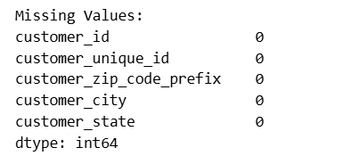

Figure 3: Missing Value Analysis
Missing values were checked using Pandas.
print(df.isnull().sum())

Result
The analysis found:
Total Missing Values = 0
Missing values were checked using Pandas.
print(df.isnull().sum())

Result
The analysis found:
Total Missing Values = 0
Therefore, no imputation technique such as mean, median, mode, or forward filling was required.
No records were removed because of missing values.

Methodological Explanation
Missing-value handling is important because incomplete records can affect calculations and may produce misleading analytical results. Since this dataset contained no missing values, retaining all records was the most appropriate approach.

9. Duplicate Record Detection

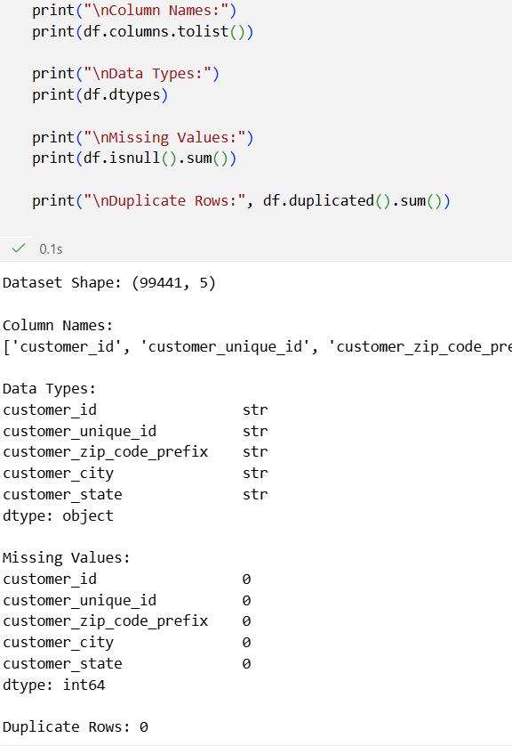
Figure 4: Duplicate Record Check
Duplicate rows were checked using:
print("Duplicate Rows:", df.duplicated().sum())

Result
Duplicate Records = 0

Therefore, no duplicate records needed to be removed.
Duplicate removal is important in logistics analytics because repeated records can artificially increase customer counts and distort regional analysis.

10. Data Type Correction
The customer_zip_code_prefix column was initially stored as an integer.
However, ZIP codes are identifiers rather than continuous numerical measurements. Therefore, treating them as numerical values could create an incorrect interpretation.
The ZIP-code field was converted into string format and standardized to five digits.
df["customer_zip_code_prefix"] = (
df["customer_zip_code_prefix"]
.astype(str)
.str.zfill(5)
)

Reason for the Transformation
For example, a ZIP prefix such as 1234 should be represented as:
01234
rather than:
1234
This maintains the correct identifier format.

11. ZIP-Code Validation

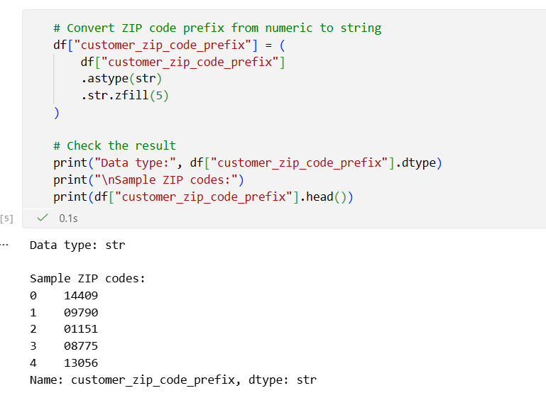

Figure 5: ZIP Code Validation Results
After conversion, the ZIP codes were validated for length and numeric content.
zip_length = df["customer_zip_code_prefix"].str.len()

print(
"ZIP codes with invalid length:",
(zip_length != 5).sum()
)

print(
"ZIP codes with non-numeric values:",
(~df["customer_zip_code_prefix"].str.isnumeric()).sum()
)

Results
- Invalid ZIP length: 0
- Non-numeric ZIP values: 0
Therefore, all ZIP-code values passed the validation checks.

12. Text Data Cleaning
The city and state columns were checked for unnecessary leading or trailing spaces.
print(
"City values with leading/trailing spaces:",
(df["customer_city"] != df["customer_city"].str.strip()).sum()
)

print(
"State values with leading/trailing spaces:",
(df["customer_state"] != df["customer_state"].str.strip()).sum()
)

Result
- City values with extra spaces: 0
- State values with extra spaces: 0
For final standardization, city names were converted to lowercase and state codes to uppercase.

cleaned_df = df.copy()

cleaned_df = cleaned_df.drop_duplicates()

cleaned_df["customer_city"] = (
cleaned_df["customer_city"]
.str.strip()
.str.lower()
)

cleaned_df["customer_state"] = (
cleaned_df["customer_state"]
.str.strip()
.str.upper()
)
This improves consistency when grouping or filtering the data.

13. Empty Value Validation
Empty text values were also checked.
print(
"Empty city values:",
(df["customer_city"].str.strip() == "").sum()
)

print(
"Empty state values:",
(df["customer_state"].str.strip() == "").sum()
)

Results
- Empty city values: 0
- Empty state values: 0
Therefore, no additional treatment was required.

14. Outlier Detection
Outlier detection was considered as part of the preprocessing process.
However, the selected customer dataset mainly contains:
- Customer identifiers
- Geographic ZIP-code prefixes
- City names
- State codes
It does not contain meaningful continuous numerical variables such as delivery time, freight cost, distance, or order value.
Therefore, traditional statistical outlier techniques such as:
- IQR
- Z-score
- Box-plot based numerical outlier detection
were not applied to this particular dataset.

Methodological Explanation
Applying statistical outlier detection to identifiers or ZIP codes would not have meaningful analytical interpretation. Outlier detection should be applied only when a numerical variable represents a measurable quantity.

15. Normalization and Scaling
Normalization or standardization was also considered.
However, the dataset does not contain meaningful continuous numerical features.
The ZIP-code prefix was initially numeric, but it represents a geographic identifier and not a continuous measurement.
Therefore, techniques such as:
MinMaxScaler()
or
StandardScaler()
were not applied.

Reason
Scaling ZIP codes would create artificial numerical relationships between geographic identifiers.
For example, a ZIP code of 50000 is not necessarily “twice” the geographic value of a ZIP code of 25000.
Therefore, keeping ZIP codes as strings was the appropriate preprocessing decision.

The state SP (São Paulo) had the highest number of customers.

16. Regional Analysis Summary
The following analysis was used to identify the most significant state and city:
top_state = df["customer_state"].value_counts().idxmax()
top_state_count = df["customer_state"].value_counts().max()

top_city = df["customer_city"].value_counts().idxmax()
top_city_count = df["customer_city"].value_counts().max()

print("Regional Analysis Summary")
print("-------------------------")
print(f"Top State: {top_state}")
print(f"Customers in Top State: {top_state_count}")
print(f"Top City: {top_city}")
print(f"Customers in Top City: {top_city_count}")
print(f"Total States: {df['customer_state'].nunique()}")
print(f"Total Cities: {df['customer_city'].nunique()}")
The dataset contains:
- 27 states
- 4,119 cities
The analysis showed a concentration of customers in major states and cities, which can be useful for regional logistics planning.

17. Final Data Quality Report

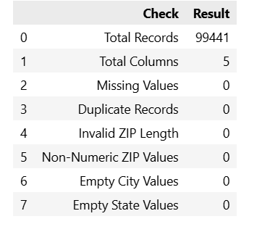

Figure 6: Final Data Quality Report
A final quality report was created to verify the processed dataset.
quality_report = pd.DataFrame({
"Check": [
"Total Records",
"Total Columns",
"Missing Values",
"Duplicate Records",
"Invalid ZIP Length",
"Non-Numeric ZIP Values",
"Empty City Values",
"Empty State Values"
],
"Result": [
len(df),
len(df.columns),
df.isnull().sum().sum(),
df.duplicated().sum(),
(df["customer_zip_code_prefix"].str.len() != 5).sum(),
(~df["customer_zip_code_prefix"].str.isnumeric()).sum(),
(df["customer_city"].str.strip() == "").sum(),
(df["customer_state"].str.strip() == "").sum()
]
})

display(quality_report)

Final Results
Quality Check | Result
Total Records | 99,441
Total Columns | 5
Missing Values | 0
Duplicate Records | 0
Invalid ZIP Length | 0
Non-Numeric ZIP Values | 0
Empty City Values | 0
Empty State Values | 0
The final checks confirm that the dataset is consistent and suitable for further analysis.

18. Before and After Cleaning Comparison
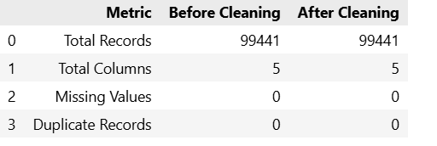

Figure 7: Before and After Data Cleaning Comparison
A comparison between the original and cleaned dataset was performed.
raw_df = pd.read_csv("olist_customers_dataset.csv")

comparison = pd.DataFrame({
"Metric": [
"Total Records",
"Total Columns",
"Missing Values",
"Duplicate Records"
],
"Before Cleaning": [
raw_df.shape[0],
raw_df.shape[1],
raw_df.isnull().sum().sum(),
raw_df.duplicated().sum()
],
"After Cleaning": [
cleaned_df.shape[0],
cleaned_df.shape[1],
cleaned_df.isnull().sum().sum(),
cleaned_df.duplicated().sum()
]
})

display(comparison)

Comparison
Metric | Before Cleaning | After Cleaning
Total Records | 99,441 | 99,441
Total Columns | 5 | 5
Missing Values | 0 | 0
Duplicate Records | 0 | 0
The number of records remained unchanged because no missing or duplicate records required removal.

19. Saving the Cleaned Dataset
The cleaned dataset was saved as a new CSV file.
cleaned_df.to_csv(
"cleaned_olist_customers.csv",
index=False
)

print("Cleaned dataset saved successfully!")
The output file generated was:
cleaned_olist_customers.csv
This preserves the original dataset while providing a cleaned version for further analysis.

20. Final Dataset Verification

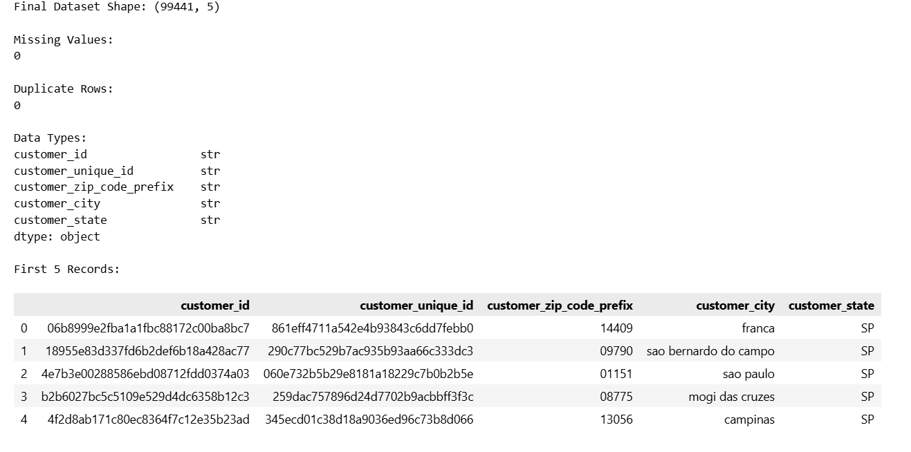

Figure 8: Final Cleaned Dataset Verification
The saved dataset was reloaded to verify that the output file was correctly generated.
final_df = pd.read_csv(
"cleaned_olist_customers.csv",
dtype={"customer_zip_code_prefix": str}
)

print("Final Dataset Shape:", final_df.shape)

print("\nMissing Values:")
print(final_df.isnull().sum().sum())

print("\nDuplicate Rows:")
print(final_df.duplicated().sum())

print("\nData Types:")
print(final_df.dtypes)

print("\nFirst 5 Records:")
display(final_df.head())

Verification Result
- Final dataset shape: 99,441 × 5
- Missing values: 0
- Duplicate rows: 0
- ZIP-code format successfully preserved as string.

21. Preprocessing Methodology Summary
The complete preprocessing pipeline consisted of:
Data Collection → Data Inspection → Missing Value Check → Duplicate Check → Data Type Correction → ZIP Validation → Text Standardization → EDA → Data Quality Validation → Cleaned Dataset Export → Final Verification
Each preprocessing technique was selected according to the actual characteristics and meaning of the dataset variables.

22. Reflection
Data quality plays an important role in logistics analysis and decision-making. Incorrect, missing, duplicate, or inconsistent data can lead to inaccurate customer distribution analysis and unreliable operational decisions.
In this project, the dataset was checked for missing values, duplicate records, invalid ZIP codes, and inconsistent text values. The ZIP-code field was also converted into a consistent string format because it represents a geographic identifier rather than a continuous numerical measurement.
After preprocessing, the dataset became more consistent and reliable for further logistics analysis. High-quality data can help organizations better understand customer distribution, identify important regions, and support data-driven planning and resource allocation.
This preprocessing process also demonstrates that not every dataset requires the same cleaning or normalization technique. Data preparation should be based on the meaning and characteristics of each variable.

23. Conclusion
The Week 2 data collection, cleaning, and preprocessing task was successfully completed using Python and Pandas.
The Olist customer dataset containing 99,441 records and 5 columns was inspected and processed. No missing values or duplicate records were found. ZIP-code prefixes were converted into a consistent five-digit string format and successfully validated. City and state values were standardized for consistency.
Exploratory analysis was performed to understand customer distribution across states and cities. The analysis identified customer concentration across 27 states and 4,119 cities, with SP having the highest customer count.
The cleaned dataset was exported as cleaned_olist_customers.csv and reloaded successfully for final verification.
The resulting dataset is now suitable for further logistics and customer-distribution analysis.

24. References
- Olist – Brazilian E-Commerce Public Dataset
Kaggle: Brazilian E-Commerce Public Dataset by Olist
- Pandas Documentation
Python library used for data manipulation and preprocessing.
- NumPy Documentation
Python library used for numerical computing.
- Matplotlib Documentation
Python library used for data visualization.

