WEEK 4 – PREDICTIVE MODELING AND OPTIMIZATION IN LOGISTICS SYSTEMS

Logistics Data Analytics Project
Submitted By:

Palak Bhargav
Branch: B.Tech – Computer Science & Engineering (Artificial Intelligence)
College: Arya Institute of Engineering, Technology and Management
Internship Domain: Data Analytics / Logistics Analytics
Task: Week 4 – Predictive Modeling and Optimization
Academic Year: 2026–27
Academic Year: 2026–27

Project Title

Delivery Time Prediction and Optimization in Logistics Systems
Technologies Used:
Python • Pandas • NumPy • Matplotlib • Scikit-learn • Jupyter Notebook

Submitted As Part of Internship Training
Prepared by:
Palak Bhargav

Week 4 Report

Predictive Modeling and Optimization in Logistics Systems

1. Introduction
Logistics systems generate large amounts of data related to transportation, shipment characteristics, processing time, traffic conditions, and delivery performance. Predictive analytics can help logistics organizations estimate delivery times and improve operational planning.
This project focuses on developing a machine learning model to predict shipment delivery time using logistics-related factors. A simulated logistics dataset was created using Python because the customer dataset used in earlier tasks did not contain suitable variables such as delivery time, shipment weight, processing time, and transportation cost.
Two regression models, Linear Regression and Random Forest Regression, were developed and evaluated. The models were compared using Mean Absolute Error (MAE), Root Mean Squared Error (RMSE), and R² Score. An optimization scenario was also developed to study how reducing warehouse processing time could potentially improve delivery performance.

2. Objective
The main objectives of this task are:
- To define a logistics delivery-time prediction problem.
- To create a realistic simulated logistics dataset.
- To preprocess and prepare the data for machine learning.
- To train predictive regression models.
- To evaluate model performance using MAE, RMSE, and R² Score.
- To compare different machine learning models.
- To identify important factors affecting delivery time.
- To develop an optimization scenario for improving logistics efficiency.
- To provide practical recommendations based on the analysis.

3. Problem Definition
The problem addressed in this project is delivery time prediction.
The objective is to predict the number of days required to deliver a shipment based on different logistics-related factors.

Target Variable
Delivery_Days
Accurate delivery-time prediction can help logistics organizations improve planning, resource allocation, customer communication, and operational efficiency.

4. Dataset Simulation
Since the available customer dataset from previous tasks did not contain delivery-time and transportation-related variables, a simulated logistics dataset was generated using Python.
The dataset contains 1,500 records and 7 variables.
Variable | Description
Distance_km | Shipment delivery distance
Weight_kg | Weight of the shipment
Number_of_Items | Number of items in shipment
Shipping_Cost | Estimated shipping cost
Processing_Hours | Warehouse/order processing time
Traffic_Level | Low, Medium, or High traffic
Delivery_Days | Target variable representing delivery time

Input Features
- Distance_km
- Weight_kg
- Number_of_Items
- Shipping_Cost
- Processing_Hours
- Traffic_Level
Since the available customer dataset from previous tasks did not contain delivery-time and transportation-related variables, a simulated logistics dataset was generated using Python.
The dataset contains 1,500 records and 7 variables.
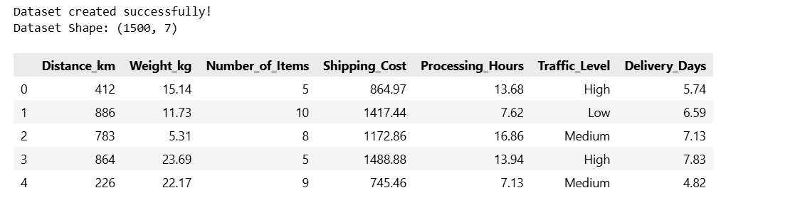
Figure 1: Simulated Logistics Data

5. Data Inspection and Preprocessing
The simulated dataset was inspected before model development. Dataset shape, column names, data types, missing values, and duplicate records were checked.
The analysis confirmed that the dataset was suitable for further machine learning processing.
The categorical Traffic_Level variable was converted into numerical values:
- Low → 0
- Medium → 1
- High → 2
This encoding allowed the machine learning models to process the traffic information numerically.
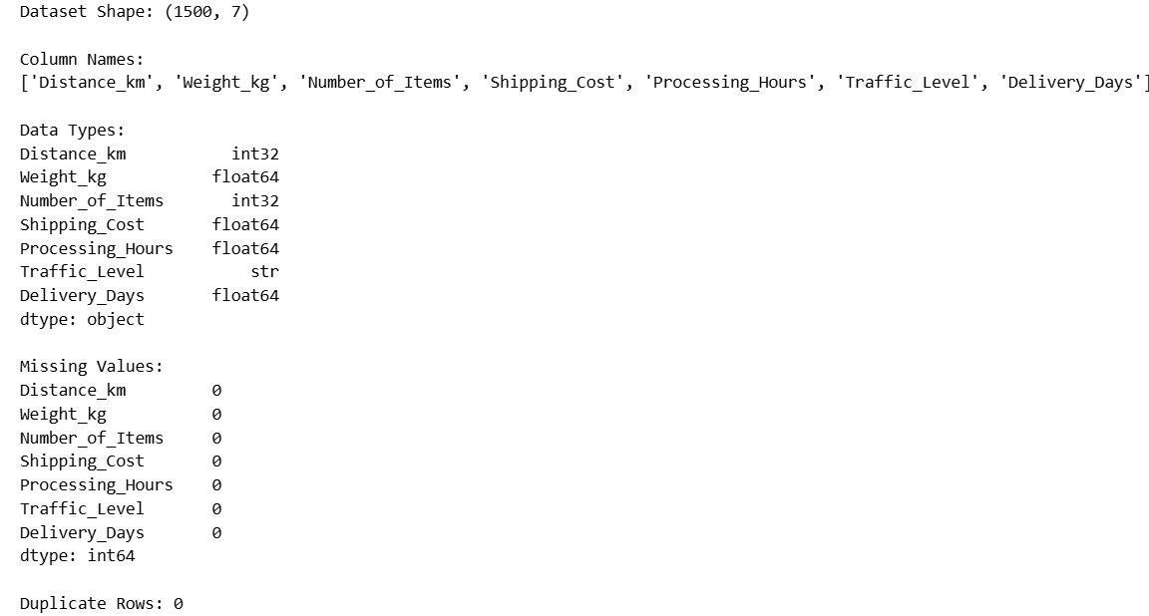

Figure 2: Dataset Inspection and Data Quality Check

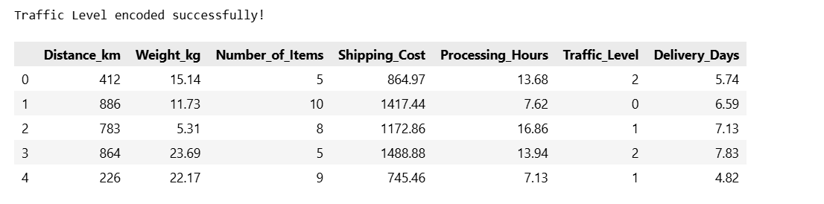
Figure 3: Traffic Level Encoding

6. Statistical Analysis
Descriptive statistics were generated to understand the distribution of numerical logistics variables.
The describe() function was used to obtain:
- Mean
- Standard deviation
- Minimum
- Maximum
- 25th percentile
- Median
- 75th percentile
This helped in understanding the general characteristics and ranges of the logistics data before model training.

7. Feature and Target Selection
For predictive modeling, the dataset was divided into input features and the target variable.

Features (X)
- Distance_km
- Weight_kg
- Number_of_Items
- Shipping_Cost
- Processing_Hours
- Traffic_Level

Target (y)
- Delivery_Days
The target variable represents the delivery time that the models need to predict.

8. Train-Test Split
The dataset was divided into training and testing sets using an 80:20 ratio.
- 80% (1,200 records) → Training data
- 20% (300 records) → Testing data
A random_state of 42 was used to ensure reproducibility.
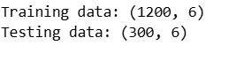
Figure 4: Training and Testing Dataset Split

9. Model Selection
Two regression algorithms were selected for this project:

9.1 Linear Regression
Linear Regression was selected as a baseline regression model because it is simple, interpretable, and suitable for predicting a continuous numerical target such as delivery time.

9.2 Random Forest Regression
Random Forest Regression was selected as a second model because it can capture nonlinear relationships between logistics features and delivery time and can provide a useful comparison against the simpler Linear Regression model.
Both models were trained using the training dataset and evaluated using the testing dataset.

10. Linear Regression Model
A Linear Regression model was trained using the selected logistics features.
The model generated predictions for delivery time on the test dataset.
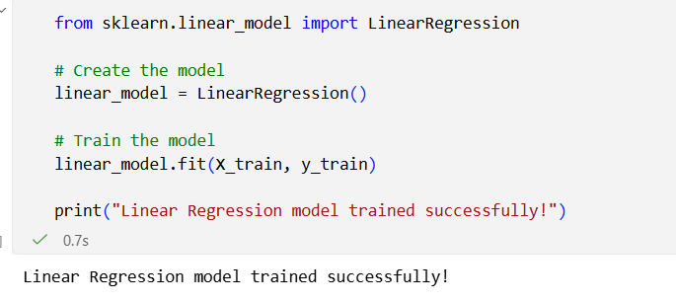
Figure 5: Linear Regression Model Training

11. Random Forest Regression Model
A Random Forest Regression model was also trained using the same training dataset.
The model was configured with 100 estimators and a fixed random state to ensure reproducibility.

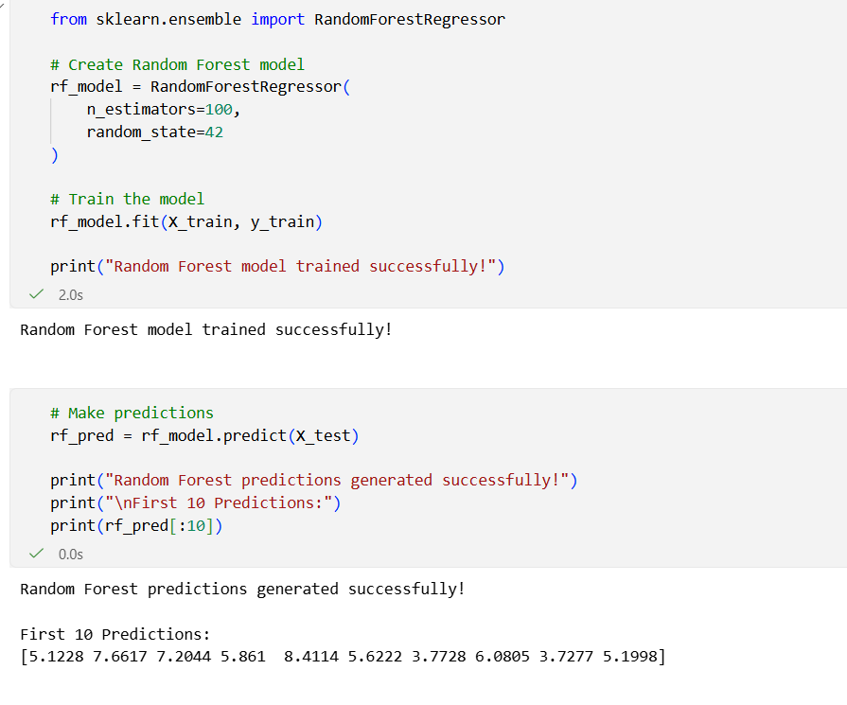
Figure 6: Random Forest Model Training

12. Model Evaluation
The models were evaluated using three important regression metrics:

Mean Absolute Error (MAE)
MAE represents the average absolute difference between actual and predicted delivery time.
Lower MAE indicates better performance.

Root Mean Squared Error (RMSE)
RMSE measures prediction error while giving more weight to larger errors.
Lower RMSE indicates better performance.

R² Score
R² indicates how well the model explains variation in the target variable.
A higher R² value indicates better performance.

13. Model Performance Comparison
The obtained results were:
Model | MAE | RMSE | R² Score
Linear Regression | 0.250 | 0.308 | 0.951
Random Forest | 0.309 | 0.379 | 0.926
Based on these results, Linear Regression performed better than Random Forest for the simulated dataset.
Linear Regression achieved the lowest MAE and RMSE and the highest R² Score.
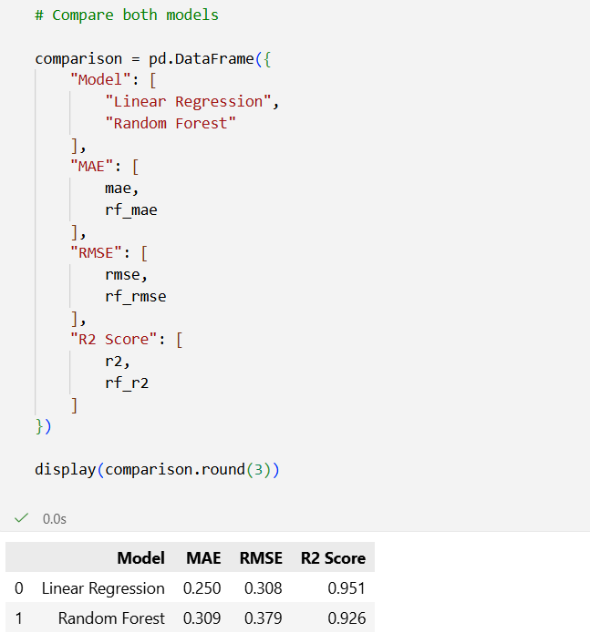
Figure 7: Model Performance Comparison

14. Model Performance Visualization
The R² scores of both models were visualized using a bar chart.
The visualization shows that Linear Regression achieved a higher R² Score than Random Forest Regression.
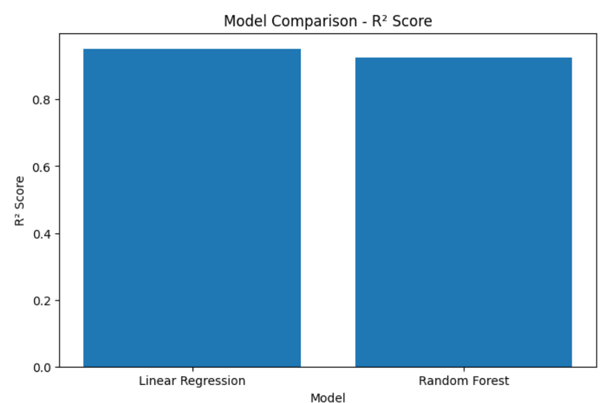Figure 8: Model Comparison Based on R² Score

15. Actual vs Predicted Delivery Time
The actual and predicted delivery times generated by the Linear Regression model were visualized using a scatter plot.
The points show a strong relationship between actual and predicted values. The close alignment of the points indicates that the model provides reasonably accurate predictions for the simulated dataset.

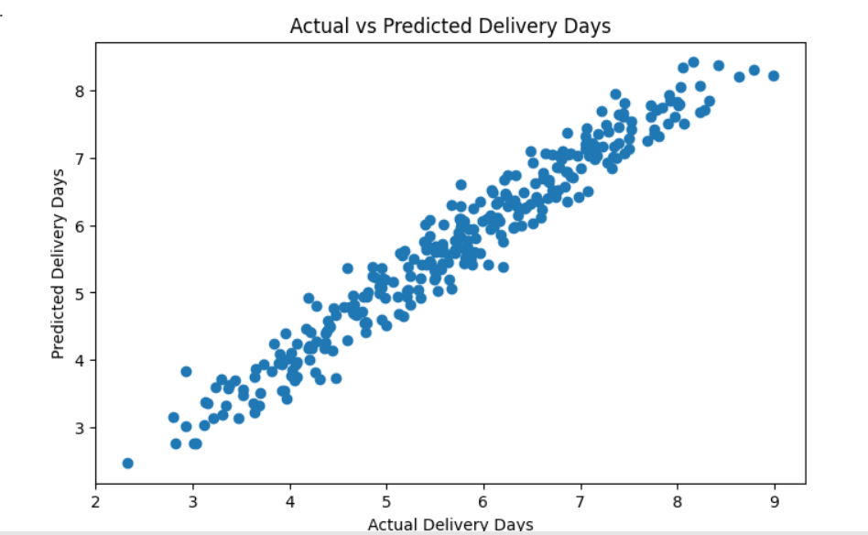
Figure 9: Actual vs Predicted Delivery Days

16. Feature Impact Analysis
Linear Regression coefficients were analyzed to understand the influence of different logistics features on predicted delivery time.
Features with larger positive coefficients have a stronger positive relationship with predicted delivery time within the simulated model.
This analysis helps identify which logistics factors should receive greater attention during operational planning.
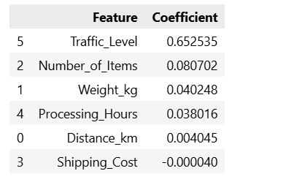
Figure 10: Feature Coefficients and Their Impact on Delivery Time

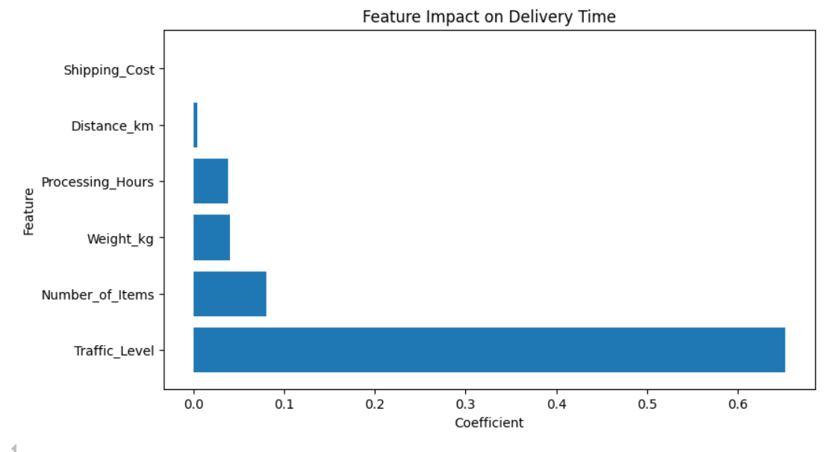
Figure 11: Feature Impact Visualization

17. Correlation Analysis
Correlation analysis was performed to understand relationships between numerical logistics variables.
The correlation matrix helps identify whether variables such as distance, shipment weight, processing time, shipping cost, and delivery time have positive or negative relationships.
A heatmap was created to visually represent these correlations.
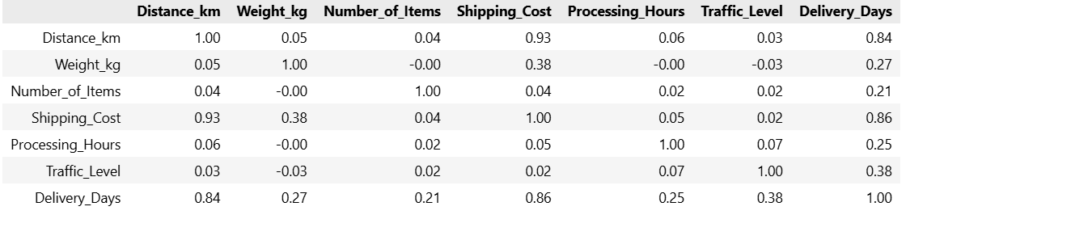
Figure 12: Correlation Matrix of Logistics Variables

18. Optimization Strategy
Predictive modeling can be extended beyond prediction to improve logistics operations.
In this project, warehouse processing time reduction was selected as an optimization scenario.
The processing time was reduced by 20% in a simulated scenario, and the trained Linear Regression model was used to predict the resulting delivery time.
The comparison between the original and optimized scenarios helps demonstrate how predictive models can support logistics optimization decisions.
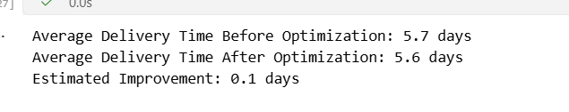
Figure 13: Simulated Delivery-Time Optimization
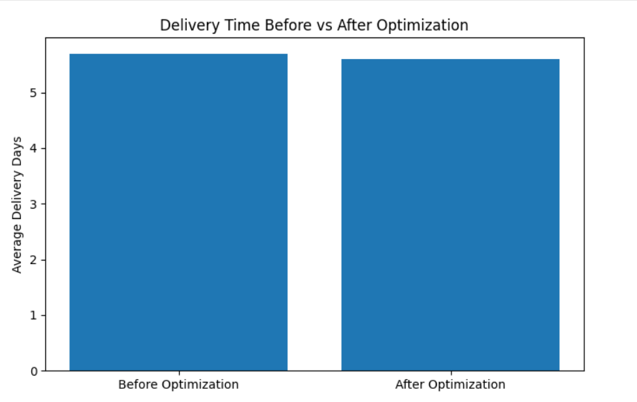
Figure 14: Delivery Time Before and After Optimization

19. Logistics Optimization Recommendations
Based on the predictive modeling and optimization analysis, the following strategies are recommended:

1. Reduce Warehouse Processing Time
Order processing workflows can be streamlined through better resource allocation and automation.

2. Improve Route Planning
Long-distance shipments should be planned using efficient routes and suitable transportation resources.

3. Consider Traffic Conditions
Traffic levels should be considered when planning shipment routes and delivery schedules.

4. Improve Resource Allocation
Warehouse and transportation resources can be allocated according to shipment characteristics and expected delivery requirements.

5. Use Predictive Analytics
Delivery-time prediction models can help logistics teams identify potential delays before they occur and take preventive action.

20. Key Findings
The major findings of the project are:
- A simulated logistics dataset containing 1,500 records and 7 variables was successfully created.
- Delivery time was modeled using six logistics-related input features.
- Two regression models were evaluated.
- Linear Regression achieved an MAE of 0.250.
- Linear Regression achieved an RMSE of 0.308.
- Linear Regression achieved an R² Score of 0.951.
- Random Forest achieved an R² Score of 0.926.
- Linear Regression was therefore selected as the better-performing model for this simulated dataset.
- Predictive modeling can support logistics planning and operational decision-making.
- Reducing processing time can be considered as a potential strategy for reducing delivery duration.

21. Limitations
This project uses a simulated logistics dataset, so the results represent a controlled analytical scenario rather than actual company performance.The model can be improved in future work using real logistics data containing actual delivery times, GPS/route information, weather conditions, vehicle information, warehouse capacity, and historical shipment records.

22. Future Scope
Future improvements can include:
- Using real-world logistics datasets.
- Applying cross-validation for more robust model evaluation.
- Performing hyperparameter tuning.
- Testing additional algorithms such as Gradient Boosting and XGBoost.
- Developing route optimization techniques.
- Incorporating real-time traffic and weather data.
- Building a dashboard for monitoring predicted delivery times.
- Developing a real-time logistics decision-support system.

23. Conclusion
This project demonstrated the use of predictive analytics for a logistics delivery-time prediction problem. A simulated logistics dataset was generated and prepared using Python, after which Linear Regression and Random Forest Regression models were trained and evaluated.
Among the two models, Linear Regression provided the best performance, achieving an MAE of 0.250, RMSE of 0.308, and R² Score of 0.951 on the test data.
The project also demonstrated how predictive modeling can support optimization decisions. A simulated reduction in warehouse processing time was used to examine its potential effect on delivery duration.
Overall, the project shows that machine learning can be used to support delivery-time prediction, identify important logistics factors, and assist organizations in improving operational efficiency and resource planning.

