

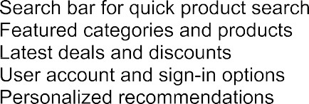

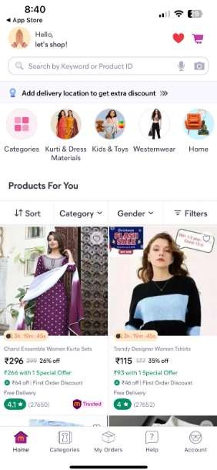



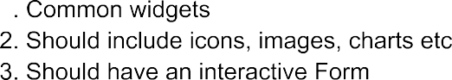



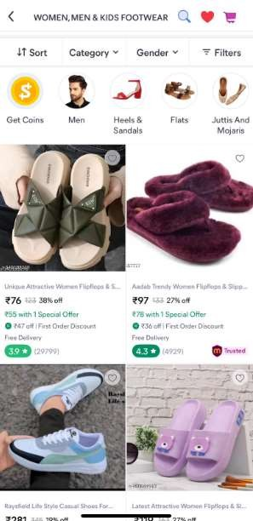

 

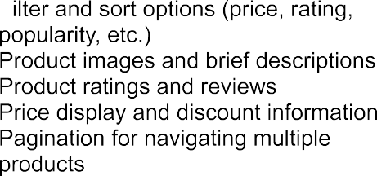

|  |  |
| --- | --- |
|  | **Login Page Features:**   1. **User Authentication** – Login via **Email & Password**, **Google Sign-In**, or **OTP**. 2. **Form Validation** – Ensures valid input before submission. 3. **Forgot Password** – Allows users to reset passwords via email. 4. **Social Login** – Quick access using Google Sign-In. 5. **Smooth UI** – Responsive design using Material UI.   **Firebase Usage in Project:**   * **Firebase Authentication** – Manages user login/signup securely. * **Firestore Database** – Stores users, products, cart, and orders. * **Firebase Storage** – Saves product images and profile pictures. * **Cloud Messaging (FCM)** – Sends order updates & notifications. * **Firebase Analytics** – Tracks user behavior & popular products. |

