SOFTWARE REQUIREMENTS SPECIFICATION (SRS)
Project Title: Smart Traffic Enforcement and Management Platform Using Computer Vision
Technology Stack:
Frontend: Next.js (TypeScript) with Tailwind CSS
Backend: Node.js with Express.js
Database: Supabase (PostgreSQL)
Machine Learning Layer: Python, YOLOv8, OpenCV, Scikit-learn

1. Introduction

1.1 Purpose
This document defines the complete functional and non-functional requirements for the Smart Traffic Enforcement and Management Platform. The system aims to monitor traffic using computer vision, estimate real-time traffic density, detect red-light violations, suggest adaptive signal timings, and provide a centralized web dashboard for traffic authorities.

1.2 Scope
The system processes live or recorded traffic feeds to detect and count vehicles, classify traffic density using machine learning, detect violations, store records in a centralized database, and display analytics via a web dashboard. The system does not perform number plate recognition or control physical traffic hardware.

1.3 Definitions and Acronyms
ML – Machine Learning
CV – Computer Vision
API – Application Programming Interface
JWT – JSON Web Token
UI – User Interface
DB – Database

2. Overall Description

2.1 System Architecture Overview
Camera Feed → ML Processing Service (Python + YOLOv8) → Backend API (Node.js + Express) → Supabase Database → Frontend Dashboard (Next.js + Tailwind CSS)

2.2 Product Functions
• Vehicle detection using pretrained YOLOv8 model
• Vehicle counting per class (car, bike, bus, truck)
• Traffic density classification using supervised ML
• Adaptive signal timing recommendation
• Red-light violation detection using stop-line logic
• Violation logging and record storage
• Analytics visualization on web dashboard

2.3 User Classes
Admin: Traffic authority personnel with access to dashboard, analytics, and violation logs.
System: ML processing service that sends structured traffic data automatically.

3. Functional Requirements

3.1 Machine Learning Requirements
FR-ML-1: The system shall detect cars, bikes, buses, and trucks using YOLOv8.
FR-ML-2: The system shall count vehicles per frame and compute total vehicle count.
FR-ML-3: The system shall send traffic count data to backend in JSON format at regular intervals.
FR-ML-4: The system shall classify traffic density as Low, Medium, or High using Decision Tree model.
FR-ML-5: The system shall suggest adaptive green signal timing based on density.
FR-ML-6: The system shall detect vehicles crossing a predefined stop line during red signal.
FR-ML-7: The system shall capture snapshot reference for each violation.

3.2 Backend Requirements
FR-BE-1: Provide REST APIs for traffic data submission.
FR-BE-2: Provide API to store violation records.
FR-BE-3: Provide API to fetch traffic logs per junction.
FR-BE-4: Provide analytics API for aggregated statistics.
FR-BE-5: Implement JWT-based authentication for admin login.
FR-BE-6: Validate incoming JSON data from ML service.

3.3 Database Requirements
The database shall contain the following tables:
1. junctions (id, name, location)
2. traffic_logs (id, junction_id, timestamp, cars, bikes, buses, trucks, total, density, green_time)
3. violations (id, junction_id, vehicle_type, timestamp, image_url)
4. users (id, email, password_hash, role)

3.4 Frontend Requirements
FR-FE-1: Display real-time vehicle counts.
FR-FE-2: Display density level and suggested green time.
FR-FE-3: Display violation logs in table format.
FR-FE-4: Provide analytics charts (traffic trends and vehicle distribution).
FR-FE-5: Implement responsive UI using Tailwind CSS.
FR-FE-6: Implement protected admin routes.

4. Non-Functional Requirements
Performance:
• Detection latency shall be under 2 seconds.
• API response time shall be under 500 milliseconds.
Security:
• JWT-based authentication.
• Password hashing using bcrypt.
• Secure HTTPS communication.
Scalability:
• Support multiple junctions.
• Handle up to 100,000 traffic log records.
Reliability:
• System uptime ≥ 95%.
• Graceful error handling and logging.
Usability:
• Clean modern admin dashboard.
• Responsive across devices.

5. Technology Stack
ML Layer: Python, YOLOv8, OpenCV, Scikit-learn
Backend: Node.js, Express.js, Supabase SDK, JWT, bcrypt
Frontend: Next.js (TypeScript), Tailwind CSS, Axios, Recharts
Database: Supabase PostgreSQL

6. System Constraints
• No number plate recognition.
• Use recorded traffic video for demonstration.
• No real hardware signal integration.

7. Future Enhancements
• Reinforcement learning-based signal optimization.
• Multi-camera tracking across junctions.
• Traffic congestion prediction.
• Heatmap visualization.

8. System Architecture Diagram
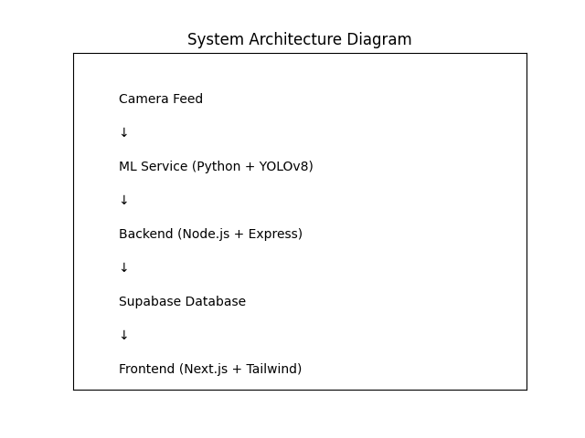

9. Use Case Diagram
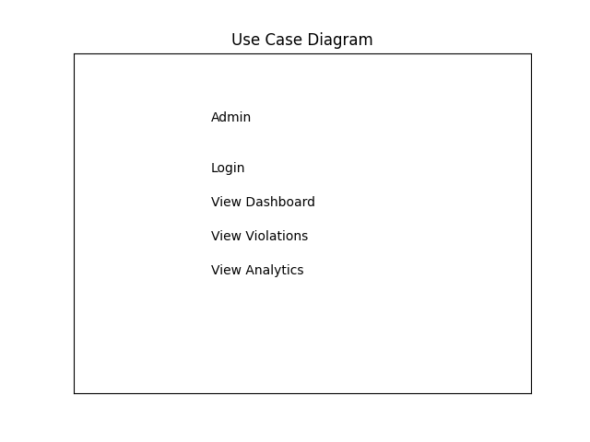

10. Data Flow Diagram
