PROJECT REPORT

ON

**EXPLORATORY DATA ANALYSIS OF DELHI VIDHAN SABHA ELECTIONS 2020 & PREDICTION**

*Submitted to Vellore Institute of Technology*

*By*

ANUDEEP SIDHANTHI

(Roll No: 21MDT0032)

PALAK GOEL

(Roll No: 21MDT0041)



*Under the guidance of*

Dr. Rushi Kumar B

Associate Professor, SAS

VIT, Vellore

Course Code: CSE 5007

Course Title: Exploratory Data Analysis

J Component

SCHOOL OF ADVANCED SCIENCES

2021-2023

DECLARATION

We **Anudeep Sidhanthi** and **Palak Goel,** hereby declare that the project work entitled “**EXPLORATORY DATA ANALYSIS OF DELHI VIDHAN SABHA ELECTIONS 2020 & PREDICTION**” submitted to Vellore Institute of Technology, Vellore is a record of the original work done by us and this project work is presented in the partial fulfilment of the requirements for the award of the Degree of Master of Science in Data Science and is a record of J- component of project work carried out by us under the guidance of **Prof. Rushi Kumar B**. The results embodied in this thesis have not been submitted to any other university or institute for the award of any degree or diploma.

Place **:** **Vellore**

Date **:** 06/06/2022

Signature of Faculty :

ACKNOWLEDGEMENT

We are deeply indebted to all those who helped us directly or indirectly. Our deepest thanks to **Dr. Rushi Kumar** , **Department of Mathematics, SAS, VIT** for guiding and correcting us. He has taken utmost care to go through the project and make necessary amendments as and when needed. We extend thanks to our classmates and professors of **VIT** for their continued support and inputs.

**VELLORE. ANUDEEP SIDHANTHI**

**PALAK GOEL**

**TABLE OF CONTENTS:**

|  |  |  |
| --- | --- | --- |
| **S.No.** | **Title** | **Page No.** |
| 1 | Abstract | 3 |
| 2 | Objective | 3 |
| 3 | Motivation | 4 |
| 4 | Background | 4 |
| 5 | Introduction | 5 |
| 6 | Project Description | 5 |
| 7 | Literature Review | 6 |
| 8 | Methodology | 8 |
| 9 | Problem Formulation | 13 |
| 10 | Results | 30 |
| 11 | Conclusion | 31 |
| 12 | Technical Specification | 32 |
| 13 | References | 32 |

# ABSTRACT

The Delhi Legislative Assembly, also known as the Delhi Vidhan Sabha, is a [unicameral](https://en.wikipedia.org/wiki/Unicameral) [legislature](https://en.wikipedia.org/wiki/Legislature) of the union territory of [Delhi](https://en.wikipedia.org/wiki/Delhi) in India. At present, it consists of 70 [members](https://en.wikipedia.org/wiki/Member_of_the_Legislative_Assembly_(India)), directly elected from [70 constituencies](https://en.wikipedia.org/wiki/List_of_constituencies_of_the_Delhi_Legislative_Assembly).

Through this project, we will analyze 2020 Vidhan Sabha Election results for state Delhi which depends on various features. We will perform Exploratory Data Analysis (EDA) which includes techniques like data extraction, data cleaning and selecting major features from the data. We identify the data types, perform scaling on data, label encoding for converting categorical data. We also predict the results of upcoming Vidhan Sabha Elections in Delhi by using Machine Learning Algorithm i.e., Random Forest Regressor, KNN, Logistic Regression, Decision Tree, SVM.

# OBJECTIVE

1. Detailed exploratory analysis of Vidhan Sabha 2020 Election for Delhi to understand the dataset in more depth.
   * What is the distribution of Constituencies over the district in Delhi State
   * Sunburst image of all the District and Constituencies
   * Which Parties have been present in most constituencies and district
   * What has been the general Win vs Loss relationship for the Parties in 2020?
   * What is the Gender Ratio of the Contestants? Also the Gender Ratio of the Winners?
   * What is the Educational Qualification of our politicians?
   * What is the relationship of Age and Politics?
   * What relation does the Politician category have with the election results?
   * Have the politicians been involved with criminal activities?
   * Plotting the Assets vs Liabilities amount for Winning Politicians
   * Which party has won the most constituencies?
2. Prediction of upcoming election by using Random forest, SVM, LOGISTIC REGRESSION, DECISION TREE, KNN.

# MOTIVATION

**Politics** is the way that people living in groups make decisions. Politics is about making agreements between people so that they can live together in groups such as [tribes](https://simple.wikipedia.org/wiki/Tribe), [cities](https://simple.wikipedia.org/wiki/City), or [countries](https://simple.wikipedia.org/wiki/Country). In large groups, such as countries, some people may spend a lot of their time making such agreements. These people are called [politicians](https://simple.wikipedia.org/wiki/Politician). Politicians, and sometimes other people, may get together to form a [government](https://simple.wikipedia.org/wiki/Government). The study of politics in universities is called [political science](https://simple.wikipedia.org/wiki/Political_science), political studies, or [public administration](https://simple.wikipedia.org/wiki/Public_administration).

In everyday life, the term "politics" refers to the way that countries are governed, and to the ways that governments make rules and laws. Politics can also be seen in other groups, such as in companies, clubs, schools, and churches.

Political knowledge is “the range of factual information about politics that is stored in long-term memory”. More extensive knowledge about polity, politics, and policy is presumed to enable and encourage people to participate in politics. Indeed, empirical evidence suggests that political knowledge contributes to more stable and consistent political attitudes, helps citizens achieve their own interests and make decisions that conform with their attitudes and preferences, promotes support for democratic values, facilitates trust in the political system, and motivates political participation.

**BACKGROUND**

In the last Delhi Legislative Assembly Elections in 2015, the Arvind Kejriwal-led Aam Aadmi Party (AAP) won a landmark victory after it secured 67 of the total 70 seats in the state legislature. The poll itself was necessitated after Delhi remaining under President's Rule for about a year and the then Delhi governor Najeeb Jung recommending the Union Cabinet to conduct fresh elections, in which AAP emerged with a huge victory, primarily banking on the huge popularity that Kejriwal had been enjoying at the time.

To understand the context further, we would have to go further back to the previous legislative assembly elections in 2013. During the 2013 Delhi Elections, the BJP (along with its pre-poll ally Shiromani Akali Dal) had emerged as the single-largest party in the state, having won 32 out of 70 seats, but failed to form a government with support from others. Consequently, after the governor invited the second-largest party AAP, they formed the Delhi government with Arvind Kejriwal as the Delhi Chief Minister. However, in 2014 he resigned from his post, publicly voicing his discontent regarding his inability to table the Jan Lokpal Bill in the Delhi Assembly due to stiff opposition from other parties. Following this, the state went under President's Rule for about a year after which fresh elections were held, in which Kejriwal emerged as victorious, himself having defeated incumbent Chief Minister Sheila Dixit from the New Delhi seat.

# INTRODUCTION

Legislative Assembly elections were held in Delhi on 8 February 2020 to elect 70 members of the Delhi Legislative Assembly. Voters turnout was recorded at 62.82%, a decline of 4.65% from the previous assembly election in Delhi but 2.2% more than the 2019 Indian general election in Delhi. The term of the assembly elected in 2015 expired on 22 February 2020. The Aam Aadmi Party, led by Arvind Kejriwal won 62 seats to claim an absolute majority in the elections. The previous Assembly elections were held in February 2015. After the election, the Aam Aadmi Party formed the state government, with Arvind Kejriwal becoming Chief Minister.

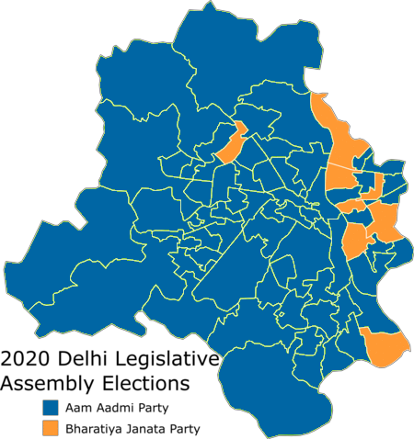

# 

# 

# 

# 

**DESCRIPTION**

* Treating missing values by fillna and interpolation.
* Visualizing the missing values by heat map.
* EDA for Data Extraction and to visualize the dataset in clear form.
* Python includes some packages like Pandas, NumPy, Matplotlib, Seaborn, sklearn, etc.
* Importing the Libraries which contains in-build function.

**LITERATURE REVIEW**

ExploratorydataanalysiswasdonebyParamarthaSenguptaon Lok Sabha Elections (The General Elections) for the year 2019.

Detailed Exploratory Data Analysis Uttar Pradesh Elections was performed by Bukun from Kolkata in the year 2017. The election to the 17th Uttar Pradesh Legislative Assembly was held from 11 February to 8 March 2017 in 7 phases. An phase wise analysis has been conducted.

For Uttar Pradesh State: UP Analysis, District Analysis, Phase wise Analysis, Party Analysis, Winner Analysis, Region wise Analysis was conducted by Manish Kumar from Hyderabad in the year 2017.

Univariate Analysis, Bivariate Analysis was done on [Tamil Nadu 2021 State Assembly Elections](https://www.kaggle.com/praveengovi/tn-state-elections-eda-pattern-trends/data) by Praveen from Singapore in 2021.

How India Voted in 2019? - EDA & Prediction (96.3%) by Liston Tellis uses the Random Forest Classifier to predict the winners of the election. In order to know the optimum number of trees required to predict the result with highest accuracy, they plotted the accuracy score for various values of k and selected k value that gives highest accuracy. They have achieved an accuracy of about 96**.**3% using Random Forest Classifier.

# METHODOLOGY

This section presents a brief explanation of the data used and the methodology followed to accomplish results.

|  |  |  |
| --- | --- | --- |
| S.No. | Attribute | Description |
|  | STATE | Indicates the Delhi State for all rows |
|  | DISTRICT | It indicates the District of each constituency |
|  | AC NO. | Shows the Constituency Number, totally we have 70 constituency |
|  | AC NAME | Shows the Constituency Name |
|  | CANDIDATE NAME | It indicates the Candidate Name contesting in each constituency |
|  | WINNER | It is a binary column, shows only 1 and 0. 1 is for the winner and 0 for the loser. |
|  | SEX | Indicates the Gender for all Candidates contested |
|  | ASSETS_in num | Shows the Assets expressed in numerical form of the candidates. |
|  | ASSETS_in_alph | Shows the Assets expressed in alphabets of the candidates. |
|  | ASSETS | Shows the Assets of Candidates in both numerical and alphabetical form. |
|  | QUALIFICATION | It is a categorical data showing the Educational Qualification of the Candidates Contested. |
|  | CRIMINAL CASES | Shows the number of Criminal cases each candidate is having |
|  | AGE | It indicates the age of the candidates contested. |
|  | CATEGORY | Shows the category of the candidates contested. It has two values: GENERAL AND SC. |
|  | PARTY | Indicates the Political Party of the candidate contested in the Election. |
|  | SYMBOL | It shows the symbol of the party in which the candidate has contested. |
|  | GENERAL | It is a Quantitative Data indicating the total number of votes casted in the Poll Booth directly on the day of Election. |
|  | POSTAL | It is a Quantitative Data indicating the total number of votes casted through Post. This is especially for the Government Servants who will be on duty on the day of Election. |
|  | TOTAL | It adds both the General Votes and Postal Votes. |
|  | % VOTES POLLED | It indicates the percentage of votes over the total votes polled in that particular constituency. |
|  | %OVER TOTAL ELECTORS | It indicates the percentage of votes over the total electors in that particular constituency. |
|  | TOTAL ELECTORS | It shows the total electors in the particular constituency. |

**PROBLEM**

**FORMULATION**

# PROBLEM FORMULATION

Importing Libraries:

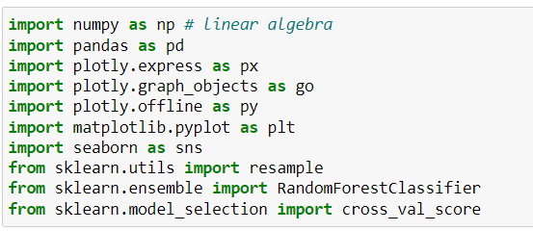

**DATA SET PREPRATION FOR EDA**

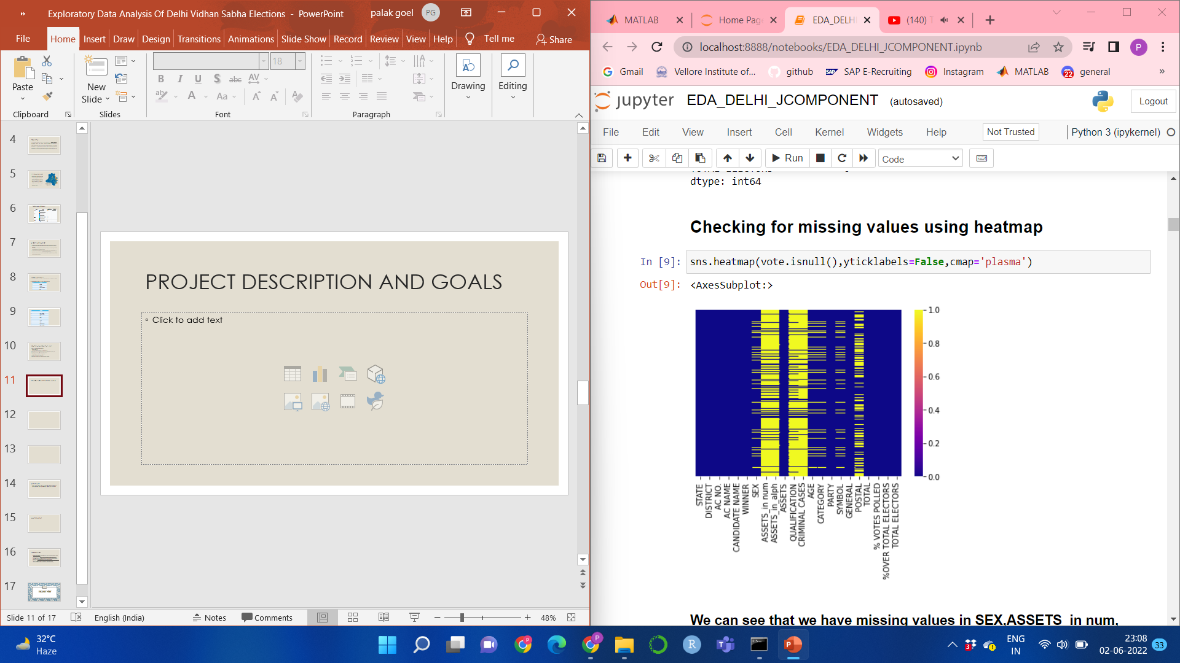

* We can see that we have missing values in SEX, ASSETS_in num, ASSETS_in alph, Qualification, Criminal Cases, Age, Category, Symbol, Postal columns of our dataset.
* Our Objective first is to treat the missing values

**TREATMENT OF MISSING VALUES:**

1. Treating missing values of postal votes by fillna() function
2. Treating missing value of Assets_in num by mean imputation.
3. Treating null values of Criminal cases using interpolation technique.
4. Since our dataset contains Election details, we have NOTA in it. NOTA, or "None of the Above", is the option which enables the voter to officially register a vote of rejection for all candidates who are contesting. If a voter chooses to press NOTA it indicates that the voter has not chosen to vote for any of the party.

NOTA does not have Gender, Category, Age, Symbol.

So presence of missing values in that columns does not take any effect on our data.

**Heat map after treating missing values**

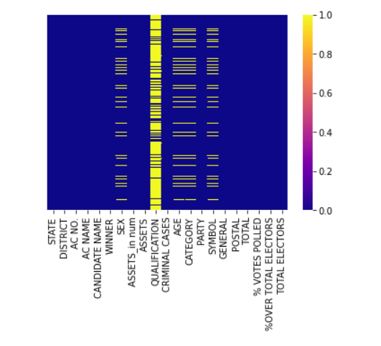

Only missing value which is left untreated is Educational Qualification of the Candidates. Since the type of the missing value is categorical, we are left with little imputation options. So that missing values cannot be treated. Our data set has Educational Qualifications of the Candidates who have won the Elections and we performed EDA on the winning candidates only.

**DATA SET INFORMATION**

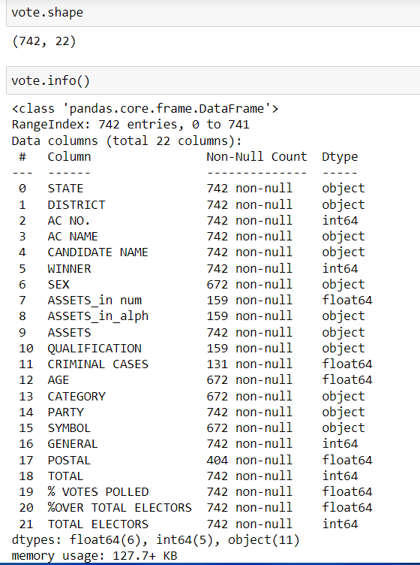

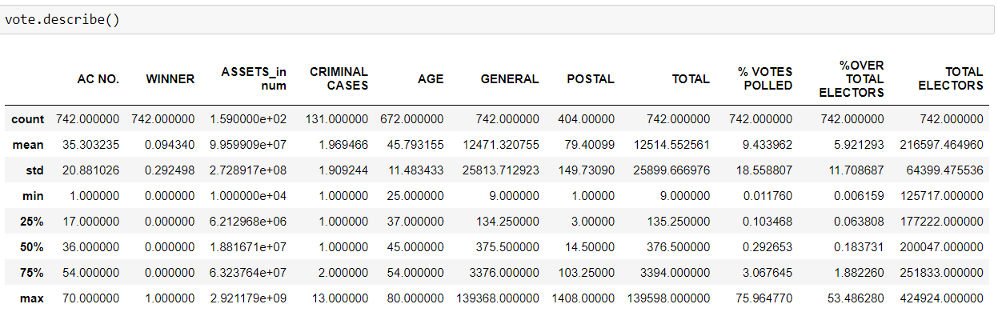

**VISUALIZATIONS**

**SUNBURST IMAGE OF ALL DISTRICTS AND CONSTITUENCIES AND THEIR TOTAL ELECTORS**

**Sunburst Plot:**

Sunburst plots visualize hierarchical data spanning outwards radially from root to leaves. Similar to Icicle charts and Treemaps, the hierarchy is defined by labels and parents attributes. The root starts from the center and children are added to the outer rings.

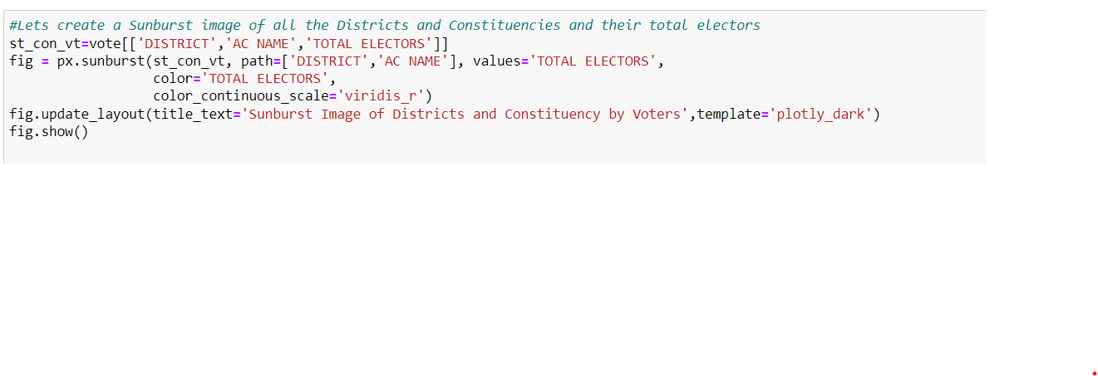

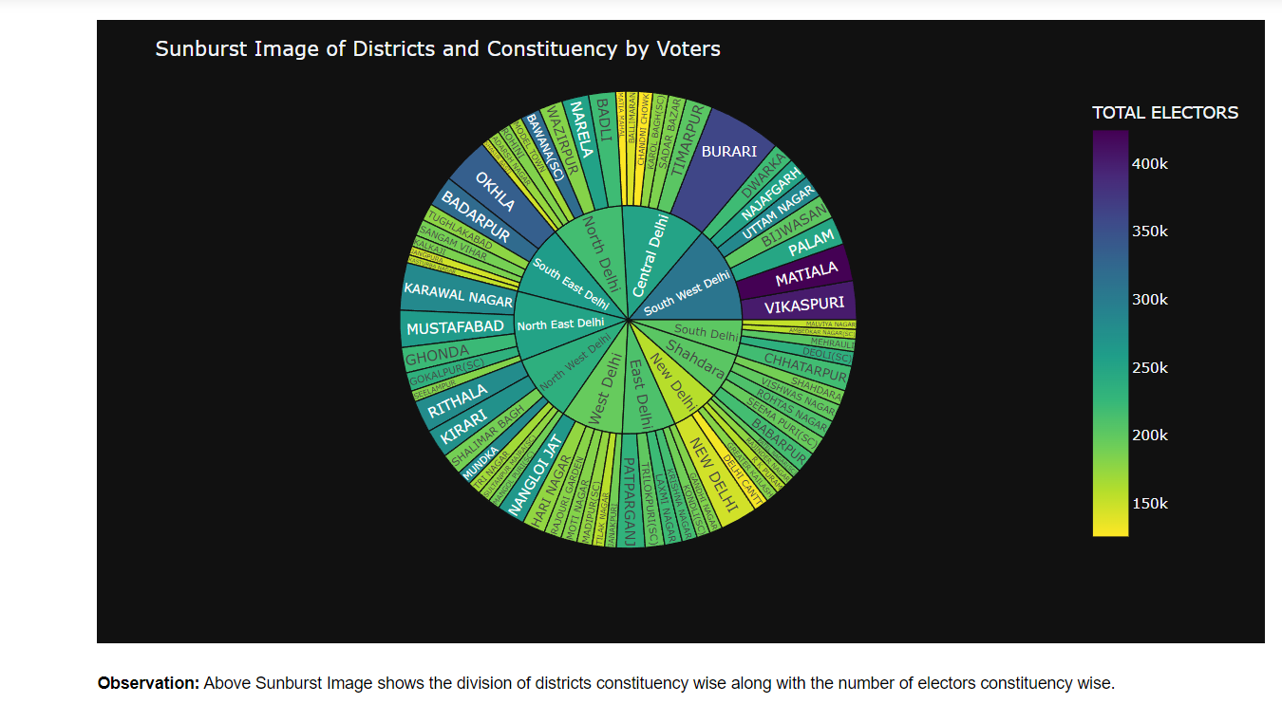

**DISTRIBUTION OF CONSTITUENCIES OVER ALL DISTRICT**

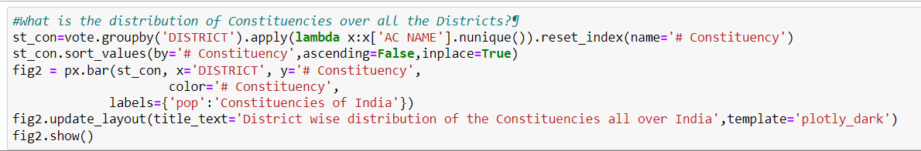

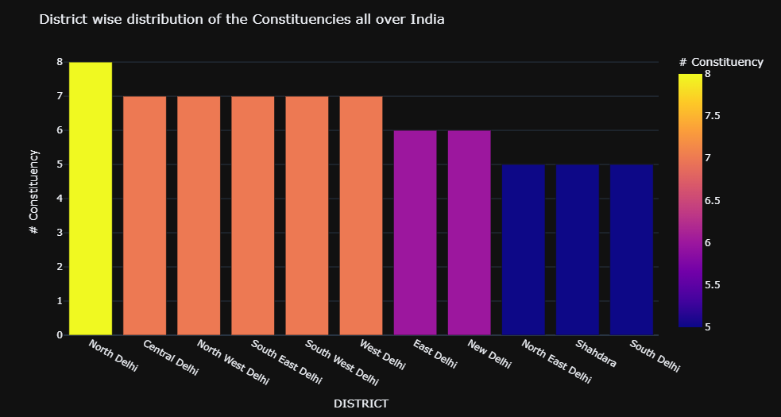

**Observation:** North Delhi District has the most number of constituencies followed by Central, NorthWest, South East South West and West Delhi. Number of constituecies are directly proportional to the population

of that district. North Delhi has the highest population since it has most (8) constituencie

**CONSTITUENCIES VS DISTRICT WISE**

**PARTICIPATION**

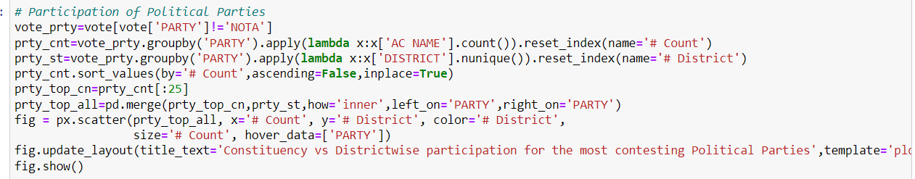

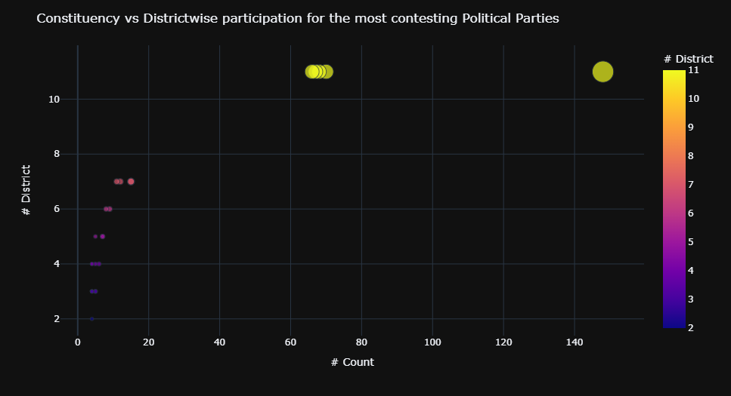

**Observation**: The Aam Aadmi Party(AAP) has participated in all the constituencies over Delhi, followed by Bahujan Samaj Party who contested in 68 Constituencies and third party in the list is Bharatiya Janata Party. AAP, BSP and BJP contested in all 11 districts of Delhi. One of the Major Political Party in India is Indian National Congess Party, it contested in 66 constituencies covering 11 Districts of Delhi. While these are the major parties to contest almost all over Delhi, we see the rest of the parties have restricted themselves to a handfull of districts.

**WIN COUNTS BY A POLITICAL PARTY IN 2020 DELHI ASSEMBLY ELECTION**

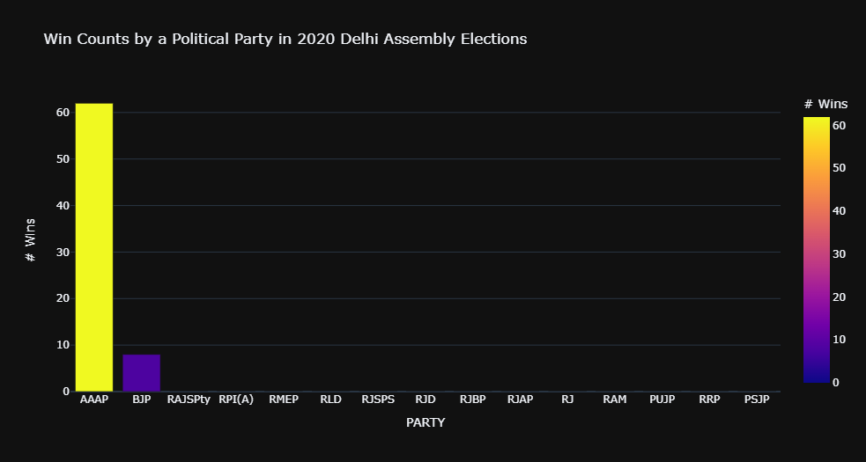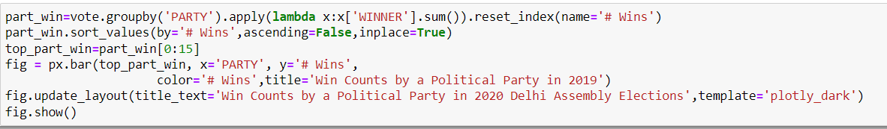

**Observation:** As seen from the data, In 2020 Delhi Assembly Elections, AAP has won the maximum constituencies all over Delhi. The below Bar Chart also suggests the same. The distribution of the other parties contested is also presented. BJP, which is the only party other than AAP to win a constituency stood 2nd in the number of victories with only 8 constituency wins, which is practically 1/8th of the constituencies won by AAP.

**DISTRICTWISE REPORT CARD FOR ALL THE PARTIES**

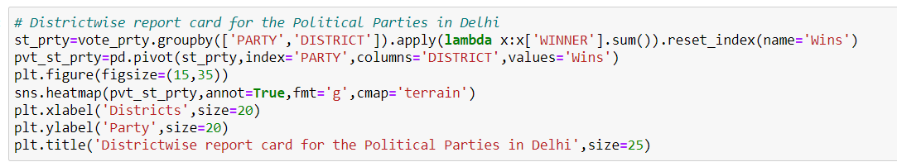

**Observation:**This heatmap shows the report card of the Political parties district wise i.e., how many constituencies they have won in a district. AAP won in all districts but their lowest percentage of wins districtwise is in North East Delhi and Shahdara where they have won 3 out of 5 constituencies contested respectively. Whereas BJP have won only in 5 out of 11 Districts contested in which they got victory in 8 constituencies. The INC didn't open the account in the assembly this year, too Having the same performance in the previous election, the Indian National Congress is considered perished in Delhi. Other Parties are in the same situation.

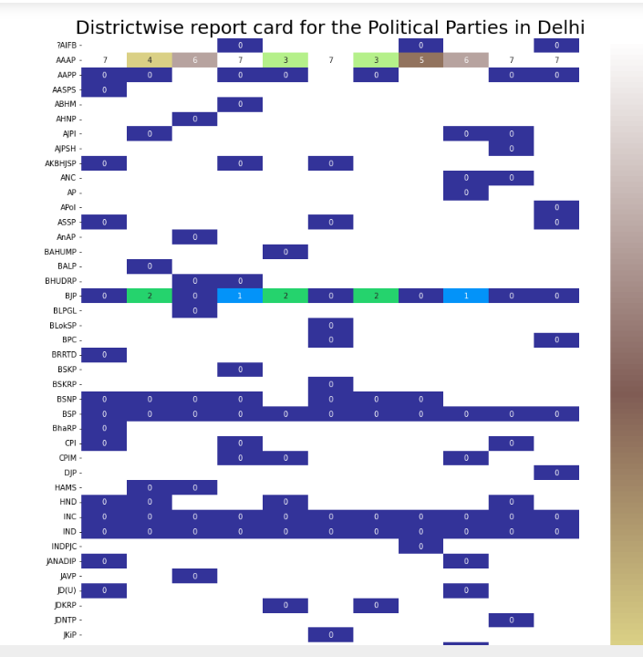

**WINNING CANDIDATES PER PARTY**

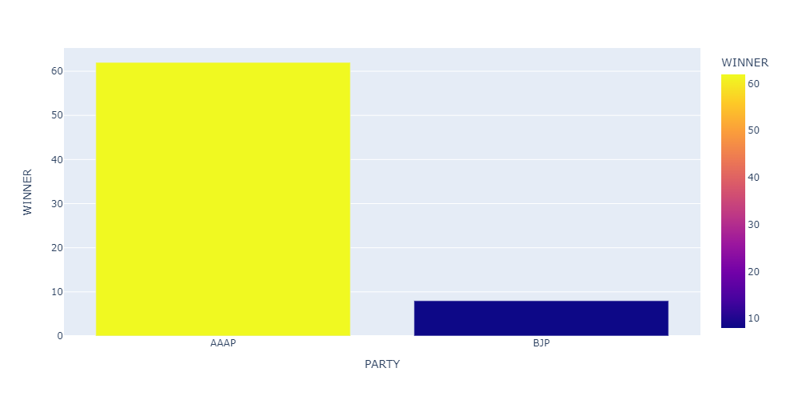

**Observation:** Arvind Kejriwal's Aam Aadmi Party (AAP) won 62 seats in the 70-member Delhi Assembly election.

From its strong performance in 2015, the party lost only five seats and less than a percentage point in vote share.

Despite a hard-fought and frequently contentious campaign in which major names such as Prime Minister Narendra Modi and Union Home Minister Amit Shah addressed rallies, the BJP won only eight seats, up three from its 2015 result.

The Congress failed to open its account again again, and the party's candidates were destined to forfeit their deposits on 63 of the 66 seats at stake.

Only AAP and BJP candidates represented their parties in the Assembly.

**WIN AND LOSS ANALYSIS FOR TOP PARTIES**

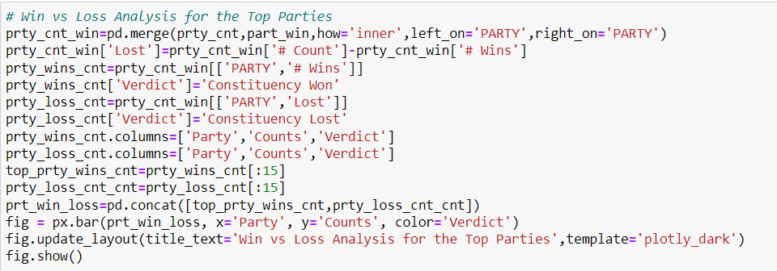

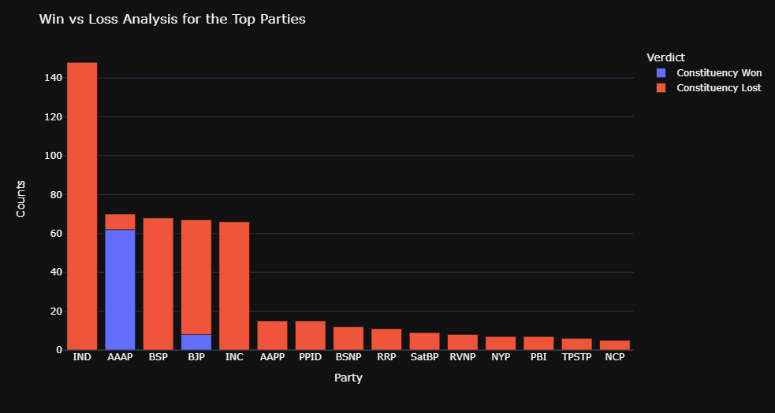

**Observation** As seen in the above chart, the 2020 Delhi Assembly elections have been extremely unlucky for the Independent Candidates as none of the contested 148 Candidates have won. Same is the case with INC,BSP and other parties who saw a major failure. AAP has won 88.57% winning ratio where as BJP's win to loss ratio is 11.42%. Only Successful party other than AAP is BJ

**Male VS Female Ratio- All Candidates**

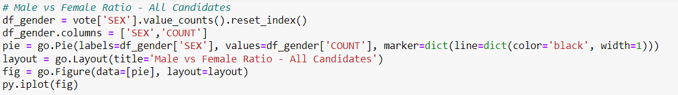

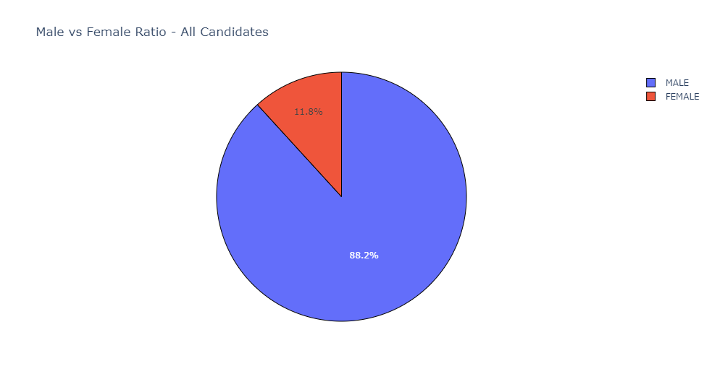

**Male Vs Female Ratio – Winners**

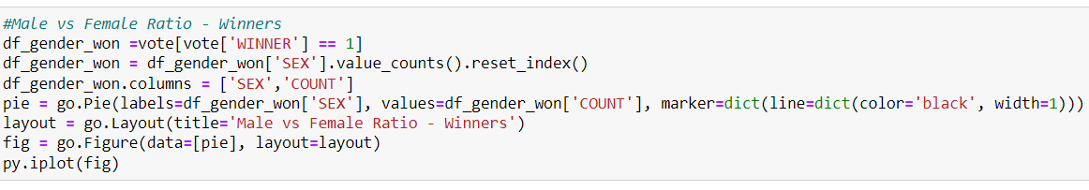

# 

\

**Observation:** Only 11.8 percent (79 out of 672) of the complete list of participants are female politicians, while 88.2 percent (593 out of 672) are male. When it comes to the winners, female politicians account for 11.4 percent (8 out of 70), whereas male politicians account for 88.6 percent (62 out of 70). As can be seen from the graph above, the gender ratio is not evenly spread.

**Fact:** The AAP had nine women candidates, and eight of them won.

**AGE COUNTS DISTRIBUTION AMONG THE POLITICIAN**



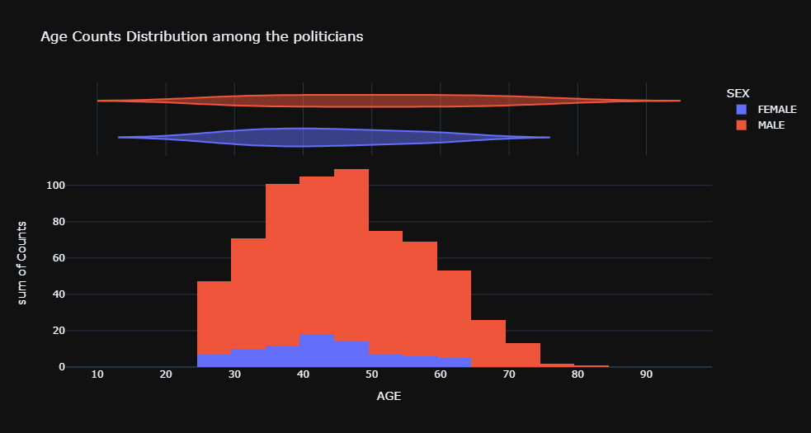

**Observation:** Most Number of female politicians have their average age between 40-44, while for male politician, it ranges from 45-49 range. The average age of male politicians is more as compared to female politicians contesting for the Delhi Assembly elections 2020.

**CATEGORY WISE WIN COUNT**

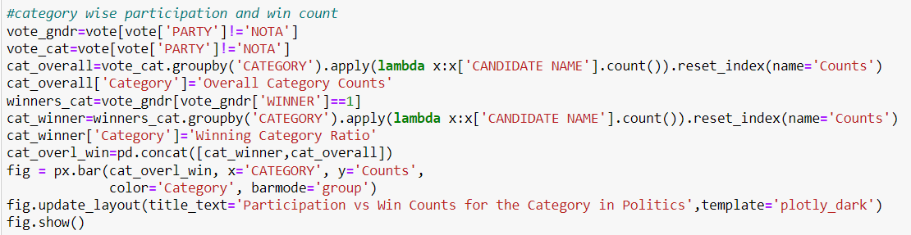

**Observation** The Category participation of General-SC have been in the ratio of 522:150- while as of the winners, the ratios have been modified to 58:12

**Fact:** The Aam Aadmi Party won all 12 seats allocated for SC candidates, with a winning margin of about 12,000 votes.

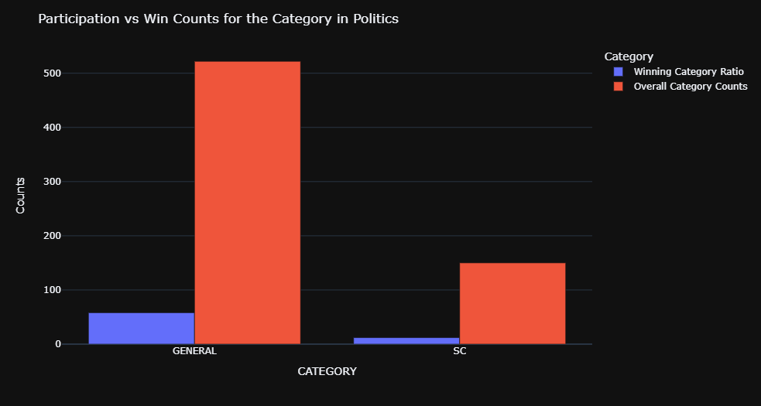

**YOUNGEST MLAs**

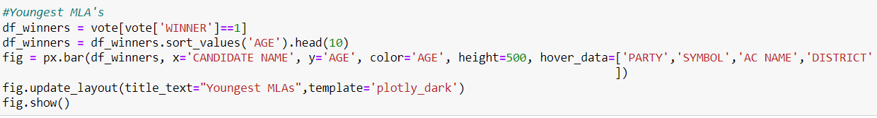

**Observation:**

**Kuldeep Kumar** , Delhi's youngest MLA(30) , was elected from the Kondli (SC) Assembly seat, which is part of the East Delhi parliamentary seat.

**Raghav Chadha**, a 31-year-old chartered accountant, is one of the Delhi Assembly's youngest members. Chadha, an AAP spokesman for many years and one of the party's most amiable faces, defeated BJP candidate Sardar R P Singh by 20,058 votes in the Rajinder Nagar seat.

Next three youngest MLA's Prakash Jarwal, Rituraj Govind and Rakhi Birla.

**Fact:**The freshly elected members of the Delhi Assembly (MLAs) are roughly five years older on average than the previous Assembly members. This is hardly surprising given that three of the five youngest members of 2015 are still among the five youngest, although with a five-year age difference. The youngest MLA this time is about five years older than the youngest in 2015, as is the oldest.

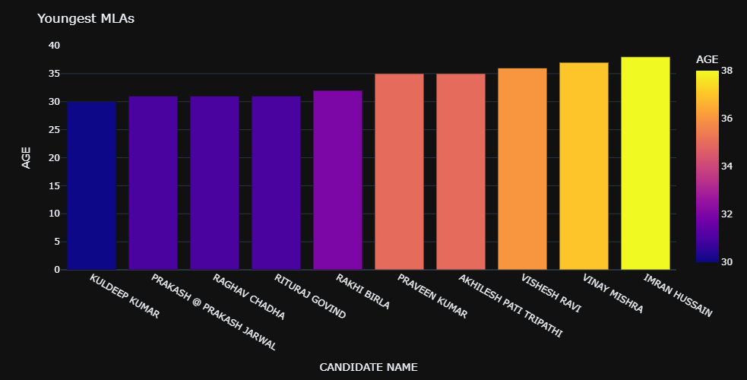

**CODE FOR BAR CHART OF OLDEST MLAs**

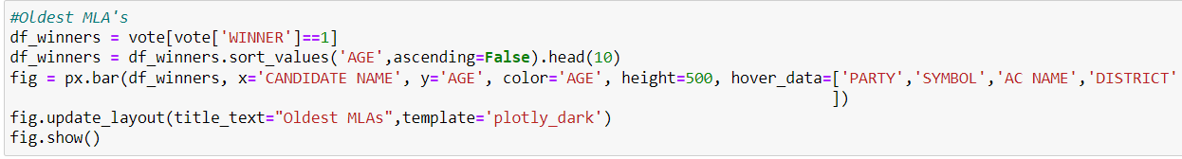

**Observation: Ram Niwas Goel**the Oldest MLA aged 72 is an Indian politician serving as Speaker of the Delhi legislative assembly since 2015. He serves as a Member of Delhi Legislative Assembly for Shahdara.

**Parlad Singh** is next oldest (69) MLA. He is an Experienced Politician who has represented 5 times in Delhi Assembly.

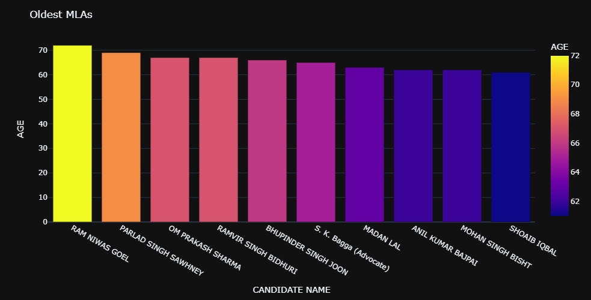

**VOTERS DISTRIBUTION OVER DISTRICT**



**Observation:** South West Delhi District has highest number of voters followed by North Delhi which has almost 13.6% of total Delhi voters. New Delhi district has least number of voters which counts to 6.01% of total Delhi voters

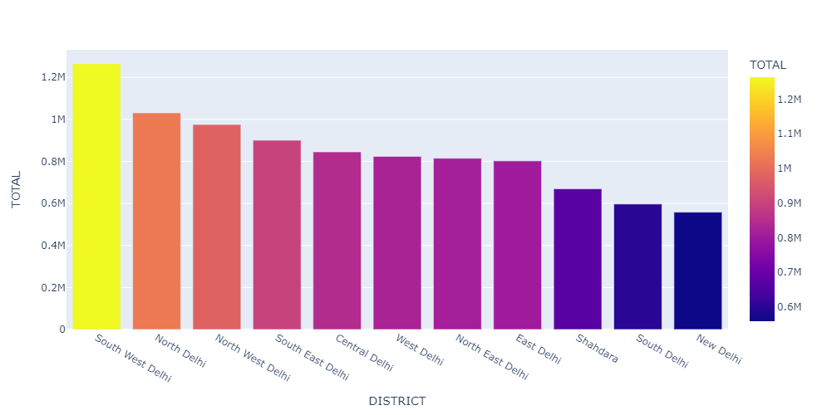

**CODE FOR VOTING % DISTRICT WISE**

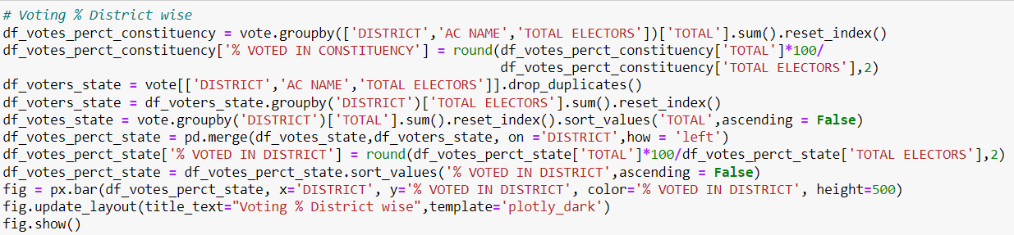

**Observation:** Even though South West Delhi has highest number of voters but North East Delhi voters turned out the most on the voting day. It has 68.78 voting percentage. New Delhi stands last even in the voting percentage. Only 56.42% of its total voters have casted their votes.

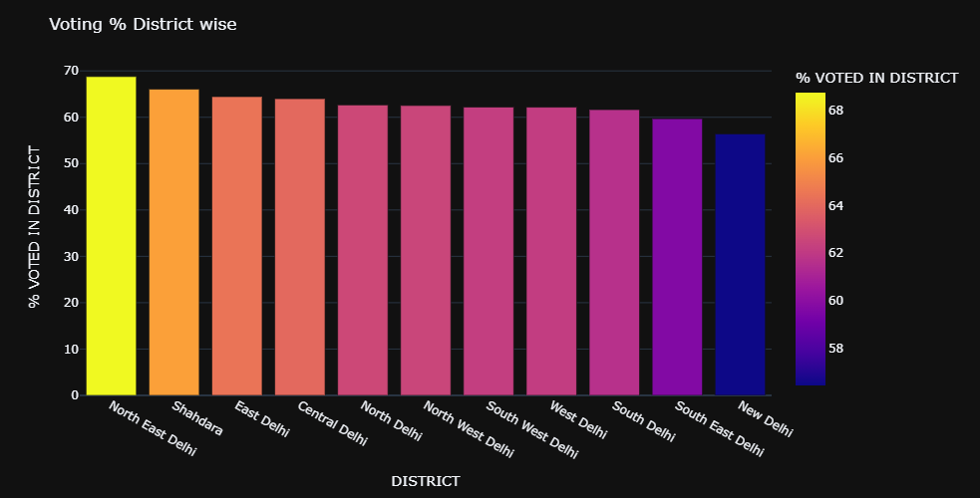

**PARTY WISE VOTE SHARE**

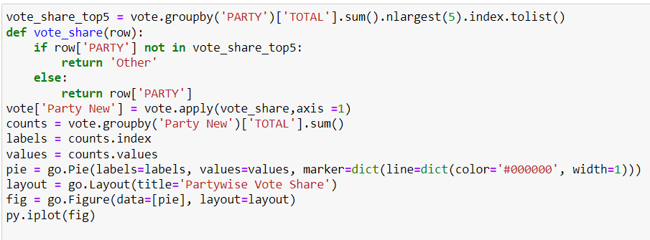

**Observation**: The Aam Aadmi Party received over 54 percent support in 2020 legislative assembly elections in Delhi, followed by the Bharatiya Janata Party with around 39 percent. The AAP achieved a landslide win, taking 62 of the 70 seats, with the BJP taking the remaining eight.

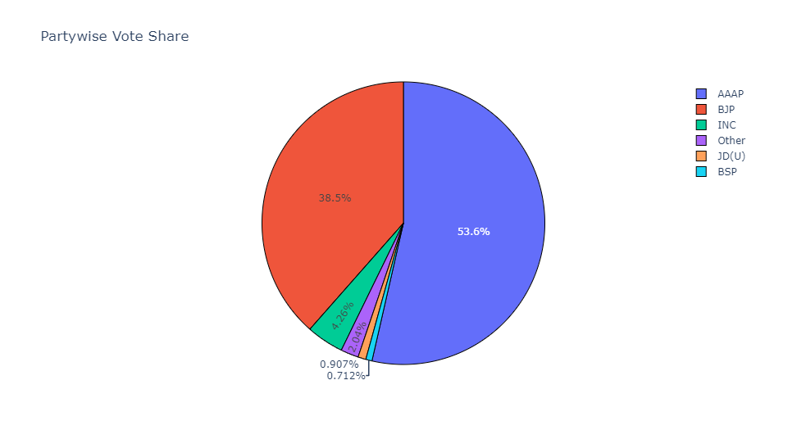

**EDUCATIONAL QUALIFICATION OF THE WINNERS**

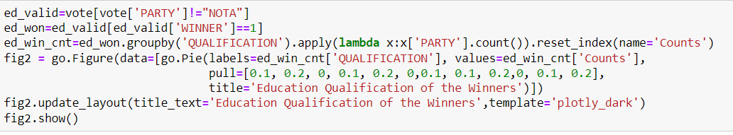

**Observation:** The overall proportion of persons with a Bachelor's degree or above who won the election is 60.12%. This is an excellent statistic, because educated politicians are a critical component of a country's progress. However, over 40% of politicians do not have a professional degree. I hope that as time goes on, we improve on this element and make educational qualifications a main consideration while voting!

**Fact:** There are 23, down from 24 in 2015, MLAs who have disclosed their educational level between 8th and 12th pass. However, the number of MLAs who have indicated that they hold a bachelor's degree or more has decreased from 43 to 42. The number of MLAs who have declared degrees has increased from three in 2015 to five this year.

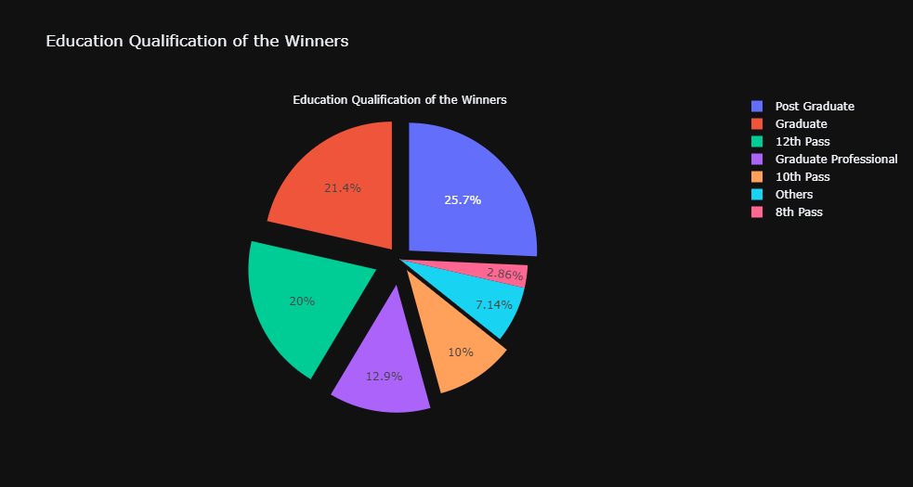

**ASSETS OF WINNING CANDIDATE**

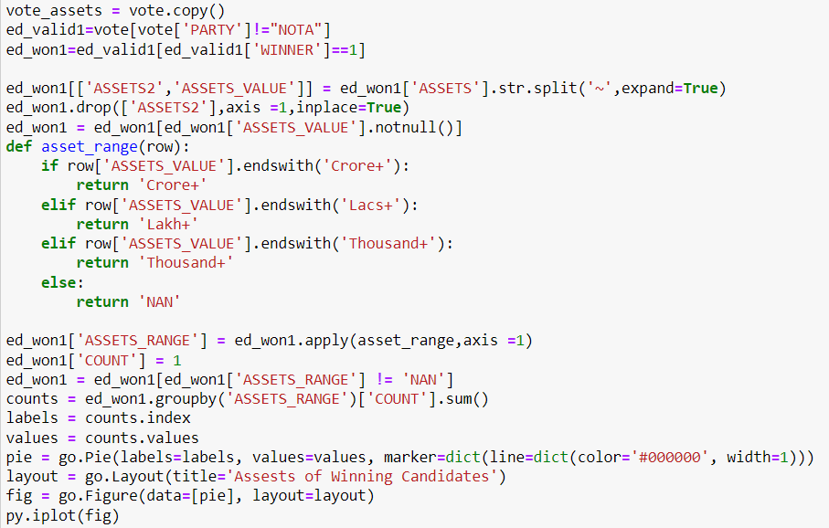

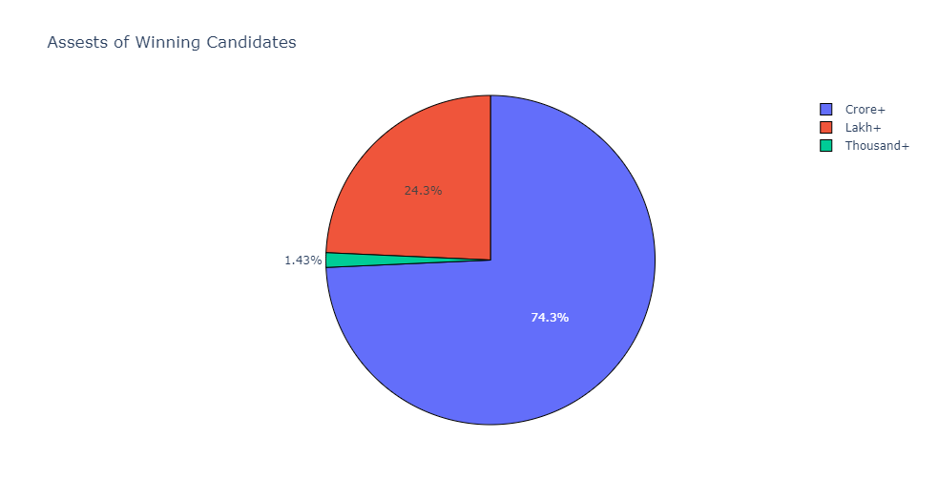

**Observation:**74.3% of Delhi MLA's assets worth more than a crore.

**Fact :** The Delhi Assembly 2020 MLAs are wealthier than the last one. Delhi has elected 52 crorepatis for 2020, up from 44 in 2015.

* A Delhi MLA's average net worth is Rs 14.3 crore.
* Aam Aadmi Party MLA from Mundka, Dharampal Lakra — seem to be to responsible for the upward trend in average assets of MLAs. In his self-sworn declaration, Lakra, a first-time MLA, disclosed assets of Rs 292.1 crore, making him the richest Delhi legislator ever.
* With assets around Rs 18,000, AAP's Rakhi Bidlan remained the poorest MLA. She was also one of the youngest and poorest members in the 2015 Delhi assembly. She has disclosed assets of Rs 76,421 including Rs 40,000 cash on hand this time.

**CRIMINAL CASES COUNT AMONG THE CANDIDATES**

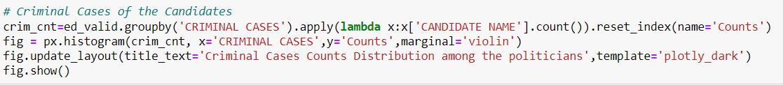

**Observations**: Many politicians have been associated with criminal activities. Majority of the candidates have an average of 3 criminal cases. Always these cases pressed need not be genuine, but obviously, when its multiple- this is a serious issue. We must take the responsibility while voting, as it is our duty to choose the right person- as a duty towards the nation.

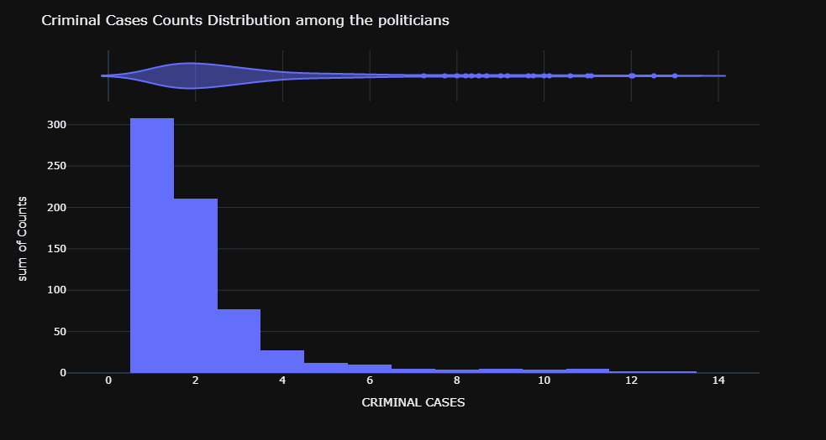

**Sunburst Image of Districts and their MLA's along with their criminal cases count**

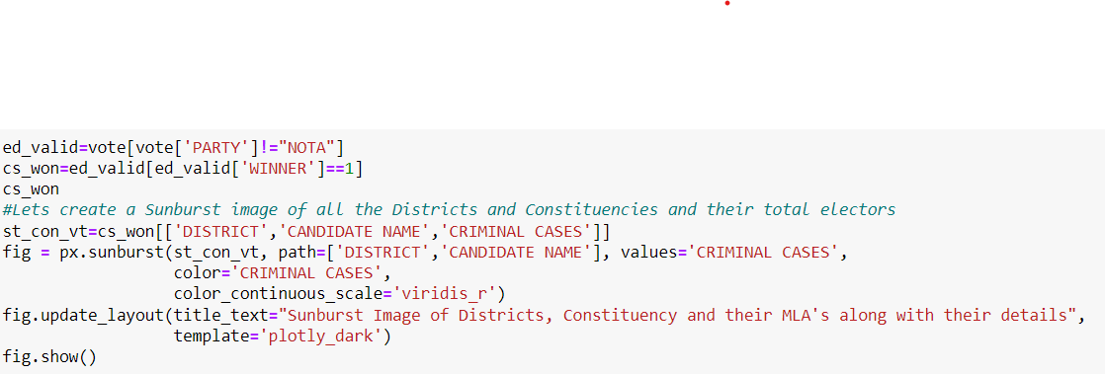

.

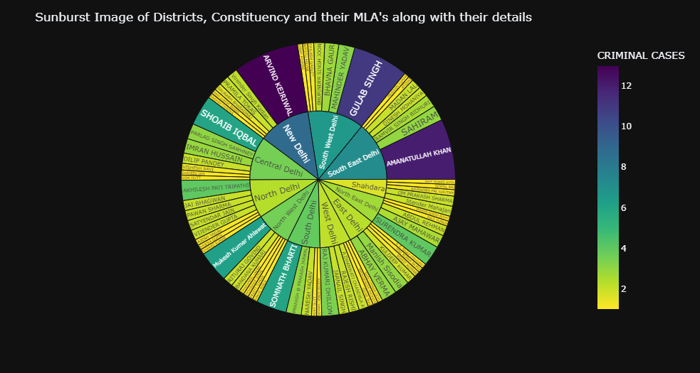

**Observation:** Above Sunburst image beautifully shows details of all the candidates who have registered win in Delhi Assembly Elections 2020. It shows the winners constituency wise and also district wise. Along with it, it depicts their Criminal Cases.

**Fact:** Thirty-seven of Delhi's freshly elected MLAs have declared severe criminal charges against themselves, including attempted murder and at least one rape case. According to the statements made by these MLAs, 43 of them are facing criminal accusations, with 37 of them declaring severe crimes such as rape, attempted murder, and crime against women

**PREDICTION**

**PREDICTION**

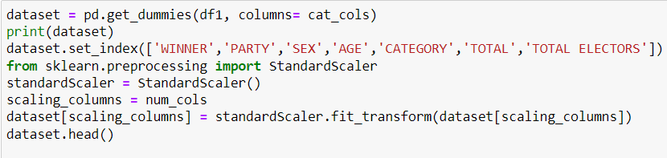 We have done Prediction using:

1. Random Forest Classifier
2. Logistic Regressor
3. Support Vector Machine
4. K Nearest Neighbour
5. Decision Tree

* Firstly, we have converted the categorical data into numbers by replacing using get dummy function to treat the categorical data.
* Next we have performed data preprocessing to scale the data

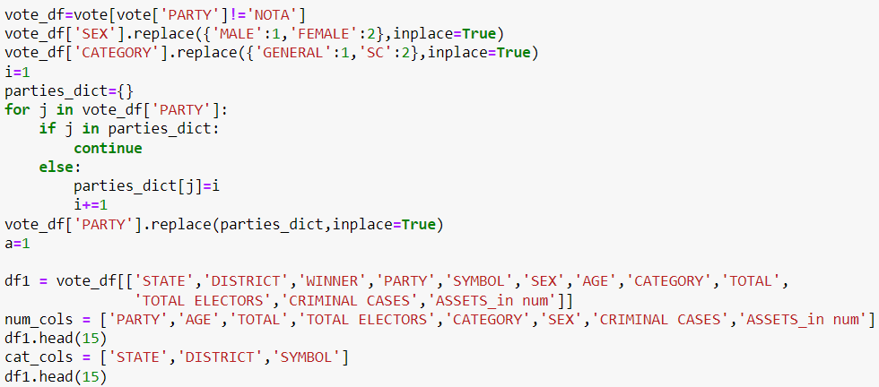



**RESAMPLING THE DATA FOR PREDICTION**

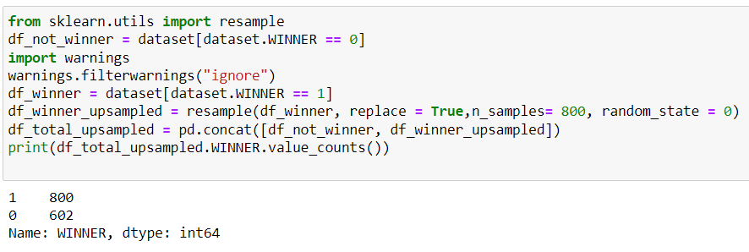

**RANDOM FOREST CLASSIFIER**

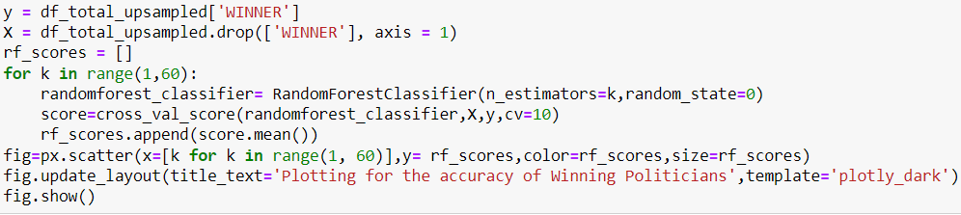

**PLOT OF ACCURACY FOR RANDOM FOREST CLASSIFIER**

ACCURACY =99.002%

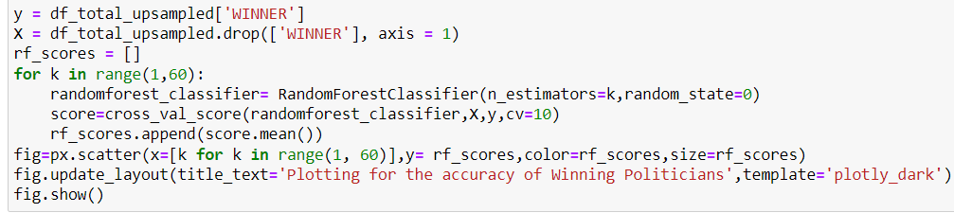

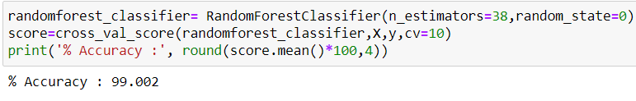

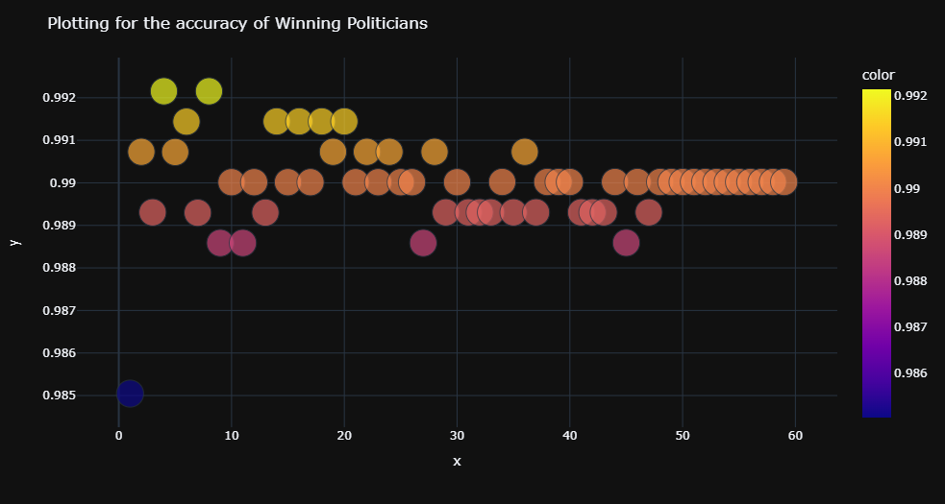

**LOGISTIC REGRESSOR**

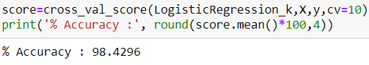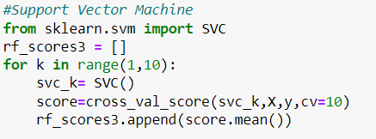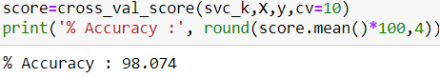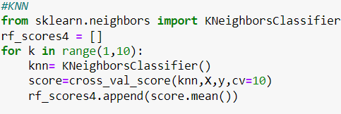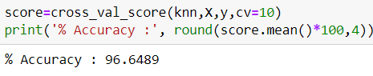

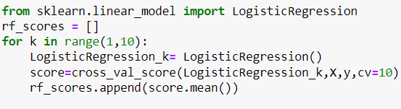

**ACCURACY=98.42%**

**SUPPORT VECTOR MACHINE**

**ACCURACY=98.07%**

**K NEAREST NEIGHBOUR**

**ACCURACY=96.64%**

**DECISION TREE**

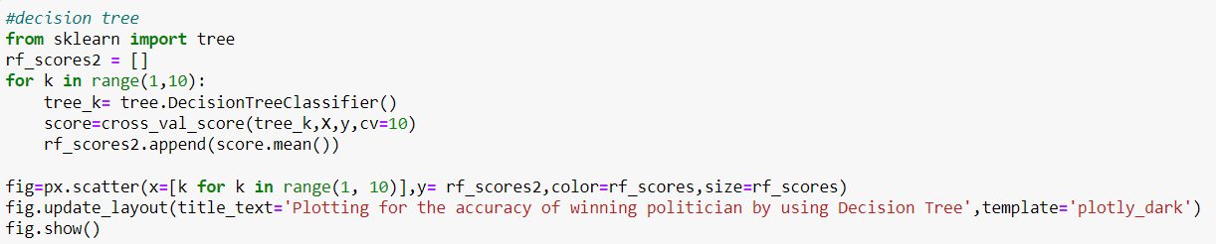

**ACCURACY=99.002**

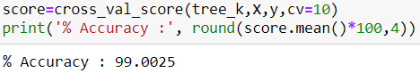

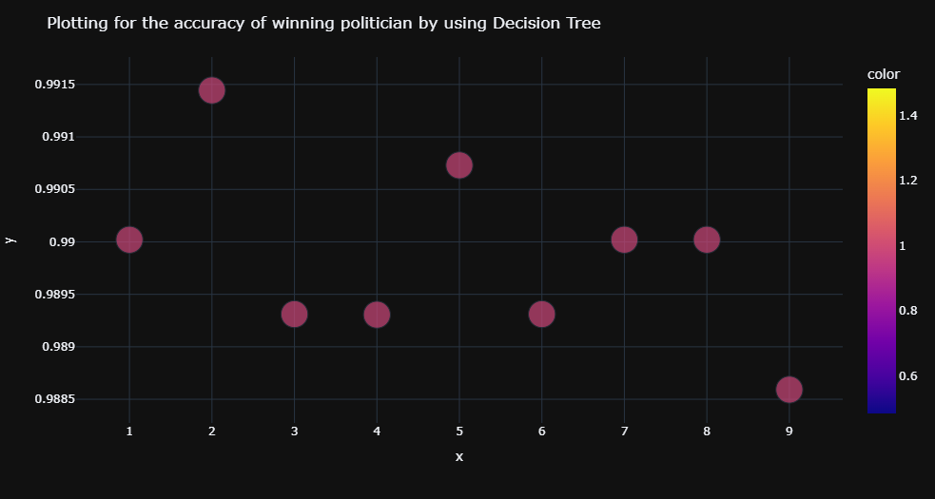

**LIMITATION**

We do not have data for ASSETS , QUALIFICATION AND CRIMINAL CASES details for all the Candidates, so this lead to some biased prediction as these attributes are more important for prediction so it’s a major limitation of our project.

We have treated these missing values by using various imputations which might not be 100% accurate to predict the results.

# CONCLUSION

Defeating the Modi-Shah juggernaut in Delhi, twice in a row with a landslide, the AAP’s achievement is a rarity. Not many opposition leaders have been able to survive Narendra Modi’s popularity or Amit Shah’s machinations. Modi is so popular that he [won](https://economictimes.indiatimes.com/news/elections/lok-sabha/india/bjp-gets-over-50-votes-in-several-states-repeats-2014-landslide-in-north-west-india/articleshow/69464644.cms?from=mdr)more than 50 per cent votes for the BJP in much of north India, including Delhi, in the 2019 Lok Sabha election

Through our Project we have performed detailed Exploratory Data Analysis on Delhi State Assembly Elections 2020. We have found out various insights and patterns using the dataset through our project.

We have also performed various Prediction techniques for predicting the results with the given variables.

# TECHNICAL SPECIFICATIONS

## PYTHON

1. It is an open source, interpreted, high level language and provides great approach for object-oriented programming.
2. Python provide great functionality to deal with mathematics, statistics and scientific function.

## JUPYTER

1. We have took ANACONDA NAVIGATOR 2.1.1

CMD.exe Prompt 0.1.1

JUPYTER NOTEBOOK 6.4.11 (Python ) as our analytics tool.

**REFERENCES**

* DATASET: General Legislative Election 2020 DELHI election-> https://eci.gov.in/files/file/12027-general-legislative-election-2020/
* For CRIMINAL CASES-> <https://www.oneindia.com/delhi-mlas-with-criminal-cases/>
* For QUALIFICATION-> <https://www.oneindia.com/educational-qualification-of-delhi-mlas/>
* For ASEESTS-> <https://www.oneindia.com/assets-details-of-delhi-mlas/>
* For Technical Help-> [https://www.kaggle.com/paramarthasengupta/eda-plotly-prediction-indian-elections-2019#What-has-been-the-performance-of-the-Parties-Statewise](https://www.kaggle.com/paramarthasengupta/eda-plotly-prediction-indian-elections-2019)