Java Assignment 4

Name: Palak Kumari
Roll No: 25SCS1003001665
Course: B.Tech CSE Subject: Java Programming

Question 1: Identify whether a number is even or odd

Program-
import java.util.Scanner; public class evenodd {
public static void main(String[] args){ Scanner sc=new Scanner(System.in); System.out.println("enter a no");
int n =sc.nextInt();

if(n%2==0)
System.out.println(n+" is a even number."); else
System.out.println(n +" is a odd number. ");
}
}
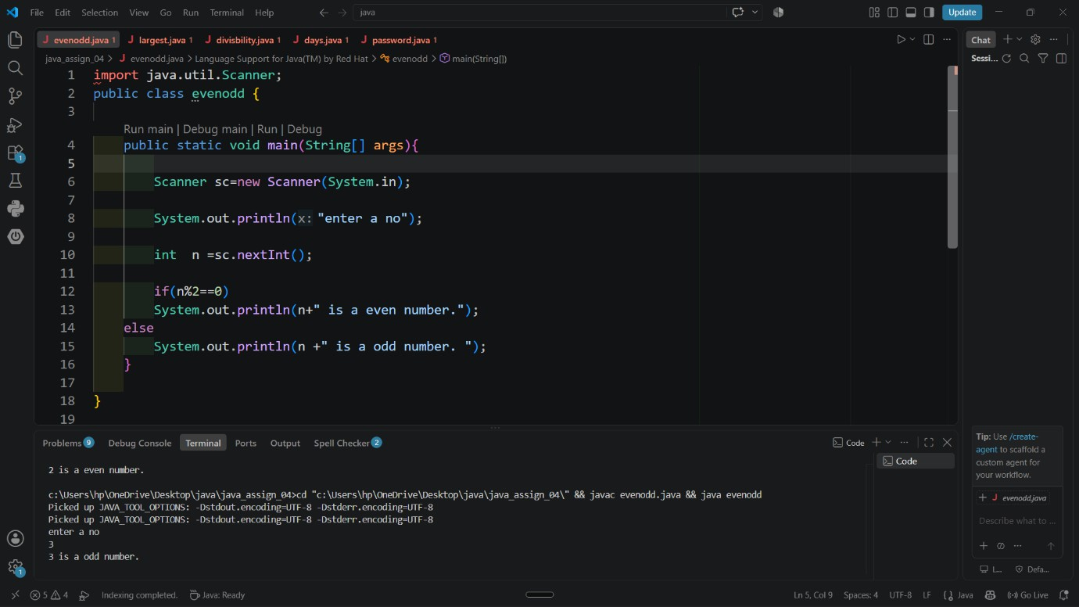
Output-

Question 2: Largest of three numbers

Program:
import java.util.Scanner; public class largest {
public static void main(String[]args){ Scanner sc=new Scanner(System.in); System.out.println("enter three numbers"); int n1=sc.nextInt();
int n2=sc.nextInt(); int n3=sc.nextInt(); if(n1>n2&&n1>n3)
System.out.println(n1+" is the greatest number"); else if(n2>n1&&n2>n3)
System.out.println(n2+" is the greatest number"); else if(n3>n1&&n3>n2)
System.out.println(n3+" is the greatest number "); else
System.out.println("all are same number");
} }
Output:
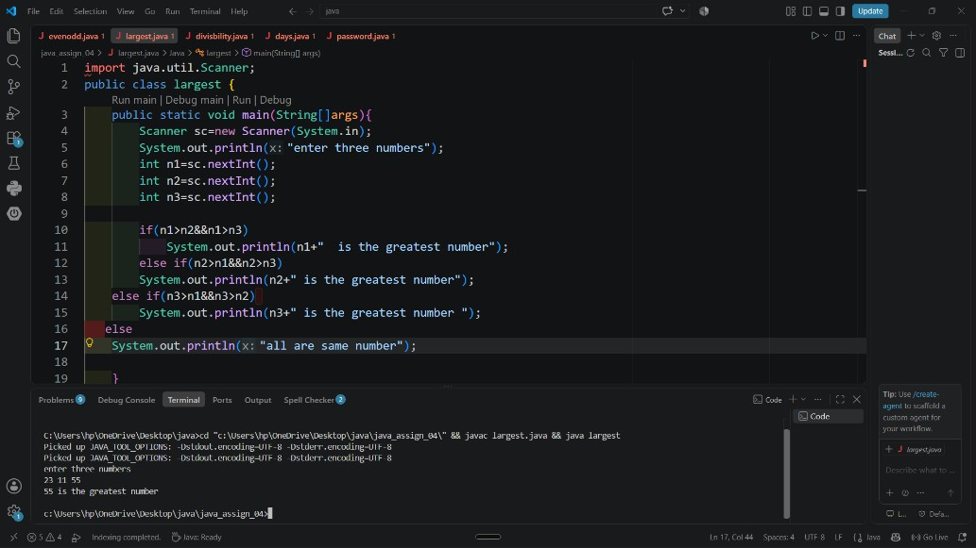

Question 3: Divisible by 5 and 10 Program:
import java.util.Scanner; class divisbility{
public static void main(String[]args){ System.out.println("enter a number"); Scanner sc=new Scanner(System.in);
int n=sc.nextInt(); if(n%5==0)
{
if(n%10==0)
System.out.println(n+" is divisible by both 5 and 10.");
}
else
System.out.println(n+" is not divisible by both 5 and 10.");
} }
Output-
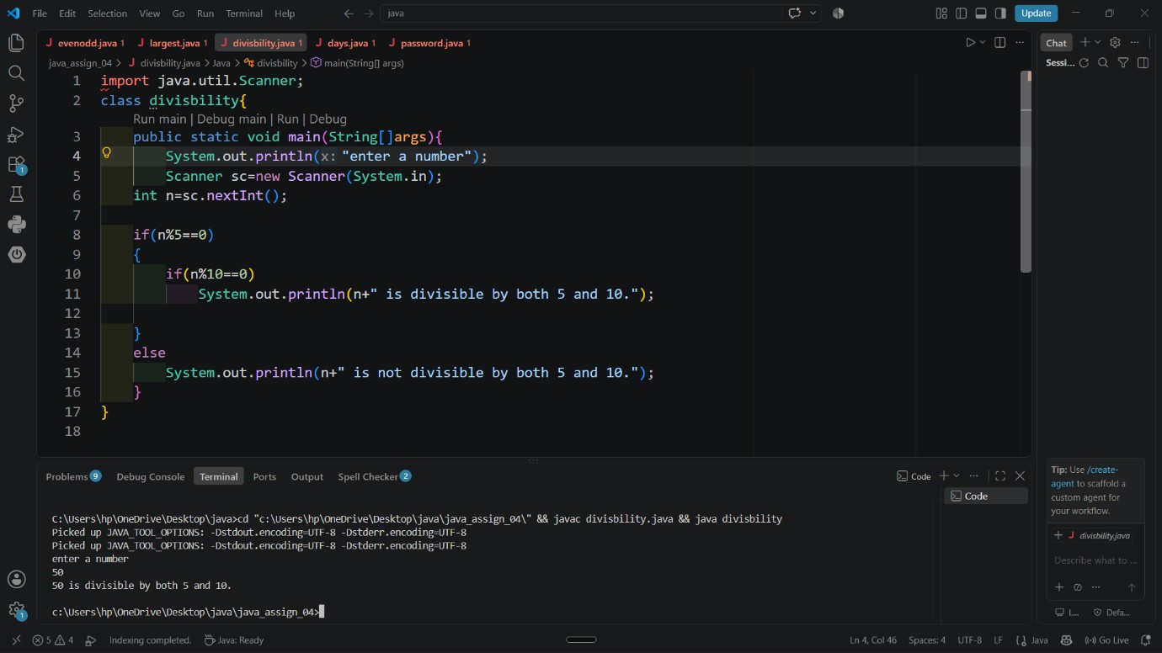

Question 4- Day is a working or weekend Program-
import java.util.Scanner; public class days {
public static void main(String[] args){ Scanner sc=new Scanner(System.in);
System.out.println("enter a number between 1 to 7");

int n=sc.nextInt();

if(n>=1&&n<=5)
System.out.println("it is a working day"); else
System.out.println("it is a weekend");
}
}
Output-
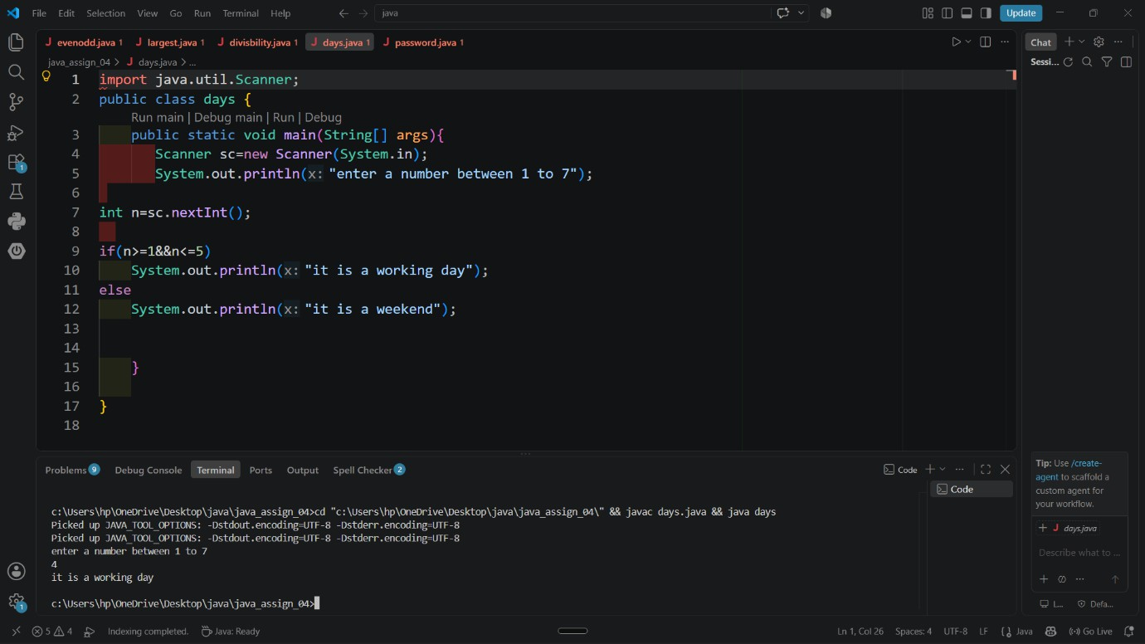

Question 5- Identify the strength of the password Program-
import java.util.Scanner; public class password {
public static void main(String[]args){ Scanner sc=new Scanner(System.in);
System.out.println("enter a password to be checked "); String p=sc.nextLine();
int l=p.length(); if(l<8)
System.out.println("password too short"); else if (l<12)
System.out.println("password is acceptable "); else if(l>12)
System.out.println("strong password");
}
}
Output-
