Java Assignment 5

Name: Palak Kumari
Roll No: 25SCS1003001665
Course: B.Tech CSE
Subject: Java Programming

- Find the sum of numbers from 1 to N

Program-
import java.util.Scanner;

class SumN {
public static void main(String[] args) {
Scanner sc = new Scanner(System.in);

System.out.print("Enter N: ");
int n = sc.nextInt();

int sum = 0;

for (int i = 1; i <= n; i++) {
sum = sum + i;
}

System.out.println("Sum = " + sum);
}
}

Output-
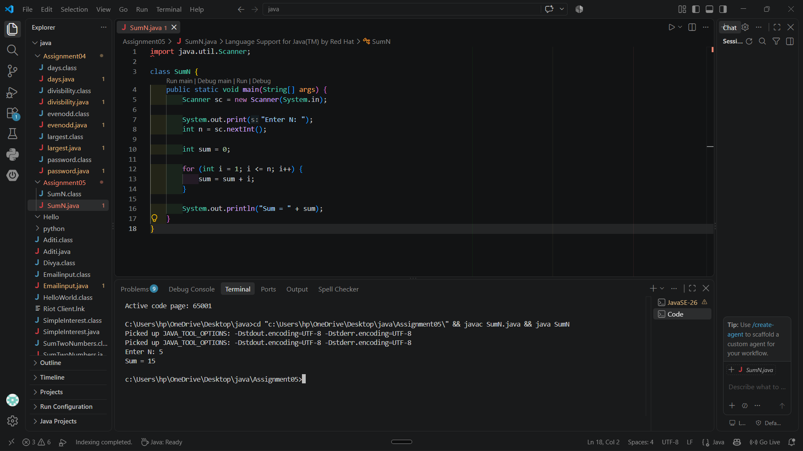

- Print multiples of 5 from 1 to 100
Program-
class MultiplesOf5 {
public static void main(String[] args) {

for (int i = 5; i <= 100; i = i + 5) {
System.out.println(i);
}
}
}

Output-
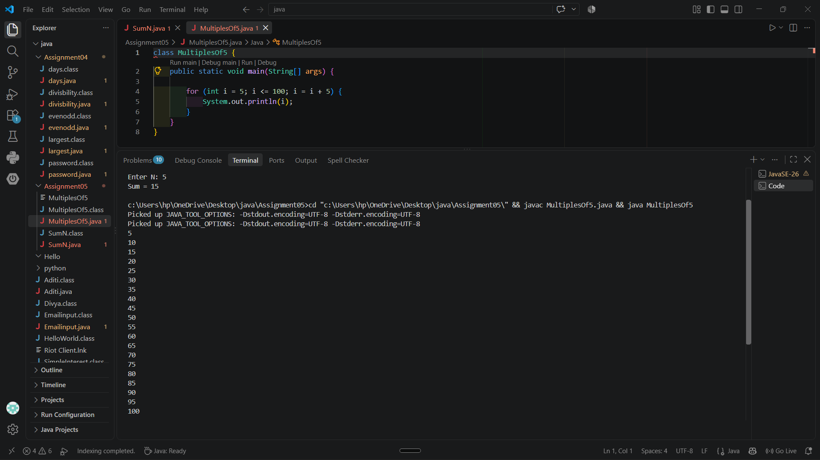

3. Count numbers divisible by 3 between 1 and N
Program-
import java.util.Scanner;
class Divisibleby3 {
public static void main(String[] args) {
Scanner sc = new Scanner(System.in);
System.out.print("Enter N: ");
int n = sc.nextInt();
int count = 0;
for (int i = 1; i <= n; i++) {
if (i % 3 == 0) {
count++;
} }
System.out.println("Count = " + count);
} }
Output-
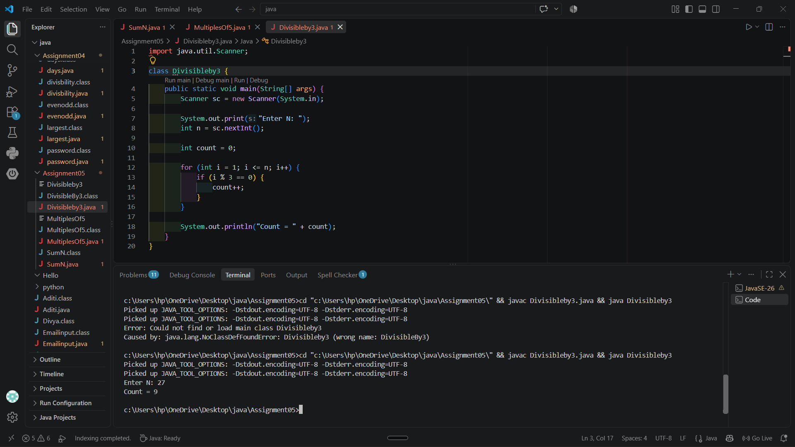

4. Check whether a number is prime or not
Program-
import java.util.Scanner;
class PrimeCheck {
public static void main(String[] args) {
Scanner sc = new Scanner(System.in);
System.out.print("Enter a number: ");
int n = sc.nextInt();
int count = 0;
for (int i = 1; i <= n; i++) {
if (n % i == 0) {
count++;
} }
if (count == 2)
System.out.println("Prime");
else
System.out.println("Not Prime");
} }
Output-
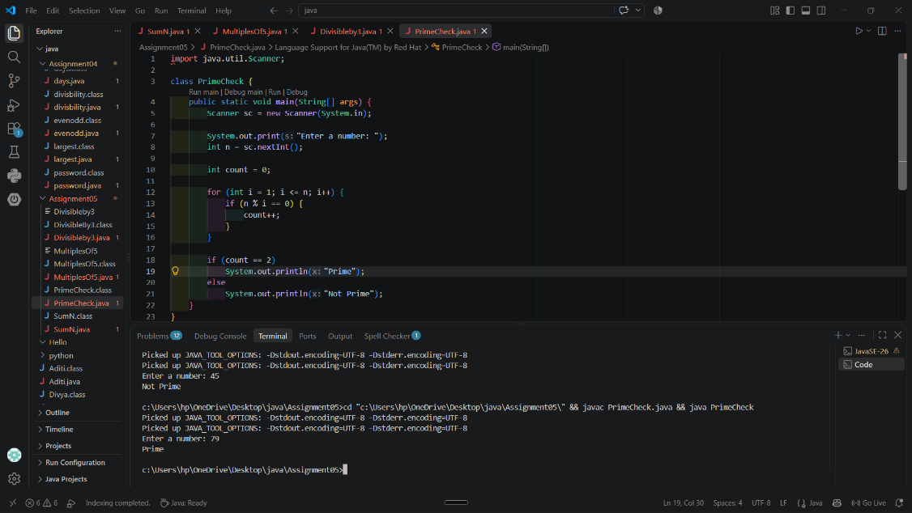
5. Reverse of a given number
Program-
import java.util.Scanner;
class ReverseNumber {
public static void main(String[] args) {
Scanner sc = new Scanner(System.in);
System.out.print("Enter a number: ");
int n = sc.nextInt();
int reverse = 0;
while (n > 0) {
int digit = n % 10;
reverse = reverse * 10 + digit;
n = n / 10;
}
System.out.println("Reverse = " + reverse);
} }
Output-
