An Internship Report
Of
Social Media Marketing Internship
Submitted
To
School of Computer Science and Engineering
IILM University, Greater Noida, U.P.
In partial fulfilment of the requirement of degree of
B.Tech
By
Roll Number of Student: 25SCS1003001665
Name of Student: PALAK KUMARI

Candidate's Declaration
I, PALAK KUMARI, do hereby declare that the internship report titled "Social Media Marketing Internship at ARUNAVI (ASB Enterprises)" has been completed by me to fulfil the requirement for the award of the degree of Bachelor of Technology. All the references have been quoted and I have not taken as such any material from any other source. I affirm that this report is my own and has not been submitted to any other institute for any degree/diploma requirement, and further I shall be solely responsible for any kind of copyright violation in this regard.
Signature:-
Student Name: PALAK KUMARI
Roll No.: 25SCS1003001665

Acknowledgement
I am using this opportunity to express my gratitude to everyone who supported me throughout the internship. I am thankful for their aspiring guidance, invaluably constructive criticism and friendly advice during this work. I am sincerely grateful to them for sharing their truthful and illuminating views on a number of issues related to this work.
I would like to thank ARUNAVI (ASB Enterprises) for providing me the opportunity to undertake this internship, and my Reporting Manager, Mr. Nishant Kumar, for his continuous guidance and support throughout the internship period. I am also thankful to my institute, IILM University, Greater Noida, and the faculty of the School of Computer Science and Engineering for their continuous support and encouragement.
I express my gratitude to my parents for their blessings.
Signature:-
Student Name: PALAK KUMARI
Roll No.: 25SCS1003001665

Table of Contents
1. Candidate's Declaration 2
2. Acknowledgement 3
3. Internship Offer Letter 5
Internship Completion Certificate 6
4. Project Description 7
4.1 Introduction 7
4.2 Organization Profile 7
4.3 Problem Statement 7
4.4 Internship Objectives 7
4.5 Scope of the Internship 8
4.6 Technologies and Tools Used 8
4.7 Methodology 8
4.8 Expected Outcomes 8
4.9 Certificates of Completion and Communication Proof 9
5. Bibliography/References 10

3. Internship Offer Letter
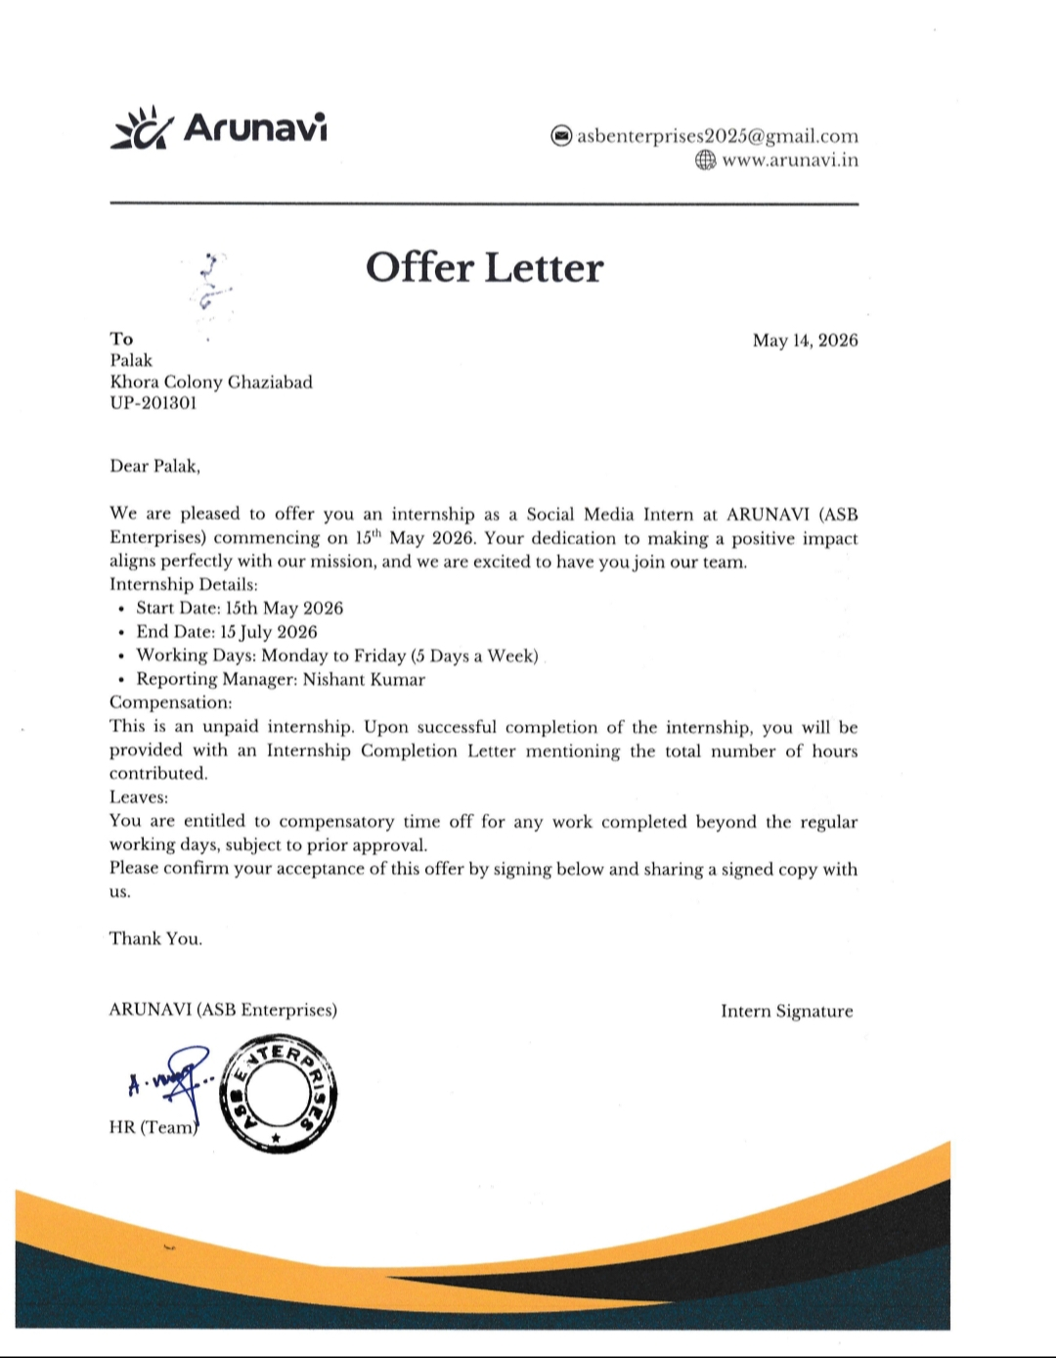

Internship Completion Certificate
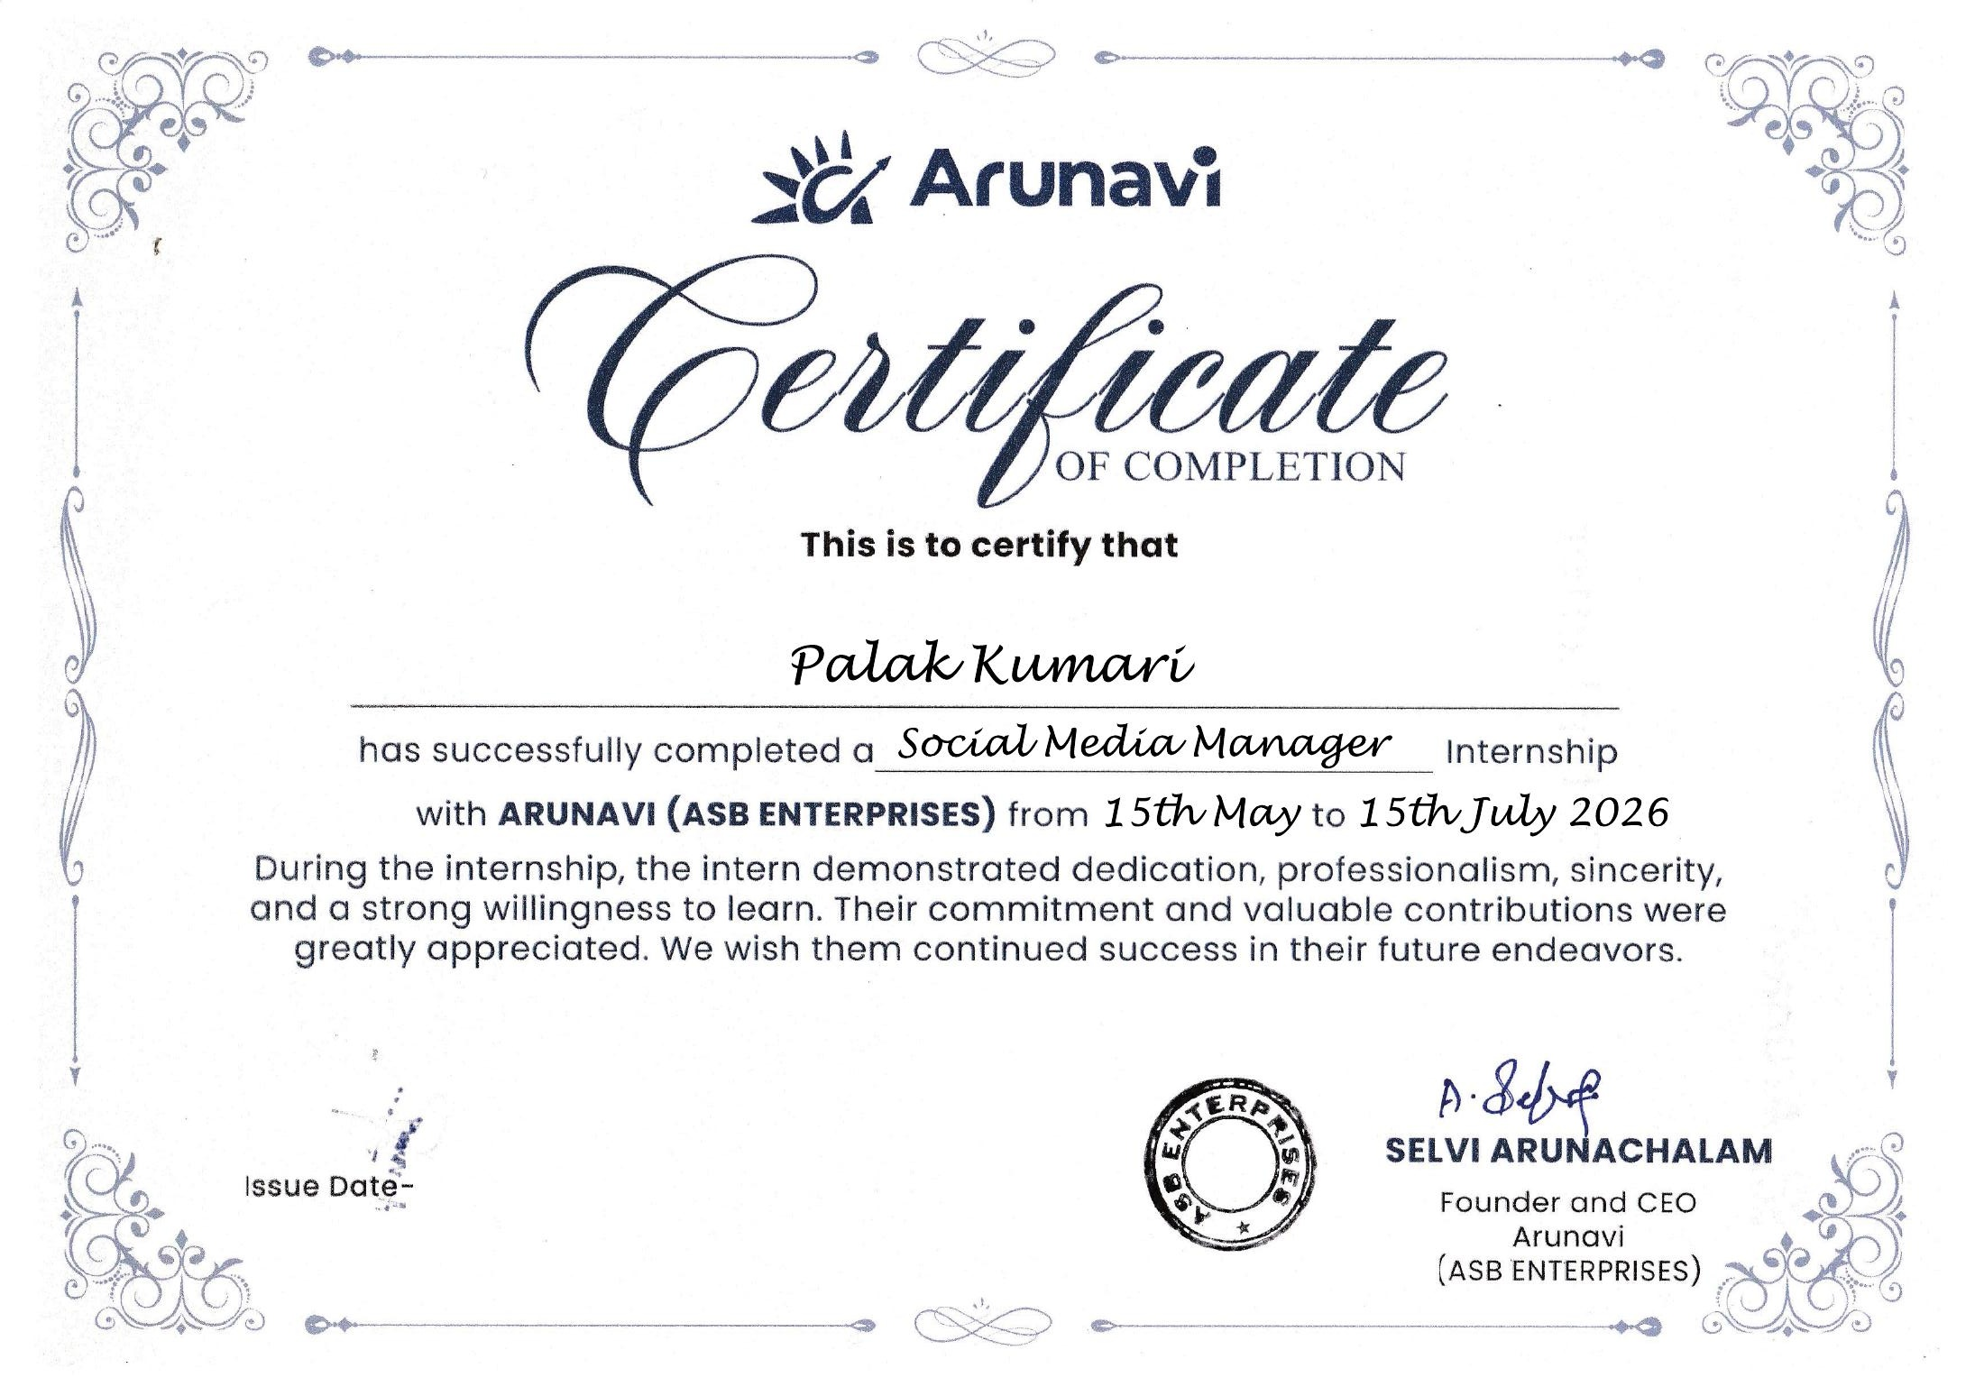

4. Project Description

4.1 Introduction
This report presents a detailed account of the internship undertaken as a Social Media Intern at ARUNAVI (ASB Enterprises). The internship was carried out from 15th May 2026 to 15th July 2026, spanning 9 weeks, as part of the requirement of the Bachelor of Technology programme at IILM University, Greater Noida. The internship was unpaid, followed a Monday-to-Friday working schedule, and was carried out under the supervision of Reporting Manager Mr. Nishant Kumar.
The primary aim of this internship was to build practical, hands-on experience in social media management — planning and executing content across multiple platforms, writing engaging copy, tracking performance through analytics, and supporting paid promotional campaigns. On successful completion of the internship, a Certificate of Completion was issued by ARUNAVI (ASB Enterprises), certifying the role of Social Media Manager.

4.2 Organization Profile
ARUNAVI, operated by ASB Enterprises, is led by Founder and CEO Ms. Selvi Arunachalam. The organization brings on interns to support its social media presence, offering hands-on experience in day-to-day digital content, audience engagement, and brand communication across platforms such as Instagram, Facebook, and Twitter.

4.3 Problem Statement
Growing brands need a consistent, engaging voice across social media platforms — from planning content and writing captions, to publishing on schedule and tracking what resonates with the audience. Many organizations struggle to maintain this consistency without dedicated support. The internship addressed this gap by taking on the day-to-day responsibility of planning, creating, publishing, and analyzing content for ARUNAVI (ASB Enterprises) across Instagram, Facebook, and Twitter, turning routine posting into a more consistent, data-informed content strategy.

4.4 Internship Objectives
- To plan and maintain a monthly content calendar across Instagram, Facebook, and Twitter.
- To write captions, hashtags, and post copy aligned with the brand voice.
- To schedule and publish posts consistently across platforms.
- To engage with followers by responding to comments and messages.
- To track engagement metrics and report on content performance.
- To research trends, competitor pages, and new content ideas.
- To assist with paid ad campaigns and boosted posts.

4.5 Scope of the Internship
The scope of this internship covered the complete day-to-day social media workflow for ARUNAVI (ASB Enterprises) — from content planning and design, to copywriting, scheduling, publishing, follower engagement, and performance analysis, across Instagram, Facebook, and Twitter. It also included competitor and trend research, and assisting with paid promotional campaigns. The internship was limited to the organization’s own social media channels and did not extend to external client accounts.

4.6 Technologies and Tools Used
- Design & Content Creation: Canva, Adobe Photoshop
- Scheduling & Management: Meta Business Suite
- Analytics & Reporting: Instagram Insights, Facebook Insights, Google Analytics
- Platforms Managed: Instagram, Facebook, Twitter

4.7 Methodology
The internship followed a structured, phase-wise methodology across its 9-week duration, combining content planning, creation, publishing, engagement, and analytics, as summarized in the table below.
Weeks | Phase | Description
1–2 | Onboarding & Planning | Understood the brand voice and built the monthly content calendar for Instagram, Facebook, and Twitter.
3–4 | Content Creation | Designed posts using Canva and Photoshop; wrote captions, hashtags, and post copy.
5–6 | Publishing & Engagement | Scheduled and published posts via Meta Business Suite; engaged with followers by responding to comments and messages.
7–9 | Analytics & Campaigns | Tracked engagement metrics using Instagram/Facebook Insights and Google Analytics; researched trends and competitor pages; assisted with boosted posts and paid ad campaigns.

4.8 Expected Outcomes
- Practical experience in social media content planning and execution.
- Understanding of audience engagement and analytics-driven content strategy.
- Improved copywriting and caption-writing skills.
- Experience coordinating with a team and meeting content deadlines.
- Exposure to brand communication and social media growth tactics.

4.9 Certificates of Completion and Communication Proof
The Internship Offer Letter and the Internship Completion Certificate issued by ARUNAVI (ASB Enterprises), confirming the internship period from 15th May 2026 to 15th July 2026 in the role of Social Media Manager, are attached in Chapter 3 of this report.

5. Bibliography/References
- ARUNAVI (ASB Enterprises), "Offer Letter – Social Media Internship," May 14, 2026.
- ARUNAVI (ASB Enterprises), "Certificate of Completion – Social Media Manager Internship," 2026.
- ARUNAVI (ASB Enterprises), Company Website, https://www.arunavi.in
- Meta Business Suite Help Center, https://www.facebook.com/business/help
- Canva, https://www.canva.com

