System Requirements Statement (SRS) –

SpendWise

Doc. Ref. :

Version : 0.4

Status : Drafted

Created by : Abhishek Ingle, Akanksha Soor, Aparna Bolke, Palak Sen

Date : 25-Jun-2024

1. Introduction 3

2. Functional Requirements 4

2.1 User Module 5

2.2 Small Business Module 11

2.3 admin Module 17

2.4 Use Case Diagram.............................................................................................................................22

THIS DOCUMENT CONTAINS 23 NUMBERED PAGES

# Introduction

This document explains the system requirements and scope for developing Expense Tracking System.

Expense Tracking System could divide the four main parts, User part, Business part, Admin part.

This document describes the system requirement of the Account part.

# Functional Requirements

The Account part of Expense Tracking System has three modules which are divided 31 processes described as below.

|  |  |  |
| --- | --- | --- |
| **No** | **BRS requirement ID** | **Description** |
| **2.1** | **User Module** | |
| **2.1.1** | **F1** | **Account Creation Process** |
| **2.1.2** | **F2** | **Login Process** |
| **2.1.3** | **F3** | **Forgot Password Process** |
| **2.1.4** | **F4** | **Modify Account Process** |
| **2.1.5** | **F5** | **Add Expenses Process** |
| **2.1.6** | **F6** | **Delete Expenses Process** |
| **2.1.7** | **F7** | **Generate Mini Statement Process** |
| **2.1.8** | **F8** | **Multi-Categorization Process** |
| **2.1.9** | **F9** | **Set Budget Process** |
| **2.1.10** | **F10** | **Budget Analyzation Process** |
| **2.1.11** | **F11** | **Multi-user Grouping Process** |
| **2.1.12** | **F12** | **Expense Splitting Process** |
| **2.1.13** | **F13** | **Scanning Receipt Process** |
| **2.1.14** | **F14** | **Modifying Expense Process** |
| **2.2** | **Small** **Business Module** | |
| **2.2.1** | **F15** | **Account Creation Process** |
| **2.2.2** | **F16** | **Login Process** |
| **2.2.3** | **F17** | **Forgot Password Process** |
| **2.2.4** | **F18** | **Modify Account Process** |
| **2.2.5** | **F19** | **Income / Expenses Management Process\*\*\*** |
| **2.2.6** | **F20** | **Creating Group by Department Process** |
| **2.2.7** | **F21** | **Sub-Head Grouping** |
| **2.2.8** | **F22** | **Multi-Mini Statement Generation\*\*** |
| **2.2.9** | **F23** | **Multi-Categorization Process** |
| **2.2.10** | **F24** | **Expense Verification/Authenticate Process** |
| **2.2.11** | **F25** | **Over-Expenditure Analysing Process\*\*** |
| **2.2.12** | **F26** | **Reimbursed/Accelerate Process\*\*** |
| **2.2.13** | **F27** | **Report Generation** |
| **2.2.14** | **F29** | **Set Budget** |
| **2.2.15** | **F30** | **Budget Analyzation Process** |
| **2.3 Admin Module** | | |
| **2.3.1** | **F28** | **Login Process** |
| **2.3.2** | **F30** | **Authentication Of Users Process** |
| **2.3.3** | **F31** | **Categorizing the Users Process** |

## User Module

* User of system who wants to keep track of their expenses.

* He is also able to view the Monthly/Annual Expenditure.

### Account Creation Process

* SpendWise compels to create the account before using it. So, System should provide the function which makes creates new account.
* When user creates new account, the function demands some information described as below.

1. Login information
2. Contact Details

* The Login information

The Login information consists of some items described as below.

1. UserID
2. Password
3. First Name
4. Last Name
5. E-mail address
6. User Type
   * All items are compulsory demanded.
   * UserID

* The UserID should be unique. If the UserID correspond with not case-sensitive to other which is previously registered, the UserID should not be registered as an account.
  + Password
* The Password has constrains which makes the Password consists of more than or equal 8 and less than or equal 16 characteristics including characters described as below.

1. Numeric figure (at least one)
2. Capital alphabet (A-Z)(at least one)
3. Small alphabet (a-z)(at least one)
4. Special character (#, $, %, &, etc.) (at least one)

* The Password is masked by dummy characters. The re-entering Password is demanded.
* The Password must be encrypted in System.
  + User Type

The User Type falls into three categories described as below.

1. General User/Personal User
2. Small Organization
3. Administrator

* The User Type defines also three types of user; "General user", “Organization", and "Administrator user”.
* In an Account Creation Process, the user can select General user.
* No one could select The Administrator, because Administrator is implemented to System Admins in advance.
* Contact Details
* The Contact Detail consists of some items described as below.

1. Permanent Address
2. Contact Phone No
3. Email Id
   * All items are compulsory demanded.
   * Permanent Address

* Permanent Address should be filled.
* But only the state should be selected from options.
* The Security Question information

The Security Question information is needed when user lost their Password. This information consists of two items described as below.

1. Selected Question
2. Answer
   * All items are compulsory demanded.
   * Some questions which are difficult to answer for anyone else are prepared in advance.

E.g. what is your favorite food ?

* + A question should be selected from options by the user, and the Answer is registered by the user only.
* Login information should be entered on one screen, and then user information and Security Question information should be entered on another screen.

### Login Process

* SpendWise always compels user authentication before using itself except when a new account is successfully created.
* The user authentication demands UserID and Password. The UserID and the Password should be checked in three ways.
  + First, The UserID and the Password should be existed and correct.
* If The UserID and the Password are not equal to what the user has registered, the user authentication cannot be provided.
  + Second, the User Type linked to the UserID should be "General User".
* When the User Type is "General user", then user can be placed on “User DashBoard”.
  + Finally, UserID should be available.
* The Administrator can decide whether the UserID is available or suspended – Refer to the SRS of the Admin part.
* If user is rejected, user authentication is not provided for system user.
* The farmer account should alive for so long as the duration decided by Admin.
* Only when the three checks are successfully completed, user can be placed on respected page.
* The “User Home ” provides the some items described as below.

1. A trigger to logout
2. A trigger to update Account
3. A trigger to Change Password
4. A trigger to Add Expenses
5. A trigger to Delete Expenses
6. A trigger to generate mini statement
7. A trigger to Analysis Budget
8. A trigger to Create Group
9. A trigger to set Monthly/Annual Budget

### Forgot Password Process

* When system user lost their Password, the recovery method should be provided by system.

The recovery method is described as below.

* + First, system user enters their UserID .
  + Next, system demands the Answer which has been registered since when the Account was created.
  + Only when the Answer is correct, user get the new password by E-mail which also has been registered since when the Account was created.
  + The new password is automatically generated by System.
* Of course, the new password should consist of more than or equal 8 and less than or equal 16 characteristics including at least a numeric figure, a capital alphabet, a small alphabet, and a special character.
* As a consequence, The user could get the authentication using the new password.
  + Then, the user had better change the new password manually.
* If the Answer is not correct, otherwise, the correct Answer is demanded for user again.
  + In that case, Of course, user couldn’t get the new password.

### Modify Account Process

* SpendWise System should provide the function which makes the account updated for farmer.
* The information user could update is described below.

1. Login information
2. User information
3. Security Question Information

* The Login information

The updatable items as described below.

1. First Name
2. Last Name
3. E-mail address
   * All items are compulsory demanded, but updating is optional.

* The User information

The updatable items as described below.

1. User Name
2. User Phone No
3. E-mail address
4. Permanent address
   * All items are compulsory demanded, but updating is optional.

* The Security Question information

The updatable items as described below.

1. Selected Question
2. Answer
   * All items are compulsory demanded, but updating is optional.

### Add Expenses

* Add Expenditure methods are described as below.

1. Expenses Type
2. Date
3. Amount

### 2.1.6 Delete Expenses

* Delete Expenses Process are described as below.

1. Delete expense
2. Multi Delete

* User can see expense before deleting expense.

### Mini statement generation

* The following details are required to generate a mini statement.

1. Number of Recent Transactions
2. Date Range (optional).
3. Monthly/Annual Transactions.

### Multi-Categorization Process

* When User is adding Expenses He can categorization on type of expenditure
* Types of expenditure are : -
  + Food
  + Clothes
  + Travel
  + Groceries
  + Cosmetics
  + Medicine

### Set Budget Analyzation

* After Adding expenses if user wants to analyze expenditure then he can generate analyzation process.
* By Analyzing User Get the pattern of expenditure

### Budget Analyzation

* After Adding expenses if user wants to analyze expenditure then he can generate analyzation process.
* By Analyzing User Get the pattern of expenditure

### Multi-user Grouping

* multiple members Added to single group
* Split Expenses .
* Calculating Money you owes/lent to someone.

### Multi-user Grouping

* • Users can create new groups for different purposes, such as household expenses, trip expenses, or office project expenses.
* Group members can add expenses that are shared among all or specific group members. Each expense entry includes details such as amount, date, category, and payer.
* The system provides various options for splitting expenses (equally, by shares, or custom splits) to accommodate different scenarios.
* A real-time dashboard displays the group’s total expenses, individual contributions, and outstanding balances. It provides a clear overview of the group’s financial status.
* Members receive notifications for new expenses, changes in expenses, and settlement requests, ensuring everyone is up-to-date with the group's finances.

3.1.13 Expense Splitting Process

**Description**: Allows users to split expenses among multiple participants.

**Inputs**: Expense details, list of participants, splitting method.

**Outputs**: Split expense details for each participant.

**Processing**: Calculate each participant's share based on the chosen splitting method.

**Error Handling**: Display appropriate error messages if the splitting process fails.

**Calculate Shares:** The system calculates each participant's share based on the chosen method.

**Equal Split**: Divide the total amount equally among all participants.

**Percentage Split**: Allocate shares based on specified percentages.

**Custom Amount**: Allocate specified amounts to each participant.

**Display Results**: The system displays the split expense details for each participant.

3.1.14 Scanning Receipt Process

**Description**: Allows users to scan and upload receipts, automatically extracting and logging expense details.

**Inputs**: Receipt image.

**Outputs**: Extracted expense details (date, amount, category, vendor, etc.).

**Processing**: Analyse the receipt image, extract relevant data, and log the expense in the user's account.

**Error Handling**: Display appropriate error messages if the scanning or extraction process fails.

3.1.15 Modifying Expense Process

The Expenses Tracker Web Application allows users to modify logged expenses. Users can update details such as the expense amount, category, date, and description. The system ensures secure, authenticated access and real-time validation, reflecting changes immediately in the user's expense records for accurate tracking.

**Description**: Allows users to modify existing expense entries in their account.

**Inputs**: Expense ID, modified expense details.

**Outputs**: Confirmation of updated expense entry.

**Processing**: Update the expense details in the database.

**Error Handling**: Display appropriate error messages if the modification process fails.

#### Business Module

### Account Creation Process

* Expense Tracking System compels to create the account before using it. So, Expense Tracking System should provide the function which makes users create new account.
* When user creates new account, the function demands four information described as below.

1. Login information

2.Contact Details

3.Security Question Information

4.Payment information.

* The Login information

The Login information consists of some items described as below.

5.UserID

6.Password

7.First Name

8.Last Name

9.E-mail address

10.User Type

* + All items are compulsory demanded.
  + UserID
* The UserID should be unique. If the UserID correspond with not case-sensitive to other which is previously registered, the UserID should not be registered as an account.
  + Password
* The Password has constrains which makes the Password consists of more than or equal 8 and less than or equal 16 characteristics including characters described as below.

1.Numeric figure (at least one)

2.Capital alphabet (A-Z)(at least one)

3.Small alphabet (a-z)(at least one)

4.Special character (#, $, %, &, etc.) (at least one)

* The Password is masked by dummy characters. The re-entering Password is demanded.
* The Password must be encrypted in e-Farming System.
  + User Type

The User Type falls into three categories described as below.

1.User

2.Business

3.Administrator

* The User Type defines also three types of user; " Single User", "Business user", and "Administrator user”.
* In an Account Creation Process, the user can select Business.
* No one could select The Administrator, because Administrator is implemented to Expense Tracking System in advance.
* Contact Details
* The Contact Detail consists of some items described as below.

1.Permanent Address

2.Contact Phone No

* + All items are compulsory demanded.
  + Permanent Address
* Permanent Address should be filled.
* But only the state should be selected from options.
* The Security Question information

The Security Question information is needed when user lost their Password. This information consists of two items described as below.

1. Selected Question
2. Answer
   * All items are compulsory demanded.
   * Some questions which are difficult to answer for anyone else are prepared in advance.

E.g. which color do you like most?

* + A question should be selected from options by the Wholesaler, and the Answer is registered by the Wholesaler.
* Login information should be entered on one screen, and then User information and Security Question information should be entered on another screen.

### Login Process

* Expense Tracking System always compels User authentication before using itself except when a new account is successfully created.
* The user authentication demands UserID and Password. The UserID and the Password should be checked in three ways.
  + First, The UserID and the Password should be existed and correct.
* If The UserID and the Password are not equal to what the user has registered, the user authentication cannot be provided.
  + Second, the User Type linked to the UserID should be "user".
* When the User Type is " Business ", user can be placed on “Business Home”.
  + Finally, UserID should be available.
* The Administrator can decide whether the UserID is available or suspended – Refer to the SRS of the Admin part.
* If user is rejected, user authentication is not provided for Wholesaler.
* Only when the three checks are successfully completed, Business User can be placed on respected page.
* The “Business Home” provides some items described as below.

1. A trigger to logout
2. A trigger to update Account
3. A trigger to Change Password
4. A trigger to generate mini statement.
5. A trigger to set budget.
6. A trigger to analyze budget.
7. A trigger to generate report.
8. A trigger to manage expense.
9. A trigger to verify expense.

### Forgot Password Process

* When Business User lost their Password, the recovery method should be provided by Expense Tracking system.

The recovery method is described as below.

* + First, Business User enters their UserID for Expense Tracking System.
  + Next, Expense Tracking System demands the Answer which has been registered since when the Account was created.
  + Only when the Answer is correct, User gets the new password by E-mail which also has been registered since when the Account was created.
  + The new password is automatically generated by e-Farming System.
* Of course, the new password should consist of more than or equal 8 and less than or equal 16 characteristics including at least a numeric figure, a capital alphabet, a small alphabet, and a special character.
* As a consequence, The Business User could get the user authentication using the new password.
  + Then, the User had better change the new password manually.
* If the Answer is not correct, otherwise, the correct Answer is demanded again.
  + In that case, Of course, User couldn’t get the new password.

### Modify Account Process

* Expense Tracking System should provide the function which makes the account updated for Wholesaler.
* The information User could update is described below.

1. Login information

2. User information

3. Security Question Information

* The Login information

The updatable items as described below.

1. First Name
2. Last Name
3. E-mail address
   * All items are compulsory demanded, but updating is optional.

* The User information

The updatable items as described below.

1. User Name
2. User Phone No
3. E-mail address
4. Permanent address
   * All items are compulsory demanded, but updating is optional.

* The Security Question information

The updatable items as described below.

1. Selected Question
2. Answer
   * All items are compulsory demanded, but updating is optional.

### Expense Management Process***

•Search conditions are described as below.

1. Product category

2. Price range

• As the result of searching Requirements, Wholesaler could see the list of products which are available for sale.

1. Product name

2. Price

3. Quantity

4. Photos

#### Creating Group by Department Process

#### Sub-Head Grouping Process

#### Multi-Mini Statement Generation

The following details are required to generate a mini statement.

1. Number of Recent Transactions

2. Date Range (optional).

3. Monthly/Annual Transactions.

#### Multi-Categorization Process

* + 1. **Expense Verification Process**
* Users (employees, contractors, etc.) submit their expenses through the expense tracking system.
* They provide details such as date, amount, category, description, and any supporting documentation.
* Before expenses are fully processed, the system may perform automated pre-validation checks.
  + 1. **Over-Expenditure Analyzing Process**
    2. **Reimbursed/Accelerate Process**

#### Report Generation

**3.2.14 Set Budget Process**

* Users can define budget for a particular timeframe(e.g.monthly,quarterly,annually).
* New expenses entered into the system are compared against the set budget to monitor spending against allocated amounts.

**3.2.15 Budget Analyzation Process**

* After Adding expenses if user wants to analyze expenditure, then he can generate analyzation process.
* By Analyzing User Get the pattern of expenditure.

**3.2.16 Requesting for login Process \*\*\*\***

#### Admin Module

**•** Administratorshould be responsible for following activities**:**

### 2.3.1Login Process

* SpendWise System always compels user authentication before using itself except when a new account is successfully created.
* The user authentication demands UserID and Password. The UserID and the Password should be checked in three ways.
  + First, The UserID and the Password should be existed and correct.
* If The UserID and the Password are not equal to what the admin has registered, the Admin authentication cannot be provided.
  + Second, the User Type linked to the UserID should be "Admin".
* When the User Type is "Admin", user can be placed on “Admin Home”.
  + Finally, UserID should be available.
* The Administrator can decide whether the UserID is available or suspended – Refer to the SRS of the Admin part.
* If user is rejected, user authentication is not provided for system user.
* The Admin account should alive for so long as the duration decided by Admin.
* Only when the three checks are successfully completed, Admin can be placed on respected page.
* The “Admin Home” provides the some items described as below.

1. A trigger to login
2. A trigger to update Account
3. A trigger to Change Password
4. A trigger to authenticate users
5. A trigger to categorize users

### 2.3.2 Authentication of users

* Admin is required to authenticate users and small business organizatiom using a unique username and password combination.
* This basic form of authentication verifies the identity of the user based on credentials provided during login.

#### Categorizing Users Process

· The admin module allows to create account based on specific single user and small business organization.

* Adding new users to appropriate categories for single user and organization.

#### Message Acknowledgement Module

• In following conditions acknowledgement to be send

1. After completion of successful registration.
2. After every successful transaction (buy, sale).
3. Now the messages are being sent by using email but in future we can have mobile sms.

#### Use Case Diagram

**ADMIN**:

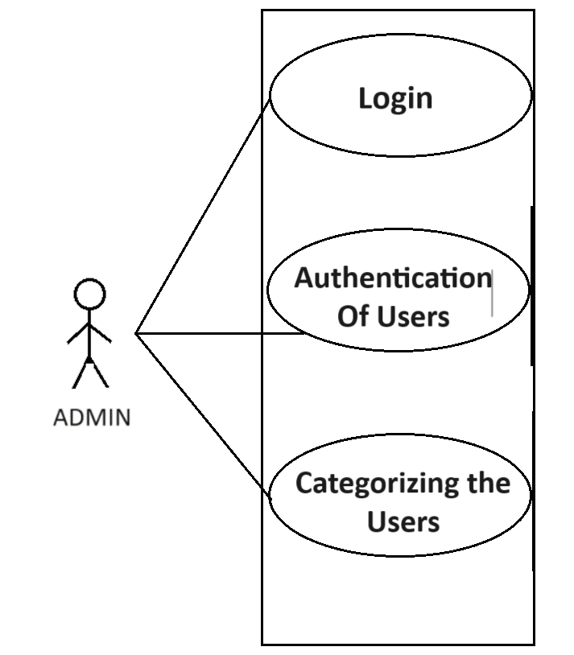**-**

*Fig. Use case diagram for admin*

1. In Admin use case diagram Admin is the Actor.
2. Admin can handle following use cases:
3. Login.
4. Authentication of user Process.
5. Categorizing the user Process.

**User:**

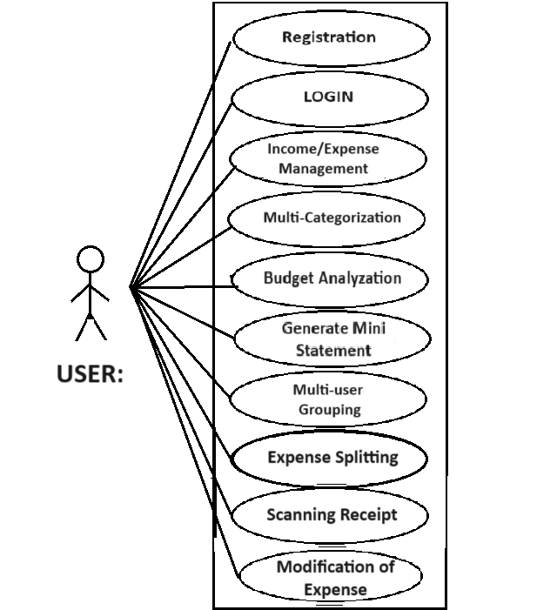

*Fig. Use case diagram for Farmer*

1. In User use case diagram User is the Actor.
2. User can handle following use cases:
3. Register.
4. Login.
5. Income/Expense Management.
6. Multi-Categorization.
7. Budget Analyzation.
8. Generate mini statement.
9. Multi-user Grouping.
10. Expense Splitting.
11. Scanning Receipt.
12. Modification of Expense.

**Small Business :**

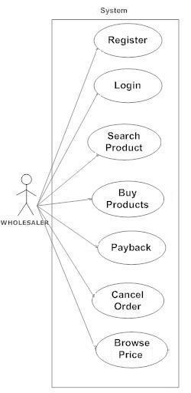

*Fig. Use case diagram for Wholesaler*

1. In Small Business use case diagram is the Actor**.**
2. Business can handle following use cases:
3. Register
4. Login