Darukaa.Earth: AI Biodiversity Intelligence Chatbot
Hackathon solution document — AI environmental scientist, not a chatbot.
GitHub repository: https://github.com/Palakagarwal28/Darukaa.earth-hackathon
The repository contains the complete project: backend, knowledge base, frontend, tests, CI.
Runs fully offline — no deployment, credentials, or API keys required.

1. Objective
Build an AI-powered conversational system that maintains a structured knowledge base of biodiversity and environmental metrics, understands user queries about ecosystems, land and climate, generates actionable non-obvious recommendations, and supports every recommendation with scientific reasoning and evidence.

2. Tech stack
Layer | Technology | Why
API backend | FastAPI (Python) + Uvicorn | Typed endpoints, auto OpenAPI docs at /docs
Retrieval (RAG) | BM25 + agro synonym map (default); TF-IDF / dense optional | 7/7 benchmark, offline, explainable scores
Knowledge store | Versioned JSON (32 evidence cards) + schema | Auditable, migratable to pgvector/Chroma
Reasoning | Deterministic multi-metric engine (no LLM in loop) | No hallucinated advice, reproducible
Conversation | Slot-filling + SQLite multi-turn memory | Clarifying Qs, context awareness
Frontend | Vanilla HTML/CSS/JS, zero build step | Runs from the same server, 3 tabs
Enrichment (optional) | Open-Meteo (keyless) + OpenAI-compatible LLM rephrase | Graceful offline fallback
Quality | pytest (12 tests), GitHub Actions CI | Green on every push
Docs deliverable | This document (DOCX->PDF via MS Word) | Submission artifact

3. System architecture
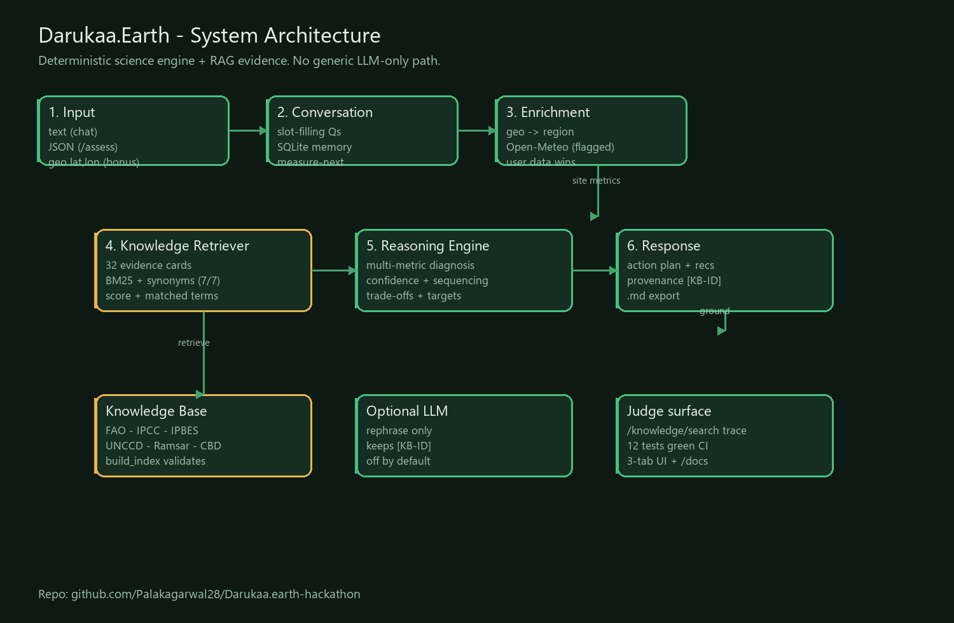
Figure 1 — end-to-end architecture: deterministic engine + RAG evidence.
Stage | Module | What it does
1. Input | Chat / Assess endpoints | Text, structured JSON, geo lat/lon (bonus)
2. Conversation | src/conversation.py | Extracts 5-domain metrics; asks clarifying Qs if soc/rainfall/land_use missing; SQLite memory
3. Enrichment | src/geo.py, src/integrations.py | Offline region inference; optional Open-Meteo fill (flagged, user data wins)
4. Retrieval | src/retriever.py, src/bm25.py | BM25 over 32 cards; returns kb_id + score + matched terms
5. Reasoning | src/reasoner.py | Interaction diagnosis, confidence, sequencing, trade-offs, targets, measure-next
6. Response | UI + JSON API | Phased plan + recs + provenance [KB-ID] + Markdown export

4. Knowledge system (critical requirement)
- 32 evidence cards covering soil pH/SOC/moisture, land use/cover, species richness/habitat diversity, temperature/rainfall, pollution/deforestation — plus measurement protocols (eDNA KB26, soil card KB27).
- Sources: FAO, IPCC AR6, IPBES (2016/2019/2023), UNCCD, Ramsar, CBD + peer-reviewed meta-analyses.
- Each card: intervention, mechanism, metrics improved, effect size, time horizon, confidence, source, region fit, conditions, contraindications.
- Validation: python -m knowledge.build_index (IDs, fields, coverage, retrieval smoke test).
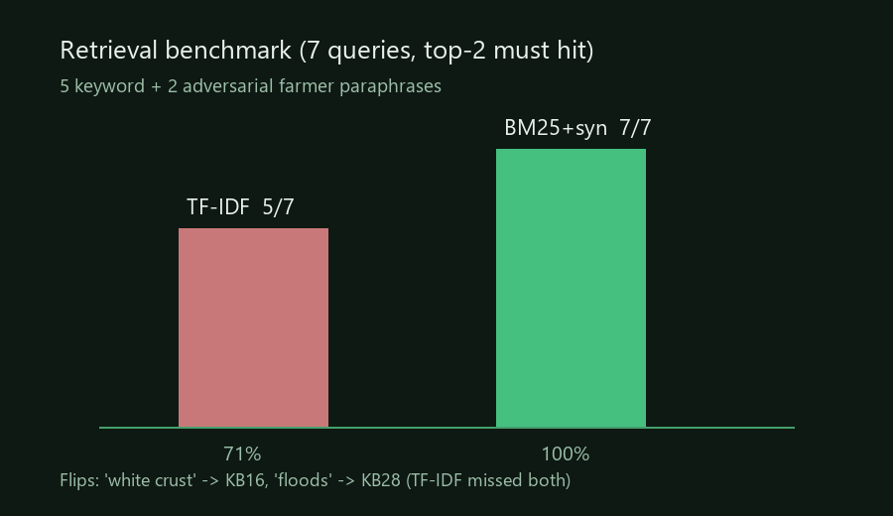
Figure 2 — retrieval benchmark: BM25+synonyms 7/7 vs TF-IDF 5/7.
The two adversarial farmer paraphrases ('white crust on field, salty' -> KB16 sodic reclamation; 'field floods every monsoon' -> KB28 drainage) miss on TF-IDF and hit on BM25 — the measured justification for the default backend. Method + full table: knowledge/retrieval_benchmark.md.

5. Conversational intelligence
- Vague input ('biodiversity is declining') triggers targeted clarifying questions, never a guess.
- Multi-turn memory per session id (SQLite); JSON overrides memory; new text merges in.
- measure_next ranks the 3 missing inputs by decision impact, driving follow-ups.
- Inputs: free text, structured JSON (/assess), geo-coordinates (region inference + climate enrich).
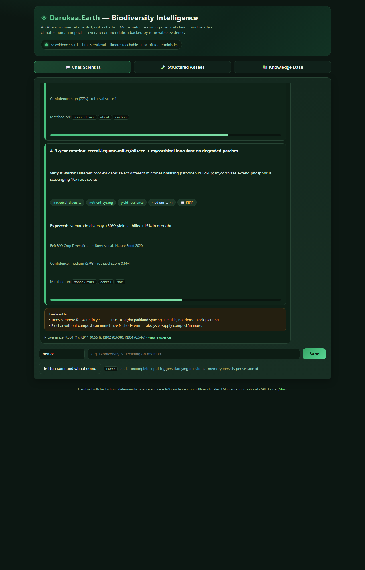
Figure 3 — Chat Scientist tab running the semi-arid wheat demo (?tab=chat&demo=1).

6. Evidence-backed, multi-metric recommendations
Every recommendation carries WHAT / WHY (mechanism) / impacted metrics / expected effect / time horizon / confidence + score / reference [KB-ID]. Example (SOC 0.3%, low rain, monoculture wheat):
- Legume intercrop -> SOC +15-25% in 2-3 yrs, pollinators +30-50% (FAO; Poeplau & Don 2015) [KB01].
- Contour bunds + farm pond -> moisture +25-40% (UNCCD; IPCC AR6) [KB04].
- Diagnosis chains variables (low SOC x drought x monoculture x pH), never single-variable answers.
- Sequenced plan: chemistry first, water early, biology over seasons — plus trade-offs and .md export.
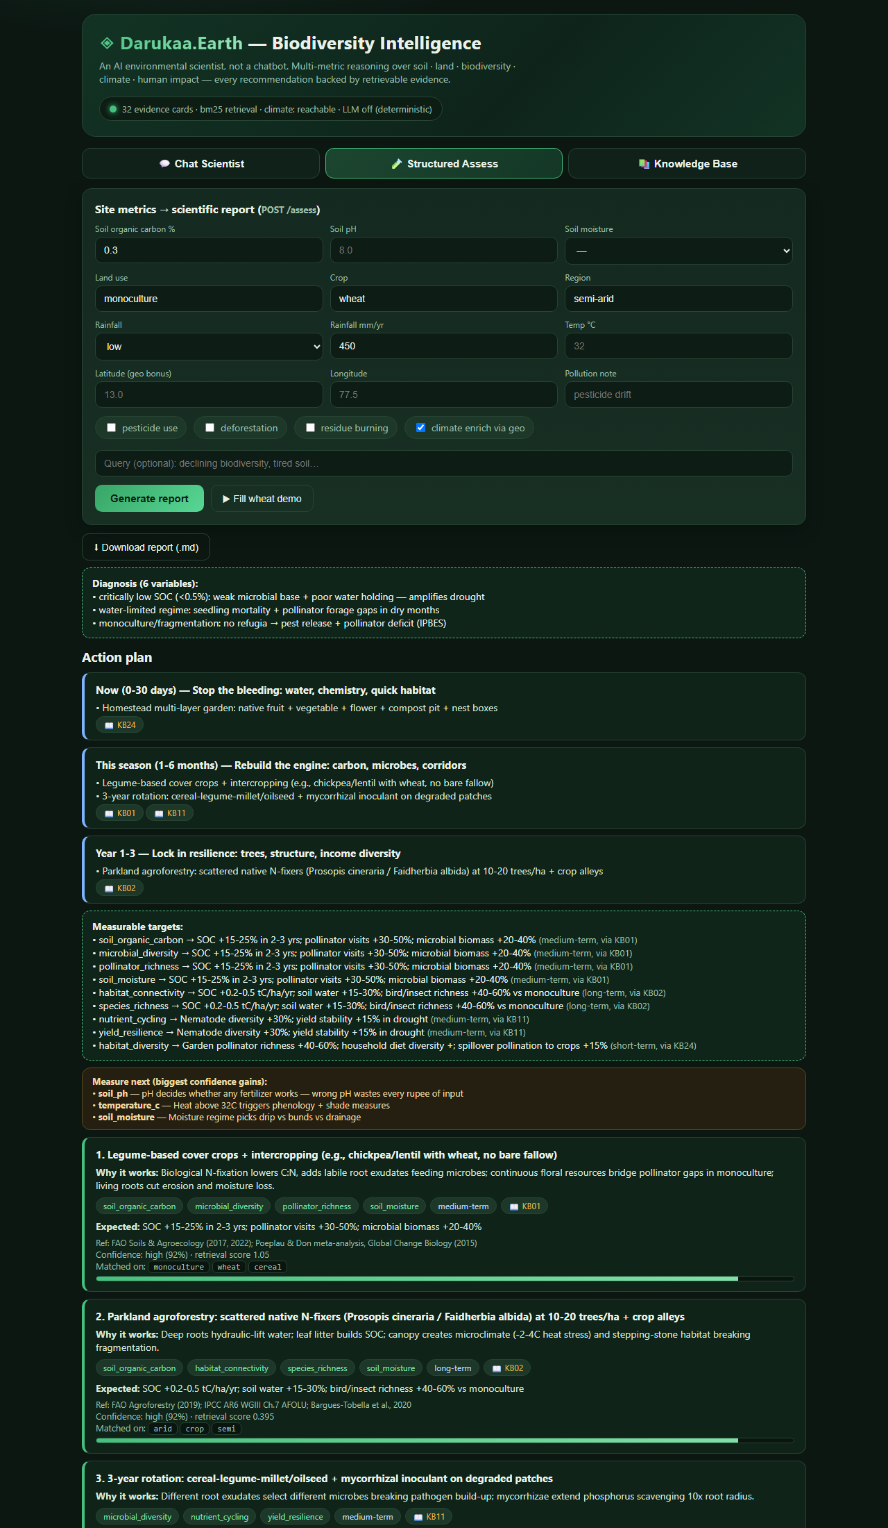
Figure 4 — Structured Assess tab: phased plan, targets, recs, provenance (?tab=assess&demo=1).

7. Knowledge grounding surface (for judges)
- GET /knowledge/search shows scores + matched terms for any query.
- GET /provenance?ids= returns the exact cited cards.
- 12 pytest tests + green GitHub Actions CI on every push.
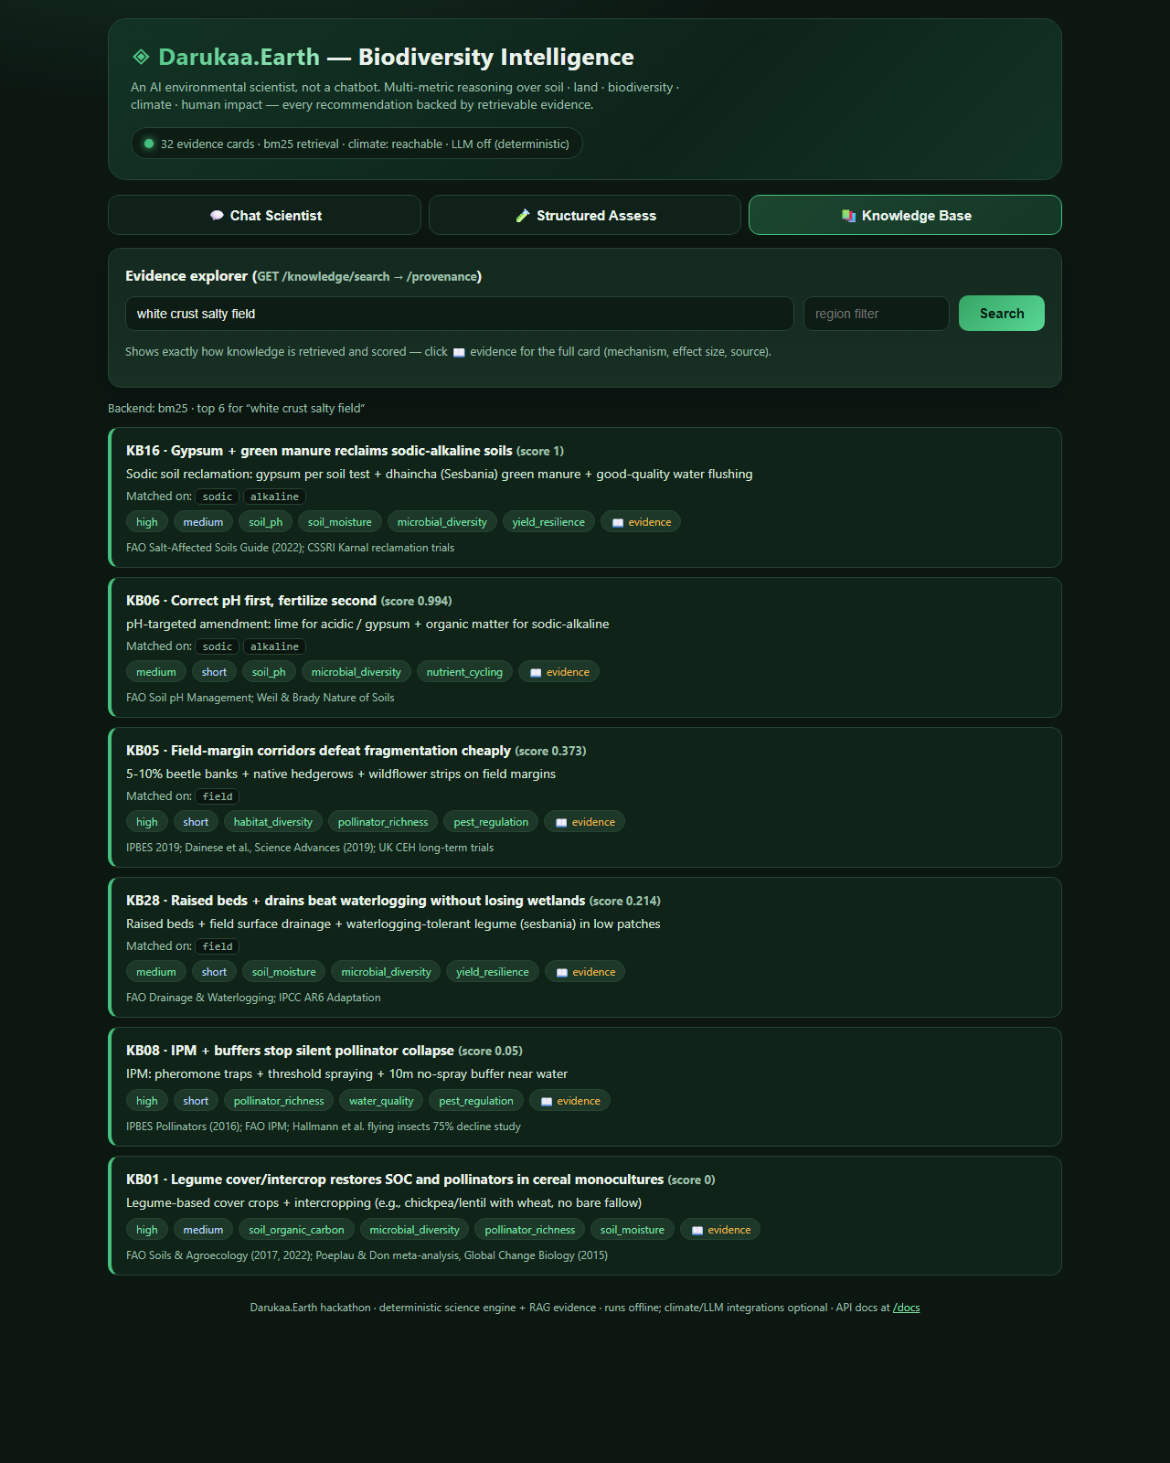
Figure 5 — Knowledge explorer tracing 'white crust salty field' to KB16.

8. API reference
Endpoint | Purpose
POST /chat | Text + memory; clarifying questions when incomplete
POST /assess | Structured JSON site -> full scientific report
GET /knowledge/search | Retrieval trace (scores, matched terms)
GET /provenance?ids= | Exact evidence cards cited
GET /sessions/{sid} | Conversation history
GET /health, /integrations/status, /docs | Status + interactive API docs

9. Evaluation summary
Metric | Result | Where to verify
Retrieval benchmark | BM25 7/7, TF-IDF 5/7 | knowledge/retrieval_benchmark.md
Retrieval latency (median) | BM25 2.3 ms; assess() 2.7 ms; HTTP 13.4 ms | Rerun snippet in ARCHITECTURE.md
Tests | 12/12 pass | python -m pytest tests -q; CI badge
Variables combined | 6 (wheat demo) | POST /assess variables_count
Offline | Identical results, no network | Disconnect + rerun demo

10. Local setup (2 minutes)
- pip install -r requirements.txt
- python -m pytest tests -q
- python -m uvicorn api.main:app --host 127.0.0.1 --port 8000 (or double-click run_local.ps1)
- Open http://127.0.0.1:8000 | shareable demos: ?tab=chat&demo=1 ?tab=assess&demo=1 ?tab=kb&demo=1&q=...
GitHub: https://github.com/Palakagarwal28/Darukaa.earth-hackathon | No deployment, keys, or credentials required.

