What’s the overall attrition rate?

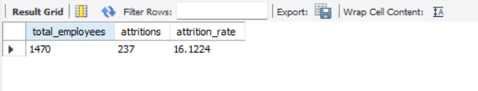

Which department has the highest attrition?

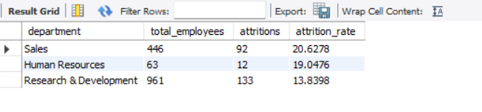

Attrition rate by gender?

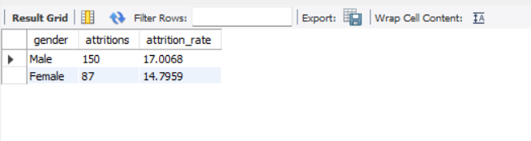

Attrition rate by job role?

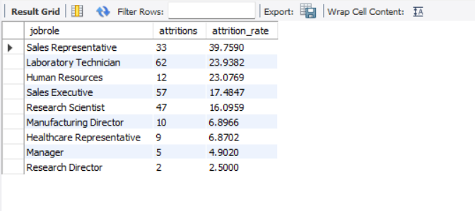

Who got promoted recently?

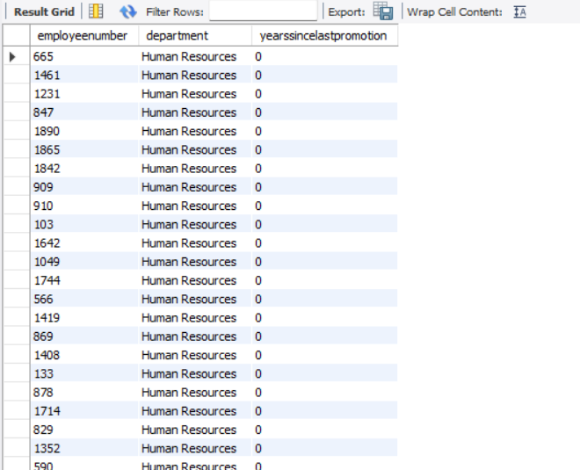

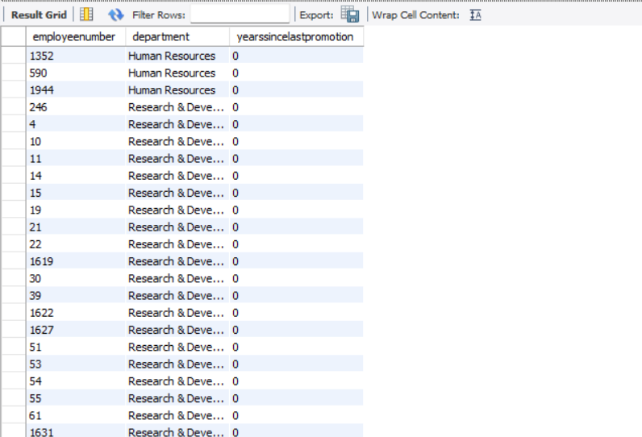

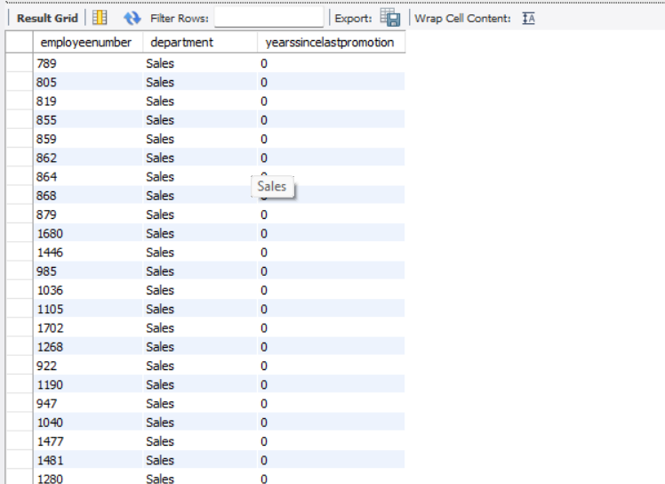

Are younger employees more likely to leave? (Use age brackets)

